**Mobile Computing**

**Student Name: Asad Ullah Shahid**

**Teacher Name: Sir Haq Nawaz**

**Lecture 02:**

In lecture two we studied GIT commands. How to merge a file on GitHub.

1. To merge a file. We need to create files

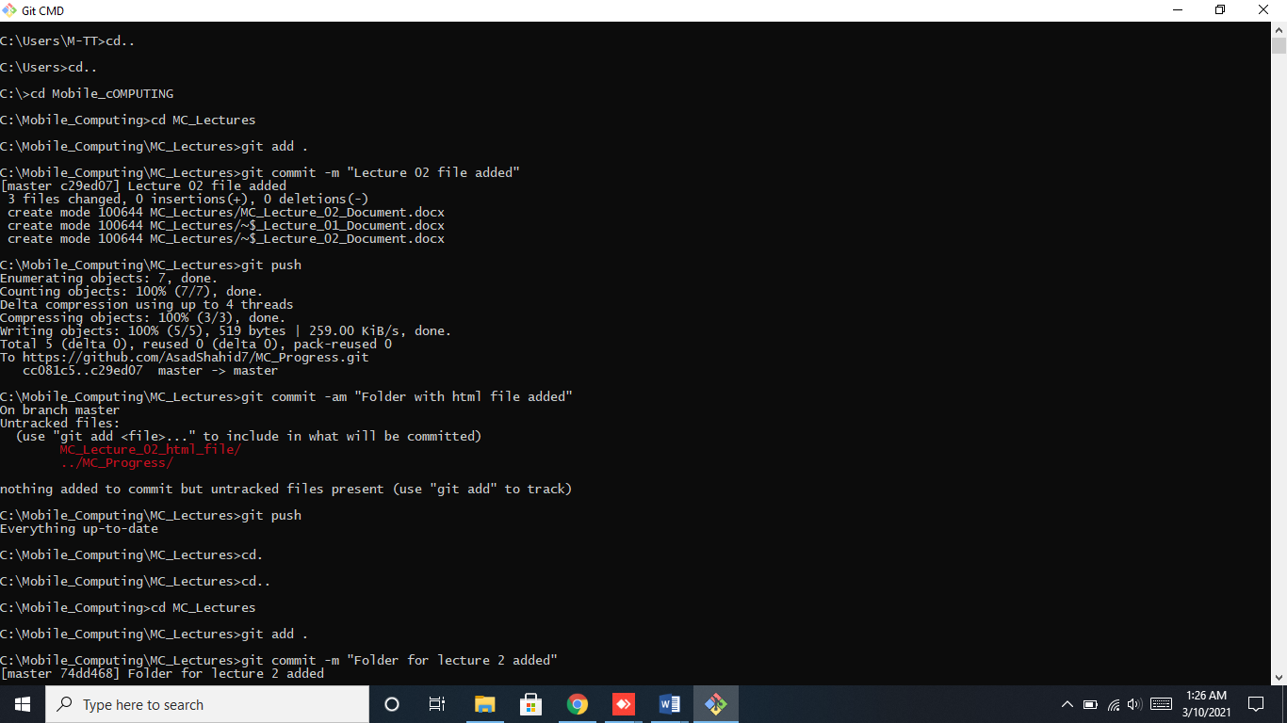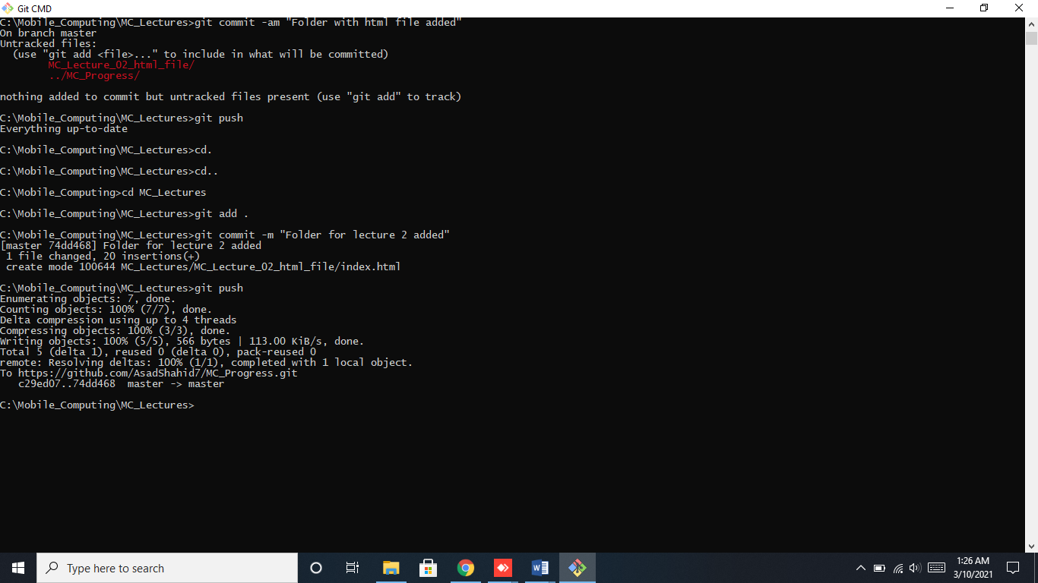

1. Now we will do changes in both files at same time.

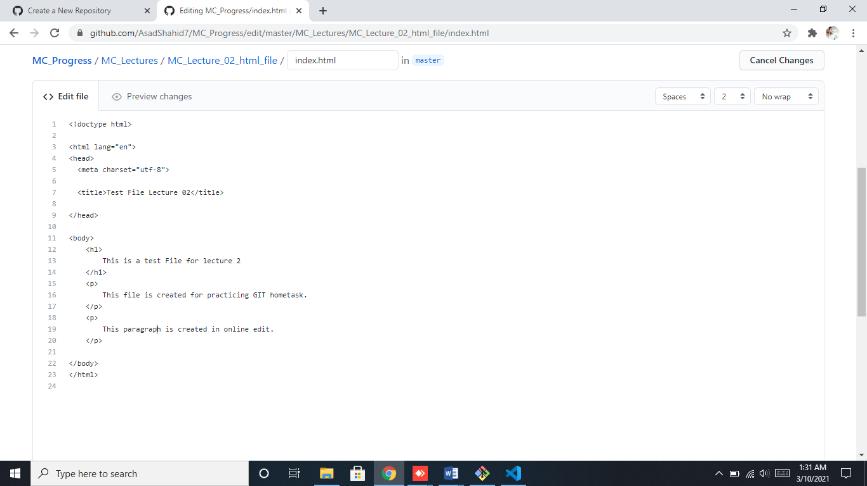

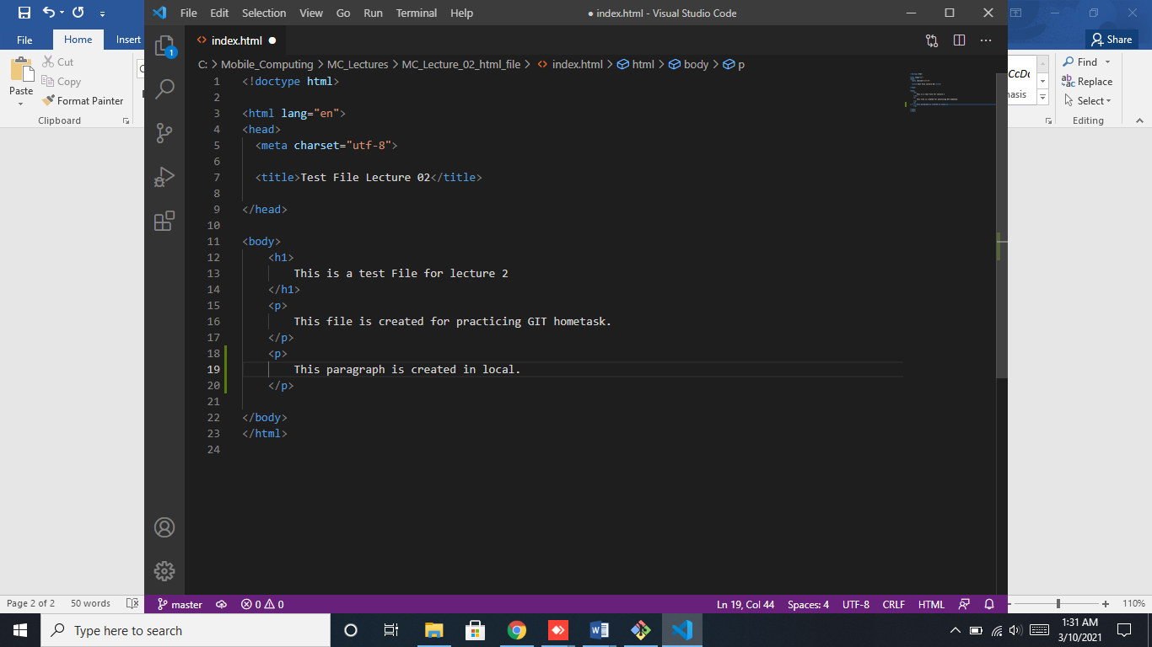

1. Now we will first commit and then pull.

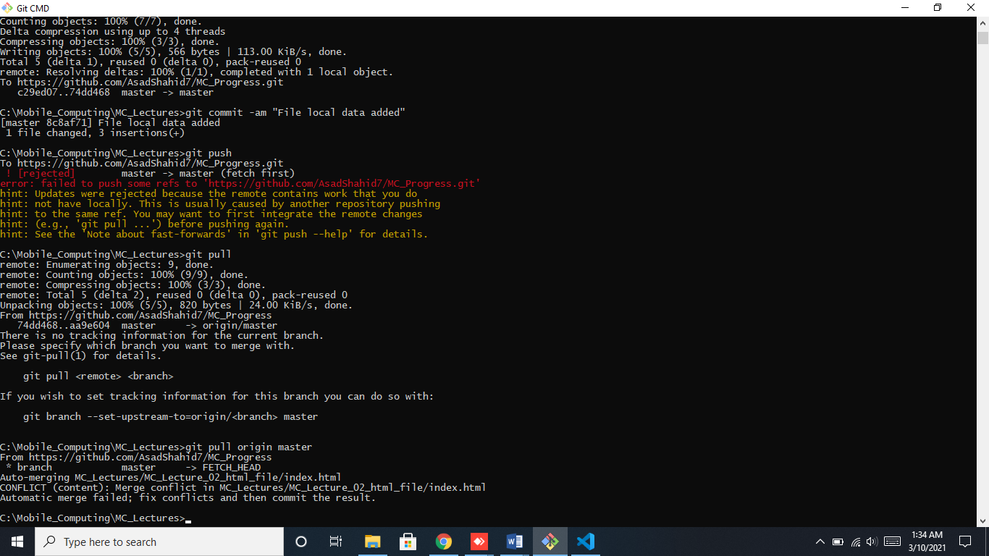

We can say merge conflicts.

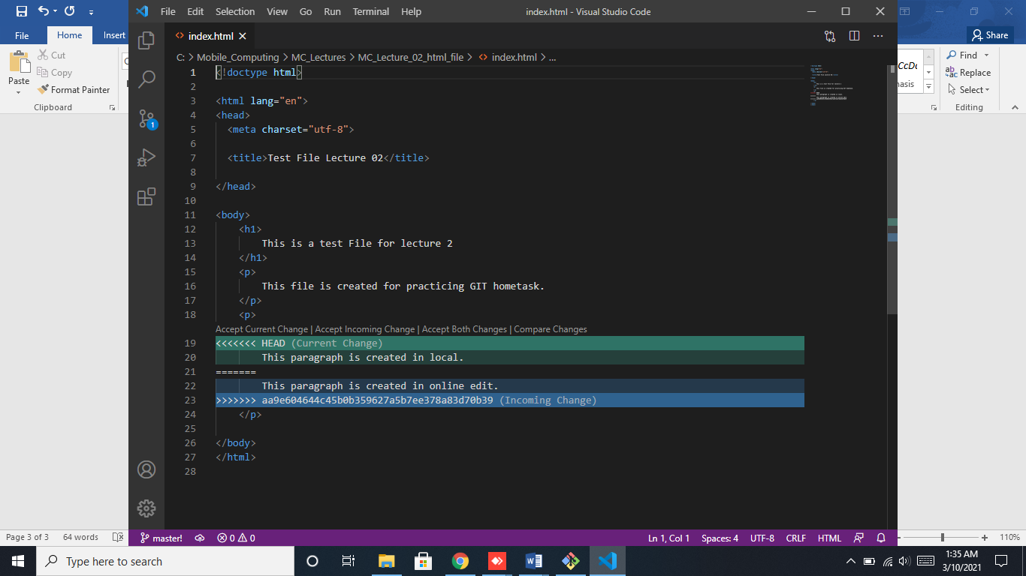

I have selected both

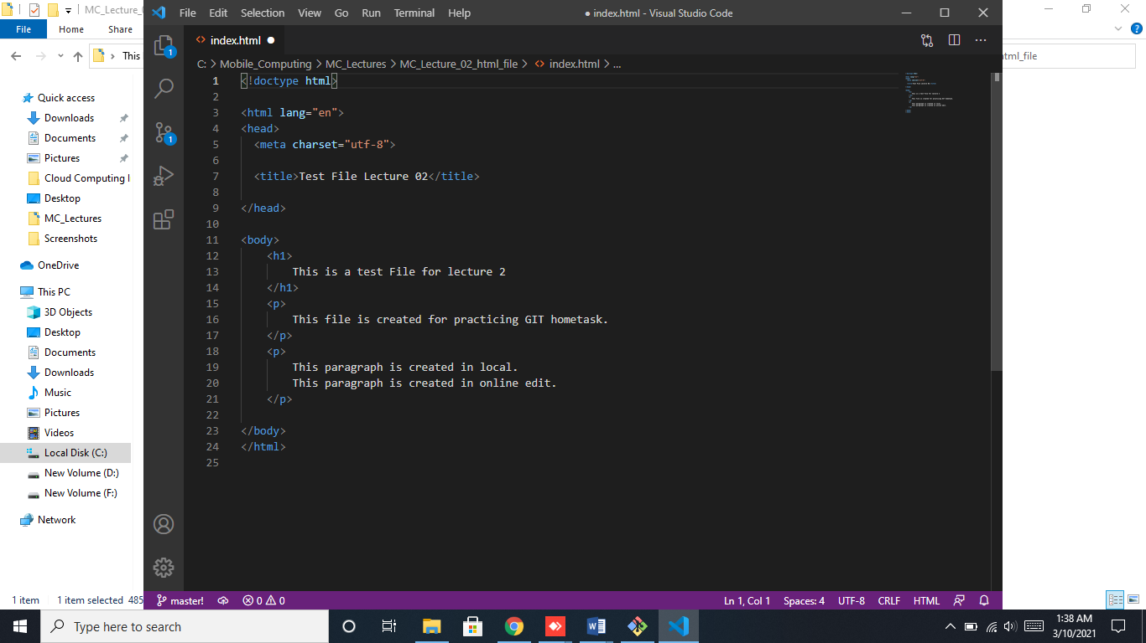

1. Now, we will run commands to update data

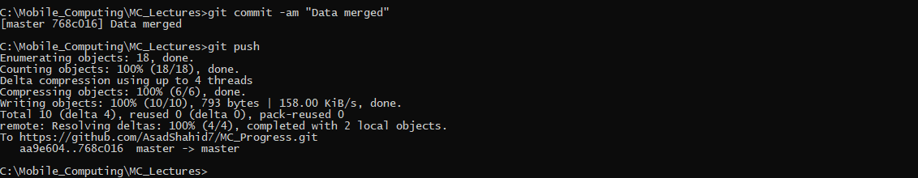

1. Online data is also merged

