**Mobile Computing**

**Student Name: Asad Ullah Shahid**

**Teacher Name: Sir Haq Nawaz**

**Lecture 05:**

**It contains same project as lecture 4 on GITHUB, I have made another button to check this**

1. We studied in this lecture, About the ACTIVITY LIFE CYCLE.
2. The first pre implemented function is onCreate. It always runs first when the activity is started.
3. Second is onStart. After the execution of onCreate the onStart function start running.
4. After these two, on staying in the activity the onResume functions start working.
5. When we move back from the activity or go somewhere to new activity the onPause functions stays there so it is the next one which is executed.
6. When the activity is about to finish or destroy the onDestroy function start working.

Below are the images of functions and console. They shows the sequence of the functions execution.

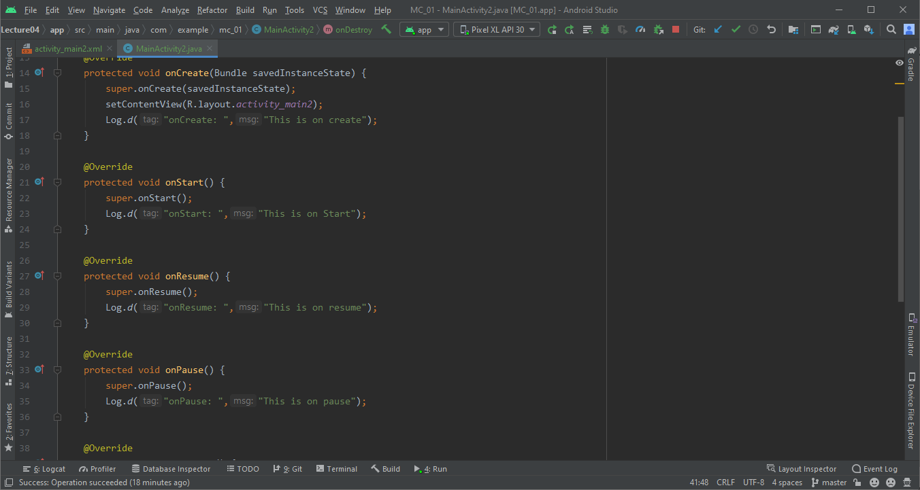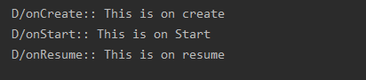

After moving to another activity.

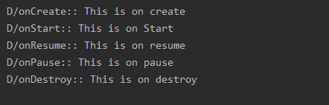

**How to maintain state.**

1. For maintaining the state, We use functions like **onSaveInstanceState();**
2. We pass our value with a identifier and when we came back on onCreate, we use our value from this function.

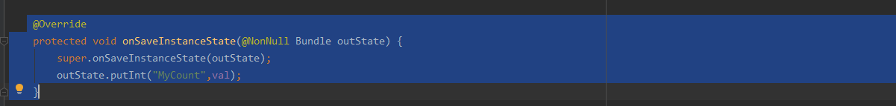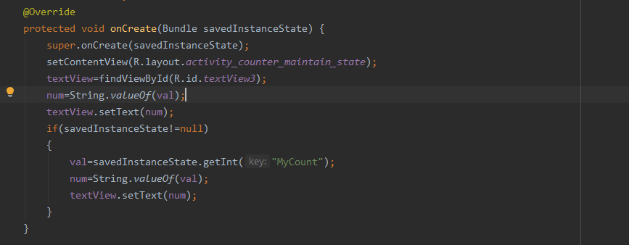

**Emulator screen images are also added**

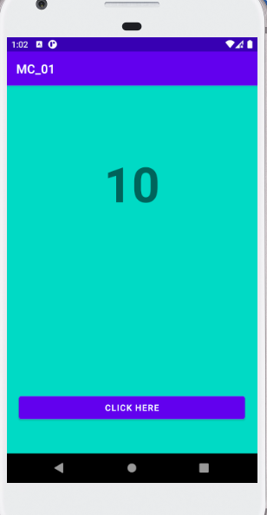

**Now after rotating the value will remain same**

