**Mobile Computing**

**Student Name: Asad Ullah Shahid**

**Teacher Name: Sir Haq Nawaz**

**Lecture 06:**

**THIS WORK WAS DONE IN CLASS, CODE IS ON GITHUB WITH LINK:**

**https://github.com/AsadShahid7/MC_Lecture_04**

In this lecture, we studied how to move from one app to another app.

1. In the xml file we added the following code

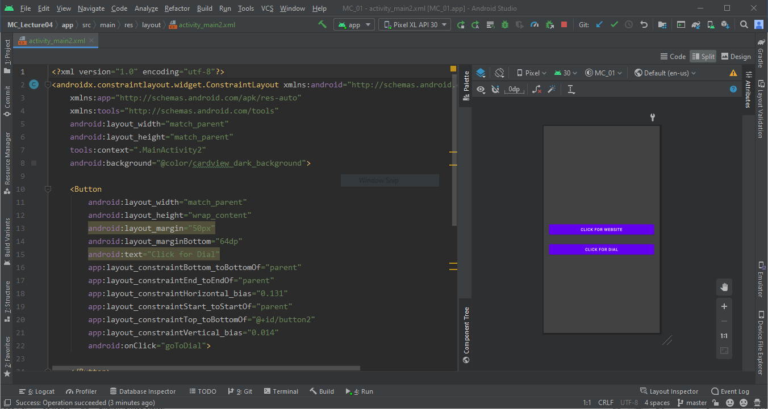

1. In the java file, we added what to do when these buttons are clicked.

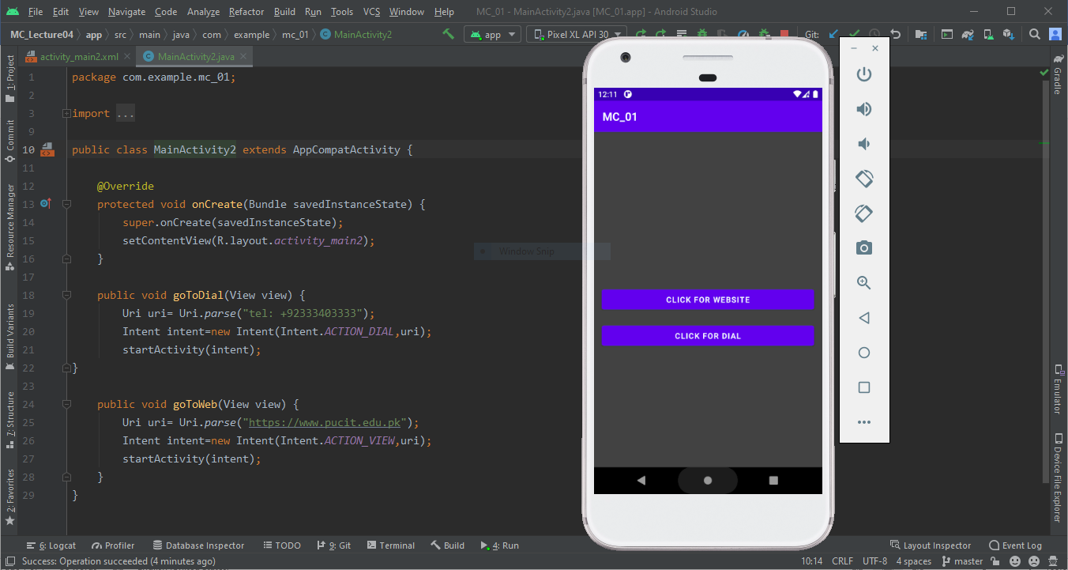

1. When a button is clicked with the code in goToDial, The phone dialer is opened with this entered number.

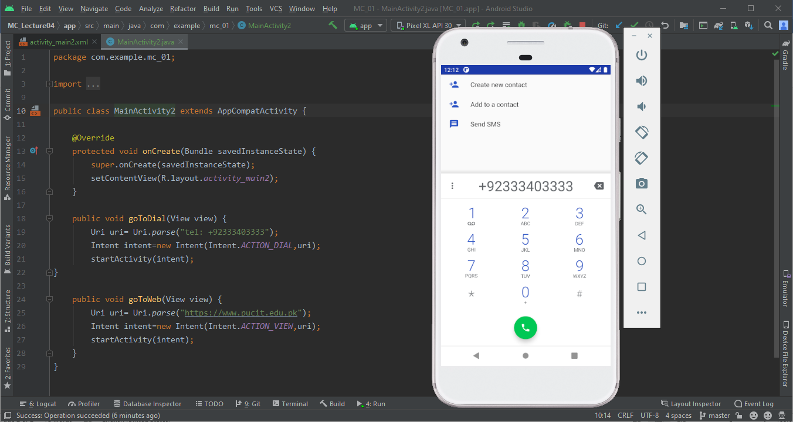

1. Same is happened when the link is clicked but it opens the website in the default browser

