**Mobile Computing**

**Student Name: Asad Ullah Shahid**

**Teacher Name: Sir Haq Nawaz**

**Lecture 10:**

**In this lecture, we studied about SQL Lite database.**

1. First we made a simple layout.

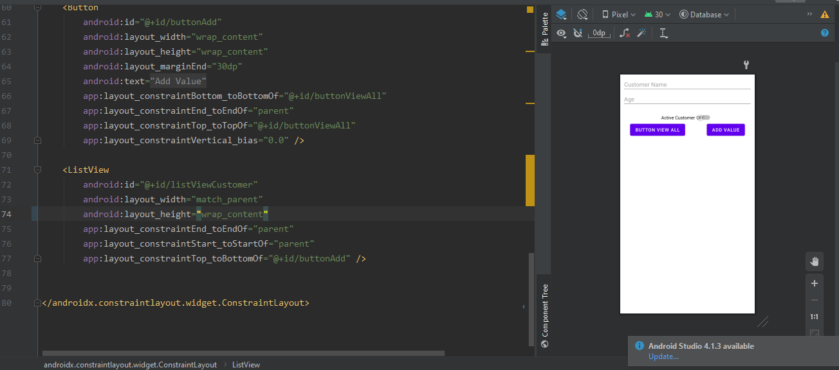

We added edit texts for name, age and switch for Status, After that we added two buttons.

1. Next, we bind our xml interface elements with java.

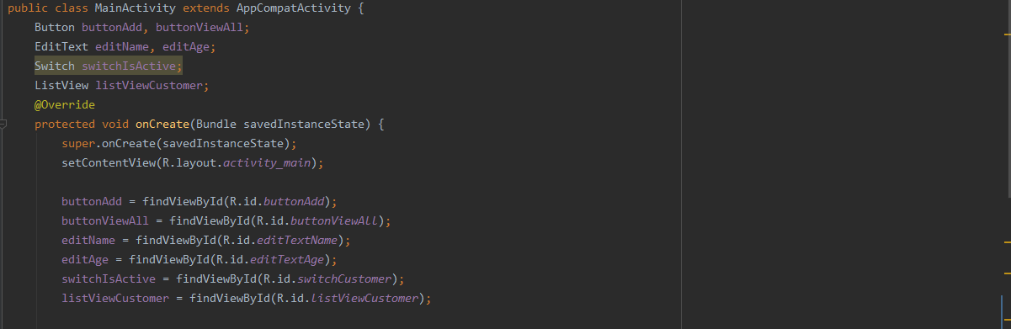

1. Now we will make a class for database, and will also make one class for database helper.

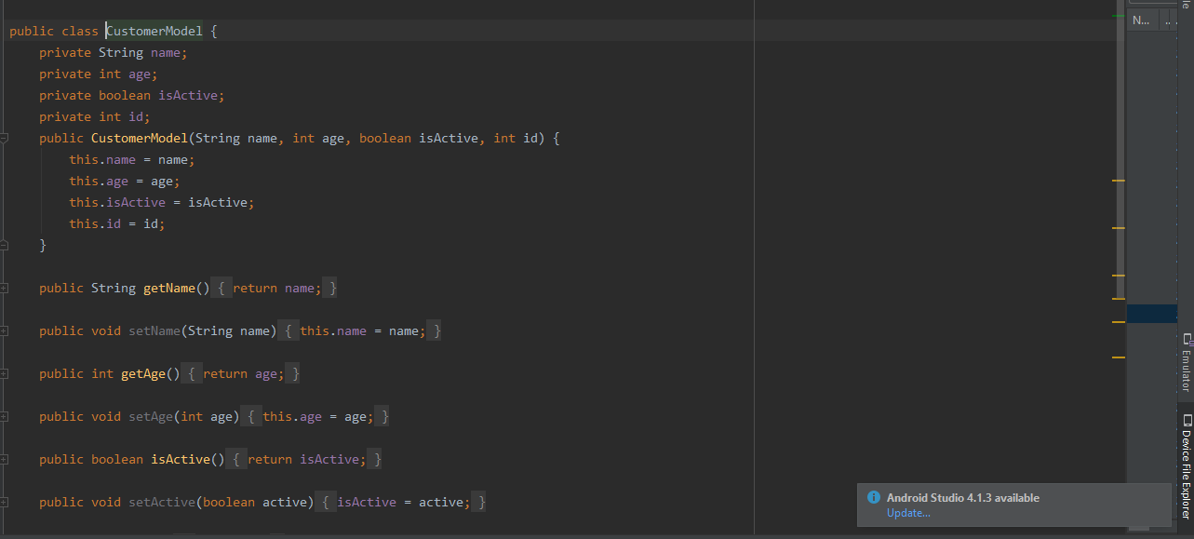

DATABASE CLASS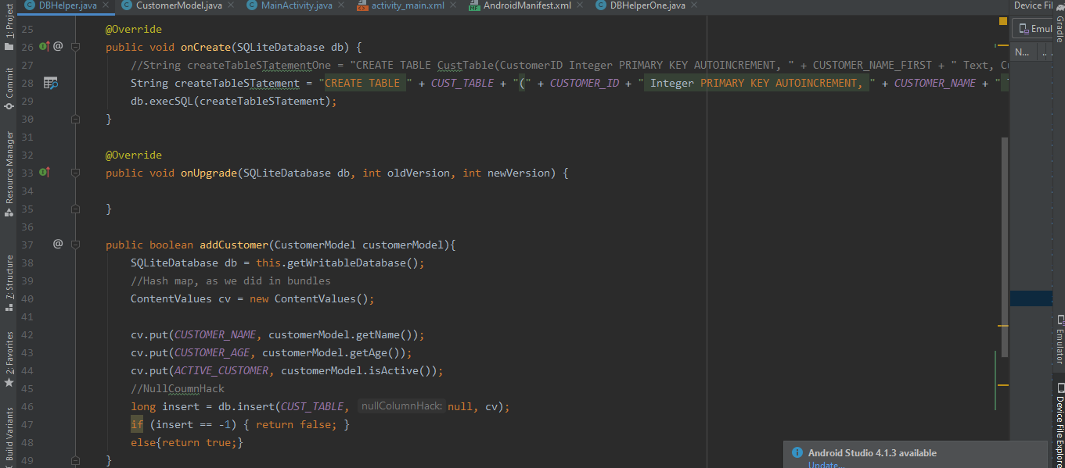

Also the function to add data in database is added.

1. Now we will save some data and will check from sqLite GUI.

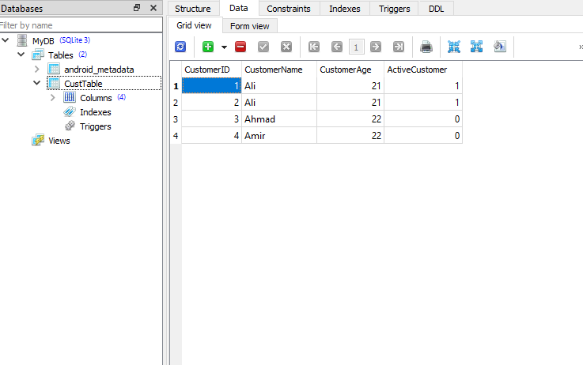

1. Now we will write function to get Data

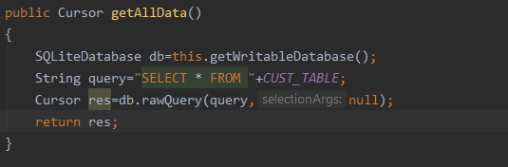

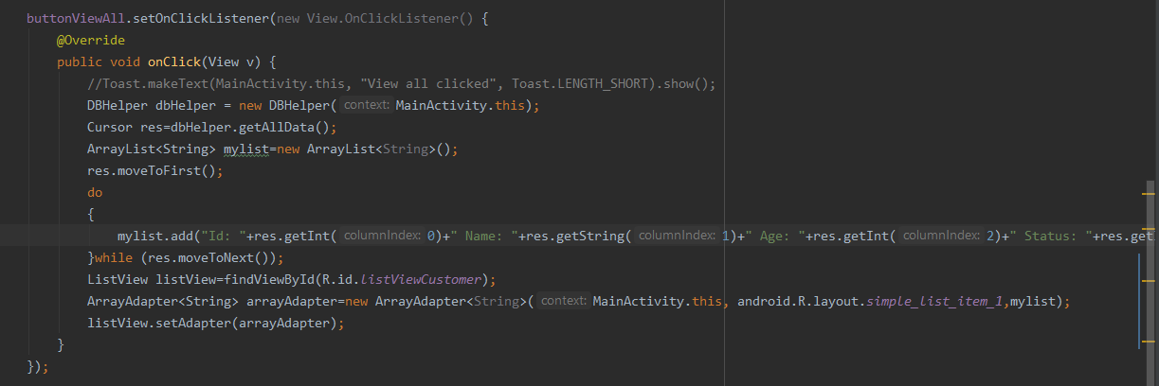

1. Saved data can be also seen on emulator

