**Mobile Computing**

**Student Name: Asad Ullah Shahid**

**Teacher Name: Sir Haq Nawaz**

**Lecture 11:**

**In this lecture we learned how to implement the Navigation Drawer.**

1. First we need to add menu folder in resources.

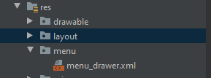

1. Now add some menu items in the file

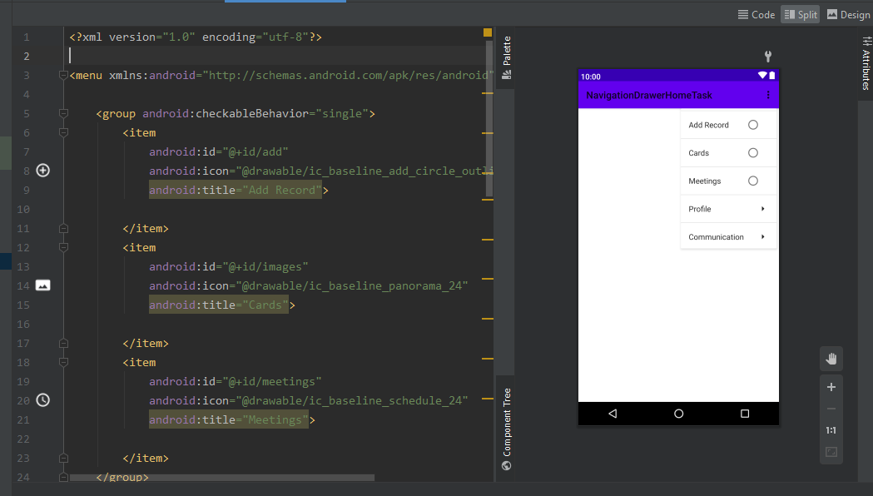

1. For icons we will add some icons in drawable from vector

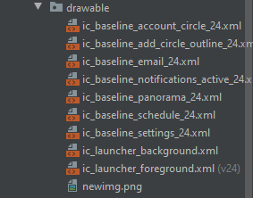

1. Now we will make a header for our Navigation Drawer

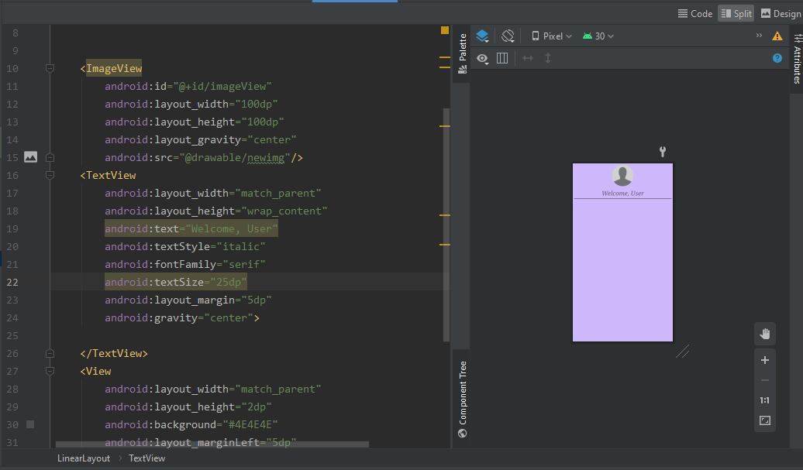

1. Now on the main page where this drawer is needed we will add its code

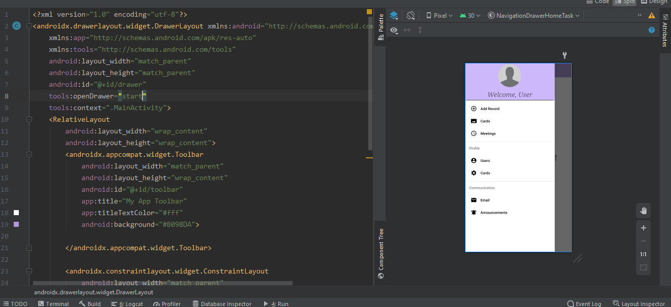

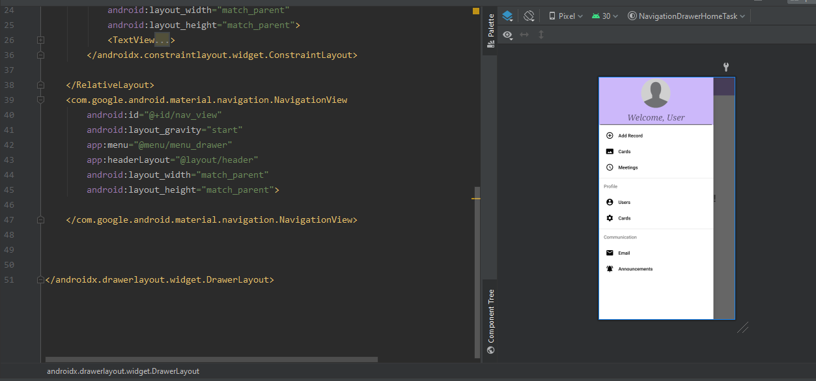

1. Now in java we will access these layouts

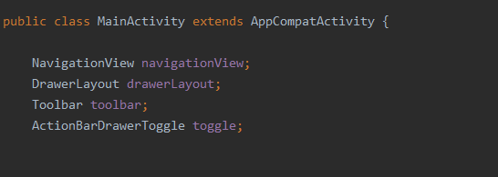

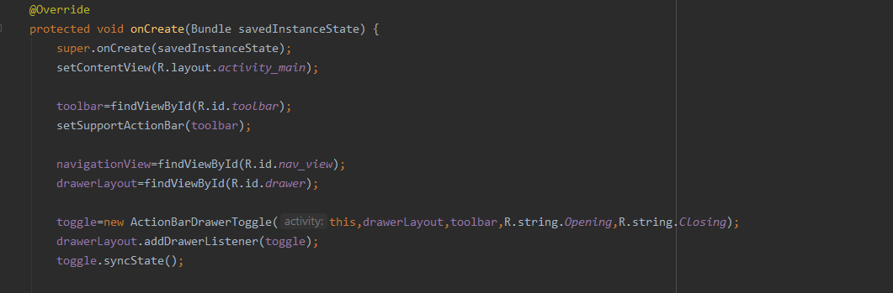

1. Set method on back button pressed

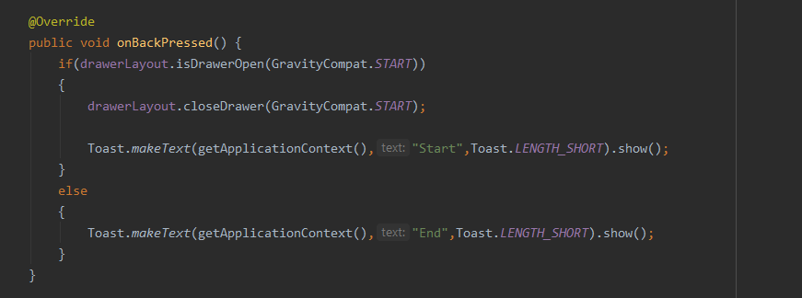

1. Now add what should happen when we click on any item in drawer

