**Mobile Computing**

**Student Name: Asad Ullah Shahid**

**Teacher Name: Sir Haq Nawaz**

**Lecture 12:**

**In this lecture we discussed about Recycler View.**

1. First I have added dependency of Recycler View



1. After that I made a card Layout for showing records

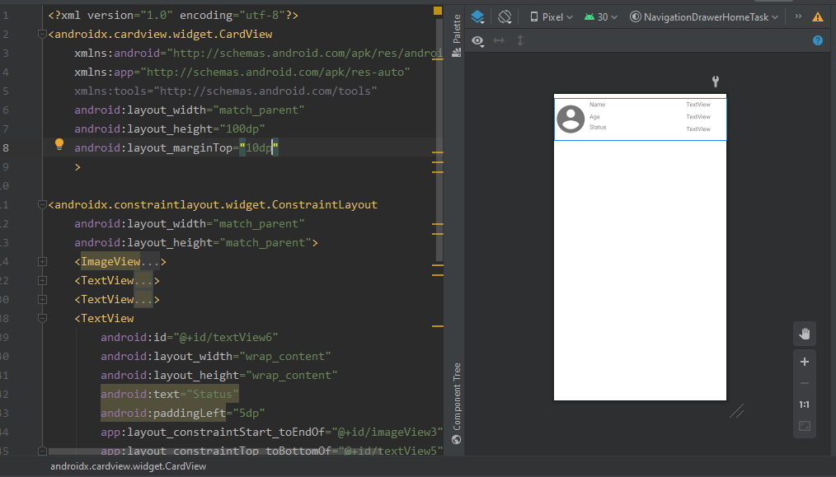

1. After that I made a customized Adapter class for Recycler View

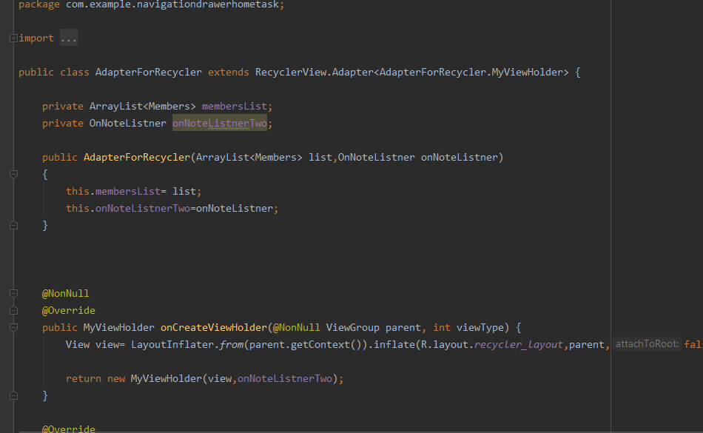

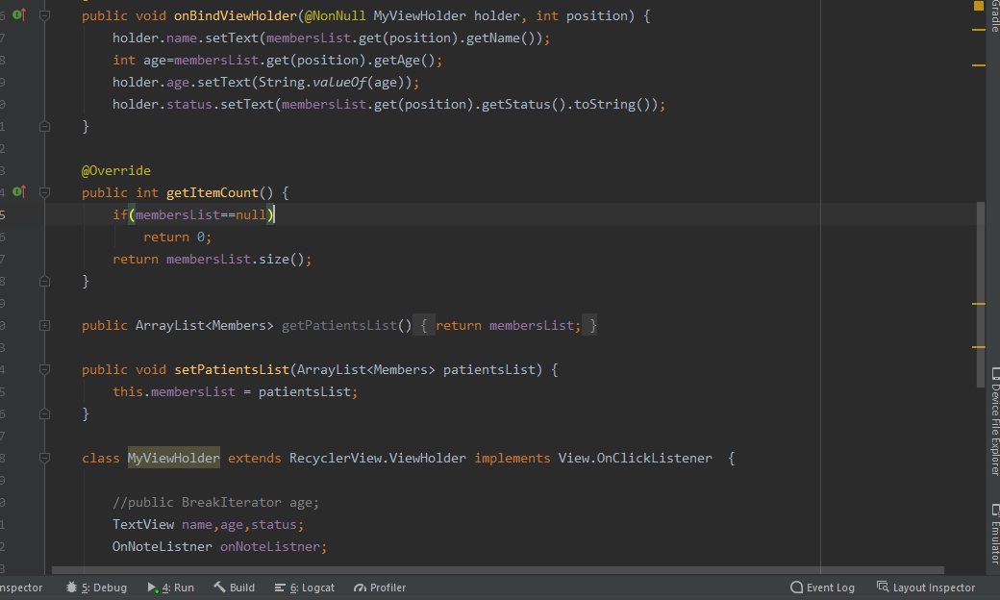

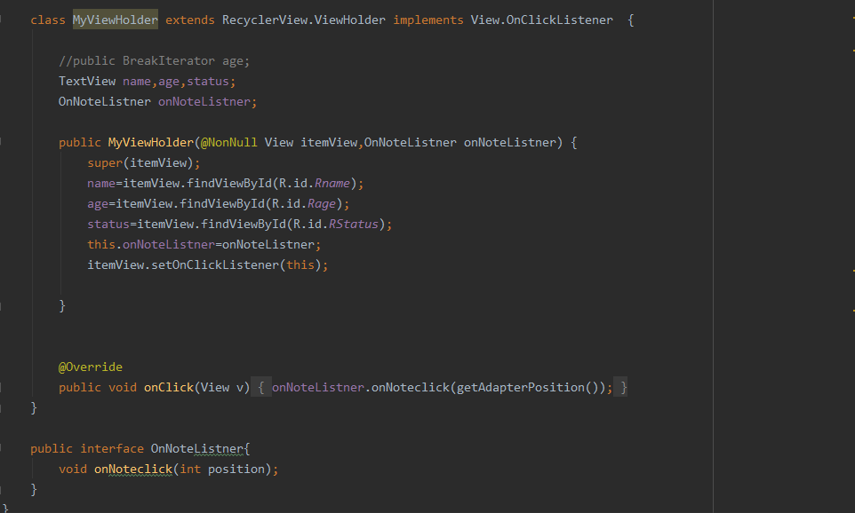

1. I also made an interface for showing result

//Image is below on the next page//

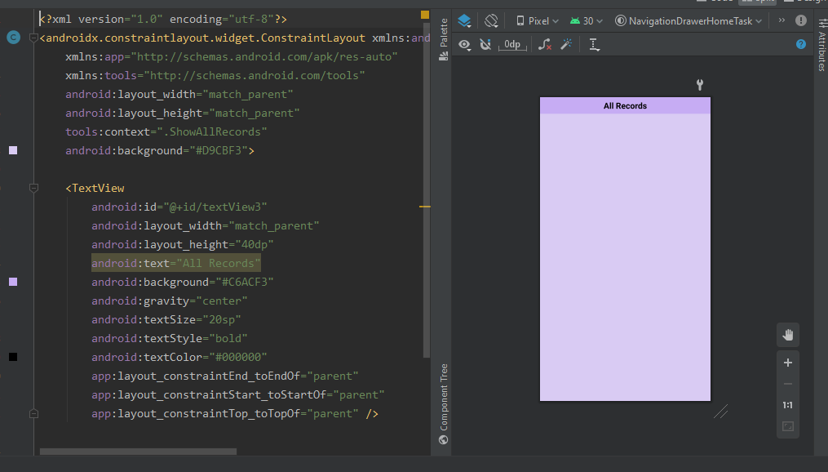

1. I made onClick submit function

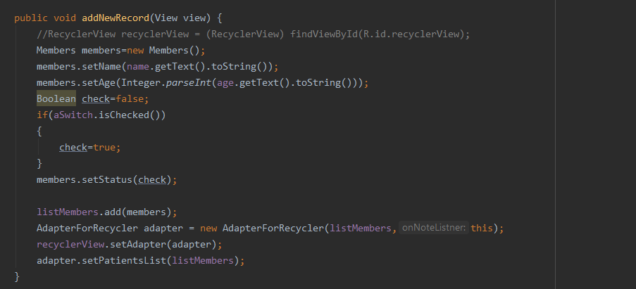

1. I also set other buttons to switch layout

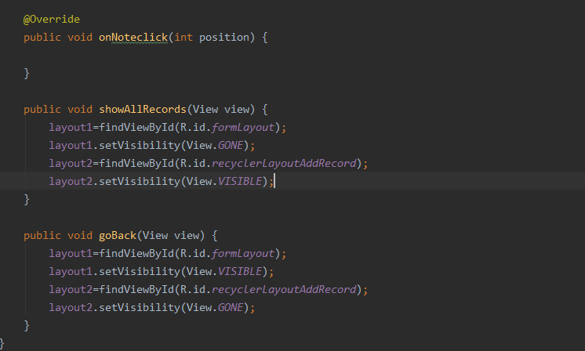

1. Here is my output

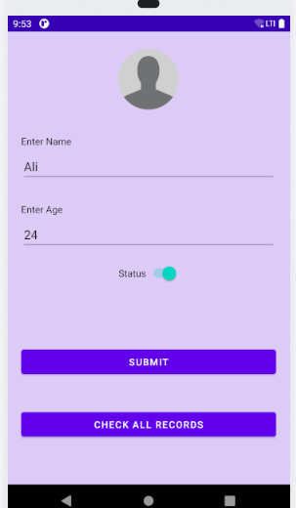

//Next image is on the next page//

