**Mobile Computing**

**Student Name: Asad Ullah Shahid**

**Teacher Name: Sir Haq Nawaz**

**Lecture 13:**

**In this lecture we discussed about Alert Dialogue BOX.**

1. First we create a simple alert dialogue box. The options were given to stay on app or to exit from app. I made this function on back button pressed

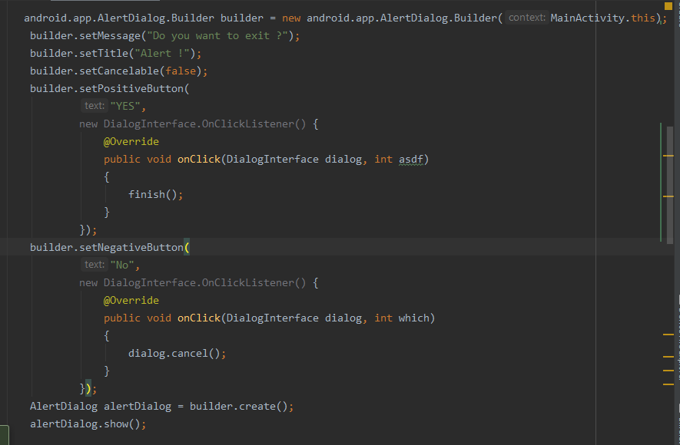

The Yes button uses finish function to kill the process and No option uses dialogue cancel function to dismiss it.

1. Create a button for multi option dialogue 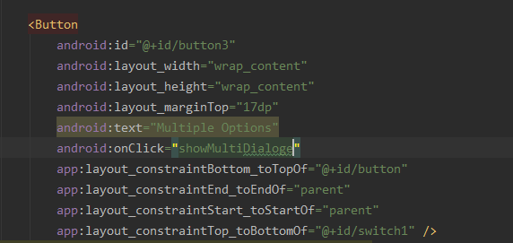
2. Now add java code for multi dialogue, first declare variables

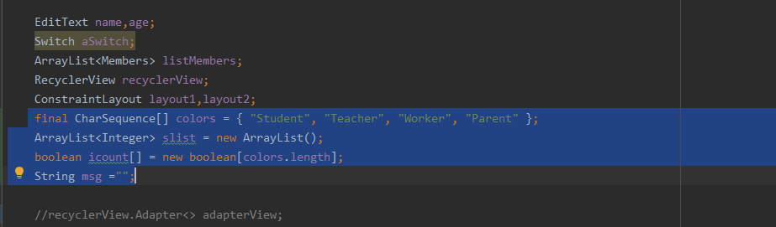

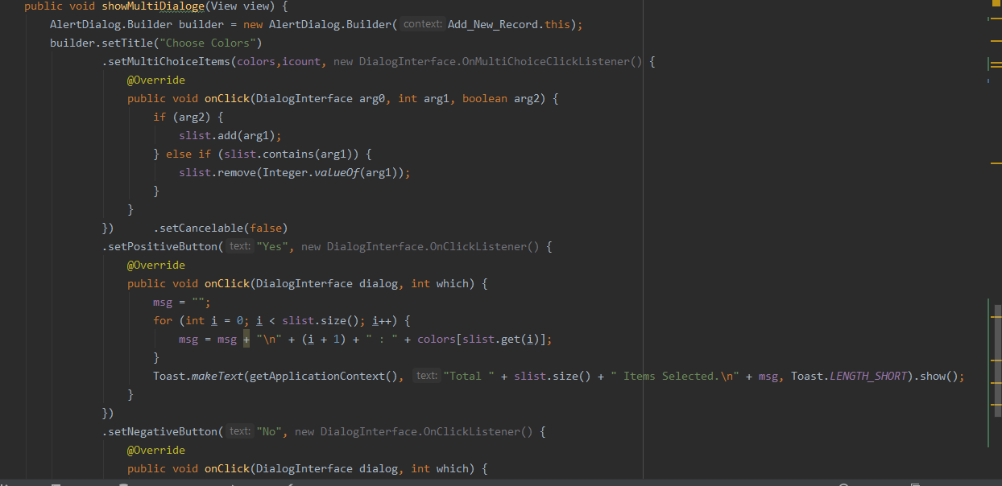

1. GUI is:

