**Mobile Computing**

**Student Name: Asad Ullah Shahid**

**Teacher Name: Sir Haq Nawaz**

**Lecture 13:**

In this lecture we discussed how to use NOTIFICATIONS in our app.

1. First create a class with name APP and extends it with android.app.Application, also make two channels variables

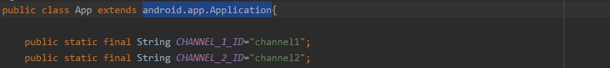

1. Now create onCreate method, so this can run in the start

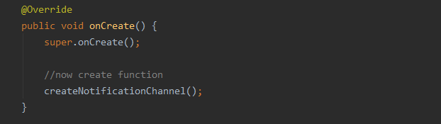

1. Now create the method we called in onCreate

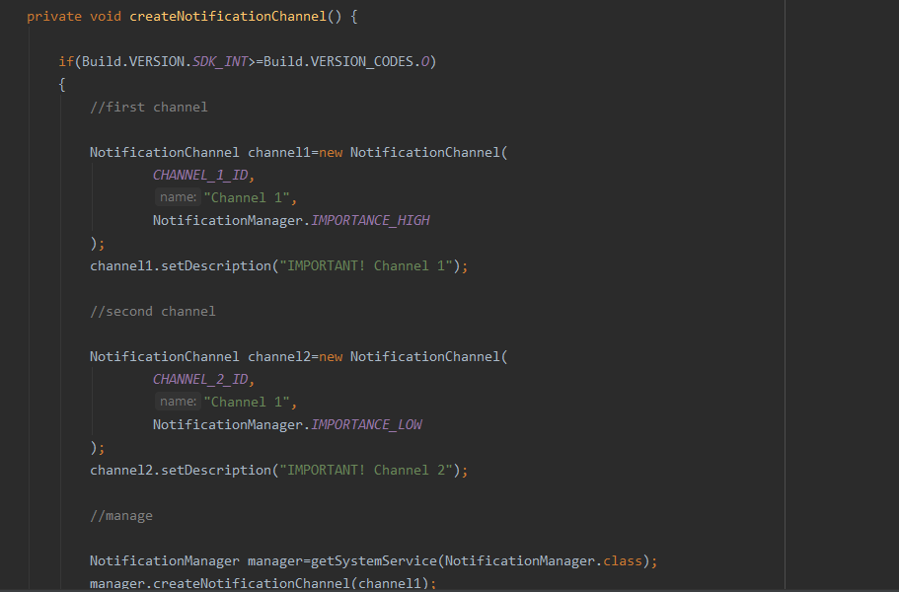

This code contains channel importance and their ids

1. Now go to manifest and add android name there

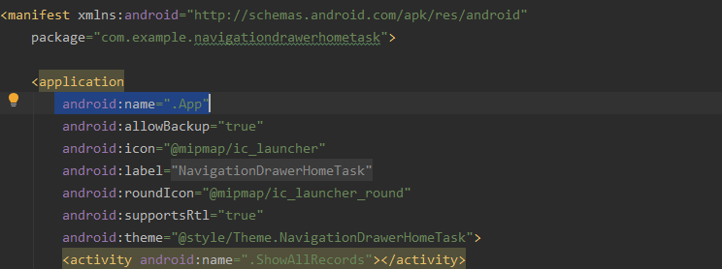

1. Now make buttons and text view where you need to have notifications

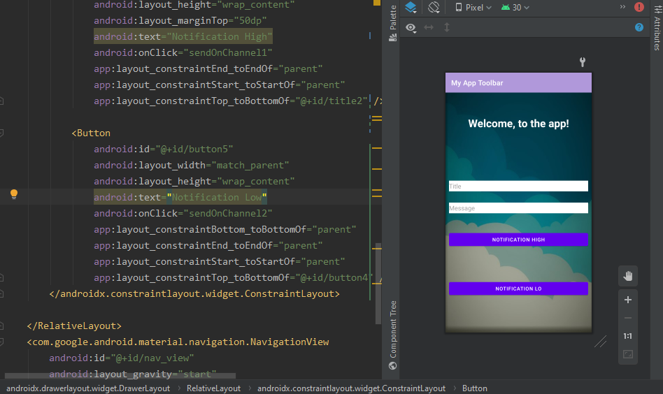

1. Now go to java file and create variables

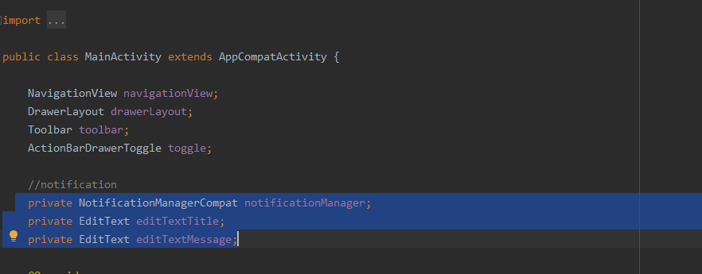

Now find these views by id in onCreate

1. Now we will do remaining work in button onclick methods

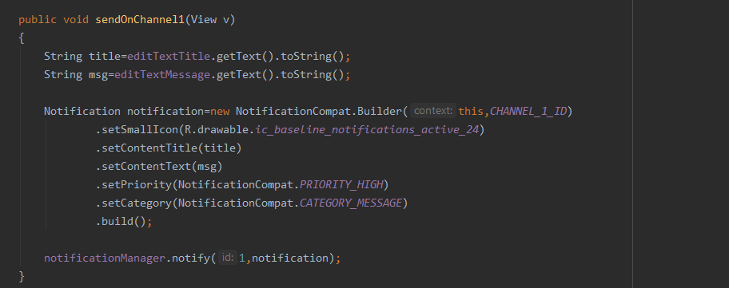

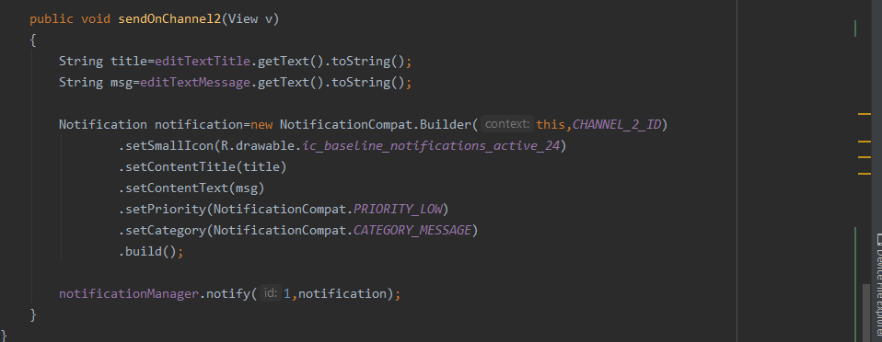

OUTPUT:

