**Mobile Computing**

**Student Name: Asad Ullah Shahid**

**Teacher Name: Sir Haq Nawaz**

**Lecture 15:**

**In this lecture we covered how to use Fragments in same activity.**

**For this first we created a simple activity.**



1. **After creating activity, we added one Frame Layout and two buttons for switching between activities.**

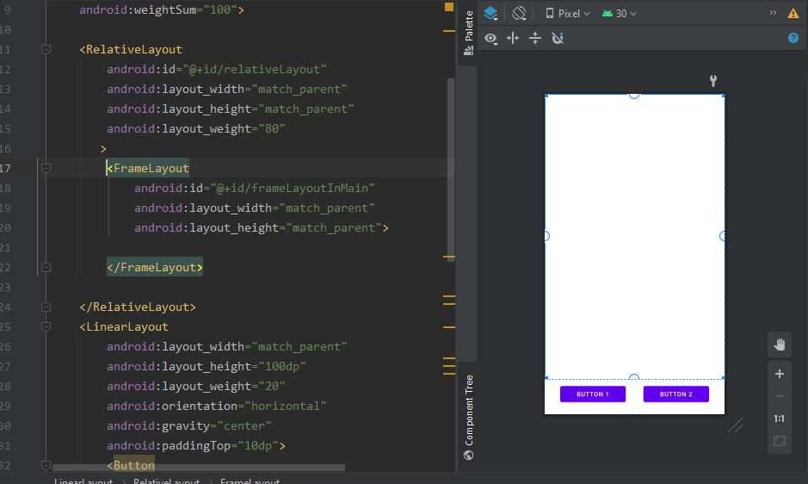

1. **Now we have to add two new fragments from the new > Fragments > Fragments (Blank)**

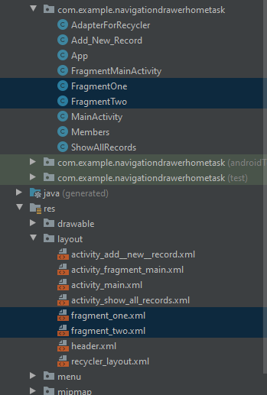

1. **After adding the blank fragments, we will arrange the view for both fragments**

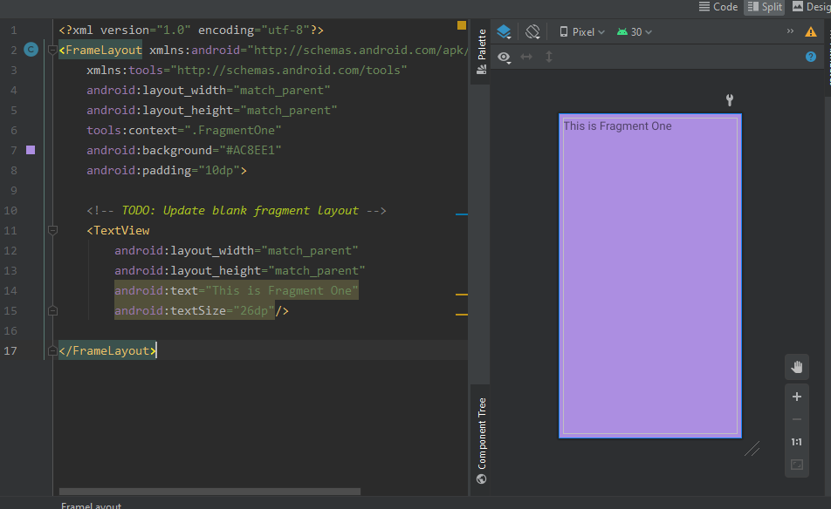

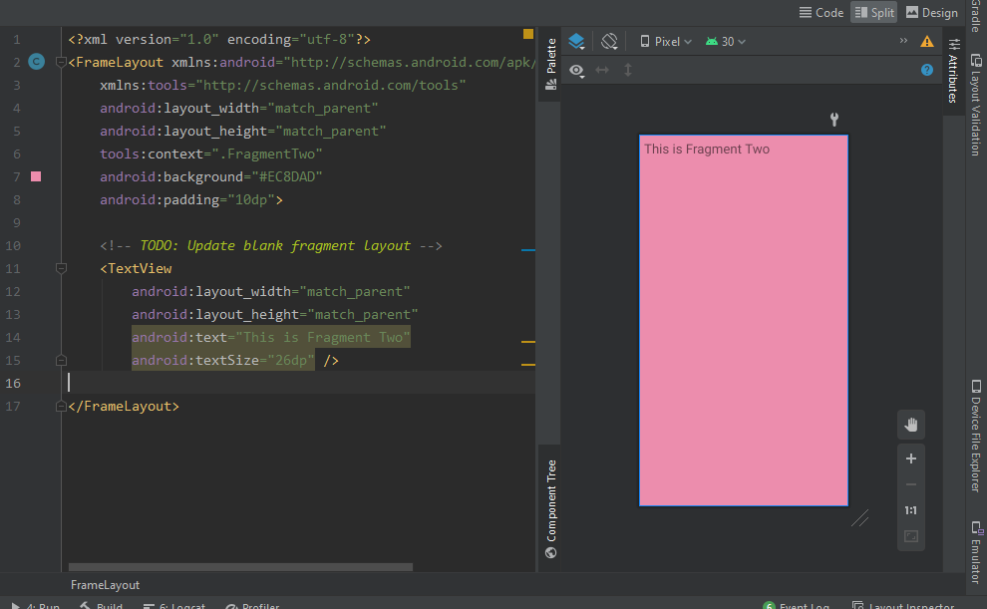

1. **Now we have to bind our layouts in such a way that they change on button click.**

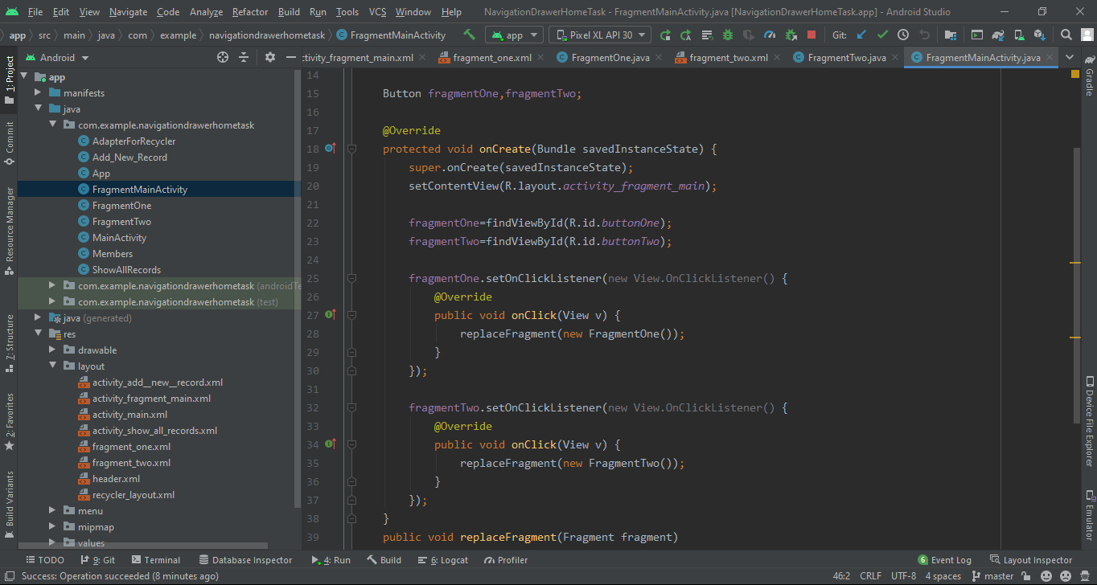

1. **Now we have to create a function replaceFragments so the fragments can change on click.**

**(Image is below)**

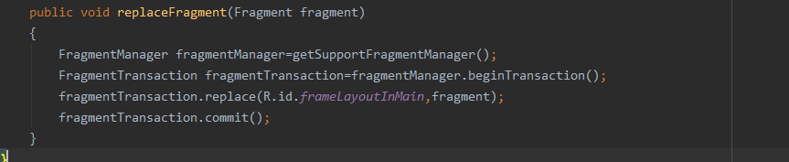

1. **Below are the images of the emulator**

