**Software Requirements and**

**Design Document**

**For**

**Hotel Management System**

**Prepared by**

**Umar Javed 22i-1050, Sheharyar Ahmed 22i-1171, Asad Amad 22i-1329**

**Department of Computer Science  
 11/24/2024**

**Contents**

1. INTRODUCTION 4
   1. Purpose 4
   2. Product Scope 4
   3. Title 5
   4. Objectives 6
   5. Problem Statement 8
   6. Product Position Statement 9
   7. Acronyms and Abbreviations 10
2. OVERALL DESCRIPTION 10
   1. Product Perspective 10
   2. Product Functions 11
   3. Stakeholder and User Description 18
   4. List of Use Cases 2
   5. Extended Use Cases 2
   6. Use Case Diagram 41
3. OTHER NONFUNCTIONAL REQUIREMENTS 41
   1. Performance Requirements 41
   2. Safety Requirements 42
   3. Security Requirements 42
   4. Software Quality Attributes 43
   5. Business Rules 43
   6. Operating Environment 43
   7. User Interfaces 44
4. DOMAIN MODEL 45
5. SYSTEM SEQUENCE DIAGRAM 45
6. SEQUENCE DIAGRAM 61
7. CLASS DIAGRAM 76
8. HIGH-LEVEL ARCHITECTURE 77
   1. Package Diagram 78
   2. Deployment Diagram 79
   3. Component Diagram 81
   4. Activity Diagram 85
9. BUSINESS CASE AND TARGET AUDIENCE 86
10. DEPENDENCIES AND CONSTRAINTS 89
11. COST AND PRICING 91
12. LICENSING AND INSTALLATION 93
13. IMPLEMENTATION SCREENSHOTS 94
14. WORK DIVISION TABLE 96

# Introduction

The Hotel Management System (HMS) is a comprehensive solution revolutionizing hotel operation, from reservation management to billing and reporting. Designed for efficiency and seamless integration, the HMS caters to diverse hotel needs, ensuring optimal front desk operations, personalized guest experiences, and strategic decision-making through robust analytics. Its purpose is to elevate operational efficiency, ensure data security, and contribute to the success of hotels in the competitive hospitality industry.

## Purpose

The Hotel Management System (HMS) serves as a pivotal tool in the hospitality industry, aimed at revolutionizing the operational landscape of hotels and ensuring a seamless and enriching experiencefor both guests and management. With its core purpose centered around efficiency and automation, the HMS streamlines intricate processes such as reservation management, guest services, billing, andreporting. By providing a comprehensive solution, the system caters to the diverse needs of hotels, ranging from boutique establishments to expansive international chains. The primary objectives encompass optimizing front desk operations, enhancing guest services through personalized experiences, and integrating seamlessly with point-of-sale systems for efficient financial transactions. Additionally, the HMS contributes to strategic decision-making by offering robust reporting and analytics features. In essence, the purpose of the Hotel Management System is toelevate operational efficiency, ensure data security, and ultimately contribute to the success andprofitability of hotels in the dynamic and competitive hospitality industry.

## Product Scope

The scope of the Hotel Management System (HMS) is extensive, encompassing a comprehensive set of functionalities designed to transform the way hotels manage their

operations. At its core, the HMS addresses the complexities associated with reservation management, allowing for real-time booking capabilities and efficient room assignment based on guest preferences. It extends its reach to elevate guest services, enabling personalization through the maintenance of detailed guest profiles and facilitating seamless communication for service requests. The system integrates with the hotel's point-of-sale system, streamlining in-house transactions and providing accurate billing for a myriad of services. Moreover, the HMS boasts robust reporting and analytics features, offering a deep dive into performance metrics and supporting data-driven decision-making for hotel management. The scope extends beyond the front desk to optimize housekeeping operations, ensuring timely room turnover and cleanliness. In summary, the scope of the HMS spans the entirety of hotel operations, promising efficiency, enhanced guest experiences, and strategic insights that contribute to the overall success of hotels in the competitive hospitality landscape.

## Title

The Hotel Management System (HMS) presents a centralized solution to optimize and streamline various facets of hotel management. Tailored to meet the specific requirements of hotel owners, managers, and staff, the system integrates reservation management, guest services, billing, staff coordination, and reportingwithin a user-friendly interface. Operating as a cohesive platform, the HMS enhances efficiency and guest experiences. It enables seamless handling of room bookings, modifications, and cancellations, while also facilitating personalized guest services. The system's capabilities extend to streamlined invoicing, payment processing, and financial tracking, fostering effective financial management. Improved staff coordination is achieved through enhanced communication and task assignment features. Additionally, the HMS empowersdecision-making through insightful reporting functionalities. Developed using a component-based software engineering approach, the system assumes compatibility with standard hotel infrastructure, with dependencies on appropriate hardware and network configurations. While the specific cost and pricing details are yet to be determined, the HMS's licensing terms will define permissions, restrictions, and potential fees for legal

software use, and professional installation by licensed personnel is required. The Hotel Management System stands as a scalable and intuitive solution, poised to revolutionize hotel operations, and elevate the efficiency of the hospitality industry.

## Objectives

A hotel management system (HMS) is designed to streamline and optimize hotel operations, enhancing both guest experience and operational efficiency. One of the primary aims is to centralize management, integrating various functions like reservations, front desk operations, housekeeping, and maintenance into a single platform. This centralization allows for automation of routine tasks such as check-ins, check-outs, room assignments, and billing, reducing manual workload and minimizing errors. Inventory management becomes more efficient with real-time tracking of room availability, maintenance schedules, and housekeeping status.

Enhancing guest experience is another critical goal. An HMS enables personalized services by utilizing guest data to offer tailored recommendations and services. Efficient communication between guests and hotel staff is facilitated through messaging systems or apps, and quick check-in/check-out options, including online processes, improve guest convenience. Revenue management is significantly improved with dynamic pricing strategies based on demand, occupancy rates, and market trends. The system helps create and manage special offers, discounts, and packages, integrating sales and marketing efforts to attract more bookings.

Comprehensive reporting and analytics are essential components of an HMS, generating detailed performance metrics, financial reports, and data-driven insights to aid in decision- making. Security and compliance are also prioritized, ensuring data security through encryption and secure storage practices while adhering to industry regulations like GDPR and

PCI DSS. Access control ensures that only authorized personnel can access sensitive information.

Integration with third-party systems is another vital aim, enabling connections with online travel agencies (OTAs), global distribution systems (GDS), booking engines, various payment gateways, and point of sale (POS) systems within the hotel. Scalability and customization are important to accommodate the growth of the hotel business, allowing the system to expand with more rooms, additional properties, and increased guest volume while offering customization options to meet specific needs.

Lastly, sustainability and efficiency are goals that an HMS supports by optimizing resource usage, such as energy and water, through smart systems and eco-friendly practices. The system supports initiatives that promote sustainability and offers guests options to participate in these programs. By achieving these goals, a hotel management system enhances operational efficiency, improves guest satisfaction, and drives profitability for the hotel.

## Problem Statement

|  |  |
| --- | --- |
| Problem | Description |
| The problem of | The issue in hotel management lies in the fragmented nature of existing systems, requiring staff to navigate multiple platforms for various operational tasks. This lack of a centralized and integrated solution hinders the smooth flow of hotel  operations. |
| Affects | This problem particularly affects the efficiency of hotel staff, from front desk personnel to housekeeping, who operate within time constraints. The fragmented system demands unnecessary time and effort, impacting their ability to provide prompt  and seamless services. |
| The result of which | The consequence of this disjointed approach is a notable waste of time and effort, leading to operational inefficiencies and the potential for errors. Guest satisfaction may suffer due to delays, miscommunications, or overlooked tasks, affecting  the overall quality of service. |
| Benefits of | Implementing a comprehensive Hotel Management System (HMS) addresses this challenge by consolidating all hotel operations onto a unified platform. This integration streamlines processes, improves communication, and enhances overall efficiency. The benefits include time savings, reduced errors, improved guest satisfaction, and a more streamlined and effective hotel management  experience. |

## Product Position Statement

|  |  |
| --- | --- |
| For | Streamlining and enhancing hotel operations. |
| Who | Hotel owners, managers, and staff seeking an integrated and efficient solution. |
| The Hotel Management System  (HMS) | A comprehensive and centralized platform designed to revolutionize hotel management |
| That | Optimizes front desk tasks, reservation management, and housekeeping while facilitating seamless integration with point-of-sale systems for enhanced financial management. |
| Unlike | Existing fragmented systems that require navigating  through multiple platforms for various operational tasks. |
| Our product | Offers a unified solution, consolidating all hotel operations into a single platform, ultimately improving efficiency, communication, and the overall guest experience. |

## Acronyms and Abbreviations

1. HMS: Hotel Management System
2. OTA: Online Travel Agency
3. CRM: Customer Relationship Management
4. IT: Information Technology
5. API: Application Programming Interface
6. TBD: To Be Determined

# Overall Description

## Product Perspective

The Hotel Management System (HMS) specified in this Software Requirements Specification (SRS) is a new, self-contained product designed to enhance the efficiency and effectiveness of hotel operations. This product is conceived to integrate various hotel functions into a single, centralized platform, improving management capabilities and guest experiences. Unlike follow- on members of an existing product family or replacements for specific existing systems, this HMS addresses contemporary demands for automation, integration, and data-driven decision- making in the hospitality industry. The development of this HMS is driven by the need for modern hotels to streamline operations, automate routine tasks, and provide personalized services to guests. It encompasses essential functions such as reservation management, front desk operations, housekeeping, maintenance, and other critical areas, aiming to reduce manual workload, minimize errors, and ensure efficient resource utilization. While the HMS operates as a standalone system, it is designed to integrate seamlessly with larger systems and third-party applications, including online travel agencies (OTAs), global distribution systems (GDS), payment gateways, and point of sale (POS) systems. These integrations are vital for providing a seamless experience across different facets of hotel operations and enhancing the overall guest experience. The HMS includes several major components: reservation management for handling guest bookings, front desk operations for managing check-in/check-out processes and guest services, housekeeping management for coordinating

cleaning schedules and room status, maintenance management for overseeing repairs and maintenance tasks, and reporting and analytics for providing insights through data analysis and reporting. Additionally, it features third-party systems integration to ensure connectivity with OTAs, GDS, payment gateways, and POS systems, as well as external interfaces for facilitating interactions with external applications and services. This structured approach ensures that all hotel operations are interconnected and managed efficiently through the HMS, providing a robust foundation for enhanced service delivery and operational excellence**.**

## Product Functions

Following are the features for HMS:

**Need to Have Features:**

**Room Management:**

Efficiently manage and allocate rooms for guests, considering availability, preferences, and special requirements.

**Reservation System:**

Implement a robust reservation system that allows guests to book rooms seamlessly, providing details on availability, rates, and accommodation options.

**Billing and Invoicing:**

Streamline the billing and invoicing process, ensuring accurate and transparent financial transactions for guests, including room charges and additional services.

**Guest Check-in and Checkout:**

Develop a user-friendly system for hassle-free guest check-in and checkout processes, reducing waiting times and enhancing overall guest satisfaction.

**Staff Management:**

Efficiently manage staff assignments, schedules, and tasks to ensure smooth operations in various departments, including housekeeping, front desk, and maintenance.

**Inventory Management:**

Implement an inventory management system to track and manage hotel supplies, ensuring timely restocking and preventing shortages.

**Reporting and Analytic**

Provide comprehensive reporting and analytics features to hotel management for insights into occupancy rates, revenue, guest preferences, and operational efficiency.

**Customer Relationship Management (CRM):**

Develop a CRM system to maintain guest profiles, preferences, and communication history, enabling personalized services and targeted marketing.

**Guest Services Portal:**

Provide a platform for guests to access and request personalized services, such as room preferences, special requests, or amenities.

**Dynamic Pricing:**

Implement dynamic pricing strategies based on demand, seasonality, and other factors to maximize revenue.

**Staff Assignment and Tracking:**

Assign tasks to staff members, monitor their progress, and streamline communication for efficient teamwork.

**Staff Training and Development:**

Manage training programs and certifications for staff to ensure continuous improvement and adherence to standards.

**Waste Management:**

Implement sustainable waste management practices to minimize environmental impact.

**Emergency Response System:**

Implements an emergency response system for handling incidents and ensuring guest safety during emergencies.

### Dashboard Overview:

A centralized dashboard offering an at-a-glance overview of key performance indicators, including occupancy rates, revenue, check-in/check-out status, and pending tasks.

**Nice to Have Features:**

**Enhanced Guest Experience Features:**

Integrate innovative features to enhance the guest experience, such as personalized welcome messages, room customization options, and loyalty programs.

**Smart Room Technology:**

Explore the integration of smart room technologies, allowing guests to control room settings (lights, temperature, etc.) through mobile apps or voice commands.

**Intelligent Pricing System:**

Implement an intelligent pricing system that considers various factors, such as demand, events, and seasonal trends, to optimize room rates and maximize revenue.

**Integration with External Services:**

Provide integration capabilities with external services, such as online travel agencies (OTAs), for seamless data exchange and increased visibility.

**Environmental Sustainability Features:**

Integrate ecofriendly practices, such as energy efficient systems, waste reduction measures, and options for guests to choose sustainable practices during their stay.

**Mobile check-in and Keyless Entry:**

Implement mobile check-in options and keyless entry systems for guests, enhancing convenience and reducing physical contact.

**Advanced Security Measures:**

Explore advanced security features, including biometric authentication for staff access and guest identity verification, ensuring a secure environment.

**Multilingual Support:**

Provide multilingual support in the hotel management system to cater to a diverse range of guests from different linguistic backgrounds.

**Lost and Found Management:**

Track and manage lost and found items efficiently, ensuring a smooth process for both guests

and staff.

**Event and Conference Management:**

Facilitate the organization of events and conferences within the hotel, managing bookings,

resources, and scheduling.

**Weather Integration:**

Provide guests with real-time weather updates and local forecasts to enhance their experience and planning

## Stakeholder and User Description

#### Stakeholder Summary

*Non-User Stakeholders*

|  |  |  |
| --- | --- | --- |
| **Name** | **Description** | **Responsibilities** |
| System Analyst  Requirements Specifier  Technical Reviewer | The System Analyst plays a crucial role in the project, leading and coordinating requirements elicitation and use case modeling. They are responsible for outlining the system's functionality, ensuring a clear understanding of project goals and user needs.  The Requirements Specifier acts as a bridge between stakeholders and the development team. Working closely with analysts, they translate user requests and needs into comprehensive requirements for the design phase, ensuring accurate and effective communication.  The Technical Reviewer is an  integral part of the development cycle. Regularly engaged in the process, they provide valuable feedback on project artifacts, contributing to the refinement and improvement of the overall development process. | Leads and coordinates requirements elicitation and use case modeling activities. They outline the system's functionality by identifying key actors and specifying use cases. Their responsibility lies in ensuring that the system aligns with the project's objectives and effectively addresses user needs.  Collaborates with stakeholders to gather requests and needs, then translates these into detailed requirements for design. The Requirements Specifier ensures that the development team has a clear understanding of user expectations, facilitating the creation of a system that meets these requirements.  Actively participates in the development cycle by  providing constructive feedback on project artifacts. This role is instrumental in maintaining the quality and integrity of the project. The Technical Reviewer's involvement ensures that the technical  aspects align with established standards and best practices. |

|  |  |  |
| --- | --- | --- |
| Software Architect  Project Manager  Market Analyst | The Software Architect holds a key position in the project's technical landscape. They are responsible for defining and overseeing the software architecture, making critical technical decisions that shape the overall design and  implementation.  The Project Manager takes charge of planning, resource management, and the establishment of practices that ensure project integrity and quality. They play a vital role in  coordinating interactions with customers and users, keeping the project team focused on delivering successful outcomes.  The Market Analyst is focused on evaluating market demand for the product's features and services.  They contribute significantly to the project's success by providing insights that help in positioning the product effectively in the  market. | Shapes the software architecture by making critical technical decisions. Ensures that the architectural solution supports both functional and nonfunctional requirements. The Software Architect is responsible for maintaining the system's maintainability and overseeing the key technical aspects of the project.  Plans and manages resources, sets priorities, and establishes practices to maintain the integrity and quality of project artifacts. They coordinate interactions with customers and users, ensuring that the project team remains focused and aligned with  project goals.  Conducts assessments of market demand for the product's features and services. Their responsibilities include gathering market insights, identifying opportunities, and contributing to the strategic positioning of the product in the market. |

**Stakeholder Profiles**

#### Hotel Owner/Manager

|  |  |
| --- | --- |
| **Description** | Hotel owners or managers are primary stakeholders who own or oversee the day-to-day operations of the hotel. They are focused on maximizing profitability, ensuring guest satisfaction, and maintaining the overall reputation of the establishment. |
| **Type** | Decision maker and strategic planner in the hospitality industry. |
| **Responsibilities** | Oversee the hotel's financial performance, set strategic goals, manage staff, ensure compliance with regulations, and maintain the overall quality and reputation of the hotel |
| **Success Criteria** | Increased revenue, positive guest reviews, high occupancy rates, and  Compliance with industry standards. |
| **Involvement** | Actively involved in decision-making processes, providing strategic  direction, and participating in regular performance reviews. |

#### Front Desk Staff

|  |  |
| --- | --- |
| **Description** | Front desk staff are essential stakeholders responsible for guest interactions, check-ins, checkouts, and addressing guest inquiries. They play a crucialrole in delivering excellent customer service. |
| **Type** | Operational and customer service focused roles in the hotel industry. |
| **Responsibilities** | Greet guests, manage reservations, handle check-ins and checkouts, provide  information about hotel services, and address guest concerns. |
| **Success Criteria** | Positive guest interactions, efficient check-in/checkout processes, and effectiveproblem resolution. |
| **Involvement** | Directly engaged with guests daily, ensuring a positive experience  through out their stay. |

#### Housekeeping Staff

|  |  |
| --- | --- |
| **Description** | Housekeeping staff are vital stakeholders responsible for maintaining  cleanliness and order within the hotel. Their role directly impacts the guest experience and satisfaction. |
| **Type** | Operational roles in the hospitality industry. |
| **Responsibilities** | Clean and prepare rooms, manage laundry services, ensure cleanliness in common areas, respond to guest requests for room service, and maintain the overall hygiene of the hotel. |
| **Success Criteria** | Clean and well-maintained rooms, positive guest feedback on cleanliness, and adherence to hygiene standards. |
| **Involvement** | Engaged in daily tasks to uphold the cleanliness and hygiene standards of the hotel. |

#### IT Manager

|  |  |
| --- | --- |
| **Description** | The IT manager is a stakeholder responsible for overseeing the hotel's  technology infrastructure, including reservation systems, online booking platforms, and other IT related services. |
| **Type** | Technical and managerial role in the hotel industry. |
| **Responsibilities** | Manage and maintain the hotel's IT systems, ensure data security, oversee the reservation system, and address technical issues. |
| **Success Criteria** | Seamless operation of IT systems, secure guest data, and effective integration of technology for improved hotel operations. |
| **Involvement** | Collaborates with various departments to ensure the smooth functioning of IT  systems and troubleshoots technical issues as they arise. |

**Key Stakeholder or User Needs**

|  |  |  |  |  |
| --- | --- | --- | --- | --- |
| **Need** | **Priority** | **Concerns** | **Current Solution** | **Proposed Solutions** |
| Secured  access | High | Management ofprivate  user information | None | Manage user access with PIN  numbers and encryption |
| Scalable | Moderate | None | None | Allow ample number of access channels for end users, managed with high volume server hardware. |
| Easy to use | High | Ability to provide intuitive navigationfor all wireless devices | None | Provide user friendly, highly intuitive, help guided navigation in application regardless of wireless device in use. |
| Responsive | Moderate to High | Ability to relyon third party communicationlinks for prompt  response times | None | Create business partnerships with third party providers to ensure prompt response times. |
| Flexible (configurabl e) | High | Ability to provide a truly customized user experience | None | Provide a simple, yet robust, ability for the end user to customize the application to  enhance their user experience. |

## List of Use Cases

* + 1. Manage Guest
    2. Manage Staff
    3. Manage Booking
    4. Manage Room
    5. Perform Billing
    6. Review Feedback
    7. Manage Service Type
    8. Manage Invoice
    9. Generate Reports and Analytics
    10. Request Room Service
    11. Check-In Guest
    12. Assign Tasks
    13. Track Inventory
    14. Staff Training Program
    15. Manage Pricing

## Extended Use Cases

#### Manage Guest

|  |  |
| --- | --- |
| **Section** | **Content** |
| **ID** | UC-1 |
| **Name** | Manage Guest |
| **Scope** | Hotel Management System |
| **Level** | Sub-Function |
| **Primary Actor** | Receptionist |

|  |  |  |
| --- | --- | --- |
| **Stakeholders and Interests** | * **Guest:** To manage their personal information, bookings, and stay details efficiently. * **Receptionist/Staff:** To access and update guest information to ensure smooth service. * **Manager:** To monitor guest records and ensure compliance with hotel policies. | |
| **Pre-condition** | The guest's personal information, including contact details, is accurately recorded in the system.  The guest is either a new user or has existing records in the system. | |
| **Success Guarantee (Post-condition)** | Guest information is accurately recorded and updated.  Guests can successfully register, log in, and manage their stay details.  Staff can access and manage guest information for operational purposes. | |
| **Main Success Scenario** | **User Actions** | **System Responsibility** |
| * Guest provides personal information for registration. * Guest completes registration by providing a password. * Guest logs in using email and password. * Guest updates their personal information. | * System verifies if the email is already registered. * System stores guest information and confirms registration. * System authenticates the guest and provides access to their profile. * System saves the updated information. * System retrieves and displays booking details. |

|  |  |  |
| --- | --- | --- |
|  | * Guest views their booking history and current bookings. * Receptionist retrieves guest information using guest ID. * Staff updates guest information based on interactions. | * System displays the requested guest details. * System saves the updates made by the staff. |
| **Extensions** | Authentication **Failure:** If the login credentials are incorrect, the system prompts the user to re-enter the correct details.  Update **Conflicts:** If there is an issue updating staff information, the system notifies the user to try again or contact support.  Permission **Denied:** If the manager/administrator does not have sufficient permissions to perform certain actions, the system denies access and notifies the user. | |
| **Special Requirements** | Secure handling of staff personal and employment information.  Role-based access control to ensure appropriate access to staff management features.  Compliance with data protection and privacy laws (e.g., GDPR). | |
| **Technology and Data Variations List** | Integration with authentication services for secure login and user authentication.  Database updates to record and retrieve staff information, roles, and permissions.  Role-based access control mechanisms to manage staff permissions effectively. | |

|  |  |
| --- | --- |
| **Frequency of Occurrence** | Multiple times daily, as managers/administrators and staff members access and update their information. |
| **Open Issues** | Ensuring data integrity and consistency across multiple instances of staff information updates.  Implementing effective role-based access control mechanisms to manage staff permissions securely. |

#### Manage Staff

|  |  |
| --- | --- |
| **Section** | **Content** |
| **ID** | UC-2 |
| **Name** | Manage Staff |
| **Scope** | Hotel Management System |
| **Level** | Sub-Function |
| **Primary Actor** | Manager/Administrator |
| **Stakeholders and Interests** | Manager**/Administrator:** To manage staff information, roles, and permissions efficiently.  Staff**:** To access and update their personal and work- related information.  **System:** To maintain an accurate record of staff details and permissions for operational purposes. |
| **Pre-condition** | The staff's personal and employment details are accurately recorded in the system.  The manager/administrator has appropriate access |

|  |  |  |
| --- | --- | --- |
|  | rights to manage staff information. | |
| **Success Guarantee (Post-condition)** | Staff information is accurately recorded and updated.  Roles and permissions are assigned correctly, ensuring smooth operations.  Managers/administrators can effectively manage staff information and permissions. | |
| **Main Success Scenario** | **User Actions** | **System Responsibility** |
|  | * System authenticates the manager/administrator and provides access to staff management features. * System retrieves and displays a list of staff members with their basic details. * System retrieves and displays the selected staff member's details for viewing or editing. * System saves the updated information and updates the staff record in the database. * System verifies the manager/administrator's permissions and updates the staff's roles and permissions accordingly. * System authenticates the staff member and provides access based on their assigned roles and permissions. * System saves the updated information and updates the staff record in the database. |
|  | * Manager/administrator logs in to the system. |
|  | * Manager/administrator navigates to the staff management section. |
|  | * Manager/administrator selects a staff member to view or edit their information. |
|  | * Manager/administrator updates staff information (e.g., contact details, role, department). |
|  | * Manager/administrator assigns roles and permissions to staff members. |
|  | * Staff member logs in to the system. |
|  | * Staff member updates their personal information (e.g., contact details, emergency contacts). |

|  |  |
| --- | --- |
| **Extensions** | Authentication **Failure:** If the login credentials are incorrect, the system prompts the user to re-enter the correct details.  **Update Conflicts:** If there is an issue updating staff information, the system notifies the user to try again or contact support.  **Permission Denied:** If the manager/administrator does not have sufficient permissions to perform certain actions, the system denies access and notifies the user. |
| **Special Requirements** | Secure handling of staff personal and employment information.  Role-based access control to ensure appropriate access to staff management features.  Compliance with data protection and privacy laws (e.g., GDPR). |
| **Technology and Data Variations List** | Integration with authentication services for secure login and user authentication.  Database updates to record and retrieve staff information, roles, and permissions.  Role-based access control mechanisms to manage staff permissions effectively. |
| **Frequency of Occurrence** | Multiple times daily, as managers/administrators and staff members access and update their information. |
| **Open Issues** | Ensuring data integrity and consistency across multiple instances of staff information updates.  Implementing effective role-based access control mechanisms to manage staff permissions securely. |

#### Manage Booking

|  |  |
| --- | --- |
| **Section** | **Content** |
| **ID** | UC-3 |
| **Name** | Manage Booking |
| **Scope** | Hotel Management System |
| **Level** | Sub-Function |
| **Primary Actor** | Hotel Management |
| **Stakeholders and Interests** | * **Hotel Management:** Interested in efficiently managing bookings to optimize room occupancy and revenue. * **Guests:** Interested in making reservations, modifying bookings, and receiving confirmation of their reservations.   + Operations Team: **Interested in ensuring smooth check-in and check-out processes and resolving any booking-related issues.** |
| **Pre-condition** | Hotel Management is logged into the hotel management system. Relevant booking data, including current reservations and room availability, is accessible and up-to-date. |
| **Success Guarantee (Post-condition)** | Hotel Management has successfully managed the booking process, ensuring optimal room occupancy and guest satisfaction. |

|  |  |  |
| --- | --- | --- |
| **Main Success Scenario** | **User Actions** | **System Responsibility** |
|  | * Hotel Management accesses the booking management module. * Hotel Management views current reservations, including check-in and check-out dates, room types, and guest details. * Hotel Management modifies bookings as necessary, such as changing dates, room types, or guest information. | * Provides access to a booking management interface with relevant features and functionalities. * Displays current reservations, including details such as check-in and check-out dates, room types, and guest information. * Allows Hotel Management to modify existing bookings, confirm new bookings, and cancel bookings as needed. |
|  | * Hotel Management confirms new bookings based on room availability and guest preferences. | * Enforces booking policies and restrictions, such as minimum stay requirements and cancellation deadlines. |
|  | * Hotel Management cancels bookings if necessary, adhering to cancellation policies and notifying guests accordingly. | * Generates reports and analytics on booking trends, occupancy rates, and revenue projections to inform decision-making. |
|  | * Hotel Management generates reports on booking trends, occupancy rates, and revenue projections. |  |
| **Extensions** | * If there are conflicts or issues with modifying or confirming bookings, the system alerts Hotel Management and provides alternative solutions. * If guests request changes to their bookings directly, Hotel Management can manually update the system to reflect these changes. | |
| **Special Requirements** | * Integration with the hotel's reservation system to ensure real-time updates on room availability and pricing. | |

|  |  |
| --- | --- |
|  | * Support for multiple room types, rates, and booking channels to accommodate diverse guest preferences and requirements. |
| **Technology and Data Variations List** | * Compatibility with various reservation management systems and APIs for seamless integration. * Ability to handle large volumes of booking data and perform real-time updates without performance degradation. |
| **Frequency of Occurrence** | Booking management activities occur frequently, with ongoing reservations, modifications, and cancellations happening daily. |
| **Open Issues** | * Ensuring system reliability and uptime to prevent disruptions during peak booking periods. * Implementing robust data backup and recovery mechanisms to safeguard against data loss or corruption. |

#### Manage Room

|  |  |
| --- | --- |
| **Section** | **Content** |
| **ID** | UC-4 |
| **Name** | Manage Room |
| **Scope** | Hotel Management System |
| **Level** | Sub-Function |
| **Primary Actor** | Hotel Management |

|  |  |  |
| --- | --- | --- |
| **Stakeholders and Interests** | **Hotel Management:** Interested in efficiently managing room inventory to maximize occupancy and revenue while ensuring guest satisfaction.  Operations Team: **Interested in maintaining rooms to meet quality standards, scheduling cleaning and maintenance tasks, and addressing any room-related issues promptly.** | |
| **Pre-condition** | Hotel Management is logged into the hotel management system. Relevant room data, including room types, availability, and maintenance status, is accessible and up-to- date. | |
| **Success Guarantee (Post-condition)** | Hotel Management has successfully managed room inventory, ensuring rooms are clean, available, and properly allocated to guests. | |
| **Main Success Scenario** | **User Actions** | **System Responsibility** |
|  | Provides access to a room management interface with features for viewing, assigning, and scheduling room-related tasks.  Displays room status, including availability, occupancy, cleanliness, and maintenance needs.  Allows Hotel Management to assign rooms to guests, schedule cleaning and maintenance tasks, and block or unblock rooms for various purposes.  Generates alerts and notifications for room- related issues or tasks that require attention. |
|  | Hotel Management accesses the room management module. |
|  | Hotel Management views the current status of all rooms, including availability, occupancy, and maintenance needs. |
|  | Hotel Management assigns rooms to guests based on their preferences, availability, and booking details. |
|  | Hotel Management schedules cleaning and maintenance tasks for occupied and vacant rooms as needed. |
|  | Hotel Management blocks or unblocks |

|  |  |  |
| --- | --- | --- |
|  | rooms for specific purposes, such as maintenance, renovation, or VIP guests.  Hotel Management monitors room occupancy and availability in real-time to optimize room allocation and revenue. | Integrates with housekeeping and maintenance systems to ensure timely execution of tasks and updates on room status. |
| **Extensions** | If there are maintenance or cleanliness issues with a room, the system alerts Hotel Management and provides instructions for addressing the issue.  If there are specific room preferences or requirements from guests, Hotel Management can manually assign rooms based on these preferences. | |
| **Special Requirements** | Integration with housekeeping and maintenance systems to facilitate seamless coordination and communication.  Support for room categorization, such as standard rooms, suites, and accessible rooms, to meet diverse guest needs. | |
| **Technology and Data Variations List** | Compatibility with mobile devices for on-the-go access to room management features and notifications.  Ability to track and analyze room occupancy patterns and trends to inform strategic decision- making. | |
| **Frequency of Occurrence** | Room management activities occur regularly, with ongoing room assignments, maintenance tasks, and monitoring of room status. | |
| **Open Issues** | Ensuring effective communication and coordination between different departments involved in room management, such as housekeeping, maintenance, and front desk.  Implementing efficient workflows and processes to handle room-related tasks promptly and effectively. | |

#### Perform Billing

|  |  |
| --- | --- |
| **Section** | **Content** |
| **ID** | UC-5 |
| **Name** | Perform Billing |
| **Scope** | Hotel Management System |
| **Level** | Subfunction |
| **Primary Actor** | Receptionist |
| **Stakeholders and Interests** | * **Receptionist:** To accurately generate and present bills for guests. * **Guest:** To receive a clear and transparent bill for their stay. * **Manager:** To ensure accurate financial records and revenue generation. |
| **Pre-condition** | The guest has completed the check-out process.  Room allocation and any additional services are accurately recorded. |
| **Success Guarantee (Post-condition)** | A comprehensive and accurate bill is generated for the guest. |

|  |  |  |
| --- | --- | --- |
|  | Payment is successfully processed, and the guest receives a receipt. | |
| **Main Success Scenario** | **User Actions** | **System Responsibility** |
| * Receptionist initiates the check-out process in the system. * The receptionist reviews and verifies the bill for accuracy. * The receptionist presents the bill to the guest. * Guest provides payment through the preferred method (cash, credit card, etc.). * Receptionist processes the payment through the system. * Receptionist provides the receipt to the guest. | * System confirms room status as "vacant" and proceeds to billing. * The system compiles charges for the stay, including room charges and additional services. * System calculates and displays the total amount due. * System generates a receipt for the guest, indicating payment details. |
| **Extensions** | **Payment Issues:** If there are payment discrepancies or issues, follow the resolution process.  **Additional Service Disputes:** If the guest disputes additional service charges, address and resolve the concerns. | |
| **Special Requirements** | Secure handling of payment information. Compliance with financial regulations and tax laws. | |
| **Technology and** | Integration with payment gateway for secure | |

|  |  |
| --- | --- |
| **Data Variations List** | transaction processing.  Database updates to record payment details and maintain financial records. |
| **Frequency of Occurrence** | Multiple times daily, as guests check out. |
| **Open Issues** | Handling different payment methods and ensuring compatibility.  Addressing any discrepancies or disputes promptly to maintain guest satisfaction. |

#### Review Feedback

|  |  |
| --- | --- |
| **Section** | **Content** |
| **ID** | UC-6 |
| **Name** | Review Feedback |
| **Scope** | Hotel Management System |
| **Level** | User Goal |
| **Primary Actor** | Receptionist |
| **Stakeholders and Interests** | * **Guest:** To ensure their feedback is reviewed and acted upon. * **Receptionist:** To review guest feedback and address any issues raised. |

|  |  |  |
| --- | --- | --- |
|  | * **Manager:** To analyze feedback to improve service quality and guest satisfaction. | |
| **Pre-condition** | Feedback has been submitted by guests and recorded in the system.  The receptionist or manager has logged into the hotel management system. | |
| **Success Guarantee (Post-condition)** | Feedback is successfully reviewed and categorized. Appropriate actions are taken based on the feedback. | |
| **Main Success Scenario** | **User Actions** | **System Responsibility** |
| * Receptionist selects the "Review Feedback" option. * Receptionist views a list of submitted feedback. * Receptionist selects a specific feedback entry to review. * Receptionist categorizes the feedback (e.g., positive, negative, suggestion). * Receptionist adds notes or actions to be taken based on the feedback. * Receptionist marks the feedback as reviewed. | * System displays a list of all feedback entries. * System provides filtering options to view feedback by date, rating, or category. * System displays detailed feedback information for selected entries. * System allows categorization and annotation of feedback. * System updates the feedback status to "Reviewed" and stores notes/actions taken. |

|  |  |
| --- | --- |
| **Extensions** | * **Escalation Required:** If feedback requires higher-level action, notify the relevant department or manager. * **Follow-up Request:** If follow-up with the guest is needed, create a follow-up task. * **Feedback Analysis:** Generate reports to analyze trends in feedback over time. |
| **Special Requirements** | Secure handling of feedback data and user notes.  Efficient search and filtering capabilities for feedback entries.  Easy-to-use interface for categorizing and annotating feedback. |
| **Technology and Data Variations List** | Use secure socket layer (SSL) for data encryption during feedback submission.  Integration with analytics tools to process and analyze feedback data.  Database for storing feedback details and guest comments. |
| **Frequency of Occurrence** | Daily, as staff frequently review feedback to improve guest experience. |
| **Open Issues** | Ensuring timely review and response to feedback.  Maintaining compliance with data protection regulations during the feedback review process. |

#### Manage Service Type

|  |  |
| --- | --- |
| **Section** | **Content** |
| **ID** | UC-7 |

|  |  |  |
| --- | --- | --- |
| **Name** | Manage Service Type | |
| **Scope** | Hotel Management System | |
| **Level** | User Goal | |
| **Primary Actor** | Administrator | |
| **Stakeholders and Interests** | * **Administrator:** To efficiently manage the types of services offered by the hotel, ensuring they are up-to-date and accurately reflected in the system. * **Receptionist:** To have access to a current and accurate list of service types to assist guests. * **Guest:** To view and choose from a comprehensive and accurate list of available services. | |
| **Pre-condition** | The administrator has logged into the hotel management system with appropriate privileges. | |
| **Success Guarantee (Post-condition)** | Service types are successfully created, updated, or deleted.  The system reflects the current list of service types accurately. | |
| **Main Success Scenario** | **User Actions** | **System Responsibility** |
| * Administrator selects the "Manage Service Types" option. * Administrator chooses to create a new service type. * Administrator enters the | * System displays a form for creating a new service type. * System validates the input for completeness and correctness. * System saves the new service type in the database. |

|  |  |  |
| --- | --- | --- |
|  | service type details (e.g., name, description, pricing).   * Administrator submits the new service type. | * System confirms the creation and displays the updated list of service types. |
| **Extensions** | * **Invalid Input**: If the input is invalid or incomplete, prompt the administrator to correct the errors. * **Deletion Dependency**: If the service type is associated with existing bookings, prompt to reassign or handle dependencies before deletion. * **Duplicate Service Type**: If a duplicate service type is detected, prompt to merge or differentiate the service types. | |
| **Special Requirements** | Secure handling of service type data.  Ensure consistency and integrity of service type data across the system.  User-friendly interface for managing service types. | |
| **Technology and Data Variations List** | Use secure socket layer (SSL) for data encryption during service type management.  Integration with other system modules (e.g., booking, billing) to ensure consistency.  Database for storing and managing service type details. | |
| **Frequency of Occurrence** | Periodically, as service types are added, updated, or removed as needed. | |
| **Open Issues** | Handling dependencies and impacts on existing bookings when deleting service types. | |

|  |  |
| --- | --- |
|  | Ensuring data protection and compliance with relevant regulations during service type management. |

#### Manage Invoice

|  |  |
| --- | --- |
| **Section** | **Content** |
| **ID** | UC-8 |
| **Name** | Manage Invoice |
| **Scope** | Hotel Management System |
| **Level** | User Goal |
| **Primary Actor** | Administrator |
| **Stakeholders and Interests** | * **Guest:** To receive accurate and timely invoices for their stay and services used. * **Receptionist:** To efficiently create, update, and manage invoices for guests. * **Manager:** To oversee financial transactions and ensure accurate billing for services provided. |
| **Pre-condition** | The administrator or receptionist has logged into the hotel management system with appropriate privileges. |
| **Success Guarantee** | Invoices are successfully created, updated, or |

|  |  |  |
| --- | --- | --- |
| **(Post-condition)** | deleted.  The system accurately reflects the current status of all invoices. | |
| **Main Success Scenario** | **User Actions** | **System Responsibility** |
| * Administrator selects the "Manage Invoices" option. * Administrator chooses to create a new invoice. * Administrator enters guest details, stay information, and services used. * Administrator submits the new invoice. | * System displays a form for creating a new invoice. * System validates the input for completeness and correctness. * System calculates the total amount based on the stay and services used. * System saves the new invoice in the database. * System generates and displays the invoice for review. |
| **Extensions** | * **Invalid Input:** If the input is invalid or incomplete, prompt the administrator/receptionist to correct the errors. * **Payment Status Update:** If payment status needs to be updated (e.g., marked as paid), allow modification and reflect the change. * **Invoice Dispute:** If there is a dispute over the invoice, mark the invoice as disputed and initiate a resolution process. | |
| **Special Requirements** | Secure handling of invoice data and financial transactions.  Ensure accuracy and integrity of invoice data across the system. | |

|  |  |
| --- | --- |
|  | User-friendly interface for managing invoices. |
| **Technology and Data Variations List** | Use secure socket layer (SSL) for data encryption during invoice management.  Integration with payment gateways for real-time transaction processing.  Database for storing and managing invoice details. |
| **Frequency of Occurrence** | Daily, as invoices are generated, updated, or deleted as part of regular hotel operations. |
| **Open Issues** | Handling discrepancies and disputes in invoices efficiently.  Ensuring data protection and compliance with financial regulations during invoice management. |

#### Generate Reports and Analytics

|  |  |
| --- | --- |
| **Section** | **Content** |
| **ID** | UC-9 |
| **Name** | Generate Reports and Analytics |
| **Scope** | Hotel Management System |
| **Level** | Sub-Function |
| **Primary Actor** | Hotel Management |

|  |  |  |
| --- | --- | --- |
| **Stakeholders and Interests** | * **Hotel Management:** Interested in accessing reports and analytics to make informed decisions and optimize hotel operations. * **Owners/Investors:** Interested in understanding the financial performance and overall health of the hotel. * **Operations Team:** Interested in receiving insights to improve operational efficiency. | |
| **Pre-condition** | Hotel Management is logged into the hotel management system.  Data on occupancy rates, revenue, and operational metrics are available and up to date. | |
| **Success Guarantee (Post-condition)** | Hotel Management has accessed comprehensive reports and analytics.  Insights gained from reports and analytics are used to inform decision-making and improve hotel operations. | |
| **Main Success Scenario** | **User Actions** | **System Responsibility** |
| * Hotel Management accesses the reporting and analytics module. * Hotel Management selects desired parameters for analysis. * System generates comprehensive reports and analytics. * Hotel Management reviews and interprets the insights gained. | * Provides access to a range of reporting tools and analytics features. * Allows Hotel Management to specify criteria such as time, * Analyzes available data based on selected parameters and generates reports and analytics accordingly. * Presents reports and analytics in a user-friendly format for easy interpretation by Hotel Management. |

|  |  |
| --- | --- |
| **Extensions** | **If there are anomalies or unexpected trends in the data:**  **System highlights these anomalies and provides additional context for analysis.**  **If there are specific areas of concern or interest:**  **Hotel Management can request custom reports or analytics tailored to their needs.** |
| **Special Requirements** | Ability to handle large volumes of data and perform complex analyses in real-time.  Integration with other hotel systems (e.g., reservation system, accounting system) to ensure data accuracy and completeness. |
| **Technology and Data Variations List** | Compatibility with various data visualization tools for presenting reports and analytics.  Integration with external data sources (e.g., market trends, competitor analysis) for broader insights. |
| **Frequency of Occurrence** | Occurs regularly, as Hotel Management seeks to monitor performance and make informed decisions to drive improvements. |
| **Open Issues** | Ensuring data privacy and security measures are in place to protect sensitive information.  Optimization of reporting and analytics algorithms to improve accuracy and relevance of insights provided. |

#### Requesting Room Service

|  |  |
| --- | --- |
| **Section** | **Content** |

|  |  |  |
| --- | --- | --- |
| **ID** | UC-10 | |
| **Name** | Requesting Room Service | |
| **Scope** | Hotel Management System | |
| **Level** | User Goal | |
| **Primary Actor** | Guest | |
| **Stakeholders and Interests** | * **Guest:** To conveniently request room service items directly from their room. * **Room Service Staff:** To efficiently receive and fulfill room service requests. * **Manager:** To monitor room service operations and ensure timely delivery and guest satisfaction. | |
| **Pre-condition** | The guest is registered in the system.  The guest has logged into the hotel management system. | |
| **Success Guarantee (Post-condition)** | Room service is successfully requested by the guest.  The request details are accurately recorded and processed in the system.  The requested items are delivered to the guest's room. | |
| **Main Success Scenario** | **User Actions** | **System Responsibility** |
| * Guest selects the "Request Room Service" option. * Guest browses the menu and selects items to order. | * System displays the room service menu with available items and prices. * System adds selected items to the guest's order. * System displays the order summary for |

|  |  |  |
| --- | --- | --- |
|  | * Guest reviews the selected items and enters special instructions if any. * Guest confirms and submits the room service request. | review and allows input for special instructions.   * System records the request in the database and generates an order confirmation. * System notifies room service staff of the new request. * System updates the guest's account with the charges for the room service. |
| **Extensions** | * **Modify Order**: If the guest wishes to modify the order before submission, allow changes to the selected items and special instructions. * **Order Cancellation**: If the guest decides to cancel the order before it is processed, follow the cancellation process. * **Unavailable Items**: If an item is unavailable, prompt the guest to choose an alternative or remove the item from the order. | |
| **Special Requirements** | Secure handling of guest information and room service requests.  Real-time synchronization with the room service staff to ensure prompt delivery.  User-friendly interface for browsing and selecting room service items. | |
| **Technology and Data Variations List** | Use secure socket layer (SSL) for data encryption during the room service request process.  Integration with the inventory management system to update item availability in real-time.  Database for storing room service request details and guest orders. | |

|  |  |
| --- | --- |
| **Frequency of Occurrence** | Daily, as guests frequently request room service. |
| **Open Issues** | Ensuring timely delivery of room service orders.  Handling special dietary requests and food allergies properly.  Maintaining data protection compliance during the room service request process. |

#### Check-In Guest

|  |  |
| --- | --- |
| **Section** | **Content** |
| **ID** | UC-11 |
| **Name** | Check-In Guest |
| **Scope** | Hotel Management System |
| **Level** | User Goal |
| **Primary Actor** | Receptionist |
| **Stakeholders and Interests** | * **Receptionist:** To efficiently complete the guest check-in process. * **Guest:** To have a smooth and swift check-in experience. * **Manager:** To monitor and ensure the effectiveness of the check-in process. |

|  |  |  |
| --- | --- | --- |
| **Pre-condition** | The guest has a confirmed reservation. Room allocation details are available and up to date. | |
| **Success Guarantee (Post-condition)** | The guest is successfully checked in, and room access is granted. Relevant details are accurately recorded in the system. | |
| **Main Success Scenario** | **User Actions** | **System Responsibility** |
| * The receptionist initiates the check-in process in the system. * The receptionist verifies the guest's identity through official identification. * Receptionist allocates a room based on the guest's preferences and availability. * Receptionist generates a room key or provides access instructions to the guest. * Receptionist provides a brief overview of hotel services and amenities. | * The system displays the guest's reservation details. * System cross- checks the identification details with the reservation information. * System updates the room status to "occupied." * The system records the key issuance in the guest's profile. * System updates the check-in status and notifies relevant departments. |
| **Extensions** | **Identification Issues:** If there are issues with guest identification, follow the resolution process.  **Special Requests:** If the guest has special requests, accommodate them during the check-in process. | |

|  |  |
| --- | --- |
| **Special Requirements** | Secure handling of guest identification details. Integration with key card systems for key issuance. |
| **Technology and Data Variations List** | Use RFID or electronic key card technology for secure and efficient room access.  Database integration for real-time updates on room availability and guest profiles. |
| **Frequency of Occurrence** | Multiple times daily, as guests arrive for check-in. |
| **Open Issues** | Addressing any technical glitches in the key card system promptly.  Handling special requests efficiently to enhance guest satisfaction. |

#### Assign Tasks

|  |  |
| --- | --- |
| **Section** | **Content** |
| **ID** | UC-12 |
| **Name** | Assign Tasks |
| **Scope** | Hotel Management System |

|  |  |  |
| --- | --- | --- |
| **Level** | Sub-function | |
| **Primary Actor** | Manager | |
| **Stakeholders and Interests** | * **Manager:** To efficiently assign tasks to staff members and monitor their progress. * **Staff Members:** To receive clear and specific task assignments. * **Receptionist, Housekeeping, Maintenance Departments:** To ensure smooth coordination and operations. | |
| **Pre-condition** | The staff member is logged into the system. Task details and staff availability are up to date. | |
| **Success Guarantee (Post-condition)** | The task is successfully assigned to the staff member.  The system records the task assignment and notifies relevant parties. | |
| **Main Success Scenario** | **User Actions** | **System Responsibility** |
| * Manager accesses the task assignment module in the system. * Manager selects a staff member based on availability, skills, and workload. * Manager enters task details, including description, priority, and expected completion time. * Manager confirms the task | * System displays a list of pending tasks and available staff members. * System provides details on the selected staff member's current tasks and workload. * The system records the task details and assigns a priority level. * System notifies the staff member about the new task. * System updates the staff member's task list and workload. |

|  |  |  |
| --- | --- | --- |
|  | assignment.   * Staff member receives a notification of the assigned task. |  |
| **Extensions** | **Task Modification:** If there is a need to modify the task details or priority, follow the modification process.  **Task Completion:** If the staff member encounters issues or completes the task, update the task status. | |
| **Special Requirements** | Real-time synchronization with staff availability and workload data.  Notifications and alerts for timely task acknowledgment. | |
| **Technology and Data Variations List** | Use of push notifications or alerts for instant task notification.  Database integration for recording task details, priority, and staff workload. | |
| **Frequency of Occurrence** | Daily, as tasks need to be assigned and managed regularly. | |
| **Open Issues** | Efficient handling of urgent tasks and dynamic task prioritization.  Addressing any system performance issues during peak task assignment periods. | |

#### Track Inventory

|  |  |  |
| --- | --- | --- |
| **Section** | **Content** | |
| **ID** | UC-13 | |
| **Name** | Track Inventory | |
| **Scope** | Hotel Management System | |
| **Level** | Sub-function | |
| **Primary Actor** | Inventory Manager | |
| **Stakeholders and Interests** | * **Inventory Manager: Interested in maintaining optimal inventory levels to support hotel operations.** * **Purchasing Department: Interested in receiving timely alerts for restocking supplies.** * **Operations Team: Interested in having sufficient supplies to meet guest needs.** | |
| **Pre-condition** | Inventory Manager is logged into the hotel management system.  Initial inventory levels are recorded in the system. | |
| **Success Guarantee (Post-condition)** | Inventory levels are accurately tracked and managed.  Alerts for restocking are sent when inventory levels reach predefined thresholds. | |
| **Main Success** | **User Actions** | **System Responsibility** |

|  |  |  |
| --- | --- | --- |
| **Scenario** | * Inventory Manager accesses the inventory tracking module. * Inventory Manager views current inventory levels. * Inventory Manager monitors usage and depletion of supplies. | * Provides access to inventory management tools and functionalities. * Presents an overview of current inventory levels for all supplies. * Tracks usage and depletion of supplies based on recorded transactions. * Monitors inventory levels and sends alerts when predefined thresholds are reached, indicating the need for restocking. |
| **Extensions** | **If inventory levels are critically low:**  **The system prioritizes restocking alerts and notifies relevant personnel immediately.**  **If there are discrepancies in inventory records:**  **Inventory Manager investigates and resolves discrepancies to ensure accurate tracking.** | |
| **Special Requirements** | Ability to set and adjust restocking thresholds based on usage patterns and lead times.  Integration with purchasing and supplier systems for efficient restocking processes. | |
| **Technology and Data Variations List** | Integration with barcode or RFID scanning systems for accurate tracking of inventory transactions.  Compatibility with various inventory management systems for seamless data exchange. | |
| **Frequency of** | Occurs regularly, with inventory levels monitored and | |

|  |  |
| --- | --- |
| **Occurrence** | alerts sent as needed to maintain optimal stock levels. |
| **Open Issues** | Integration with accounting system for accurate cost tracking and budgeting.  Optimization of inventory tracking algorithms to improve accuracy and efficiency. |

#### Conduct Staff Training

|  |  |
| --- | --- |
| **Section** | **Content** |
| **ID** | UC-14 |
| **Name** | Conduct Staff Training |
| **Scope** | Hotel Management System |
| **Level** | Sub-function |
| **Primary Actor** | HR Manager |
| **Stakeholders and Interests** | * **HR Manager:** Interested in efficiently managing staff training programs to improve skills and ensure compliance with standards. * **Employees:** Interested in accessing training materials and participating in development opportunities. * **Department Managers:** Interested in having well-trained staff to meet operational needs. |

|  |  |  |
| --- | --- | --- |
|  |  | |
| **Pre-condition** | HR Manager is logged into the hotel management system.  Training materials and certifications are available and up-to-date in the system. | |
| **Success Guarantee (Post-condition)** | Staff training programs and certifications are managed effectively.  Employees have access to relevant training materials and certifications to enhance their skills. | |
| **Main Success Scenario** | **User Actions** | **System Responsibility** |
| * The security team receives an emergency alert promptly. * The security team identifies the nature and location of the emergency accurately. * The security team assesses the situation and determines appropriate response actions based on the severity and nature of the emergency. * The security team informs hotel guests about the | * The system receives emergency alerts from various sources and promptly notifies the security team. * The system provides accurate information on the nature and location of the emergency based on available data sources. * The system assists the security team in assessing the situation by providing relevant data and suggesting response options based on predefined protocols. * The system facilitates |

|  |  |  |
| --- | --- | --- |
|  | emergency and ensures their safe evacuation if necessary. | communication between the security team and emergency services by providing access to communication channels and necessary contact information. |
| **Extensions** | **If there are changes in training requirements or objectives:**  **HR Manager updates training programs accordingly and notifies affected employees.**  **If employees require additional support or resources for training:**  **HR Manager provides assistance and ensures access to necessary materials or tools.** | |
| **Special Requirements** | Ability to track employee progress and completion of training programs.  Integration with performance management systems to align training programs with career development goals. | |
| **Technology and Data Variations List** | Compatibility with various learning management systems for hosting training materials.  Integration with certification management systems to track employee certifications and renewals. | |
| **Frequency of Occurrence** | Occurs regularly to ensure ongoing staff development and compliance with industry standards. | |
| **Open Issues** | Integration with scheduling systems to avoid conflicts with operational duties. | |

|  |  |
| --- | --- |
|  | Evaluation mechanisms to assess the effectiveness of training programs and make improvements as needed. |

#### Manage Pricing

|  |  |
| --- | --- |
| **Section** | **Content** |
| **ID** | UC-15 |
| **Name** | Intelligent Pricing System |
| **Scope** | Hotel Management System |
| **Level** | Sub-function |
| **Primary Actor** | Revenue Manager |
| **Stakeholders and Interests** | * **Hotel Management:** Interested in maximizing revenue by optimizing room rates based on market demand and trends. * **Hotel Guests:** Interested in competitive pricing that reflects the value of the accommodation. |

|  |  |  |
| --- | --- | --- |
|  | * **Sales and Marketing Team:** Interested in aligning pricing strategies with promotional efforts and market positioning. | |
| **Pre-condition** | The intelligent pricing system is integrated with the hotel's booking and revenue management systems. | |
| **Success Guarantee (Post-condition)** | Room rates are optimized dynamically based on various factors, resulting in increased revenue and occupancy rates. | |
| **Main Success Scenario** | User Actions | System Responsibility |
| * The Revenue Manager configures pricing rules and parameters in the intelligent pricing system. * The system continuously monitors market demand, competitor pricing, events, and seasonal trends. * Based on the collected data and predefined rules, the system dynamically adjusts room rates. | * Provide a user- friendly interface for the Revenue Manager to set up and customize pricing rules and parameters based on business objectives and market conditions. * Integrate with external data sources and internal systems to collect relevant data for analysis, and continuously monitor market dynamics to identify pricing opportunities and threats. * Utilize machine learning algorithms or predictive analytics to analyze the collected data, apply predefined |

|  |  |  |
| --- | --- | --- |
|  |  | pricing rules, and generate optimized room rates in real- time. |
| **Extensions** | If unexpected events or changes occur (e.g., sudden increase in demand, unforeseen cancellations), the system recalculates pricing in real-time to adapt to the new conditions.  If competitors change their pricing strategies, the system analyzes the impact and adjusts room rates accordingly to remain competitive. | |
| **Special Requirements** | Integration with market data sources, booking platforms, and revenue management systems to gather relevant information for pricing decisions.  Machine learning algorithms or predictive analytics capabilities to forecast demand and optimize pricing strategies. | |
| **Technology and Data Variations List** | Data analytics tools for market analysis and forecasting  Integration interfaces with booking channels and revenue management systems  Pricing optimization algorithms and models | |
| **Frequency of Occurrence** | Continuous, as pricing optimization is an ongoing process influenced by dynamic market conditions. | |
| **Open Issues** | Ensuring the accuracy and reliability of data inputs for pricing decisions.  Balancing revenue optimization with guest satisfaction and maintaining competitive pricing in the market. | |

## Use Case Diagram

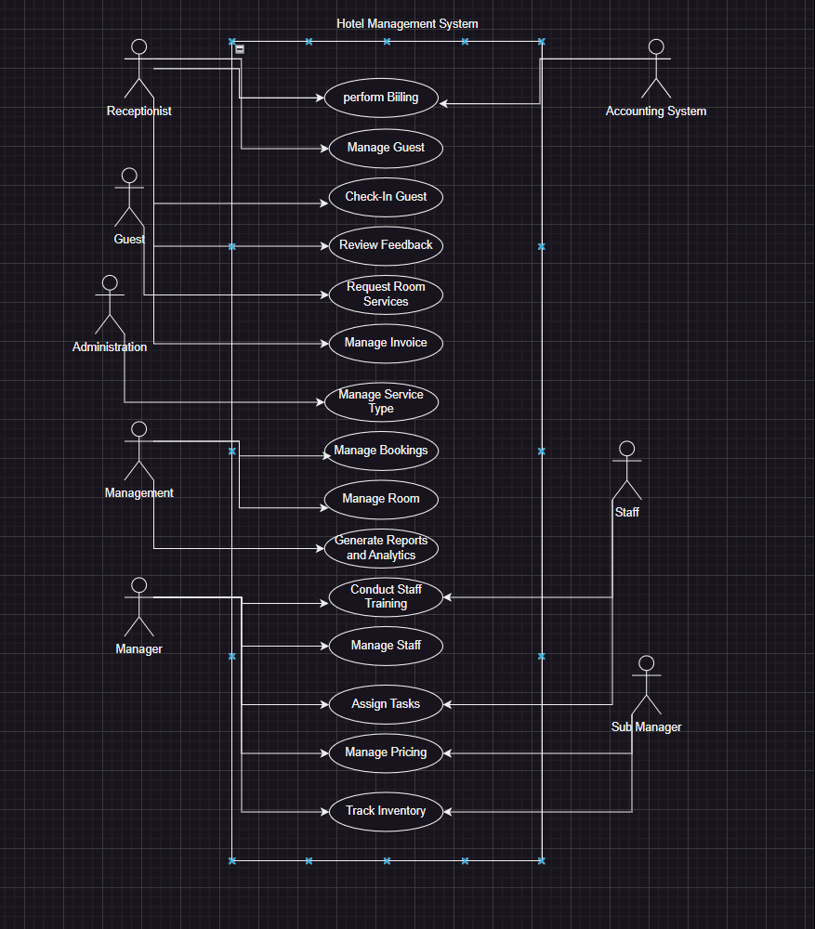

# Other Nonfunctional Requirements

## Performance Requirements

The Hotel Management System (HMS) must maintain high performance across various operational conditions to ensure optimal functionality and user satisfaction. Key performance requirements include ensuring that the system responds to user actions within 2 seconds for 95% of transactions under normal operating conditions, and that it supports up to 1,000 concurrent users without any degradation in performance, thereby ensuring seamless operation during peak times. Additionally, critical transactions such as room booking, and check-in/check-out processes must be completed within 3 seconds to maintain efficiency at the front desk. Real-time data synchronization between different modules, such as reservations, housekeeping, and maintenance, must occur within 5 seconds to ensure consistent and up-to-date information across the system. These performance benchmarks are essential for maintaining operational efficiency and delivering a positive user experience.

## Safety Requirements

The HMS must incorporate robust safety measures to prevent any loss, damage, or harm. Ensuring data integrity is crucial, which requires implementing robust data validation and error-checking mechanisms to prevent data corruption. The system must perform automated daily backups, with a recovery process capable of restoring data within 30 minutes in the event of a system failure. To protect against unauthorized access, critical system functions such as financial transactions and data deletion must be restricted to authorized personnel only. The HMS must also comply with relevant safety standards and regulations, such as OSHA guidelines for electronic systems in the hospitality industry.These safety requirements are vital for safeguarding the hotel's operations and guest information.

## Security Requirements

Security and privacy are paramount for the HMS. The system must enforce multi-factor authentication (MFA) for all user logins to enhance security. Sensitive data, both at rest and in transit, must be encrypted using industry-standard encryption protocols, such as AES-256, to protect against unauthorized access and data breaches. Role-based access control (RBAC) should be implemented to ensure users can only access data and functions necessary for their roles. The system must comply with security regulations such as GDPR and PCI DSS, ensuring that guest data and hotel operations are protected.Regular security audits must be conducted to identify and mitigate potential vulnerabilities, maintaining a high level of system security.

## Software Quality Attributes

The HMS must meet several key quality attributes to satisfy customer and developer expectations. It must be highly reliable, with an uptime of 99.9%, ensuring that the system is almost always available for use. The user interface should be intuitive and user-friendly, minimizing the learning curve for new users and ensuring ease of use. The system should be designed for easy maintenance and updates, with modular code and comprehensive documentation to facilitate these processes. Additionally, the system should be adaptable to changes, ensuring flexibility in accommodating new requirements and technologies.

Interoperability with other systems, maintainability, portability, reliability, reusability, robustness, testability, and usability are also essential quality attributes that the HMS must meet to ensure efficient and effective operations.

## Business Rules

The HMS must adhere to specific business rules to ensure proper operation. These rules include defining which individuals or roles can perform specific functions under circumstances. For instance, only authorized personnel should be able to access financial reports or perform system configurations. Front desk staff should have access to reservation and check-in/check-out functionalities, while housekeeping staff should have access to room status updates and cleaning schedules. These business rules imply certain functional requirements that the system must enforce to ensure proper role-based access and operational integrity.

## Operating Environment

The HMS must be designed to operate in a typical hotel environment, which includes various hardware and software components. It should be compatible with standard hotel hardware platforms such as desktop computers, tablets, and mobile devices used by staff.

The system should support major operating systems, including Windows, macOS, iOS, and Android, ensuring broad compatibility. Additionally, the HMS must coexist peacefully with other software applications commonly used in hotels, such as property management systems (PMS), customer relationship management (CRM) systems, and accounting

software. This compatibility ensures seamless integration and operation within the hotel’s existing technological ecosystem.

## User Interfaces

The user interface of the HMS must be intuitive and user-friendly, adhering to established GUI standards and style guides to ensure consistency. Each interface must include standard buttons and functions, such as help options, and follow screen layout constraints to maintain uniformity. For instance, all screens should have a common header and footer, with standard navigation buttons located in the same positions. Keyboard shortcuts should be implemented to enhance efficiency for power users, and error messages must be clear, concise, and consistent across the system. The HMS will need user interfaces for various components, including reservation management, front desk operations, housekeeping, and maintenance management. Detailed user interface design will be documented in a separate user interface specification to ensure all requirements are met comprehensively.

# Domain Model

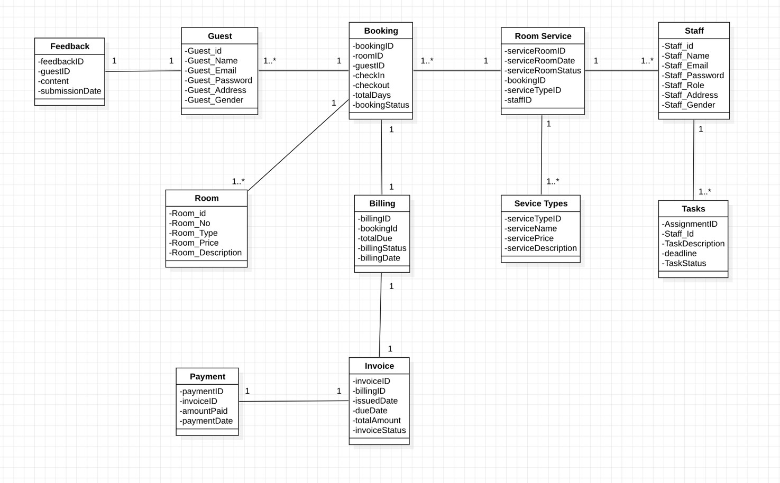

# System Sequence Diagram

Manage Guests

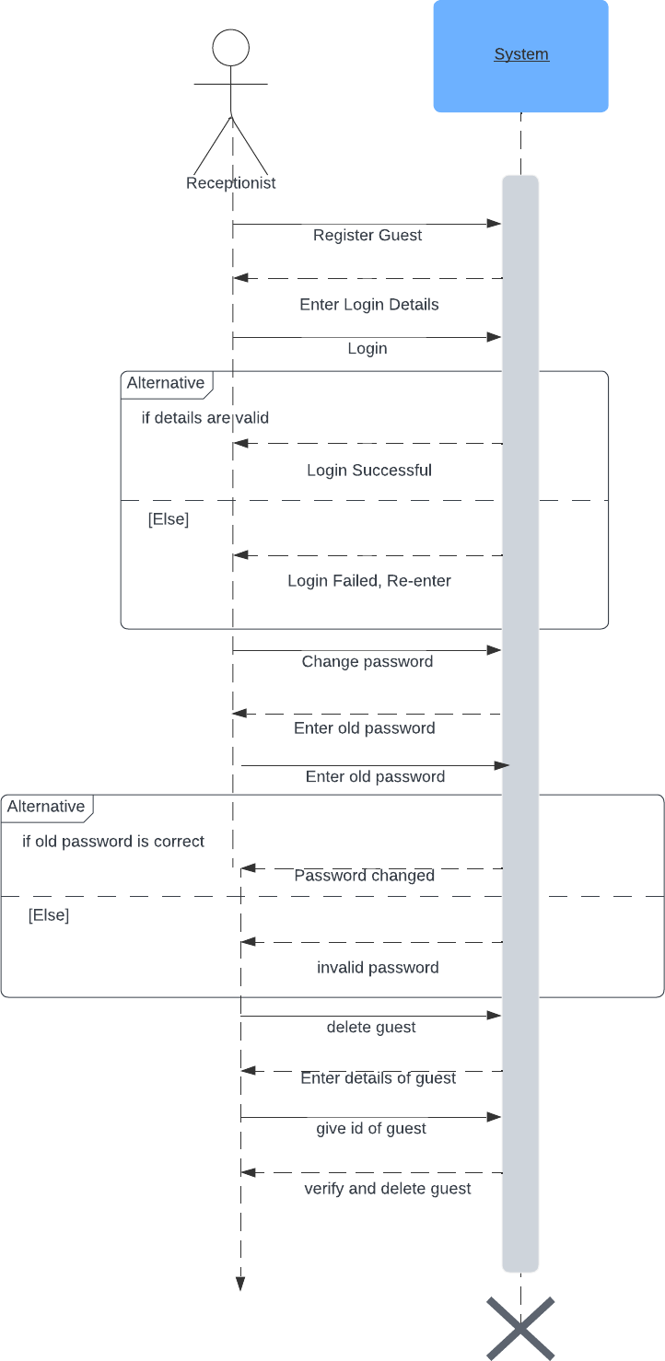

**Manage Staff**

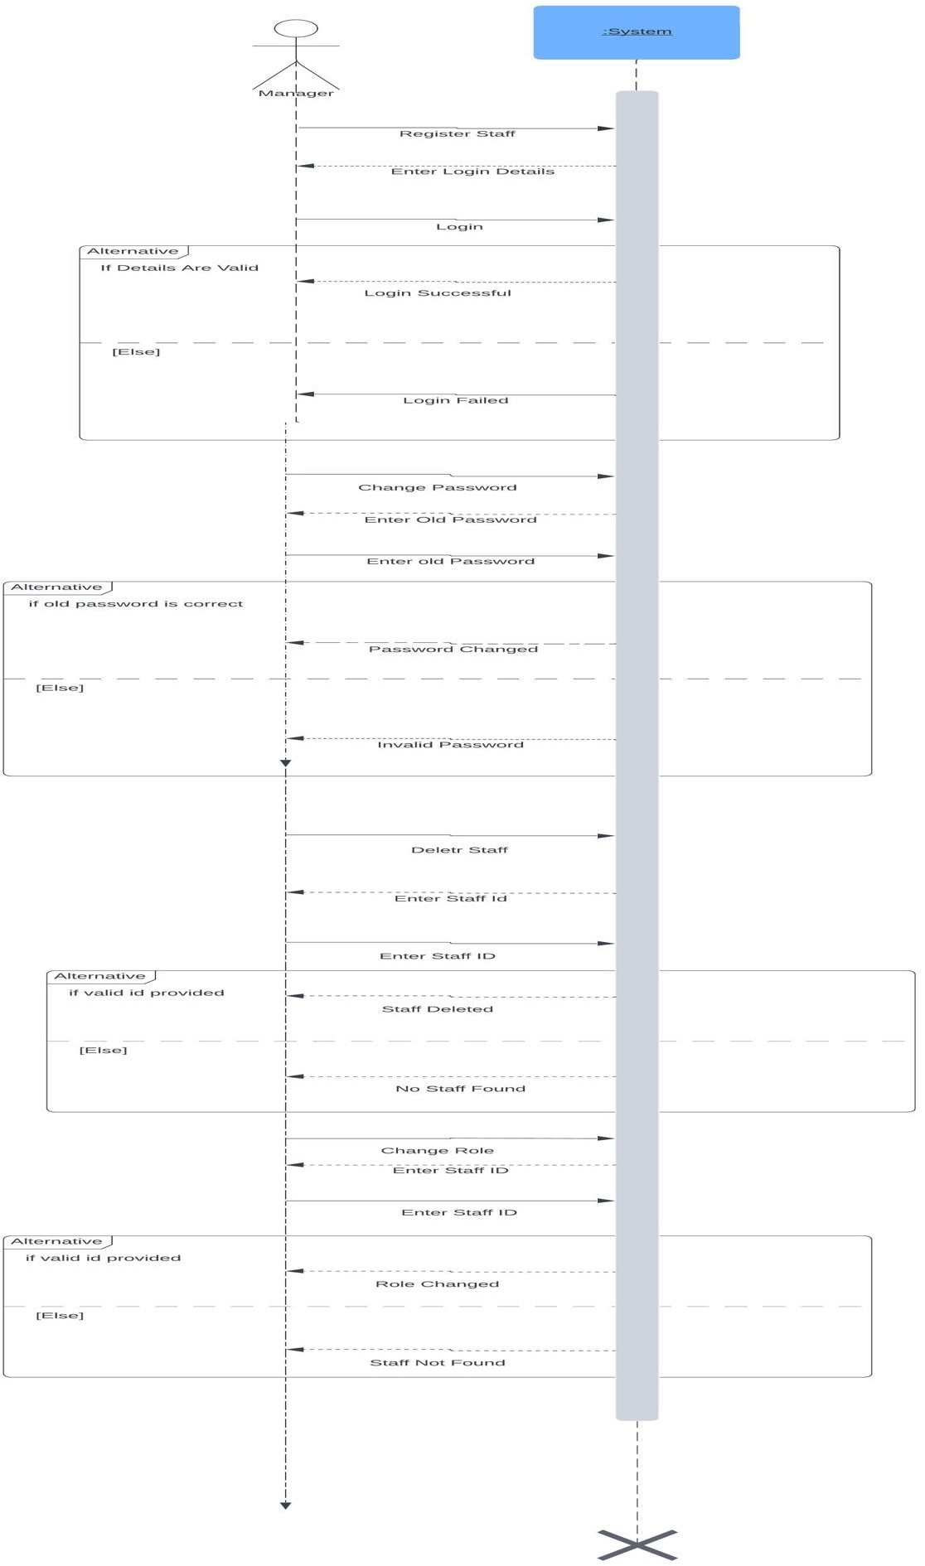

**Manage Booking**

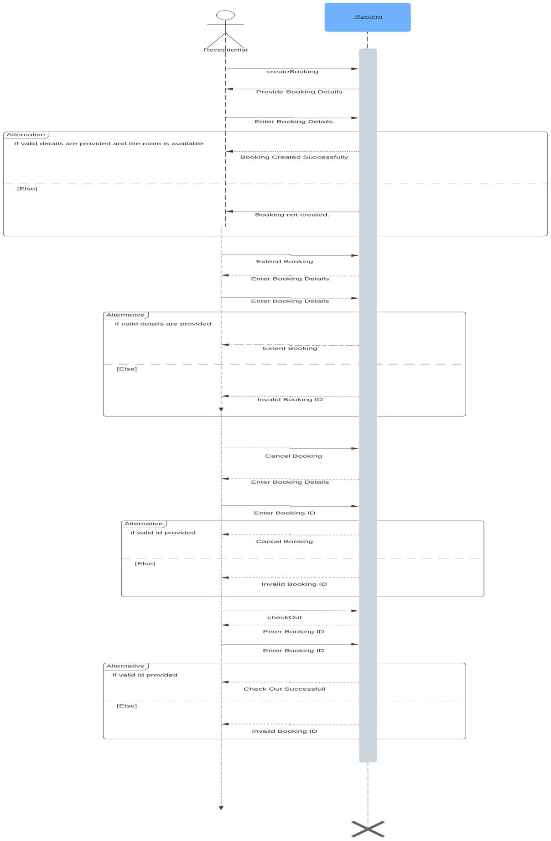

**Manage Room**

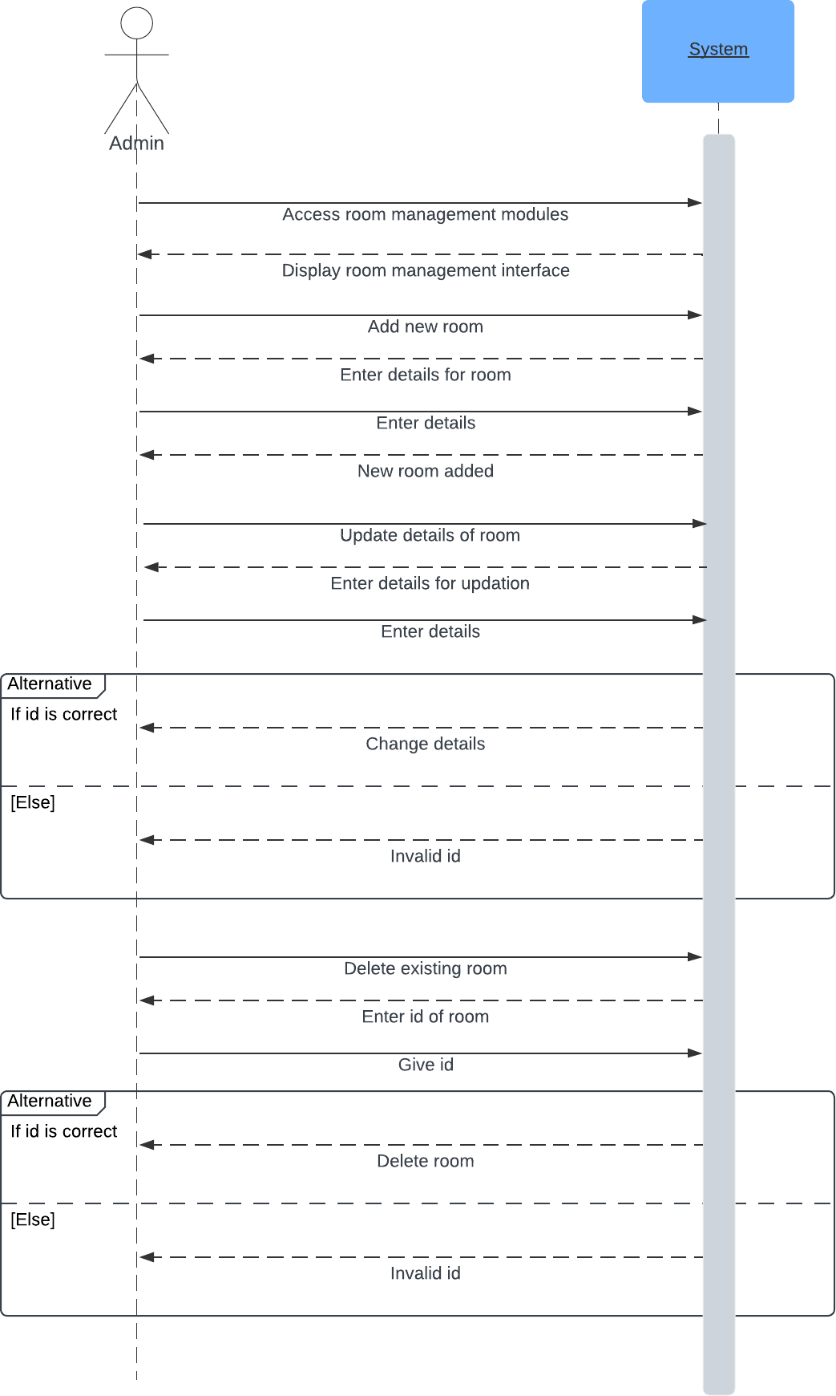

**Perform Billing**

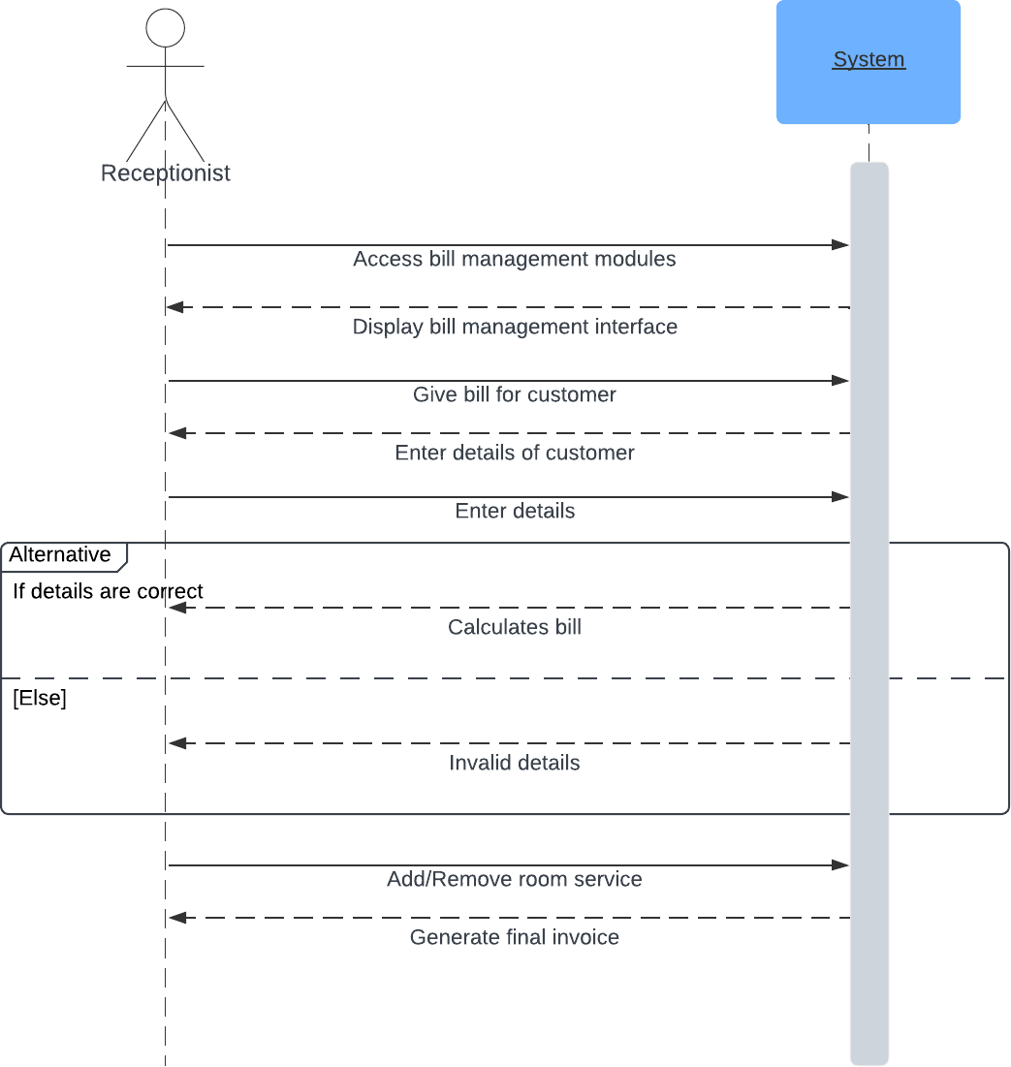

**Manage Service Types**

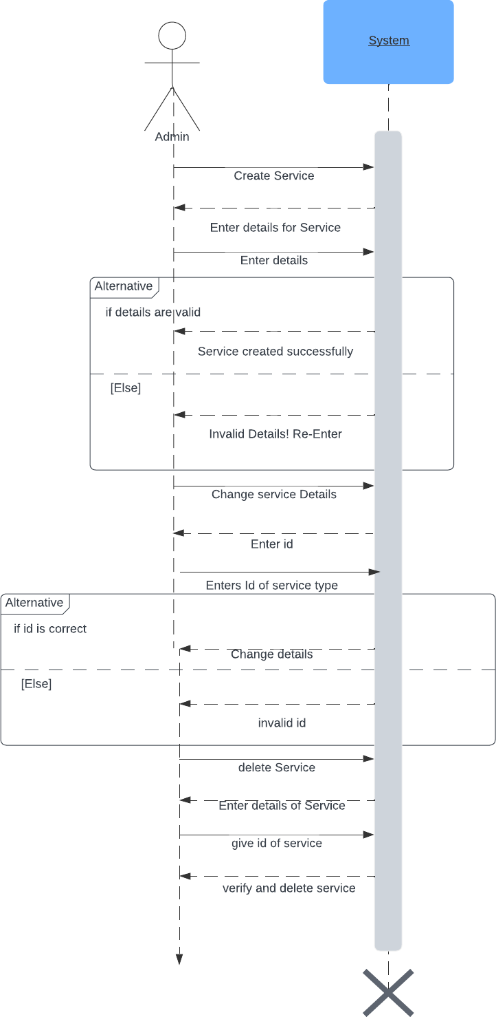

**Review Feedback**

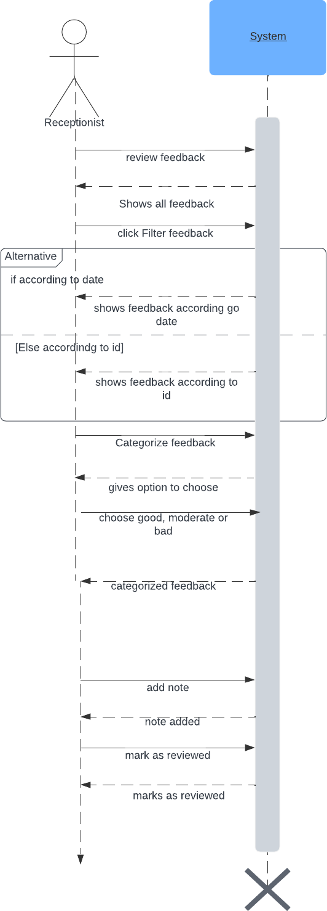

**Check-In Guest**

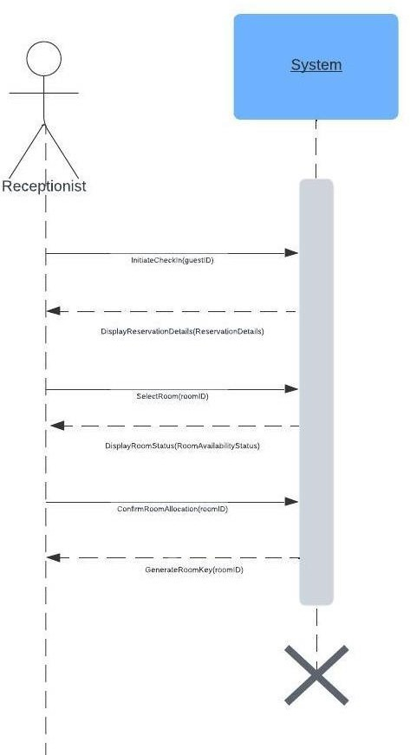

**Manage Invoice**

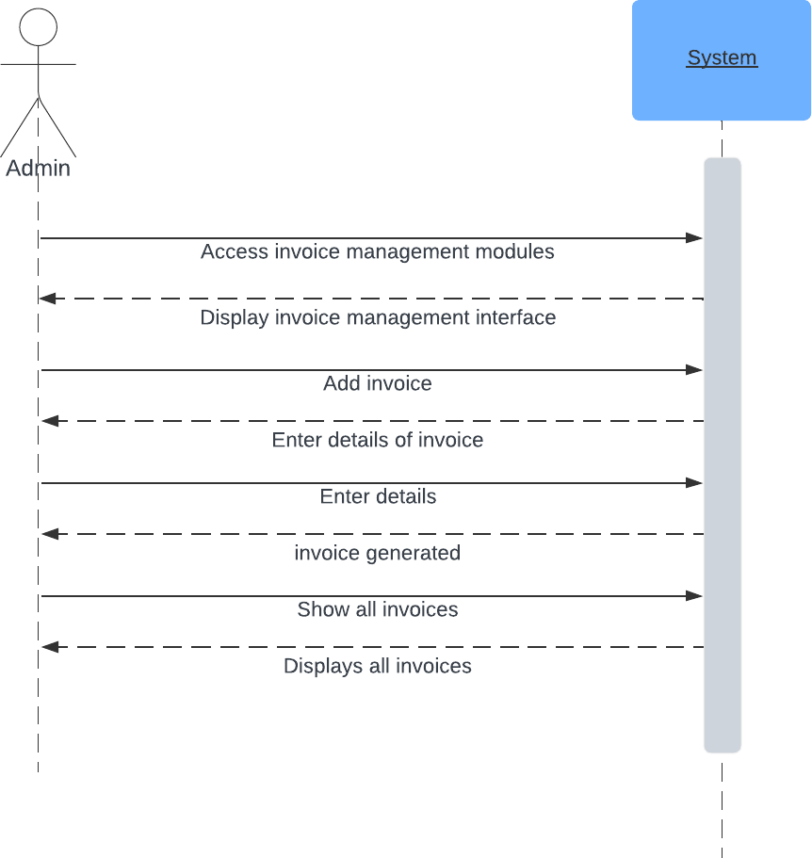

**Generate Reports and Analytics**

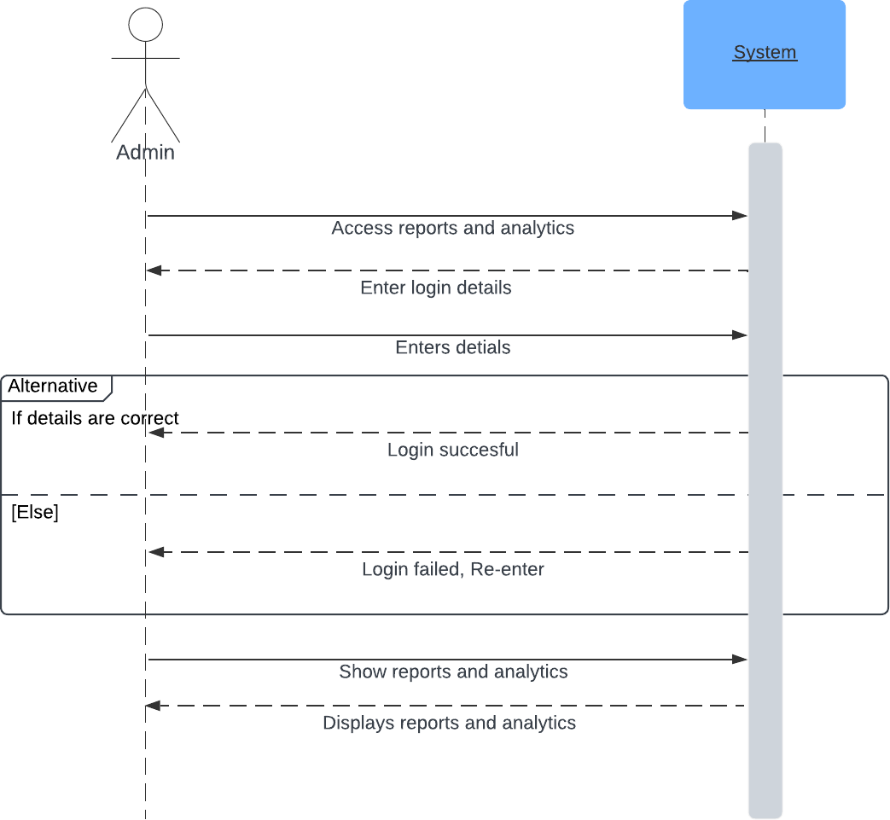

**Request Room Service**

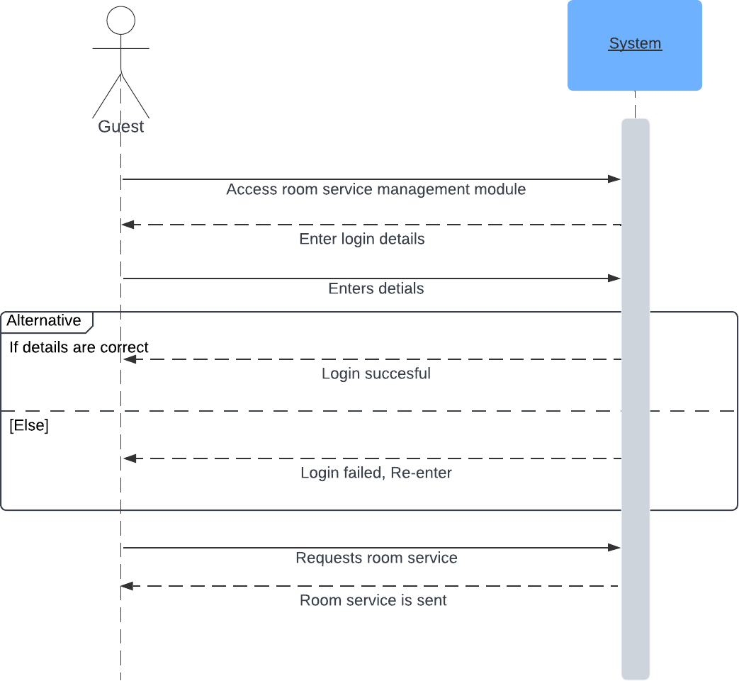

**Assignment of Task**

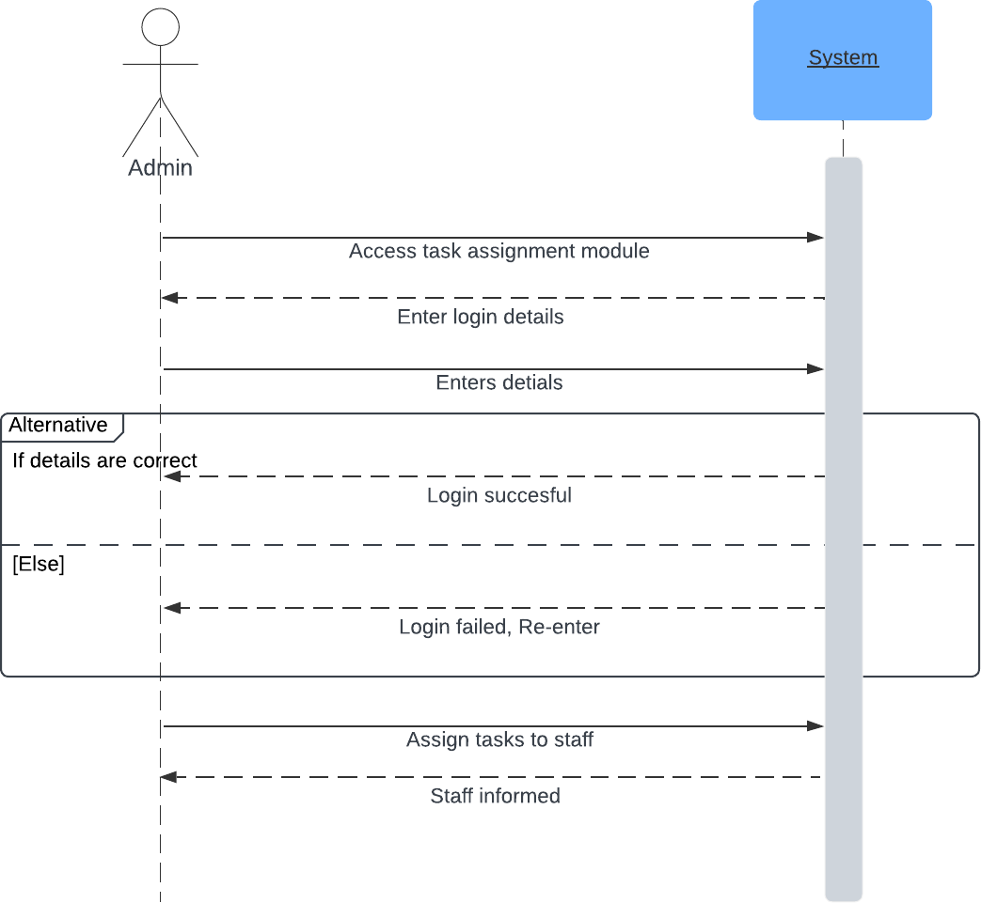

**Track Inventory**

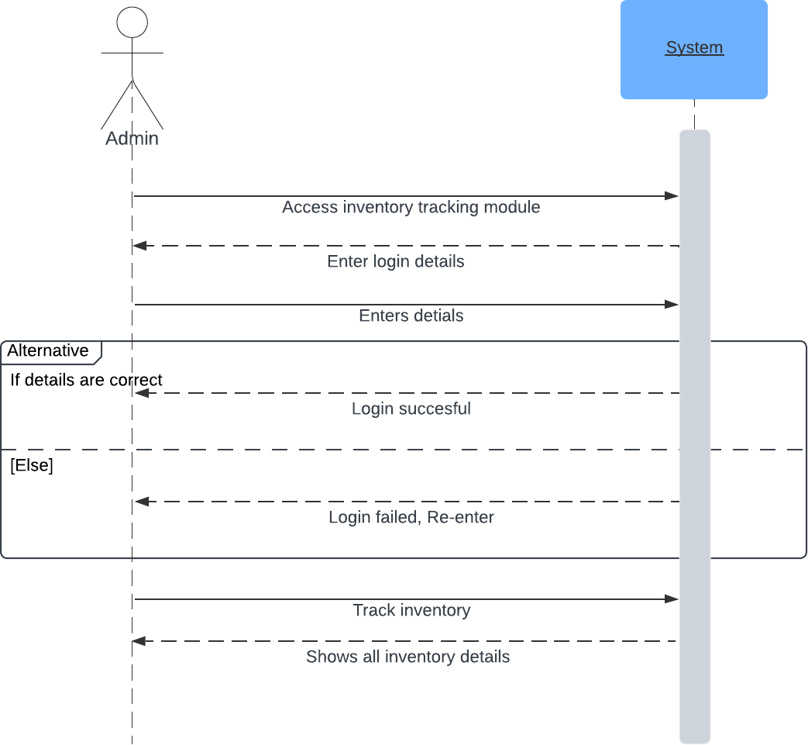

**Conduct Staff Training**

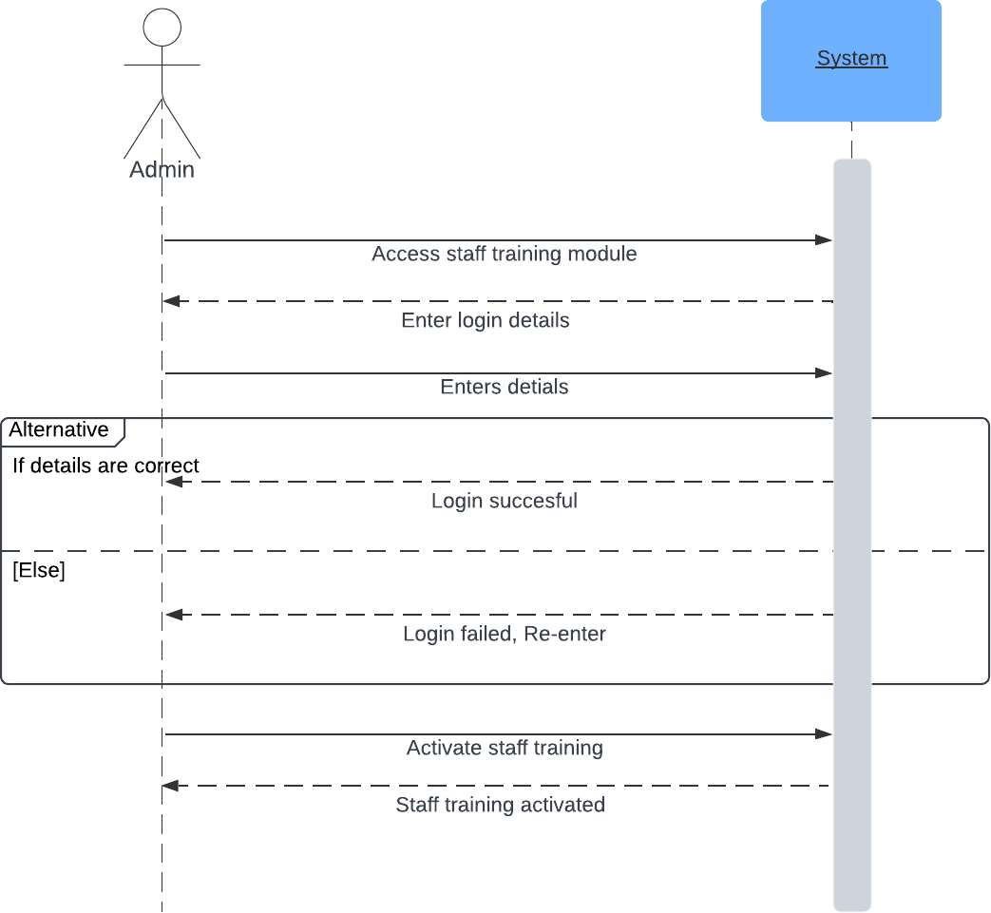

**Manage Pricing**

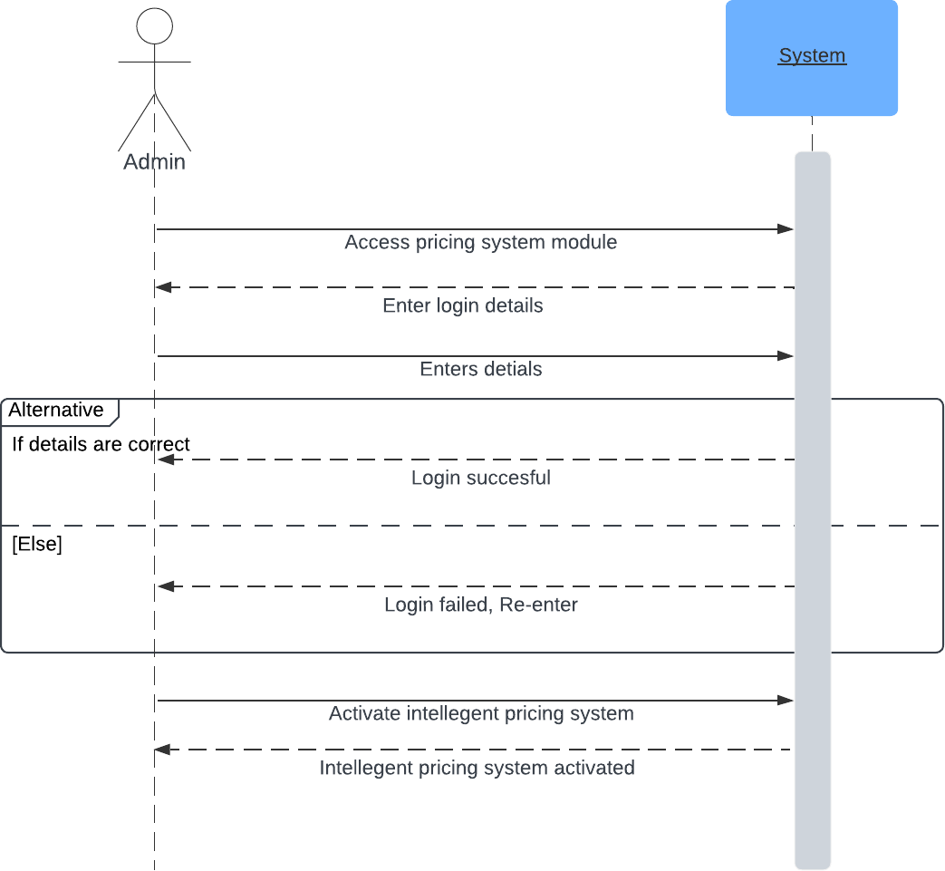

# Sequence Diagram

**Manage Guests**

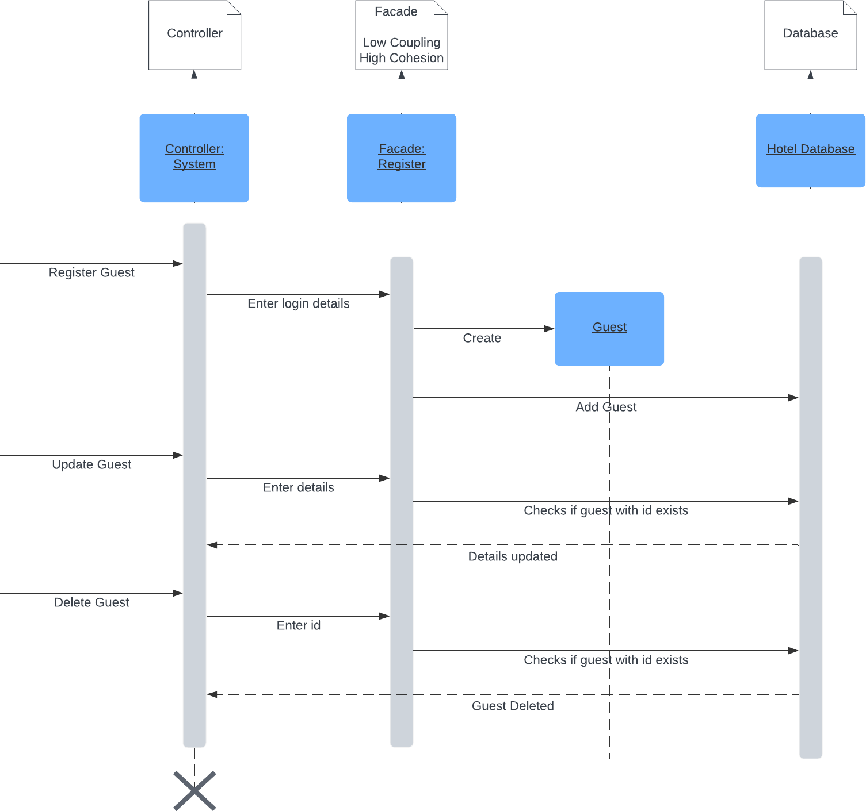

**Manage Staff**

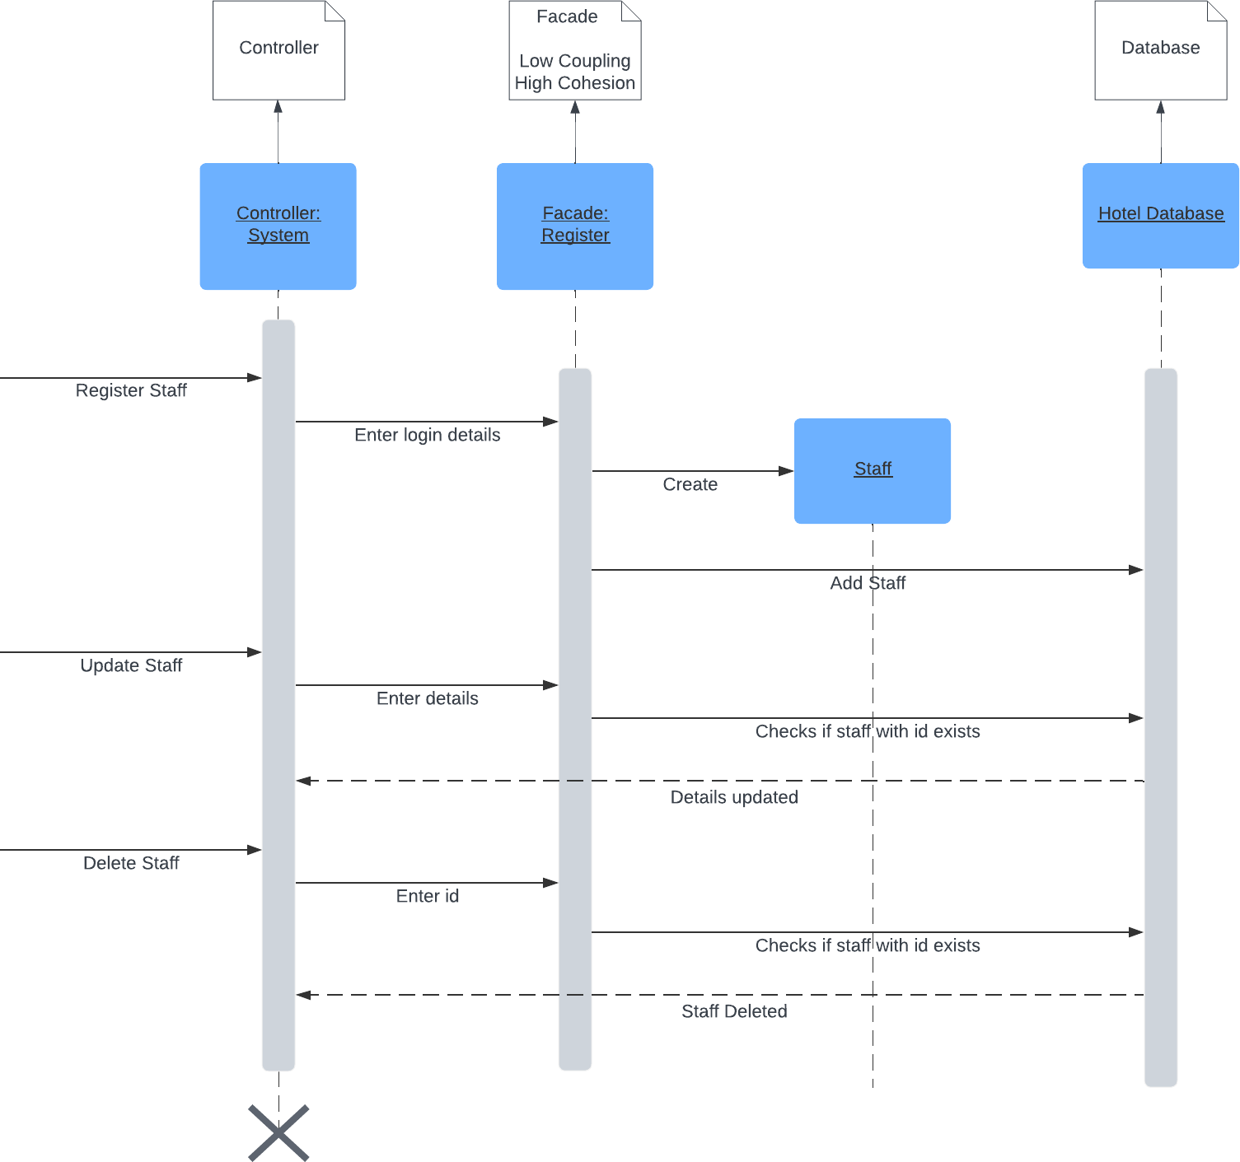

**Manage Booking**

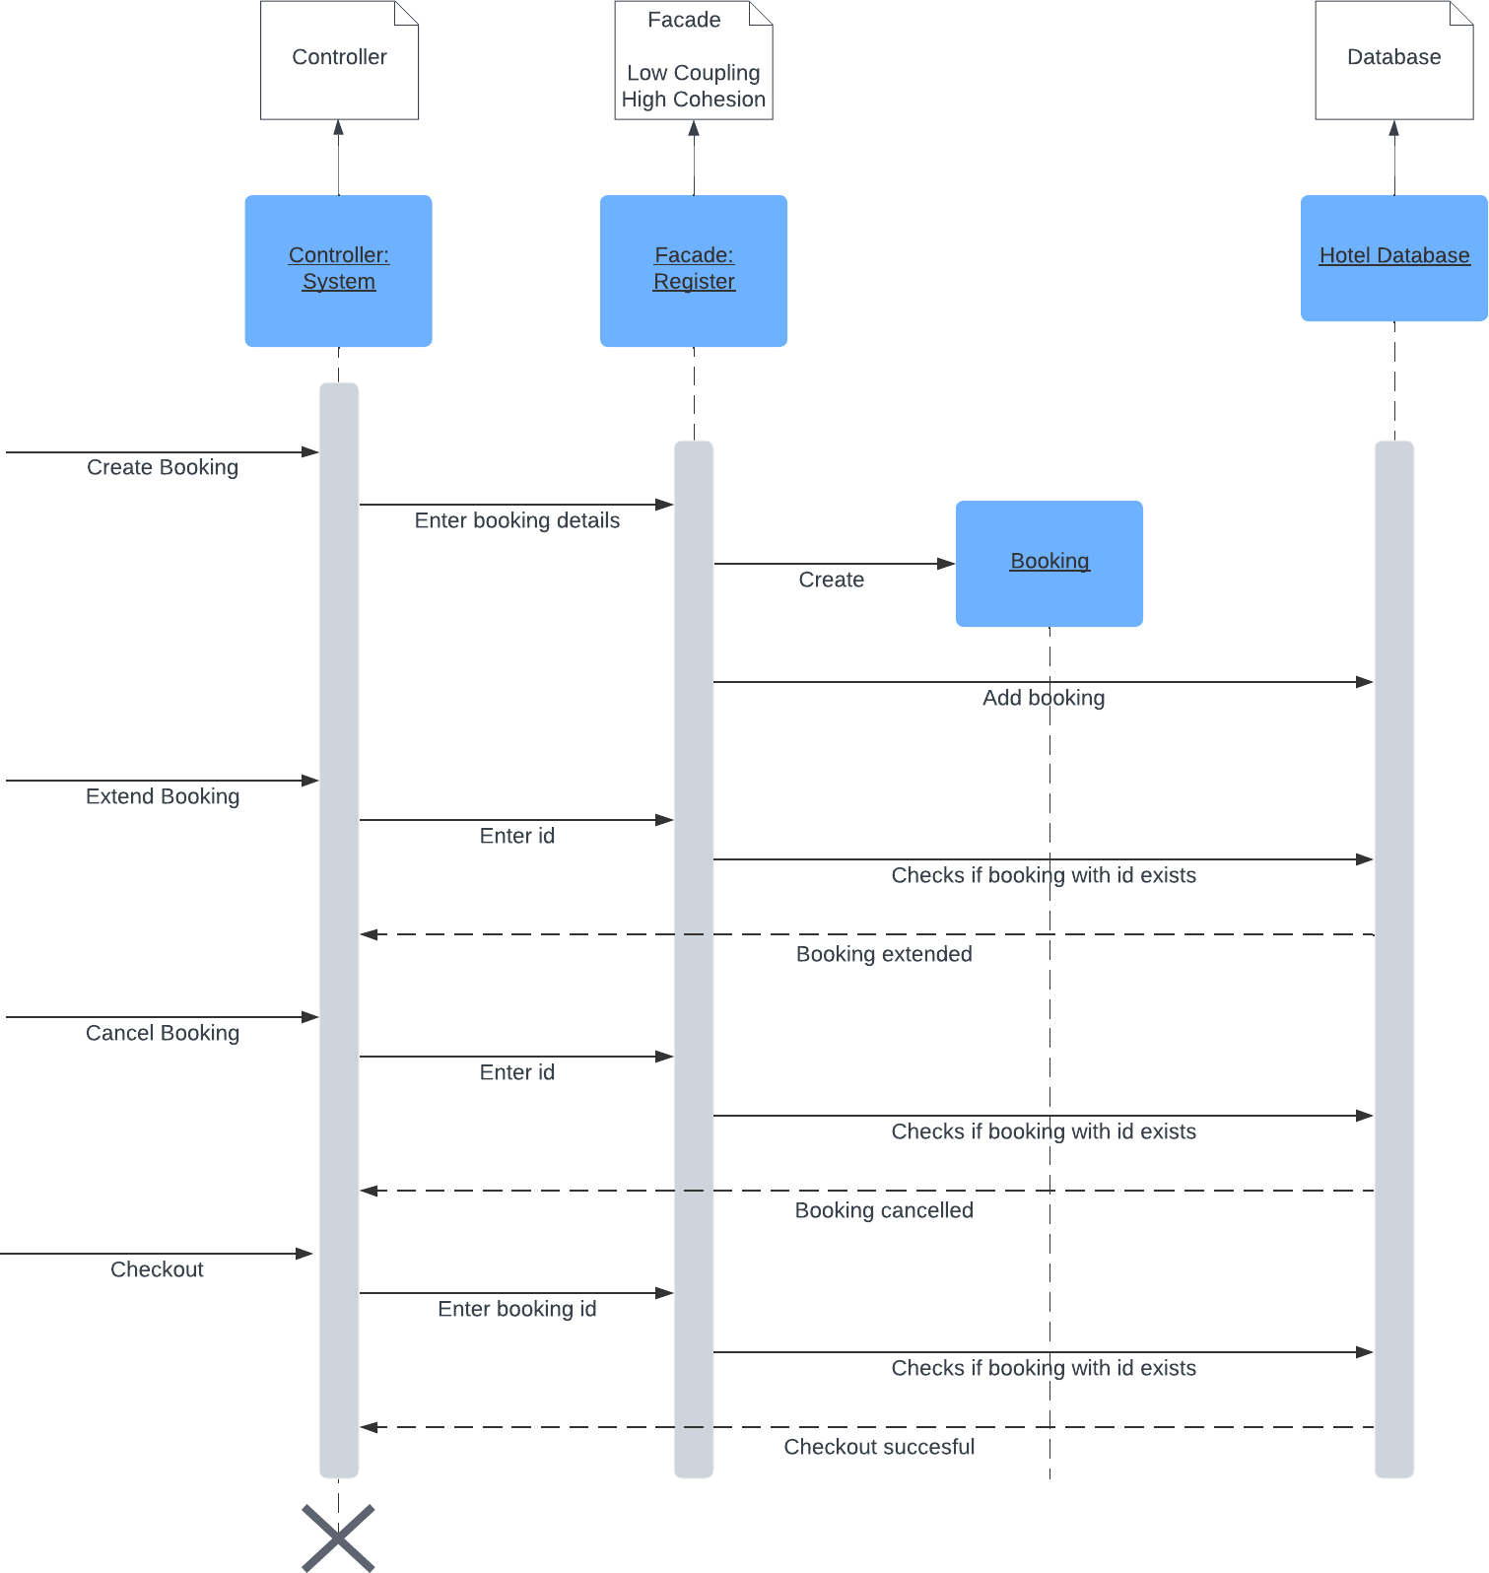

**Manage Room**

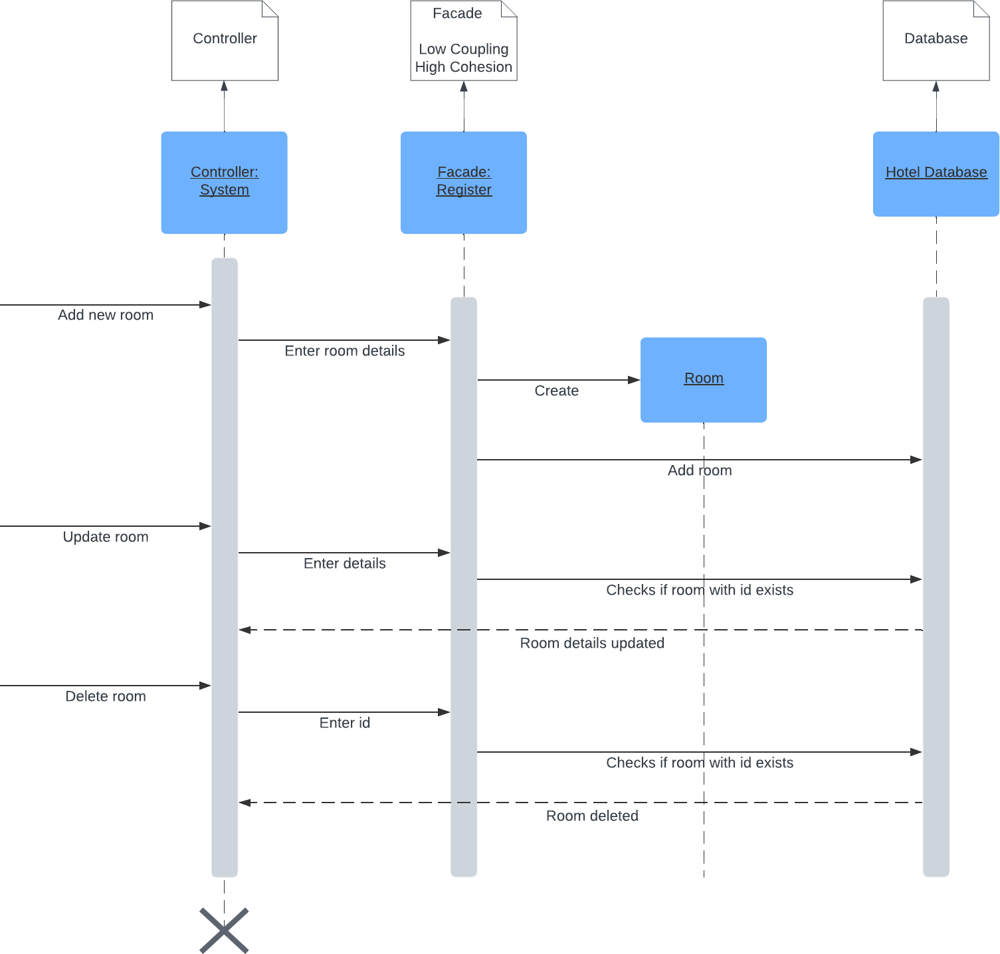

**Perform Billing**

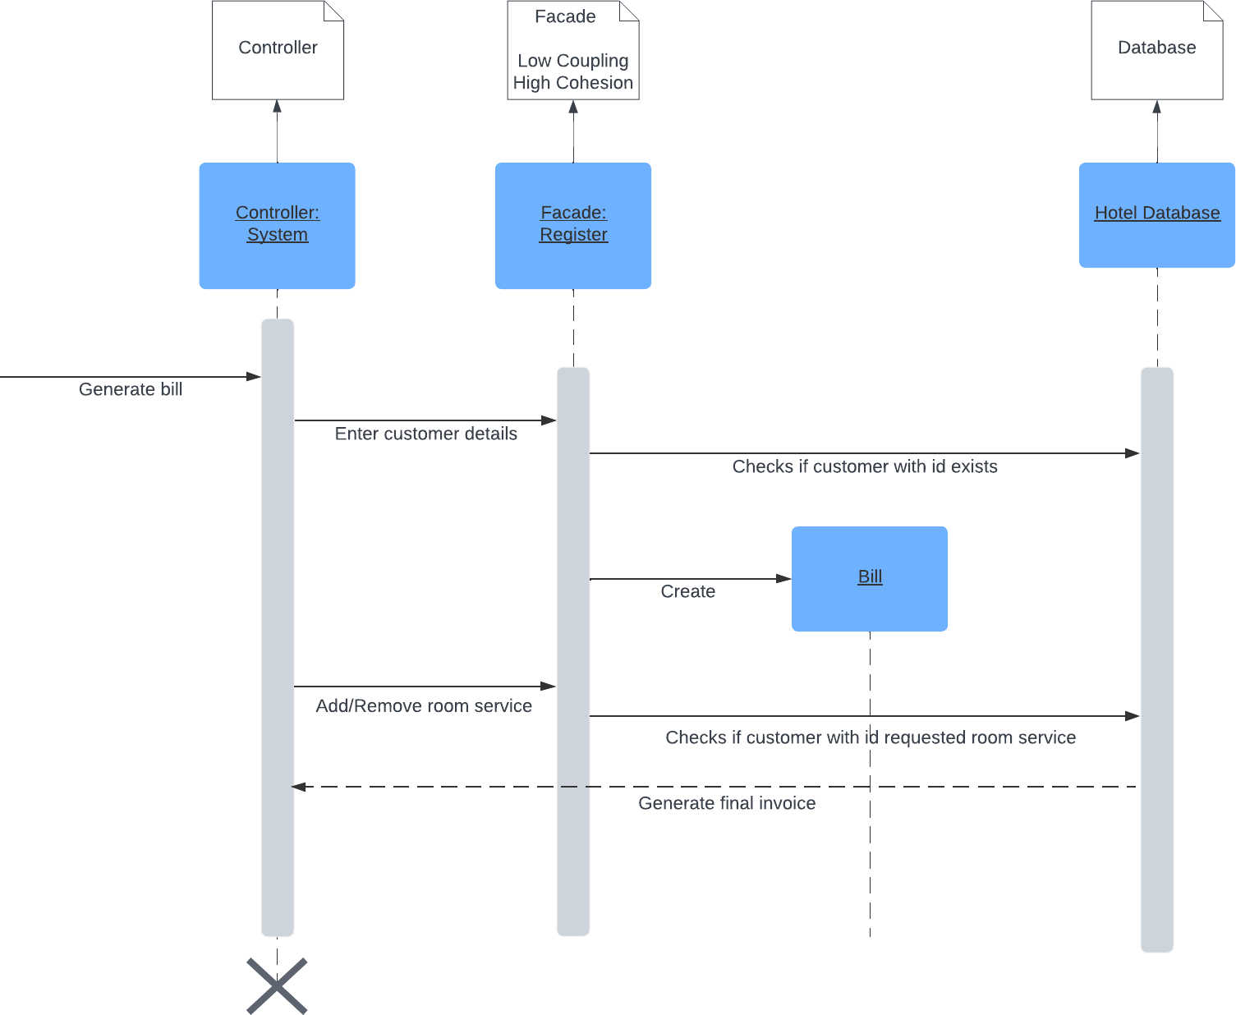

**Manage Service Types**

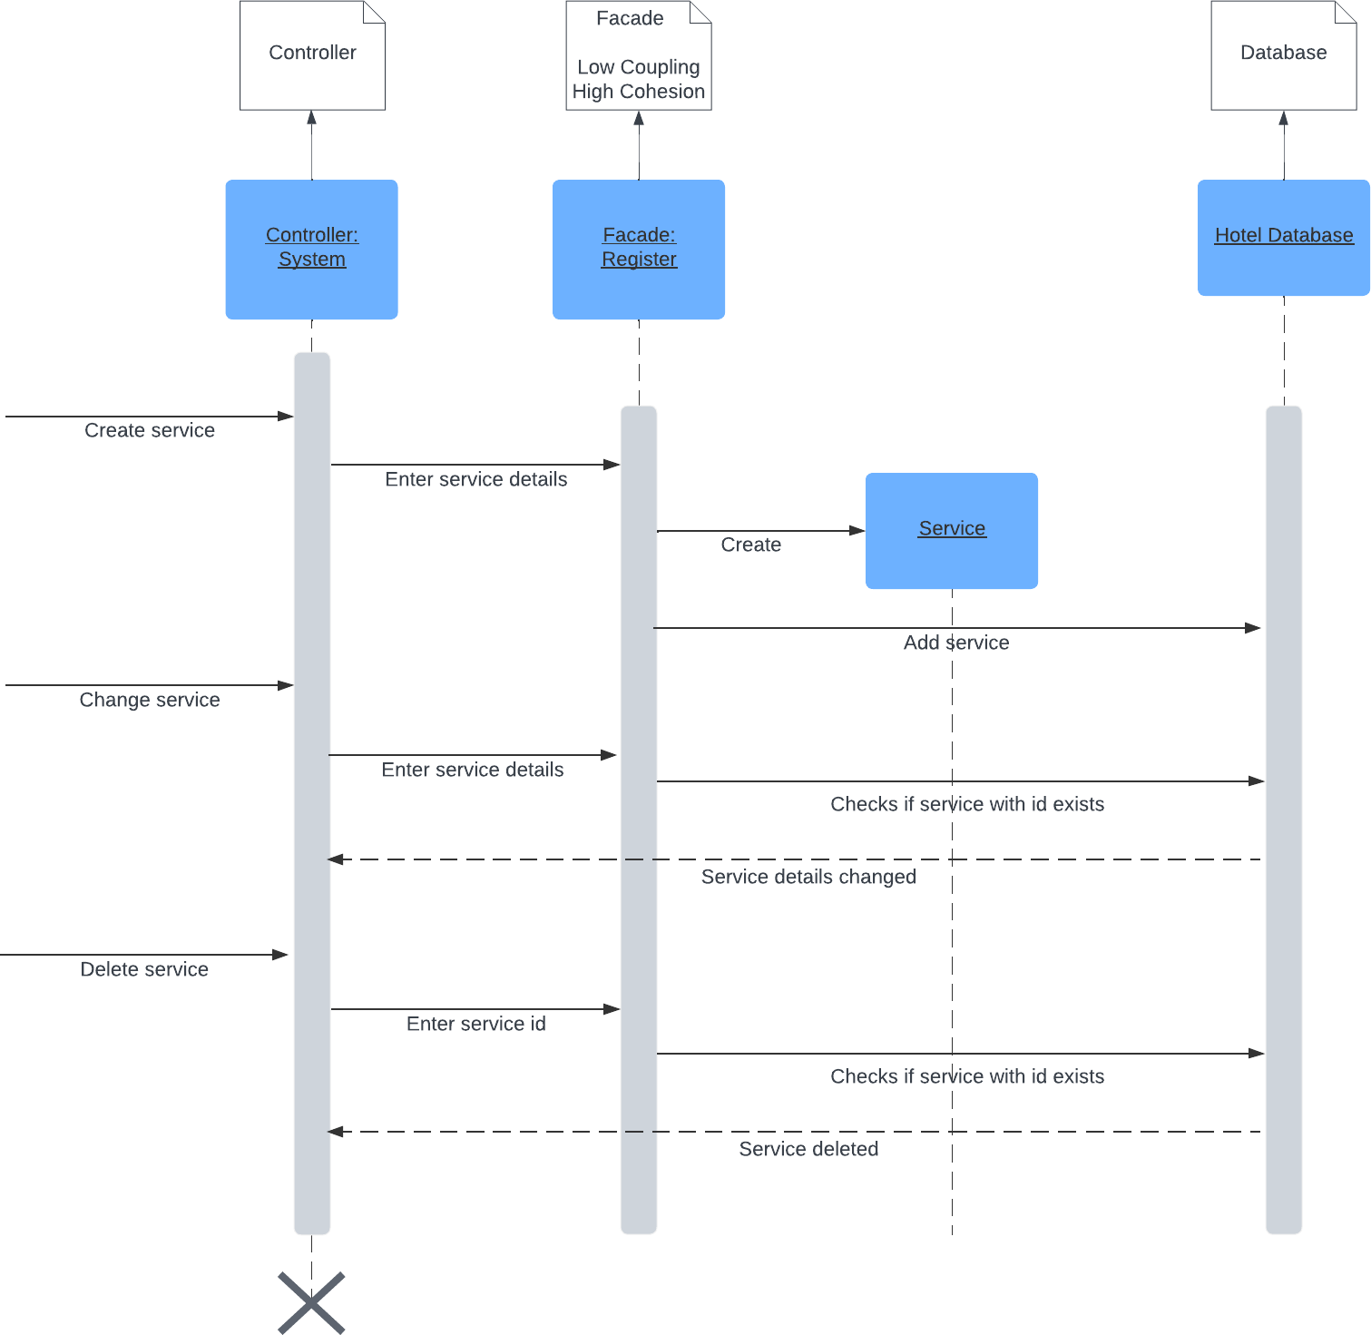

**Review Feedback**

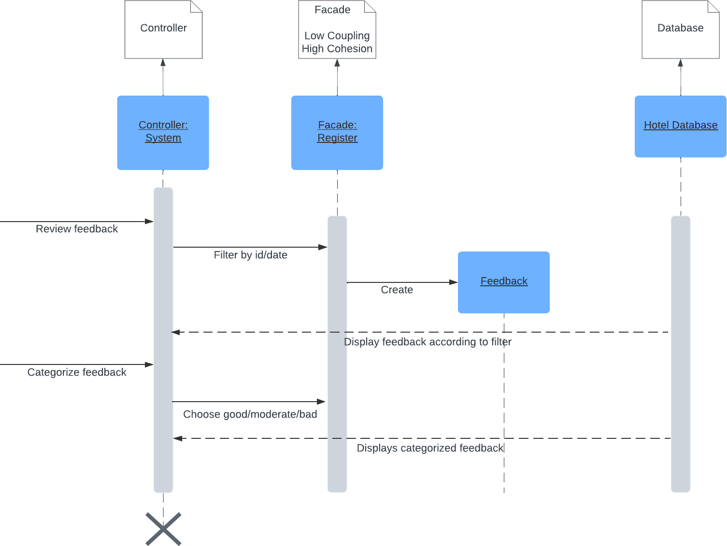

**Manage Invoice**

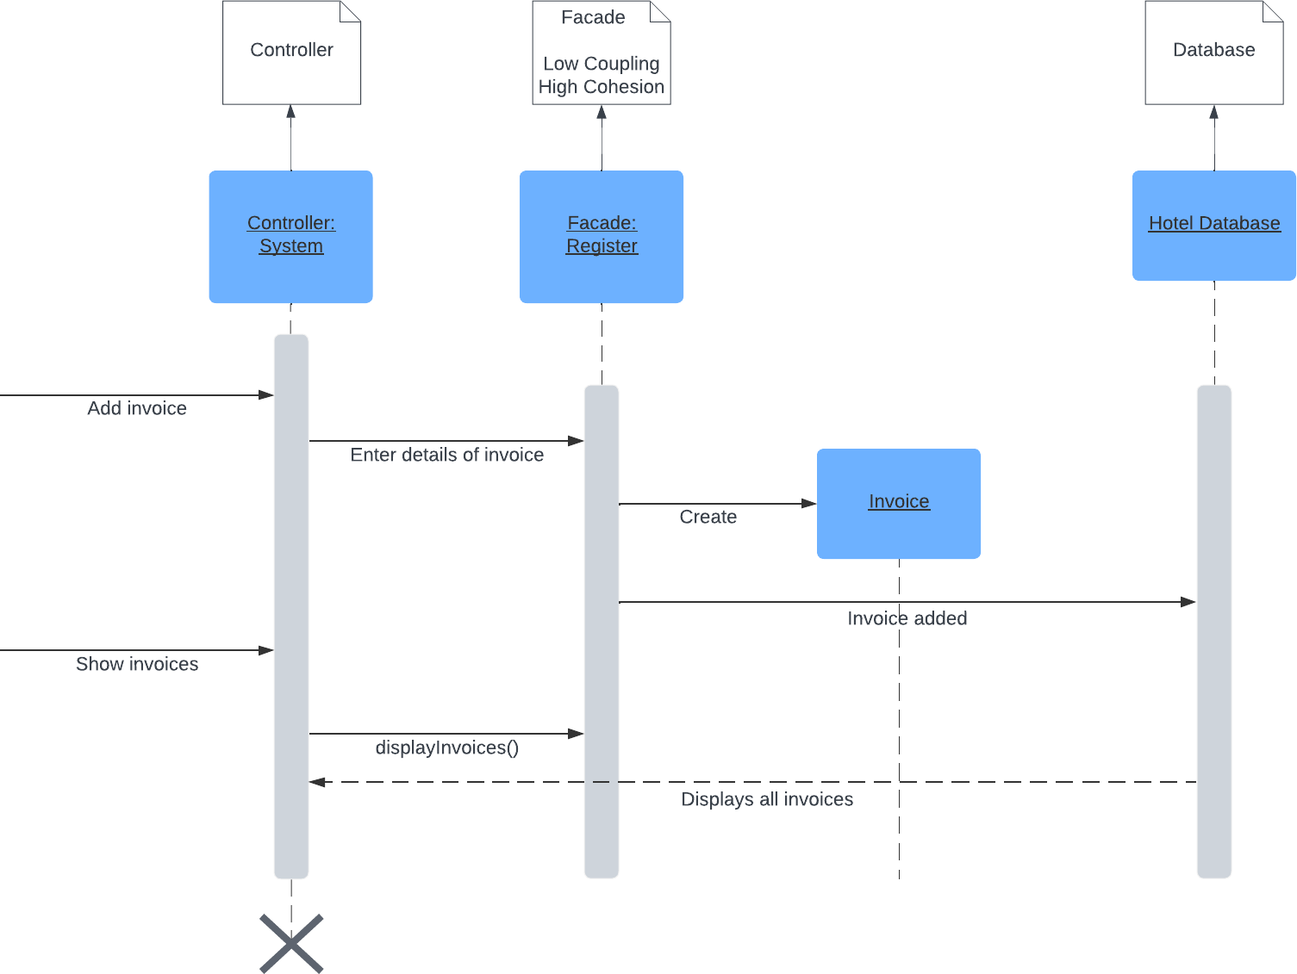

**Generate Reports and Analytics**

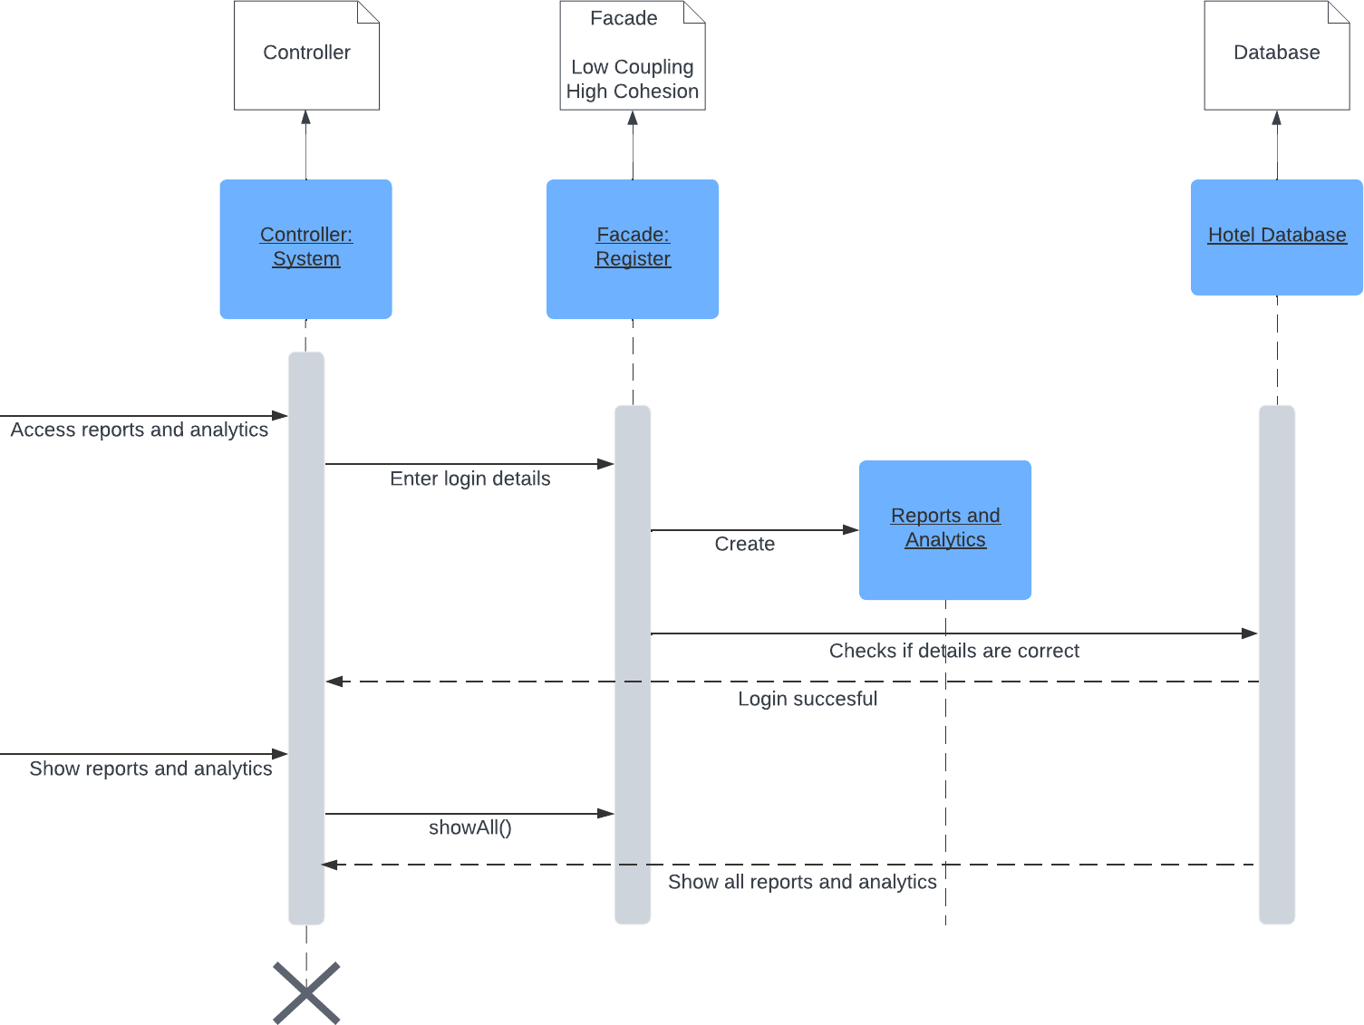

**Request Room Service**

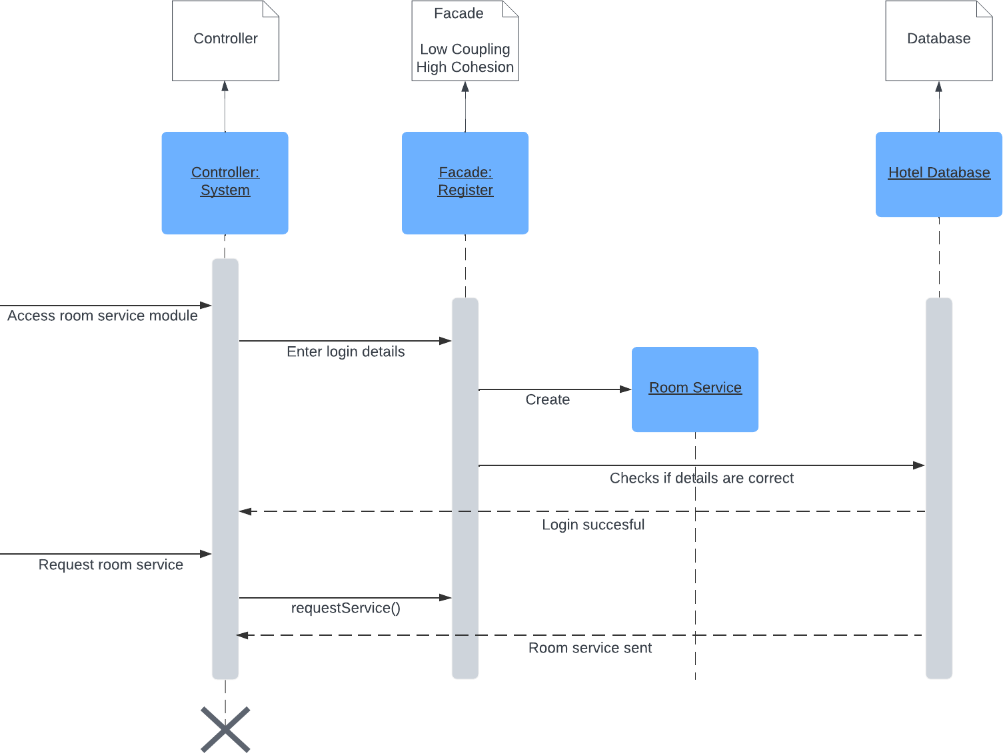

**Assign Task**

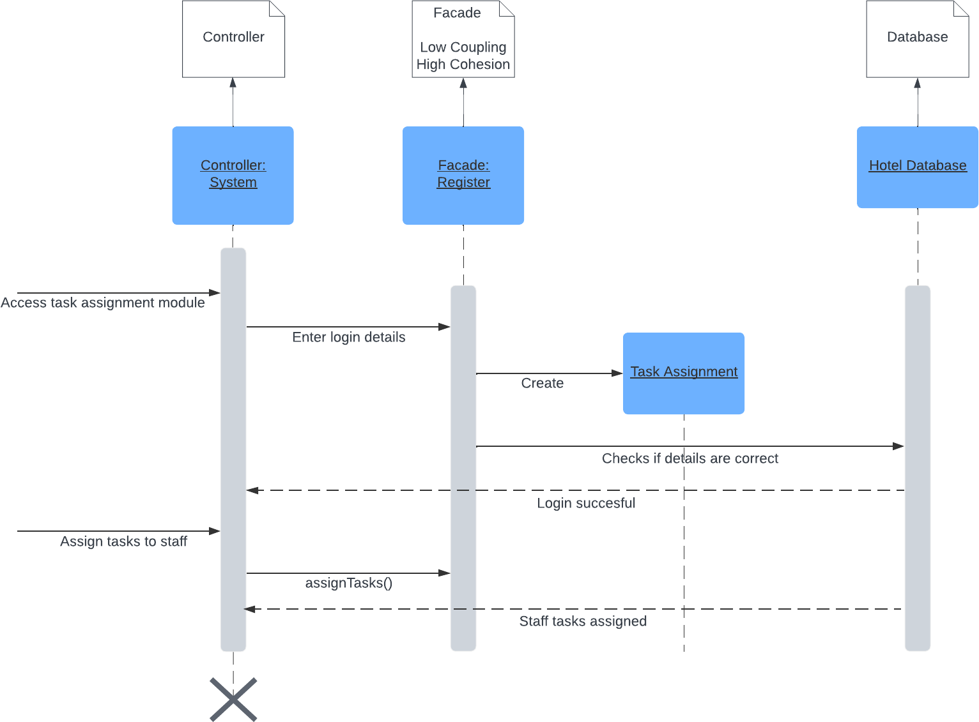

**Track Inventory**

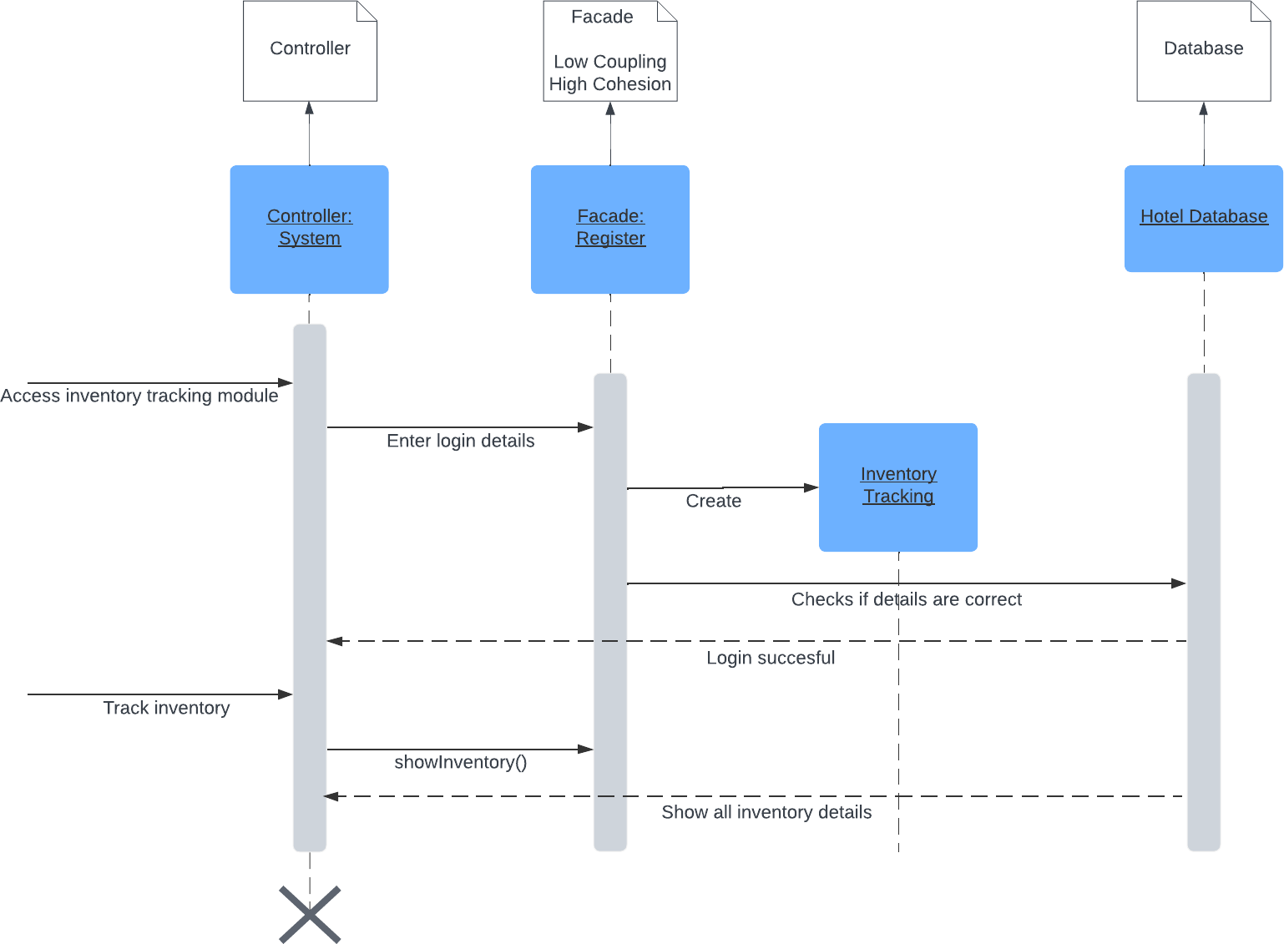

**Conduct Staff Training**

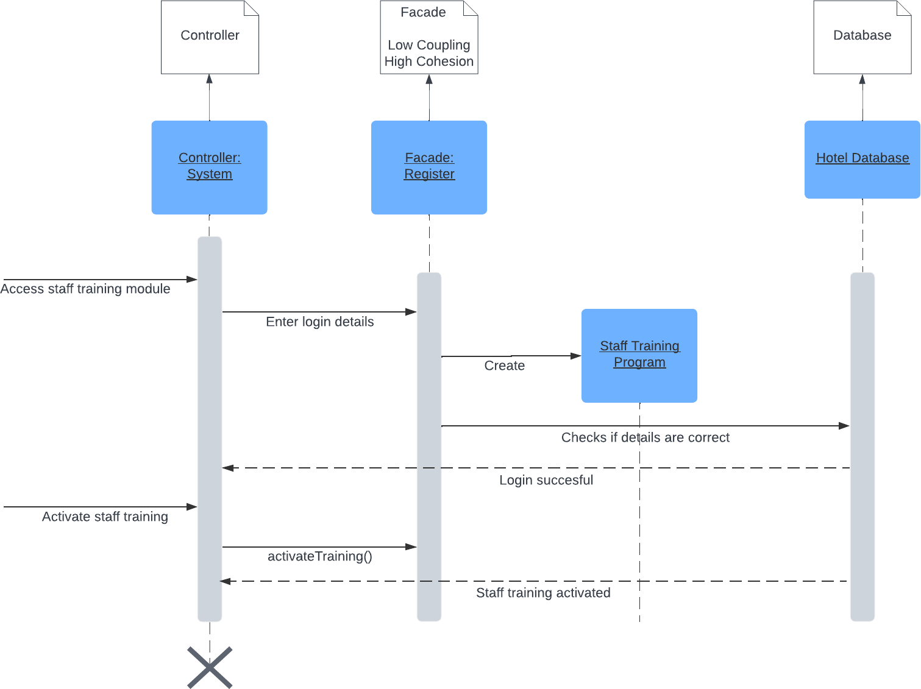

**Manage Pricing**

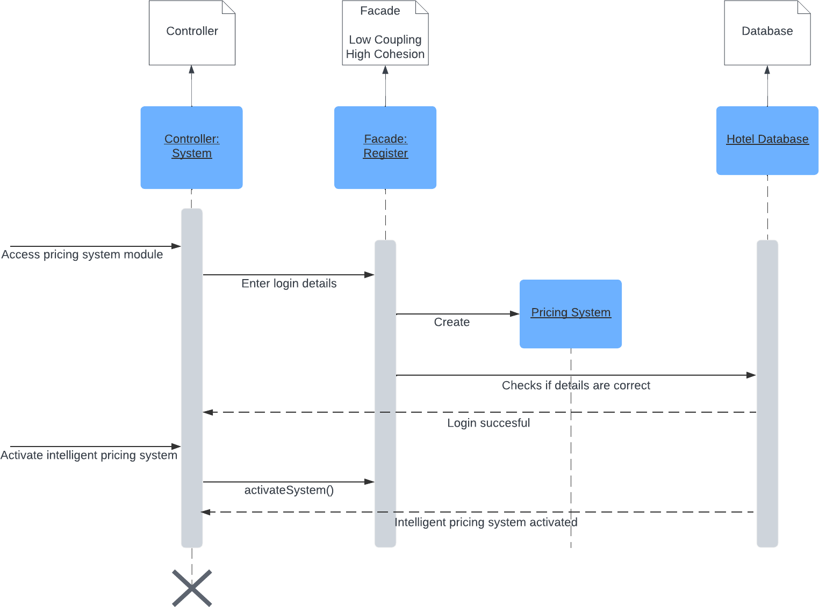

**Check-In Guest**

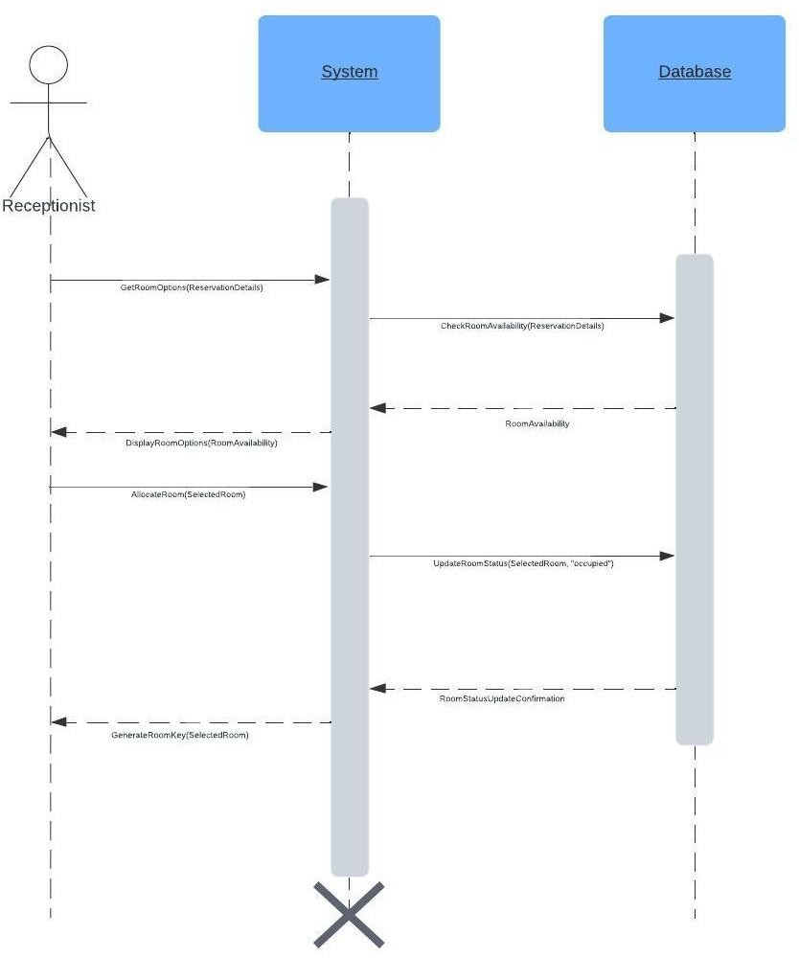

# Class Diagram

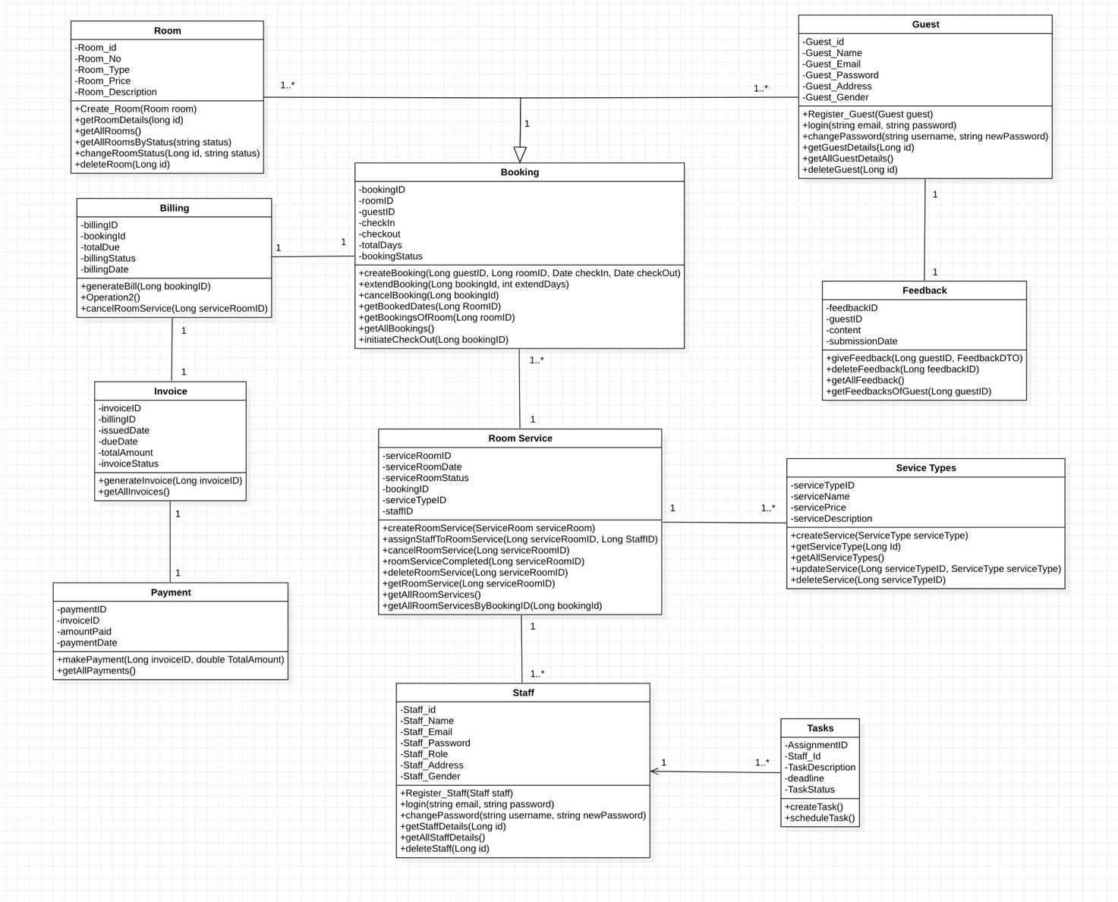

# High-level Architecture

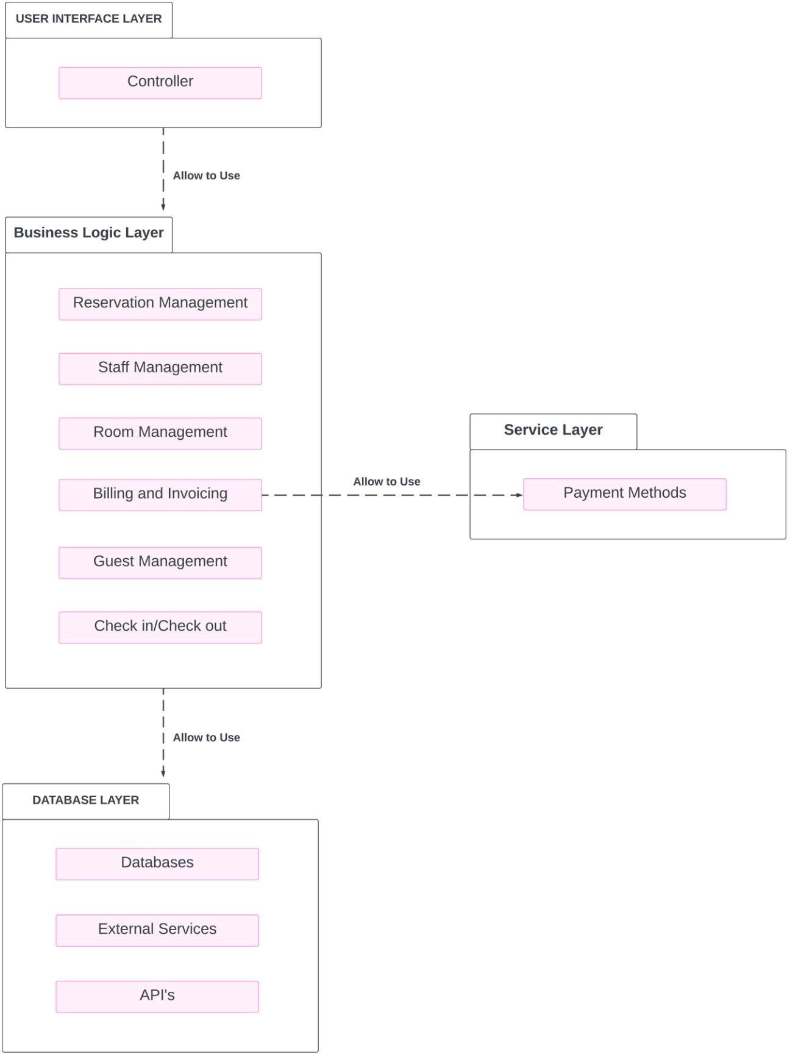

## Package Diagram

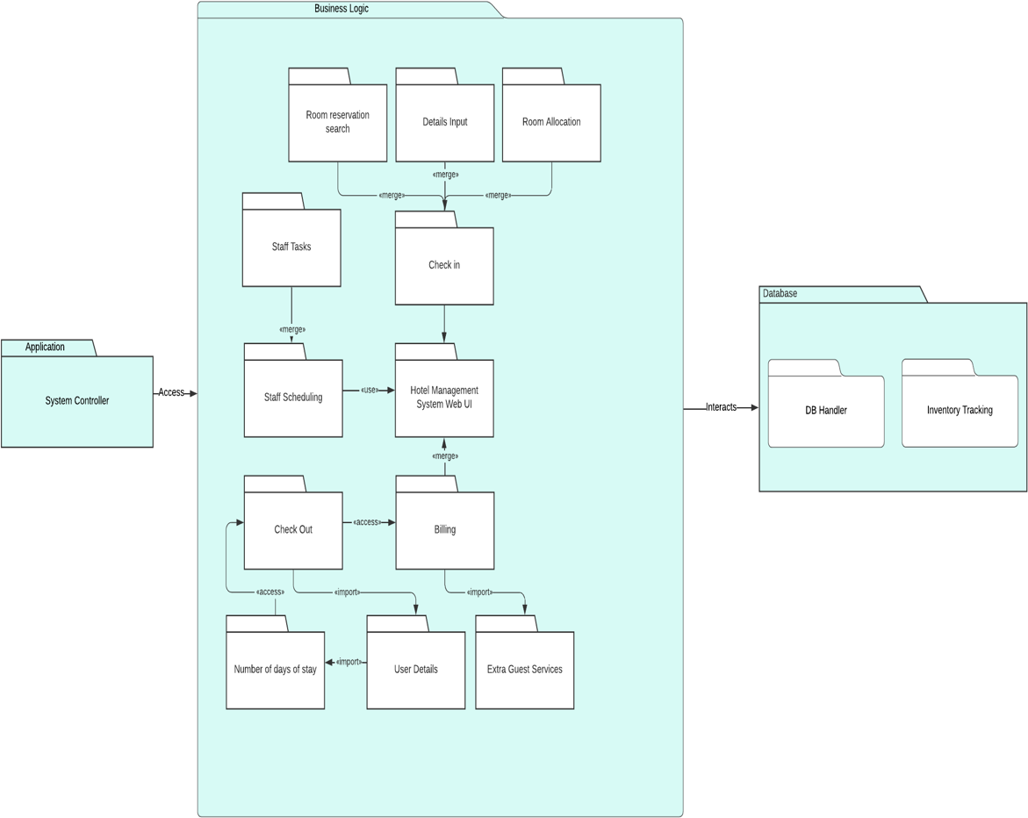

This diagram provides an overview of the software architecture in terms of packages and their interactions in the hotel management system:

* Application: Includes the System Controller, which interacts with the Business Logic layer.
* Business Logic: Contains various modules like Room Reservation Search, Details Input, Room Allocation, Check-In, Staff Tasks (including Staff Scheduling), Check Out, and Billing.
* Database: Managed by a Database Handler and includes Inventory Tracking, interacting with the Business Logic to manage data effectively.

This diagram focuses on the modular organization of the system, showing how different functional areas are grouped and how they interact.

## Deployment Diagram

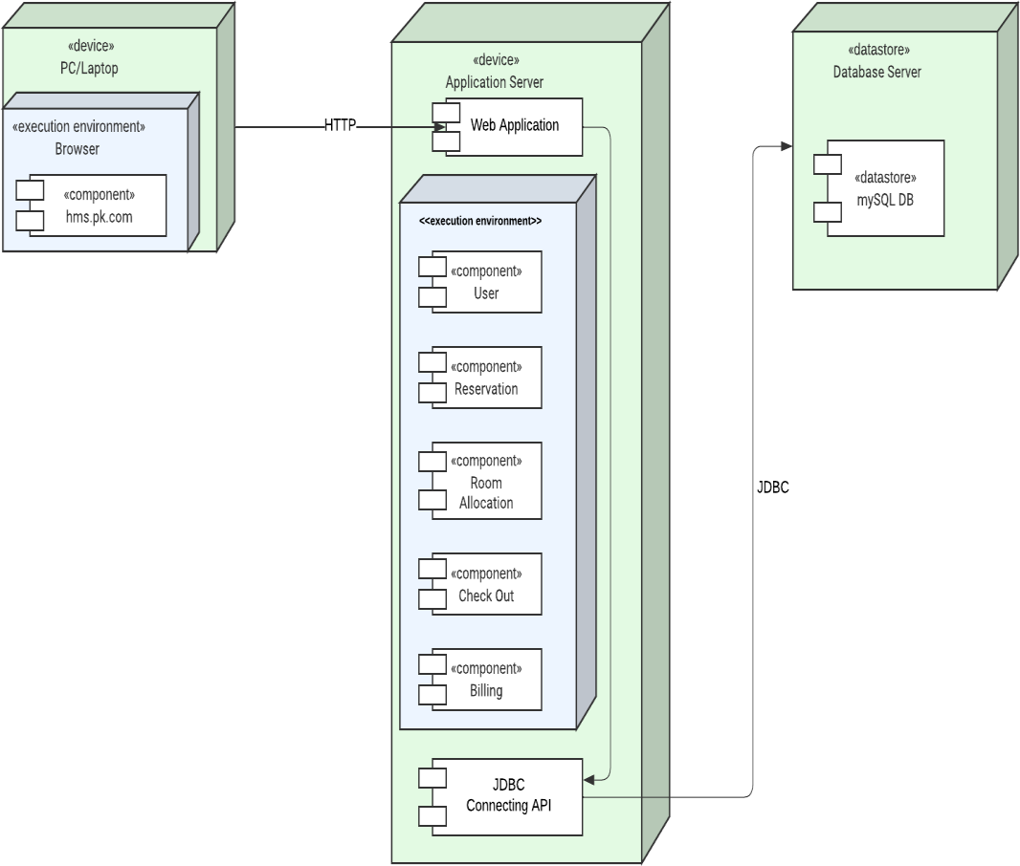

This diagram represents the physical deployment of a hotel management system across different hardware components and their interactions:

* PC/Laptop: Represents the client device where the user accesses the system through a web browser, specifically accessing the URL "hms.pk.com".
* Web Application Server: Hosts the application logic, where different components such as User, Reservation, Room Allocation, Check Out, and Billing are executed.
* Database Server: Contains the "MySQL DB" and interacts with the Web Application Server via JDBC (Java Database Connectivity) for data storage and retrieval.

This setup illustrates a typical three-tier architecture commonly used in web applications, separating client, server, and database layers for better management and scalability.

## Component Diagram

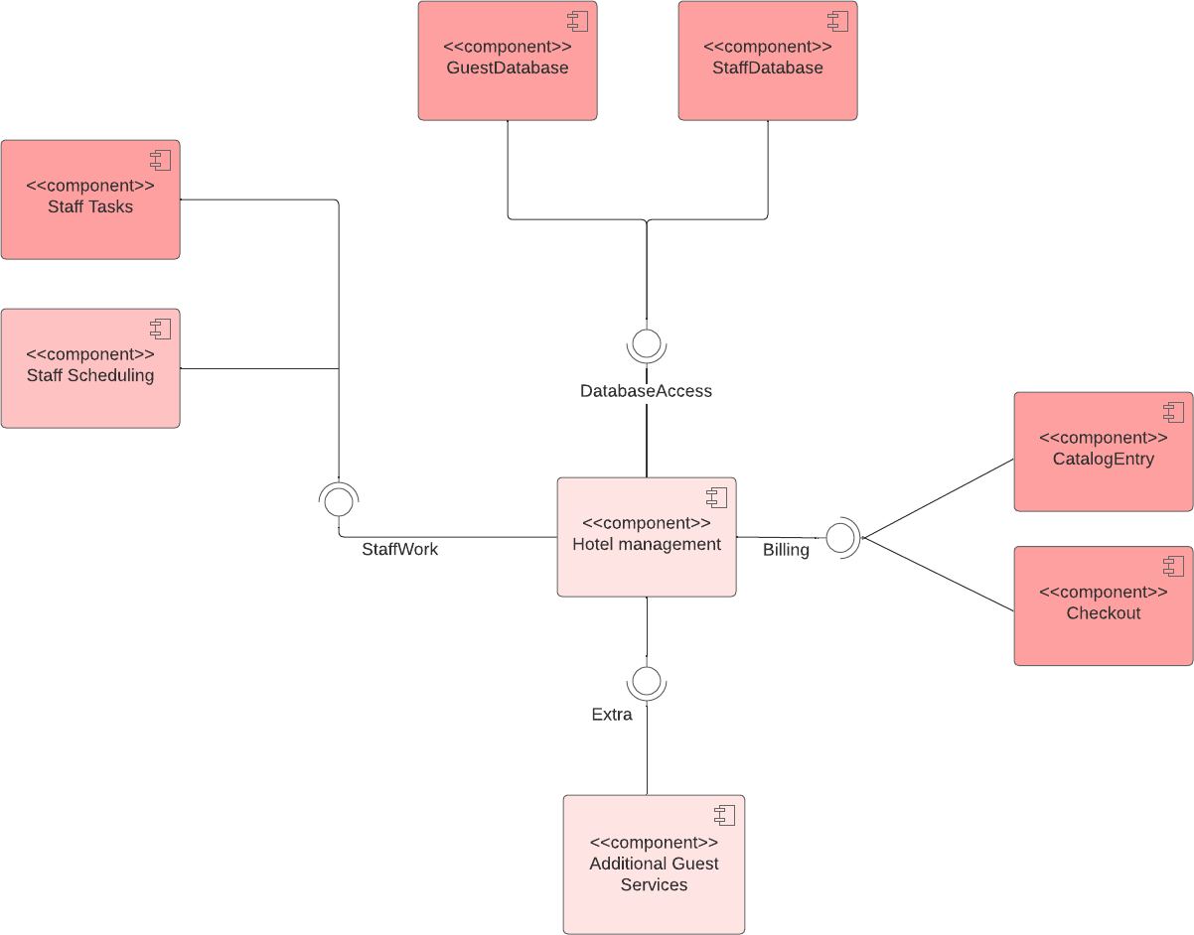

The diagram visualizes the organization and relationships between different components within a hotel management system. Here’s a breakdown of each component and their connections:

**Components**

Guest Database: Manages data related to guests.

Staff Database: Manages data related to hotel staff.

Staff Tasks: Represents the functionality to manage various staff-related tasks. Staff Scheduling: Handles the scheduling of hotel staff.

Hotel Management: The central component that oversees various functionalities within the hotel management system.

Catalog Entry: Likely manages room listings or services that the hotel offers. Checkout: Manages the checkout process for guests.

Billing: Handles the billing and payment processes.

Additional Guest Services: Manages additional services provided to guests beyond the basic room booking.

**Relationships and Flows**

Database Access: This connection likely represents the functionality for accessing and manipulating data in the Guest Database and Staff Database, suggesting these databases provide essential data for various components.

Staff Work: Indicates an operational link where the output of Staff Tasks and Staff Scheduling feeds into the broader Hotel Management system.

Extra: This could represent additional or optional services managed by the Hotel Management system but specifically interacting with the Additional Guest Services component.

**Interpretation**

The central component is the Hotel Management system which interfaces with nearly all other components, centralizing operations like billing and checkout processes.

There are specific components for handling databases, indicating a separation of concerns and clarity in data management.

The flow from components like Staff Tasks and Additional Guest Services towards central operations such as Billing and Checkout suggests these components provide necessary inputs or trigger further actions within these operations.

Overall, this diagram helps in understanding the modular architecture of the system, showing how each component contributes to the operation of the hotel management system and how data flows between these components to facilitate overall functionality.

## Activity Diagram

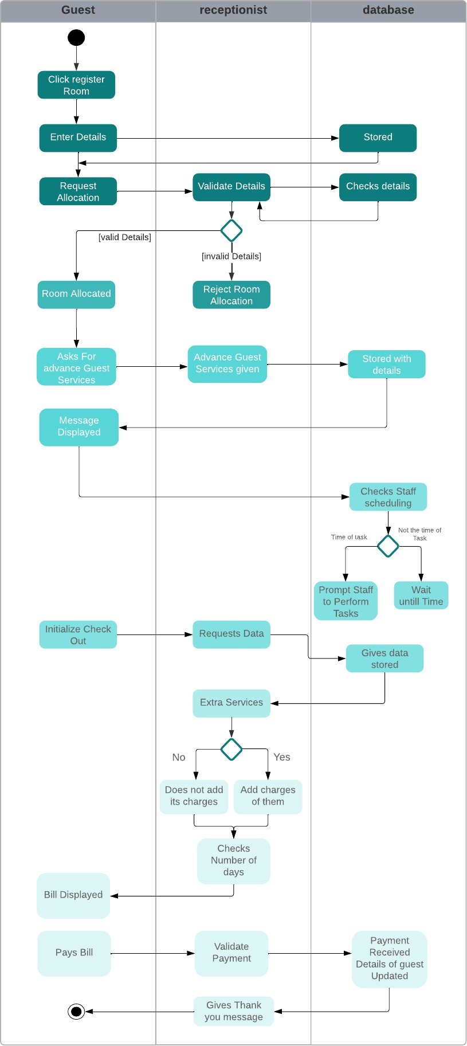

This diagram details the process flow for a guest interacting with the hotel management system, segmented by roles:

* Guest: Initiates the process by registering for a room and entering details, which leads to room allocation if details are valid.
* Receptionist: Validates guest details and manages room allocations. They also handle advanced guest services, check staff scheduling, and initiate billing processes.
* Database: Stores and retrieves information as required by the receptionist or system prompts, ensuring data consistency and availability.

This activity diagram uses swim lanes to delineate responsibilities and actions across different roles, showing a detailed process flow from guest registration to payment of the bill.

# Business Case and Target Audience

#### Business Case:

The Hotel Management System (HMS) addresses the increasing complexity of managing hotel operations by providing an integrated and efficient solution. The hospitality industry demands seamless coordination across various departments, including reservations, guest services, billing, and staff management. The HMSstreamlines these processes, enhancing

overall operational efficiency and guest satisfaction. With features such as reservation management, personalized guest services, streamlined billing, staff coordination tools, and insightful reporting, the HMS caters to the diverse needs of hotels, offering a centralized platform for comprehensive management. The business case rests on the value proposition of increased productivity, improved guest experiences, and data-driven decision-making, ultimately contributing to the hotel's competitiveness and profitability.

#### Target Audience:

Hotel Owners and Managers:

The primary audience for the HMS includes hotel owners and managers seeking to enhance their operational efficiency, streamline processes, and improve overall guest satisfaction. The system provides acentralized platform for decision-makers to monitor and manage various aspects of their hotel seamlessly.

**Front Desk Staff and Operational Teams:**

Front desk staff and operational teams within hotels are direct users of the HMS. The system assists them inhandling reservations, providing personalized services to guests, managing billing processes, and coordinating staff tasks, ultimately simplifying their daily responsibilities.

**Hospitality Industry Professionals:**

Professionals within the broader hospitality industry, including consultants, analysts, and industry experts, can benefit from the HMS's insights and features for research, analysis, and understanding emerging trendsin hotel management.

**IT Personnel and System Administrators:**

IT personnel responsible for system integration and administrators overseeing the technical aspects of theHMS are crucial stakeholders. They ensure the seamless integration of the system with existing infrastructure and maintain its functionality and security.

**Guests and Customers:**

While not direct users, the HMS indirectly benefits guests and customers by improving service quality, providing personalized experiences, and ensuring smooth and efficient hotel operations, leading to enhanced guest satisfaction.

In summary, the HMS targets a diverse audience within the hospitality industry, offering a comprehensivesolution to meet the complex management needs of hotels and contribute to their success in a competitivemarket.

# Dependencies and Constraints

**Dependency:**

#### Integration with Payment Gateways

The HMS relies on integration with payment gateways to facilitate secure and seamless financial transactions for reservations and services. Financial transactions and reservations may be disrupted, leading to inconvenience for guests and financial loss for the hotel. Establish robust partnerships with reputable payment gateway providers, ensure secure API integration, and regularly update integration protocols.

#### Internet Connectivity

The HMS heavily depends on a stable and high-speed internet connection for real-time updates, online bookings, and communication between various hotel departments. Without internet connectivity, the systemmay experience delays in processing bookings, updating room availability, and providing timely information to guests. Invest in reliable internet service providers, implement backup connectivity options, and optimize the system to function efficiently with low bandwidth.

#### Staff Training

The effective functioning of the HMS depends on staff members being well-trained in using the system for tasks such as reservations, check-ins, and guest support. Staff may

struggle to operate the system efficiently,leading to delays, errors, and a decline in guest satisfaction. Conduct regular training sessions for staff, provide user-friendly documentation, and offer ongoing support to address any challenges encountered during system usage.

**Constraints:**

#### Hardware Compatibility

The HMS may face constraints related to compatibility with existing hardware infrastructure in the hotel, such as servers, computers, and networking equipment. System malfunctions, slow performance, and potential downtime if the hardware is not compatible with the software requirements. Conduct thorough hardware assessments before system implementation, invest in necessary upgrades, and ensure that the HMS is designed to be compatible with a variety of hardware configurations.

#### Regulatory Compliance

The HMS must comply with local and international regulations related to data privacy, security, and hospitality industry standards. Legal penalties, loss of reputation, and potential suspension of hotel operations due to non-compliance with regulatory standards.

Regularly update the system to align with changing regulations, conduct audits for compliance, and implement robust security measures to safeguardguest information.

#### Limited Budget for Technology Upgrades

The hotel may have budget constraints that limit the frequency of technology upgrades and system enhancements. Outdated technology may lead to system inefficiencies, security vulnerabilities, and an inability to adopt new features that enhance guest experiences.

Prioritize essential upgrades, explore cost-effective solutions, and advocate for technology investments that demonstrate clear returns on investment

# Implementation screenshots

