23p-0699
Asad Ali
BCS-1C

COURIER SERVICE SYSTEM

#include <stdio.h>

// Function declarations
void details();
void package();
void address();
void payment();
void schedule();

// File pointers
FILE* senderfile;
FILE* packagefile;
FILE* receiverfile;

int main()
{
senderfile = fopen("sender.txt", "w");
packagefile = fopen("package.txt", "w");
receiverfile = fopen("receiver.txt", "w");

printf("Welcome to Courier Service System\n");

int num;
do {
printf("\n1. Sender Details and Information\n");
printf("2. Package Details\n");
printf("3. Order Placement\n");
printf("4. Payment Options\n");
printf("5. Schedule and Time\n");
printf("6. Exit\n");

printf("Enter your choice: ");
scanf("%d", &num);

switch (num) {
case 1:
details();
break;

case 2:
package();
break;

case 3:
address();
break;

case 4:
payment();
break;

case 5:
schedule();
break;
}
} while (num != 6);

fclose(senderfile);
fclose(packagefile);
fclose(receiverfile);

return 0;
}

void details()
{
char name[10], address[10];
int contact[11], id[4];

printf("-------------------------------------------------\n");
printf("Please enter your information\n");

printf("\nSender Details\n");
printf("--------------------------------------------\n");
printf("Enter your name: ");
scanf("%s", name);
printf("Enter your address: ");
scanf("%s", address);
printf("Enter your contact number (11 digits): ");
for (int i = 0; i < 11; i++) {
scanf("%1d", &contact[i]);
}
printf("Enter your ID (4 digits): ");
for (int i = 0; i < 4; i++) {
scanf("%1d", &id[i]);
}

fprintf(senderfile, "Name: %s\n", name);
fprintf(senderfile, "Address: %s\n", address);
for (int i = 0; i < 11; i++) {
fprintf(senderfile, "%d", contact[i]);
}
for (int i = 0; i < 4; i++) {
fprintf(senderfile, " %d", id[i]);
}

printf("\nSender details added successfully\n");
}

void package()
{
int i = 1;
char n = 'Y';
float mass = 0, size_parcel = 0;
float* ptr;
ptr = &size_parcel;

while (n == 'Y') {
float weight, height, width, length;
printf("Enter the weight of package %d in kg: ", i);
scanf("%f", &weight);
printf("Enter the height of package %d in cm: ", i);
scanf("%f", &height);
printf("Enter the length and width of package %d (in cm): ", i);
scanf("%f %f", &length, &width);

*ptr = *ptr + (height + width + length);
size_parcel = size_parcel + (height + width + length);

mass = mass + weight;
i++;

printf("Your package added successfully\n");
printf("Do you want to add another package (Y/N): ");
scanf(" %c", &n);
}

fprintf(packagefile, "Total weight: %.2f\n", mass);
fprintf(packagefile, "Total size of the packages: %.2f\n", *ptr);

if (mass <= 1 || size_parcel <= 50) {
float price1 = 20.0;
printf("Total bill for your packages: %.2f\n", price1);
fprintf(packagefile, "Total bill for your packages: %.2f\n", price1);
}
else if ((mass > 1.0 && mass <= 5.0) || (size_parcel >= 50 && size_parcel <= 100)) {
float price2 = 40.0;
printf("Total bill for your packages: %.2f\n", price2);
fprintf(packagefile, "Total bill for your packages: %.2f\n", price2);
}
else {
float price3 = 60.0;
printf("Total bill for your packages: %.2f\n", price3);
fprintf(packagefile, "Total bill for your packages: %.2f\n", price3);
}
}

void address()
{
char receiver_name[10], receiver_address[10];
int receiver_contact[11];

printf("\nReceiver Details\n");
printf("--------------------------------------------\n");
printf("Enter receiver's name: ");
scanf("%s", receiver_name);
printf("Enter receiver's address: ");
scanf("%s", receiver_address);
printf("Enter receiver's contact number (11 digits): ");
for (int i = 0; i < 11; i++) {
scanf("%1d", &receiver_contact[i]);
}

fprintf(receiverfile, "Receiver's name: %s\n", receiver_name);
fprintf(receiverfile, "Receiver's address: %s\n", receiver_address);
for (int i = 0; i < 11; i++) {
fprintf(receiverfile, "%d", receiver_contact[i]);
}

printf("\nReceiver details added successfully\n");
}

void payment()
{
int payment_method;
printf("\nPayment Options\n");
printf("--------------------------------------------\n");
printf("Choose a payment method:\n");
printf("1. Cash on Delivery\n");
printf("2. Online Payment\n");
printf("3. Credit Card\n");
printf("Enter your choice (1-3): ");
scanf("%d", &payment_method);

printf("\nPayment method selected: ");
switch (payment_method) {
case 1:
printf("Cash on Delivery\n");
fprintf(receiverfile, "Payment method: Cash on Delivery\n");
break;
case 2:
printf("Online Payment\n");
fprintf(receiverfile, "Payment method: Online Payment\n");
break;
case 3:
printf("Credit Card\n");
fprintf(receiverfile, "Payment method: Credit Card\n");
break;
default:
printf("Invalid choice\n");
break;
}
}

void schedule()
{
printf("Our office opens from:\n");

printf("-------------------------------------------------------------------\n");
printf("Monday to Saturday -- 9.00 AM to 5.00PM\nFriday--9.00AM to 1.00PM\n");

printf("We send your packages in time and in date\n");
}

OUTPUT:

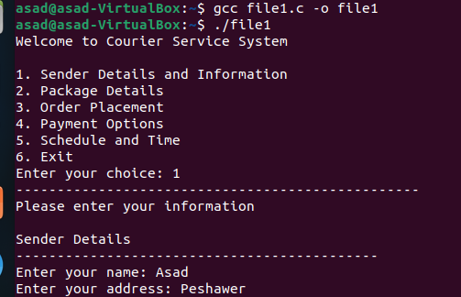

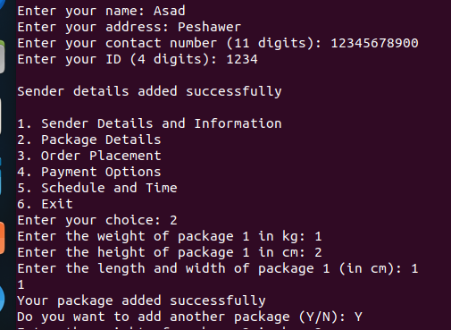
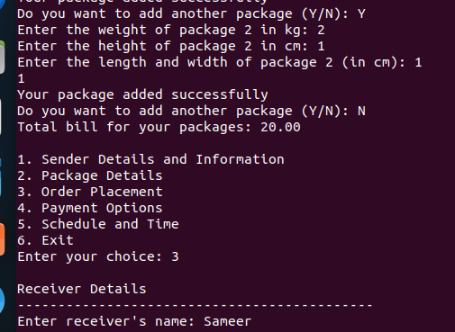
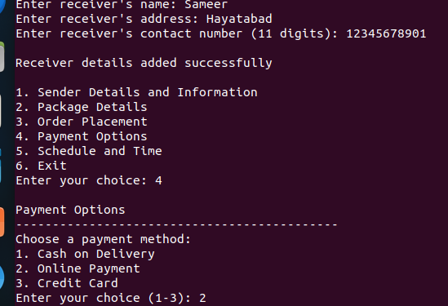

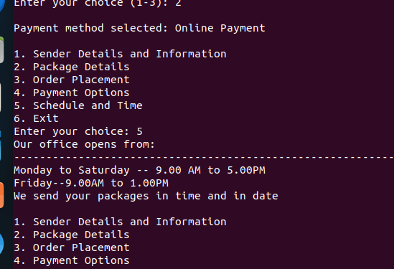

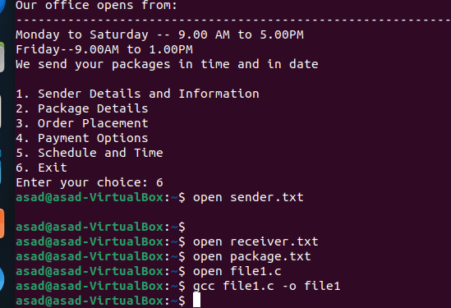
DATA IN FILES

