7-laboratoriya ishi
Mavzu: CSS orqali matn va bloklarni bezash
Ishdan maqsad:
Ushbu laboratoriya ishining maqsadi — CSS (Cascading Style Sheets) yordamida matn va blok elementlarini bezash usullarini o‘rganish, shrift, rang, fon, chegaralar va soya xossalari bilan amaliy ishlash ko‘nikmalarini shakllantirishdan iborat.

Nazariy qism:

CSS (Cascading Style Sheets) — bu veb-sahifalardagi elementlarning tashqi ko‘rinishini boshqarish uchun mo‘ljallangan uslub tili.
U HTML elementlarga dizayn, rang, shrift, fon, chegaralar, joylashuv va animatsiyalar qo‘shish imkonini beradi.
1. Matnni bezash (Text Decoration va Formatting) - matnni go‘zal, o‘qishli va tartibli qilish uchun quyidagi CSS xossalar ishlatiladi:
Xossa nomi | Vazifasi | Misol:
color | Matn rangini o‘zgartiradi | color: blue;
font-family | Shrift turini belgilaydi | font-family: Arial, sans-serif;
font-size | Shrift o‘lchamini belgilaydi | font-size: 18px;
font-weight | Shrift qalinligini belgilaydi | font-weight: bold;
font-style | Matnni qiyalash (italic) yoki normal qiladi | font-style: italic;
text-align | Matn joylashuvini belgilaydi | text-align: center;
text-decoration | Matn ostiga chiziq, ustiga chiziq yoki o‘chirish chizig‘i qo‘yadi | text-decoration: underline;
text-transform | Matnni katta-kichik harflarga o‘zgartiradi | text-transform: uppercase;
letter-spacing | Harflar orasidagi masofani o‘zgartiradi | letter-spacing: 2px;
line-height | Satrlar orasidagi masofani belgilaydi | line-height: 1.5;
text-shadow | Matnga soya qo‘shadi | text-shadow: 2px 2px 4px gray;

2. Bloklarni bezash (Block Decoration va Box Model) - veb-sahifadagi blok elementlar (div, p, section va boshqalar) ni bezash uchun quyidagilardan foydalanamiz:
Xossa nomi | Vazifasi | Misol
background-color | Fon rangini o‘zgartiradi | background-color: lightblue;
background-image | Fon sifatida rasm qo‘yadi | background-image: url('rasm.jpg');
border | Chegarani belgilaydi (eni, turi, rangi) | border: 2px solid black;
border-radius | Burchaklarni yumaloqlaydi | border-radius: 10px;
margin | Tashqi masofani (bo‘shliqni) belgilaydi | margin: 20px;
padding | Ichki masofani belgilaydi | padding: 15px;
box-shadow | Blokga soya qo‘shadi | box-shadow: 4px 4px 8px gray;
width, height | O‘lchamlarni belgilaydi | width: 300px; height: 150px;
display | Elementni joylashish turini o‘zgartiradi | display: inline-block;
text-align | Blok ichidagi matn joylashuvini belgilaydi | text-align: center;

Qo‘shimcha bezaklar
1) hover effekti — foydalanuvchi sichqonchani olib borganda o‘zgarish.
Misol:
button:hover {
background-color: orange;
color: white;
}
2) transition — o‘zgarishlarni silliq qiladi.
Misol:
div {
transition: all 0.5s;
}
div:hover {
transform: scale(1.1);
}
3)gradient — ranglarning o‘tish effektini beradi.
Misol:
background: linear-gradient(to right, red, yellow);
background: linear-gradient(to right, red, yellow);
CSS orqali matn va blok elementlarini bezashda:
Matn xossalari — shrift, rang, hizalanish, soyalar;
Blok xossalari — fon, chegara, soya, joylashish, masofa;
Animatsiya va hover effektlar — dizaynni jonlantirish uchun ishlatiladi.

Amaliy qism:
Quyidagi kod misolida CSS yordamida web sahifamni bezash amalga oshirilgan:
HTML kodi:
:root{
--bg:#ffffff;
--text:#1b1f24;
--muted:#667085;
--primary:#0b7dda;
--primary-dark:#085fa6;
--alt:#f7f9fc;
--card:#ffffff;
--border:#e6e9ef;
}
*{box-sizing:border-box}
html,body{margin:0;padding:0;background:var(--bg);color:var(--text);font-family:system-ui,-apple-system,Segoe UI,Roboto,Arial,sans-serif}
.container{max-width:1080px;margin:0 auto;padding:0 16px}
.site-header{
position:sticky;top:0;background:var(--bg);border-bottom:1px solid var(--border);z-index:1000
}
.header-inner{display:flex;align-items:center;justify-content:space-between;padding:12px 0}
.brand{display:flex;align-items:center;gap:10px;text-decoration:none;color:var(--text)}
.logo{width:40px;height:40px;object-fit:contain}
.brand-text{font-weight:700}
.nav a{margin-left:16px;text-decoration:none;color:var(--text)}
.nav a:hover{color:var(--primary)}
.hero{background:var(--alt);padding:40px 0}
.hero-inner{display:grid;grid-template-columns:1.2fr 1fr;gap:24px;align-items:center}
.hero-text h1{font-size:32px;margin:0 0 12px}
.hero-text p{color:var(--muted);margin:0 0 20px}
.hero-media img{width:100%;border-radius:12px;border:1px solid var(--border)}

.btn{display:inline-block;padding:10px 16px;border-radius:8px;border:1px solid var(--border);text-decoration:none}
.btn-primary{background:var(--primary);color:#fff;border-color:var(--primary)}
.btn-primary:hover{background:var(--primary-dark)}
.btn-outline{background:#fff;color:var(--text)}
.btn-outline:hover{border-color:var(--primary);color:var(--primary)}
.section{padding:40px 0}
.section h2{margin:0 0 16px}
.section p{color:var(--muted)}
.section-alt{background:var(--alt)}
.stats{display:grid;grid-template-columns:repeat(4,1fr);gap:16px;margin-top:16px}
.card{background:var(--card);border:1px solid var(--border);border-radius:12px;padding:16px;text-align:center}
.stat{font-size:24px;font-weight:700}
.label{color:var(--muted)}
.grid{display:grid;grid-template-columns:repeat(4,1fr);gap:16px}
.tile{background:#fff;border:1px solid var(--border);border-radius:12px;padding:16px}
.tile h3{margin:0 0 8px}
.admissions{display:grid;grid-template-columns:repeat(3,1fr);gap:16px}
.ad-card{background:#fff;border:1px solid var(--border);border-radius:12px;padding:16px}
.news-list{display:grid;grid-template-columns:repeat(3,1fr);gap:16px}
.news-item{background:#fff;border:1px solid var(--border);border-radius:12px;padding:16px}
.news-item h3{margin:0 0 8px}
.news-item time{color:var(--muted);font-size:14px}
.contact-grid{display:grid;grid-template-columns:1fr 1fr;gap:16px}
.contact-form label{display:block;margin-bottom:12px}
.contact-form input,.contact-form textarea{
width:100%;padding:10px;border:1px solid var(--border);border-radius:8px
}
.form-status{margin-top:10px;color:var(--muted)}
.site-footer{border-top:1px solid var(--border);padding:20px 0;background:#fff}
.footer-inner{display:flex;align-items:center;justify-content:space-between}
.footer-links a{margin-left:12px;color:var(--muted);text-decoration:none}
.footer-links a:hover{color:var(--primary)}
@media (max-width:980px){
.hero-inner{grid-template-columns:1fr}
.stats{grid-template-columns:repeat(2,1fr)}
.grid{grid-template-columns:repeat(2,1fr)}
.admissions{grid-template-columns:1fr 1fr}
.news-list{grid-template-columns:repeat(2,1fr)}
.contact-grid{grid-template-columns:1fr}
}
@media (max-width:600px){
.stats,.grid,.admissions,.news-list{grid-template-columns:1fr}
}
.styled-table {
width: 100%;
border-collapse: collapse;
margin: 20px 0;
font-size: 16px;
text-align: left;
}
.styled-table thead tr {
background-color: var(--primary);
color: #fff;
}
.styled-table th,
.styled-table td {
padding: 12px 15px;
border: 1px solid var(--border);
}
.styled-table tbody tr:nth-child(even) {
background-color: var(--alt);
}

Ko’rinishi:


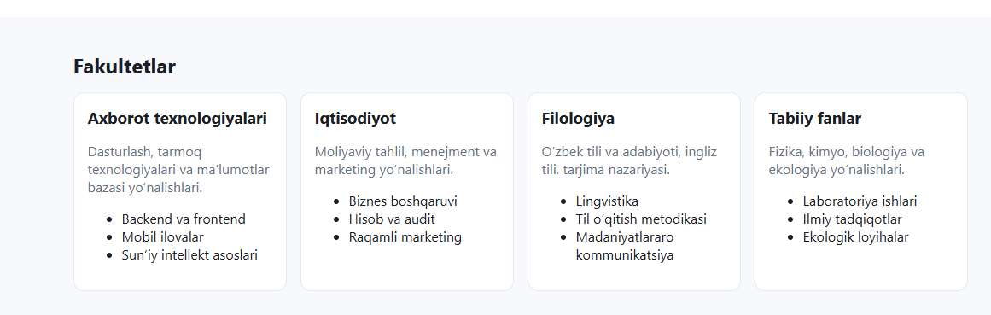
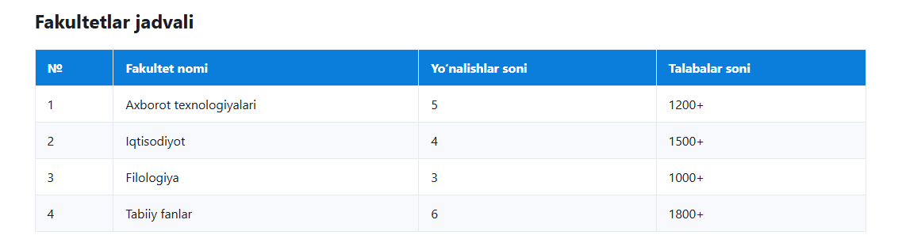
Html kodi:
<a href="#admissions" class="btn btn-primary">Qabul bo‘limi</a>
<a href="#faculties" class="btn btn-outline">Fakultetlar</a>
Ko’rinishi: sichqoncha tugma ustiga borganda


Xulosa
Ushbu laboratoriya ishini bajarish davomida men CSS orqali matn va blok elementlarini bezash usullarini amalda qo‘llashni o‘rgandim. Matn rangini, shriftini, fon rangini, chegara va soyani boshqarish orqali veb-sahifani chiroyli va zamonaviy qilish mumkinligini bilib oldim. Shuningdek, hover va transition xossalari yordamida elementlarga interaktivlik berish usullarini ham o‘rgandim. Natijada, CSS yordamida veb-sahifaning tashqi ko‘rinishini foydalanuvchiga qulay va jozibador holga keltirish mumkinligini tushundim. ARM saytini yaratishda men CSS texnologiyasidan foydalanib, matn va bloklarni bezash usullarini qo‘lladim. Natijada saytning ko‘rinishi yanada jozibador, tartibli va o‘qilishi qulay bo‘ldi. CSS yordamida har bir bo‘limga alohida uslub berildi, fonlar, soyalar, matn effektlari va hover holatlari ishlatildi. Bu ish orqali veb-dizaynning estetik tomonini chuqurroq o‘rgandim va amaliy ko‘nikmalarimni mustahkamlab oldim.

