

**Group Members**

Annas Bin Nadeem(Cs141048)

Marium Jawed(Cs141034)

Mohammad Asad (Cs141066)

Muneeba Tahir(Cs141043)

**Submitted to:**

Ubaid Aftab Chawla

**Business Statement:**

**i) Organization Background:**

Best8 is a start-up organization who provide software development services. Young motivated undergrads founded this company to pursue their dreams of entrepreneurship.

**ii) Opportunity Or problem that the project will be addressing:**

There is intense need of an android application through which people can order affordable items like clothing, footwear’s, hang bangs, jewels and some other beauty products. Our objective is to increase the market sale of low famous brands as well as facilitating citizen of Karachi with such platforms so that customers get low priced and quality products at door their step.

**iii) Organization Structure & Explanation:**

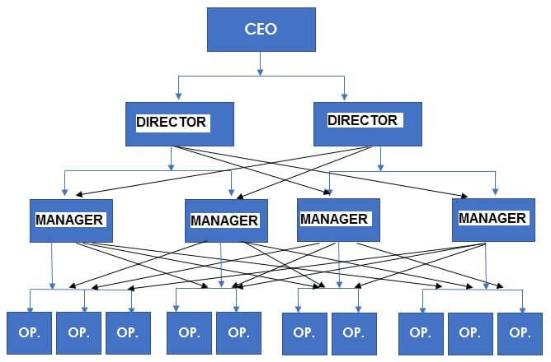

We are using “Functional structure”.Employees have to report all directors.

We know how important it is to have the right business structure for our software development company as getting it right from the start will eliminate most hitches that will crop up relating to our structure during the course of running the business. For this purpose, we intend to hire only competent and professionals in the available positions in our company.

Also due to the fact that we intend to run a wide range of services, we intend to ensure that we employ those that are capable of filling in these different positions. All our employees are those who understand the industry well and who are attuned with our vision and are committed to ensuring that we attain these goals and objectives.

We are also prepared to ensure that our workers are well paid and have welfare packages that are the best in similar categories across startups such as ours in the industry. We will also ensure that the working environment is not only conducive but is one that will enhance their skills and make them more productive.

**iv) Project Team Structure**

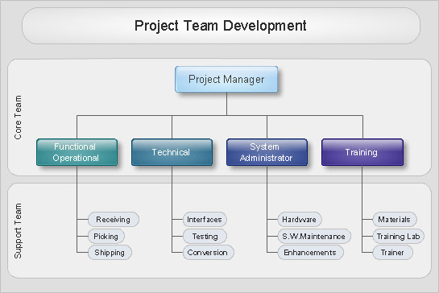

**Project Goal/Purpose/Aim/ Objectives**

**Aim of the project:**

As online shopping became a new trend, customers are more towards finding convenience. So, our aim is to facilitate people with a handy mobile app so that they can order items from a single platform embedded with different shops rather than visiting each shop's website explicitly to order valuables. As another aspect that motivate is that, we wanted to assist some unestablished shopkeepers by providing them this app who had no proper source of selling their items online (no website of their own) to generate more customers for them and get them acknowledged in the market.

**Goals:**

* Deliver fully Functional Database.
* Finish the project within the scheduled timetable.
* Finish the project within the scheduled budget.
* Finish the project with the same level of quantity.
* Finish the project within the specified guidelines.

**Benefits that the project will give to organization :**

* Make the organization’s best problem-solving experiences reusable.
* Stimulate innovation and growth.
* Benefiting the organization financially.

**Project Deliverables**

**Deliverables**

* Scope statement
* Proposal
* SRS
* SDS
* Prototype
* Weekly project meeting
* Functional application for vendor, customer
* Web interface for admin
* User guide
* Functional database ( vendor, customer, shop, admin, rider, stock, order, product)
* Unit testing
* Operation testing
* Deployment testing
* Integration testing
* System testing

**Link objectives to deliverable** (heading not completed)

**Success Criteria**

* Scope Statement should be accepted by all stakeholders.
* Proposal should be accepted by client.
* SRS / SDS should be completed on time and accepted by client.
* Prototype should be attractive and accepted by user.
* All the requirement were approved by the Client.
* Weekly project meeting should be done as schedule.
* User guide should be descriptive and usable.
* Client approve the design of the application.
* Database should be fully functional.
* Web Interface for admin should deploy on time.
* Testing team debug system and identify all the error before deployment.
* Client was satisfied after the deployment of system.

**Project Scope**

**Boundaries of the project**

* This project will affect Karachi areas only. Initially all other locations are out of scope.
* People should have to first register themselves. Only registered user can use app.

**Things included & excluded**

**Included:**

* User must be registered.
* An admin shall be able to manage all other users such as customers, riders and sellers.
* User shall be able to order from 2 different listed outlets at the same moment.
* User shall be able pay online through credit card or cash on delivery.
* User shall be able to view product information.
* User can give feedback.
* User shall be able to search product.
* User shall be able to prepare a cart.

**Excluded:**

* Web application
* IOS

**Various Parts & Phases of the project:**

**Phase I - Alpha Prototype**

* Scope statement
* Proposal
* SRS
* SDS

**Phase II - Beta Prototype**

* Web interface for admin
* Functional database ( vendor, customer, shop, admin, rider, stock, order, product)

**Phase III - Release Candidate**

* Prototype

**Phase IV - Final Product**

* Functional Product.
* Testing
* User guide

**Success Criteria**

* Project is completed on time.
* Project is completed on budget.
* Project meets the appropriate quality targets.
* Project delivered all items within the agreed scope.
* Project meets the commercial objectives for profit, revenue etc.
* Project meets the functional requirements.
* Project meets the non functional requirements e.g stability, performance, availability, scalability.
* Project handover to operational team was documented and completed appropriately.
* Training was delivered as planned to the appropriate team.
* Customer satisfaction target is achieved.
* Customer/ Staff awareness about the project was raised to the appropriate level.
* Project uses the approved technology.
* Project meets all internal appropriate information security policies.
* Team satisfaction.
* End-user satisfaction.
* Performance in term of time,cost and quality.
* Project achieves its purpose.

**Software Process Model used to build the project**

Scrum methodology will be used to build the project as allows us to make changes, add new features and keep evolving with the changing trends.

**Assumptions, Constraints and Dependencies**

**Assumptions made:**

**⦁** Assuming user have smart phone.

⦁ Assuming that user have some knowledge about smart phone.

⦁ Customer will register account by an email address.

⦁ Users Will Easily Give Way to Notifications on the First Use.

⦁ Users Read the Tutorial or Help Messages.

⦁ Users Always Need to Sign up First in case of placing order or as a rider.

Payment through credit card / cash on delivery.

User can cancel order within 15 mins.

**Time, resources, finance, business and other technical constraints**

**Business constraints:**

1. They usually focus on the available time, money, resources, assets, liquid assets, quality, knowledge, regulatory compliance, interest of stakeholders, organizational culture, risk tolerance of a project.

**Time constraints:**

1. Workers will be completing the app within schedule.
2. The deliverables such as project charter should be submitted on given deadline.

**Technical constraints:**

1. If a shop's facebook page gets deactivated our app will cater those changes accordingly.
2. If server get down application will stop.
3. Orders cancel on unpredictable weather conditions/ late delivery.
4. Order cancel on unforeseen circumstances e.g. road block etc. / late delivery.

5) Developers are skilled full in MySQL ,Java and android studio.

6) System shall be developed using Java,MySQL programming for development

**Resources constraints:**

1. Not more than 5 developers should work in parallel as budget is calculated accordingly.
2. Android studio should be updated in all computers.
3. Team members should work 5 hours a day.

**External Factors the project is dependent on**

**StakeHolders**

* **Identification & Roles of various stakeholders**

1. Vendor
2. Admin
3. Customer
4. Project manager
5. Risk Manager
6. Marketing Manager
7. Test Manager
8. Coder
9. Designer

* **Responsibilities of Stakeholders for various aspects of project**

Vendor will be responsible for:

Add/delete items on facebook

View orders from app

Cancel orders from app

View Reviews

Project Manager will be responsible for:

A *project manager* is a professional in the field of *project* management. *Project managers*  have the responsibility of the planning, procurement and execution of a *project*, in any undertaking that has a defined scope, defined start and a defined finish; regardless of industry.

Risk Manager will be responsible for:

Their role is to provide a methodology to identify and analyze the financial impact of loss to the organization, employees, the public, and the environment.Prepare risk management and insurance budgets and allocate claim costs and premiums to departments and divisions.

Marketing Manager will be responsible for:

A marketing manager is someone who manages the marketing of a business or product. So, the market manager role is that they are responsible for several services or products, or be in charge of a single product. A marketing manager needs to have an outgoing and spontaneous nature. They must follow different strategy.

Test Manager will be responsible for:

An important part of software quality is the process of testing and validating the software.Test Management role is

Organizing and controlling the Testing process.

Coder will be responsible for:

Is a person who role is to code and to create computer software

Designer will be responsible for:

The role of the designer is to make logo and to help coder to make application more attracted by designing UI.

Developer will be responsible for:

A key role in the design, installation, testing and maintenance of software systems

Admin will be responsible for:

Vendor / Customer management

Register shops

View orders Details/Info

Customer registration

View Rider Details/Info

Vendor Detail/Info

View Reviews & complaints

Generate Bil

Customer will be responsible for:

View items

Place order

Add to cart

Cancel orders

Payment by cash on delivery

Payment by credit card

Reviews about services

Reviews about product

Search product within specific brand

Search product

Conform Order

* **What deliverables are stakeholders responsible for and how?**

* **Signing Authorities**

1. Twaha Minai (Advisor)
2. Marium Jawed(Admin panel )
3. Olia Rao (Admin panel)
4. Annas Nadeem (Admin panel)
5. Muhammad Asad (Admin panel)

6) Muneeba Tahir(Admin panel)

**Expert**

* **Expert Chosen, His domain, Job Title,**

Twaha Ahmed Minai,M.Phil. (Bioinformatics), Professor in DHA Suffa University.

* **Why have you chose him as an expert**

Because of his incredible skills in Computer Science.

* **His Past experiences & success His role in the project**

Vast Experience in: Project Planning , Software Engineering , Curriculum Development, Data Analysis, Database Design, System Analysis

(Reference : https://www.linkedin.com/in/twaha-ahmed-minai-2bb785a/).

His role in the project is of an advisor and a mentor.

**Work Breakdown Structure**

1. **Project Management**
   1. Planning
   2. Scope
   3. Task
2. **Software**
   1. **Software Design**
      1. SRS
      2. SDS
      3. Prototyping
      4. Detailed Design
   2. **Software Build**
      1. Coding
      2. Debugging
   3. **Functional Database**
   4. **Testing**
      1. Unit Testing
      2. Integration Testing
      3. System Testing
      4. Operational Testing
      5. Deployment Testing
3. **Support & Service**
   1. Team Training
4. **Installation**
   1. End User Deployment
   2. User Manual

**Risk Management**

⦁ Orders cancellation on unpredictable weather conditions. It will be catered by delayed delivery of item to the customer.

⦁ Order cancel on unforeseen circumstances e.g. road block etc. It will also be catered by late delivery to the customer.

⦁ If a shop's Facebook page gets deactivated we will cater those changes manually.

⦁ If server gets down application will stop working till its fixed.

* Initially there are high chances of low response and it if it is continued for a long period it will result in decline . To cater the loss we will try to improve marketing strategy on social media and reach target market to increase our net sales.

As above all listed items are uncertain and have negative impact on our sales and reputation that is why they all are considered as risks.

**Time Phased Budget**

**Resource Sheet**

