

**Group Members**

Ali Uzair Bukhari(Cs141041)

Annas Bin Nadeem(Cs141048)

Marium Jawed(Cs141034)

Mohammad Asad (Cs141066)

Muneeba Tahir(Cs141043)

Sallar Hussain Bhutto(Cs141064)

Sheikh Saim Rasheed(Cs141062)

**Submitted to:**

Ubaid Aftab Chawla

**Table Of Content**

|  |  |  |
| --- | --- | --- |
| S No | Topic | Page No |
| 1 | Method & Quality Manual: | 01 |
| 2 | Management Responsibility | 01 |
| 3 | Quality System | 01 |
| 4 | VALIDATION PRODUCT REQUIREMENT & TEST CASE | 02 |
| 5 | Test Cases: | 05 |
| 6 | Black Box Testing | 05 |
| 7 | White Box Testing | 08 |
| 8 | User Manual | 11 |

**1) Method And Quality Manual**

**Management Responsibility**

2. Quality Achievement Steps

**1.  Identify Critical Success Factors (CSF)**

* Financial Performance
* Customer Satisfaction
* Process Improvement
* Market Share
* Employee Satisfaction
* Product Quality

**2.  Identify Key Customer Group**

* Employees
* Customers
* Suppliers
* Vendors
* Volunteers

3. Quality Policy of the company

Our Quality Policy is defined and strongly driven by the following management principles and behaviors:  
• Build a mutually profitable relationship with our customers, ensuring their long-term success, through the understanding of their needs and the needs of their customers as well  
• Achieve our commitments for quality, cost, and schedule  
• Enhance the systematic research and use of best preventive practices at all levels and ensure reliable risk management  
• Drive continual improvement and innovation based upon efficient business processes, well-defined measurements, best practices, and customer surveys  
• Develop staff competencies, creativity, empowerment and accountability  
through appropriate development programs and show strong management involvement and commitment

Insidetrends strives to be the best provider of Analytics of Facebook Data in the industry. Through the use of these guiding principles, everyone in Insidetrends is accountable for fully satisfying our customers by meeting or exceeding their needs and expectations with best-in- class solutions and services. Our goal is 100% customer satisfaction 100% of the time.

**VALIDATION PRODUCT REQUIREMENT & TEST CASE**

|  |  |  |
| --- | --- | --- |
| **No.** | **Product Requirement** | **Pass/Fail** |
|  | **General:** |  |
| RQ1 | Inside Trends shall have Add Page button. | Pass |
| RQ2 | Inside Trends shall have Analytics Dashboards. | Pass |
| RQ3 | Sentiment Analytics must be available for user pages. | Pass |
| RQ4 | Competitor Analytics must be available for each user | Pass |
| RQ5 | Report generation of all the analytics should be available. | Pass |
|  | **Add Page:** |  |
| RQ6 | When application is launched the home page appears which contains Add Page button. | Pass |
| RQ7 | User can add any facebook page. | Pass |
| RQ8 | User click on the added page which enables him to go to summary dashboard. | Pass |
| RQ9 | Each added page must contain the following dashboards listed below: |  |
| RQ9.1 | Summary Dashboard | Pass |
| RQ9.2 | Customer Dashboard | Pass |
| RQ9.3 | Posts Dashboard | Pass |
| RQ9.4 | Comparisons Dashboard | Pass |
| RQ9.5 | Reports Dashboard | Pass |
| RQ9.6 | Topic Search Dashboard | Pass |
|  | **Summary Dashboard:** |  |
| RQ10 | Summary Dashboard should contain the following: |  |
| RQ10.1 | Activity Summary | Pass |
| RQ10.2 | Engagement Summary Graph | Pass |
| RQ10.3 | Sentiment Trending Graph | Pass |
| RQ10.4 | Top User Table | Pass |
| RQ11 | **Activity Summary** should contain the following: |  |
| RQ11.1 | Statuses | Pass |
| RQ11.2 | Status Shares | Pass |
| RQ11.3 | Status Likes | Pass |
| RQ11.4 | Status Comments | Pass |
| RQ11.5 | Activity Users | Pass |
| RQ11.6 | Avg page likes | Pass |
| RQ11.7 | Average Talking About | Pass |
| RQ11.8 | Sentiment | Pass |
| RQ12 | User can add dates to see the summary of added dates. | Fail |
| RQ13 | **Top User Table** should contain the following: |  |
| RQ13.1 | Date | Pass |
| RQ13.2 | User Name | Pass |
| RQ13.3 | # of comments | Pass |
| RQ13.4 | Likes Recieved | Pass |
| RQ13.5 | Replies recieved | Pass |
| RQ13.6 | Positive Comments | Pass |
| RQ13.7 | Negative Comments | Pass |
| RQ14 | # of users shown should be equal to # of user entered. | Pass |
| RQ15 | User can see the details of the specific user by entering his name in the search bar. | Pass |
|  | **Customer Dashboard:** |  |
| RQ16 | Customer Dashboard should contain the following graph: |  |
| RQ16.1 | Unique Commenting Users | Pass |
| RQ16.2 | Top Users Creating Engagement | Pass |
| RQ16.3 | Top Users By Comments | Pass |
| RQ16.4 | Top Users By Positive Comments | Pass |
| RQ16.5 | pie chart of Sentiments Used in Comments | Pass |
| RQ17 | User can filter the dates . | Fail |
|  | **Post Dashboard:** |  |
| RQ18 | User can filter the dates . | Fail |
| RQ19 | Post Dashboard should contain the following: |  |
| RQ19.1 | All Posts | Pass |
| RQ19.2 | Post Trend | Pass |
| RQ20 | **Post Trend:** Post Trend should contain trending posts. | Fail |
| RQ21 | **All Posts:** All post should contain the following: |  |
| RQ21.1 | Description | Pass |
| RQ21.2 | Date | Pass |
| RQ21.3 | Time | Pass |
| RQ21.4 | Shares | Pass |
| RQ21.5 | Likes | Pass |
| RQ21.6 | Comments | Pass |
|  | **Comparision Dashboard:** |  |
| RQ22 | Comparision Dashboard should contain the following: |  |
| RQ22.1 | Comparision By Value | Pass |
| RQ22.2 | Comparision By Days | Pass |
| RQ23 | **Comparision By Value:** User can see the comparisions of different pages with respect to Frequency of the following: |  |
| RQ23.1 | Engagement | Pass |
| RQ23.2 | Fans | Pass |
| RQ23.3 | Talking About | Pass |
| RQ23.4 | Positive Comments | Pass |
| RQ24 | **Comparision By Days:** With respect to date user can see the following of different pages: |  |
| RQ24.1 | Engagement | Pass |
| RQ24.2 | Fans | Pass |
| RQ24.3 | Talking About | Pass |
| RQ24.4 | Positive Comments | Pass |
|  | **Reports Dashboard:** |  |
| RQ25 | Reports Dashboard should contain Summary Report. | Pass |
| RQ26 | **Summary Report:** It should contain: |  |
| RQ26.1 | Change Over Time | Pass |
| RQ26.2 | Engagement Graph | Pass |
| RQ26.3 | Page Fans Over Time | Pass |
| RQ26.4 | People Talking About Your Page Over Time | Pass |
| RQ26.5 | Sentiments Used Over Time | Pass |
| RQ27 | **Change Over Time:** should contain change in KPI's with respect to time period. | Pass |
|  | **Topic Search Dashboard:** |  |
| RQ28 | It should contain a search bar. | Pass |
| RQ29 | User can search topic. | Pass |
|  | Activities around the searched topics should be given to user in the form of graph dashboards. | Pass |
|  | **Database:** |  |
| RQ30 | Database should contain the following tables: |  |
| RQ30.1 | admin | Pass |
| RQ30.2 | Words | Pass |
| RQ30.3 | commentLikes | Pass |
| RQ30.4 | commentReplies | Pass |
| RQ30.5 | commentReplyLikes | Pass |
| RQ30.6 | commentTags | Pass |
| RQ30.7 | comments | Pass |
| RQ30.8 | contact | Pass |
| RQ30.9 | contract | Pass |
| RQ30.10 | Da­­­­ily_page_data | Pass |
| RQ30.11 | dashboards | Pass |
| RQ30.12 | invoice | Pass |
| RQ30.12 | migrations | Pass |
| RQ30.13 | page_categories | Pass |
| RQ30.14 | pages | Pass |
| RQ30.15 | pagesOfUser | Pass |
| RQ30.16 | permission_role | Pass |
| RQ30.17 | permissions | Pass |
| RQ30.18 | role_user | Pass |
| RQ30.19 | roles | Pass |
| RQ30.20 | statusLikes | Pass |
| RQ30.21 | statusTotals | Pass |
| RQ30.22 | statuses | Pass |
| RQ30.23 | story_tags | Pass |
| RQ30.24 | taskManager | Pass |
| RQ30.25 | temporary | Pass |
| RQ30.26 | topProductTotals | Pass |
| RQ30.27 | topUserTotals | Pass |
| RQ30.28 | topicSentiments | Pass |
| RQ30.29 | totalData | Pass |
| RQ30.30 | tw_account_follower | Pass |
| RQ30.31 | tw_account_following | Pass |
| RQ30.32 | tw_extractor_metadata | Pass |
| RQ30.33 | tw_favorites | Pass |
| RQ30.34 | tw_favoritings | Pass |
| RQ30.35 | tw_followers | Pass |
| RQ30.36 | tw_followings | Pass |
| RQ30.37 | tw_hash_tags | Pass |
| RQ30.38 | tw_reply_to_tweets | Pass |
| RQ30.39 | tw_reply_to_users | Pass |
| RQ30.40 | tw_retweeters | Pass |
| RQ30.41 | tw_retweets | Pass |
| RQ30.42 | tw_tweets | Pass |
| RQ30.43 | tw_twitter_acc_daily_data | Pass |
| RQ30.44 | tw_twitter_accounts | Pass |
| RQ30.45 | tw_user_twitter_accounts | Pass |
| RQ30.46 | userDashboards | Pass |
| RQ30.47 | user_pages | Pass |
| RQ30.48 | users | Pass |

**Test Cases:**

**Black Box Testing:**

|  |  |
| --- | --- |
| **Test Case** | Login_Form_001 (Functional Testing) |
| **Tester** | Mohammad Asad |
| **Date** | 1/1/2018 |
| **Status** | Tested |
| **Review Date** | 1/2/2018 |
| **Reviewed By** | Whole team |
| **Result** | Pass |
| **Precondition** | Working internet connection and registered Account |
| **Description of the test** | To check correct ID AND Password |
| **Valid Inputs/ Invalid Inputs/ expected outputs/ actual outputs** | Valid Input: id ->[cs141004@dsu.edu.pk](mailto:cs141004@dsu.edu.pk), pass -> 123456  Expected output : account log in | actual output: account log in  Invalid Input : wrong ID or password | Expected output :login failed  actual output: login failed |
| **Each passed or failed** | Passed |
| **Changes required** | - |
| **Post conditions** | Successfully logged in |

|  |  |
| --- | --- |
| **Test Case** | Login_Form_002(random testing) |
| **Tester** | Saim |
| **Date** | 1/1/2018 |
| **Status** | Tested |
| **Review Date** | 1/2/2018 |
| **Reviewed By** | Whole team |
| **Result** | Pass |
| **Precondition** | User must have a registered account |
| **Description of the test** | To check if there is a forgot password button on login page |
| **Valid Inputs/ Invalid Inputs/ expected outputs/ actual outputs** | Valid input : click on forgot pass button  Expected output: opens new page  Actual output: Button does not exists. |
| **Each passed or failed** | Failed |
| **Changes required** | Developer should create a forgot password button |
| **Post conditions** | Successfully change password |

|  |  |
| --- | --- |
| **Test Case** | Add_Page_003(functional testing) |
| **Tester** | Annas |
| **Date** | 1/1/2018 |
| **Status** | Tested |
| **Review Date** | 1/2/2018 |
| **Reviewed By** | Whole team |
| **Result** | Pass |
| **Precondition** | User must be logged in |
| **Description of the test** | To test if the add page button is adding the page or not |
| **Valid Inputs/ Invalid Inputs/ expected outputs/ actual outputs** | Valid input : click on Add page button and valid URL  Expected output: add new page to database  Actual output: add new page to database  Invalid input : Invalid URL  Expected output: does not add page  Actual output: does not add page |
| **Each passed or failed** | Passed |
| **Changes required** | Pop up appears "Page does not exists". |
| **Post conditions** | Successfully Add page to database |

|  |  |
| --- | --- |
| **Test Case** | Equivalence _class_partitioning_004 (functional testing) |
| **Tester** | Marium |
| **Date** | 1/1/2018 |
| **Status** | Tested |
| **Review Date** | 1/2/2018 |
| **Reviewed By** | Whole team |
| **Result** | Pass |
| **Precondition** | User must be logged in and a page must be selected |
| **Description of the test** | To test Equivalence class partitioning |
| **Valid Inputs/ Invalid Inputs/ expected outputs/ actual outputs** | Valid input : selected date window  Expected : display active summary according to given date.  Actual: Does not display active summary according to given date. |
| **Each passed or failed** | Failed |
| **Changes required** | Developer should make corrections in the code for it to work perfectly |
| **Post conditions** | Successfully display active summary according to date. |

|  |  |
| --- | --- |
| **Test Case** | Boundary_value_Analysis_005(functional testing) |
| **Tester** | Sallar |
| **Date** | 1/1/2018 |
| **Status** | Tested |
| **Review Date** | 1/2/2018 |
| **Reviewed By** | Whole team |
| **Result** | Pass |
| **Precondition** | User must be logged in and a page must been selected |
| **Description of the test** | To test boundary value analysis |
| **Valid Inputs/ Invalid Inputs/ expected outputs/ actual outputs** | Valid input : detects starting date and ending date  Expected output : display Min and max  Actual output: display Min and max |
| **Each passed or failed** | Passed |
| **Changes required** | - |
| **Post conditions** | Successfully display active summary |

|  |  |
| --- | --- |
| **Test Case** | Category_partioning_006(functional testing) |
| **Tester** | Sallar |
| **Date** | 1/1/2018 |
| **Status** | Tested |
| **Review Date** | 1/2/2018 |
| **Reviewed By** | Whole team |
| **Result** | Pass |
| **Precondition** | User must be logged in and a page must been selected |
| **Description of the test** | To test category partitioning that if a page is selected multiples categories must be shown |
| **Valid Inputs/ Invalid Inputs/ expected outputs/ actual outputs** | Valid input : click on a facebook page  Expected output: display multiple dashboards on left panel.  Actual output: display multiple dashboards on left panel. |
| **Each passed or failed** | Passed |
| **Changes required** | - |
| **Post conditions** | Successfully display categories |

|  |  |
| --- | --- |
| **Test Case** | Engagement_graph_007(functional testing) |
| **Tester** | Asad |
| **Date** | 1/1/2018 |
| **Status** | Tested |
| **Review Date** | 1/2/2018 |
| **Reviewed By** | Annas |
| **Result** | Pass |
| **Precondition** | User must be logged in and a page must been selected |
| **Description of the test** | To test if the engagement graph is showing effective results or if it’s button is functioning correctly. |
| **Valid Inputs/ Invalid Inputs/ expected outputs/ actual outputs** | Valid input : click on summary dashboard and clicks on the buttons  Expected output: display engagement graph and lines on graph  Actual output: display engagement graph and lines on graph  Invalid input: click on summary dashboard button and clicks on the buttons  Expected: display error  Actual: display engagement graph and lines on graph |
| **Each passed or failed** | Passed |
| **Changes required** | - |
| **Post conditions** | Successfully display categories |

**White Box Testing:**

White Box Testing:

Branch Coverage:

|  |  |
| --- | --- |
| **Test Case** | @section(sidebar) @section(breadcrumbs) |
| **Tester** | Sallar Hussain Bhutto |
| **Date** | 2/1/2018 |
| **Status** | Tested |
| **Review Date** | 2/2/2018 |
| **Reviewed By** | Whole team |
| **Result** | Pass |
| **Precondition** | Access to code |
| **Description of the test** | To check rhe branch coverage in summary.blade.ph |
| **Valid Inputs/ Invalid Inputs/ expected outputs/ actual outputs** | @section(sidebar) = side bar on summary page @section(breadcrumbs) = breadcrumb on summary page |
| **Each passed or failed** | passed |
| **Changes required** | None |
| **Post conditions** | Successfully loaded the sidebar and hided the breadcrumb |

Statement Tests:

|  |  |
| --- | --- |
| **Test Case** | Statements in customer dashboard. |
| **Tester** | Sallar Hussain Bhutto |
| **Date** | 2/1/2018 |
| **Status** | Tested |
| **Review Date** | 2/2/2018 |
| **Reviewed By** | Whole team |
| **Result** | Pass |
| **Precondition** | Access to code |
| **Description of the test** | To test the statements in customer.blade.ph |
| **Valid Inputs/ Invalid Inputs/ expected outputs/ actual outputs** | <a href="/customer/{{ $pageName }}" class="active">  <i class="fa fa-dashboard"></i>  <i class="fa fa-dashboard"></i> |
| **Each passed or failed** | passed |
| **Changes required** | None |
| **Post conditions** | Successfully directed page + CSS classes applied on divs. |

Data flow Tests:

|  |  |
| --- | --- |
| **Test Case** | Data flow testing of register.blade.php |
| **Tester** | Sallar Hussain Bhutto |
| **Date** | 2/1/2018 |
| **Status** | Tested |
| **Review Date** | 2/2/2018 |
| **Reviewed By** | Whole team |
| **Result** | Pass |
| **Precondition** | Access to code |
| **Description of the test** | To check the data flow in regiter.blade.php |
| **Valid Inputs/ Invalid Inputs/ expected outputs/ actual outputs** | FullName = sallar  email = sallar1995@gmail.com  password = 123456  select = pakistan |
| **Each passed or failed** | passed |
| **Changes required** | None |
| **Post conditions** | Data saved Successfully in database. |

Path Coverage:

|  |  |
| --- | --- |
| **Test Case** | Path coverage of login.blade.php |
| **Tester** | Sallar Hussain Bhutto |
| **Date** | 2/1/2018 |
| **Status** | Tested |
| **Review Date** | 2/2/2018 |
| **Reviewed By** | Whole team |
| **Result** | Pass |
| **Precondition** | Access to code |
| **Description of the test** | To test the if else statements in customer.blade.ph |
| **Valid Inputs/ Invalid Inputs/ expected outputs/ actual outputs** | @if(Session::has('message'))  @if(Session::has('err-msg')) |
| **Each passed or failed** | passed |
| **Changes required** | None |
| **Post conditions** | Successfully show the message or error msg. |

**2) User Manual**

**INTRODUCTION**

InsideTrends is a Social Media Analysis tool that allows you to monitor and maintain your social media presence in comparison to your competitors.

The tool offers analyses for Facebook.

InsideTrends helps you in identifying your top customers, most satisfied customers ,most local customers, compare multiple fan pages in multiple ways and developing quick comparative reports. It allows view of all your social content in a single place and determines which post is performing well and which isn't.It offers help in searching important keywords mentioned on your social media profile and changing trends over the period of time on the basis of Likes, Comments, Shares, and Statuses.

**USER MANAUAL**

Features what the software offers are provided below:

1. Sign IN
2. Sign Up
3. Desired Page selection (Company Name)
4. Customer Analytics
5. Post Analytics
6. Comparative Analytics
7. Topic Search

**1) SIGN IN**

* 1. The user will enter his registered email-ID and password
  2. Press Login button.

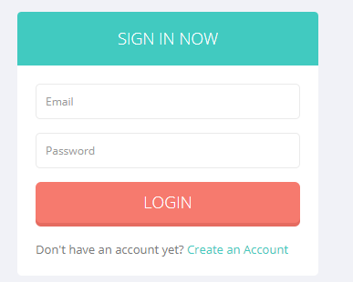

**2) SignUp**

* 1. The user create an account by providing his credentials if he is not registered
  2. Press on Register Now button.

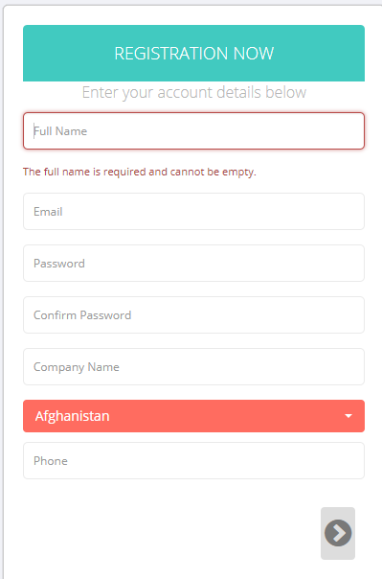

**3) Page Selection**

* 1. User will select the desire page to view the analytics of the chosen page.

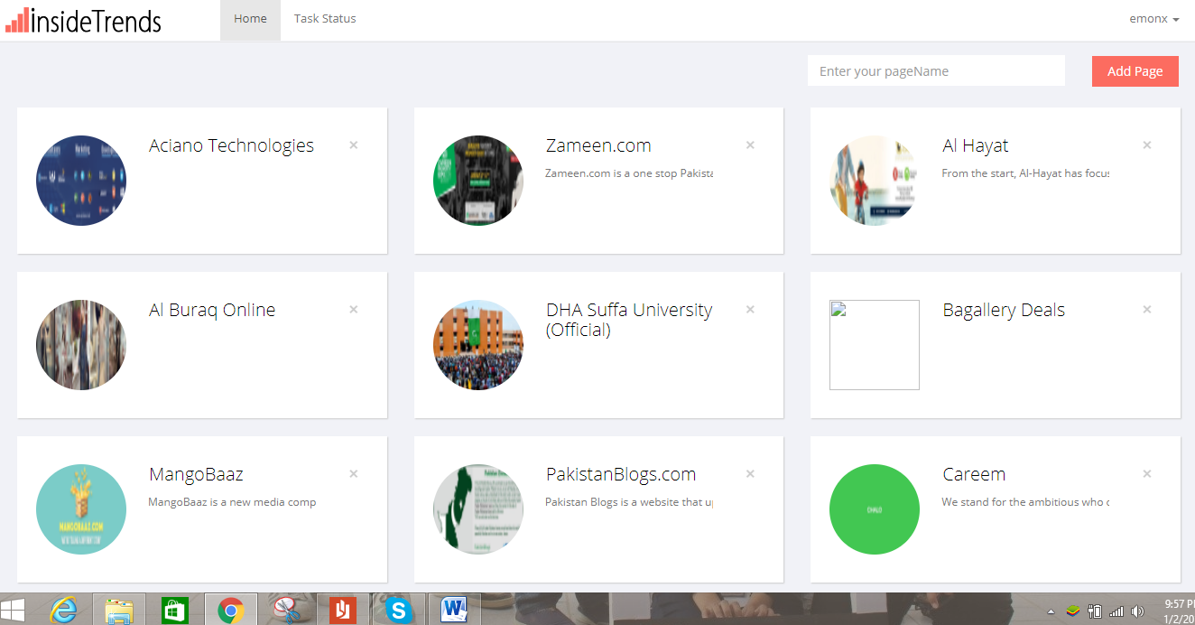

**REPORT FOR ACMDSU**

1. **Summary Dashboard**

User shall be able to view summarized analysis of activities, engagement graphand activity graph.

* Activity summary:

It offers deeper insights about trends based on status shares, likes, comments, active users, average page likes, average talking about, and sentiments.

* + By pointing a corsair on a point it shows the value at that point.

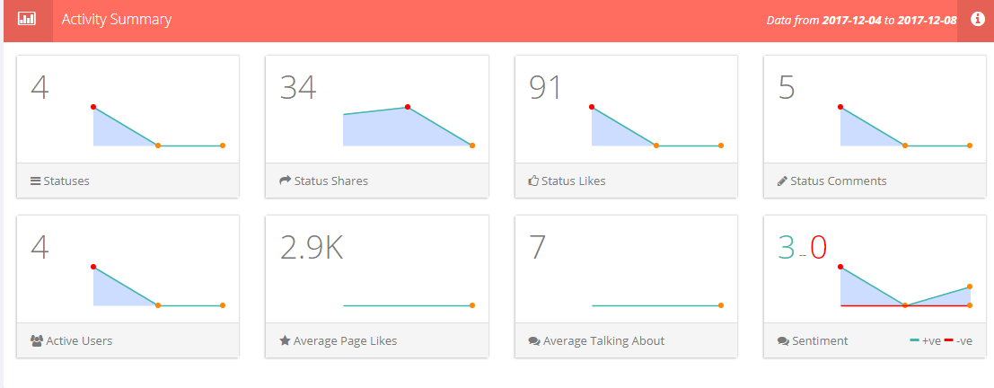

* **Engagement Summary Graph**

It shows trends regarding amount of statuses, likes, shares, comments of a post on a chosen date.

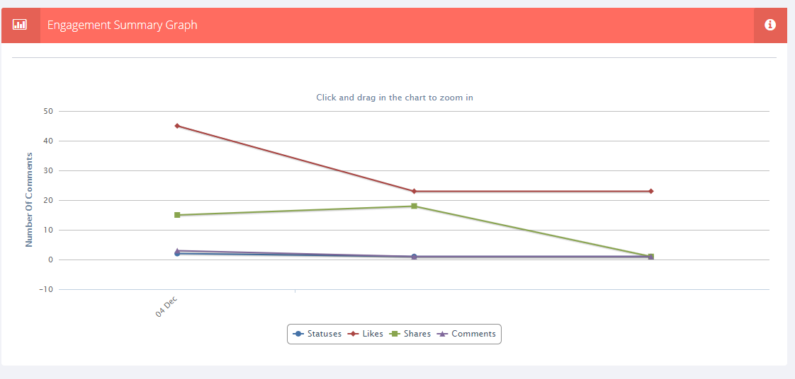

* **Sentiment Trending Graph**

It shows trends regarding amount of positive and negative comments over a post with respected date.

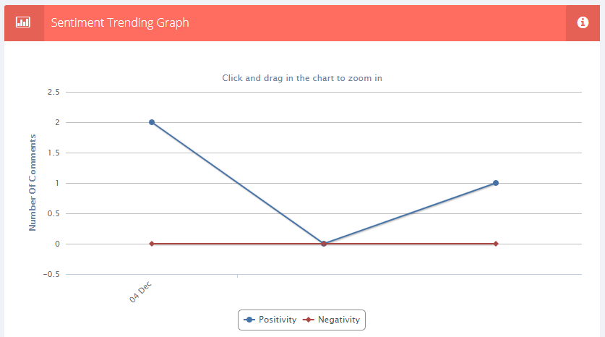

* **Top users Table**

It shows top users of the page with their names, no. of comments they did, likes received on their comments, replies received on their comments and number of positive or negative comments done by a user.

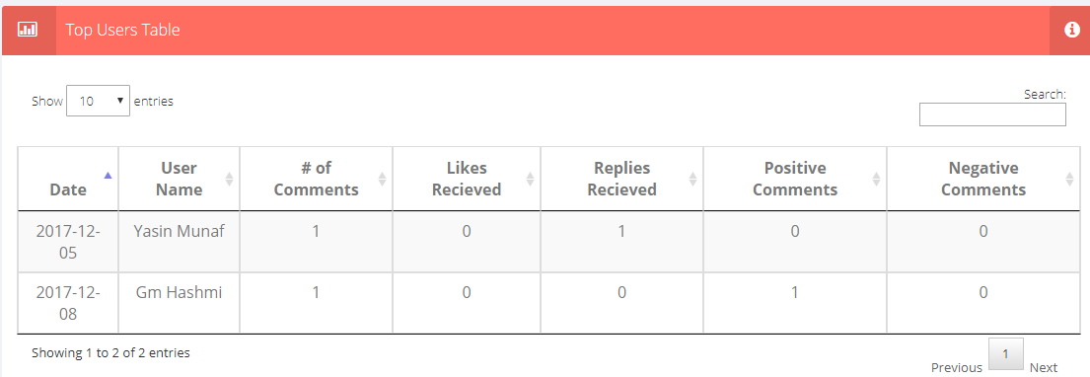

* **Customer Dashboard:**

User shall be able to view top users based on positive comments, engagement, unique comments and sentiments used in their comments

* **Unique commenting users:**

User shall be able to view amount of unique users on a respective date

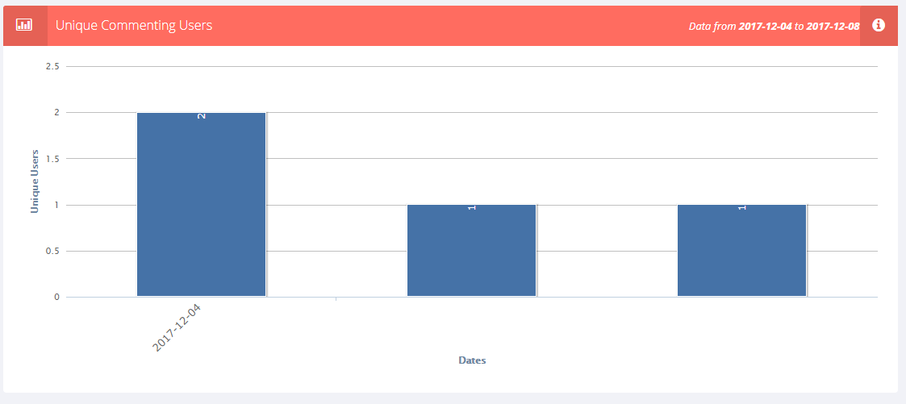

* Top Users:

Amount of top users shall be shown based on comments, positive comments and engagements of user date wise.

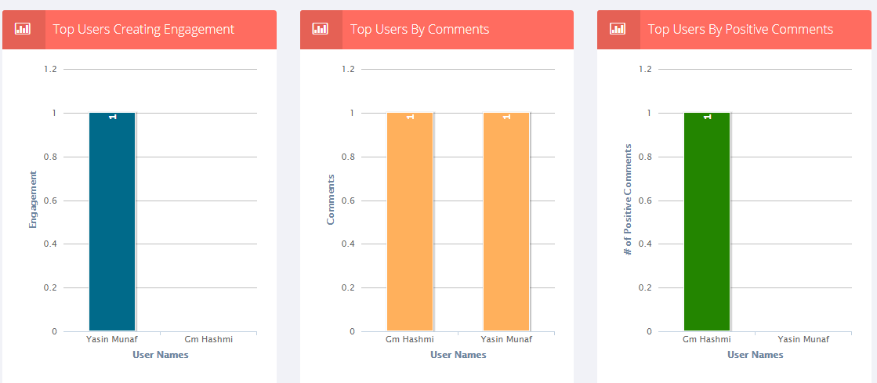

* **Sentiment Pie Chart:**

It shows a percentage of strong positive, weak positive, positive, negative, weak negative, strong negative and neutral sentiments of users used in comments.

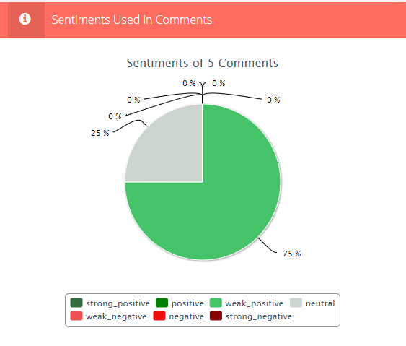

* **Post Dashboard**
  + It shows all posts of the page with comments and their number, likes on a post, shares of post, date and time.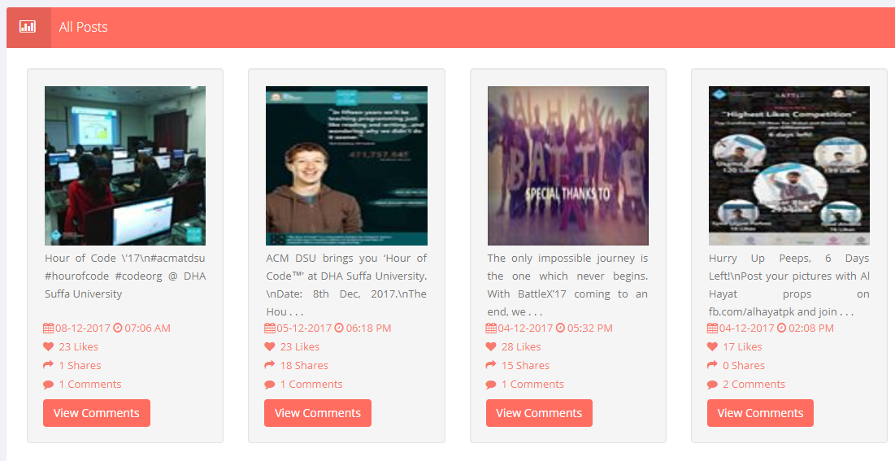
  + User select ‘view comments’ option.
  + User shall be able to view the comment of the commentator with his name.

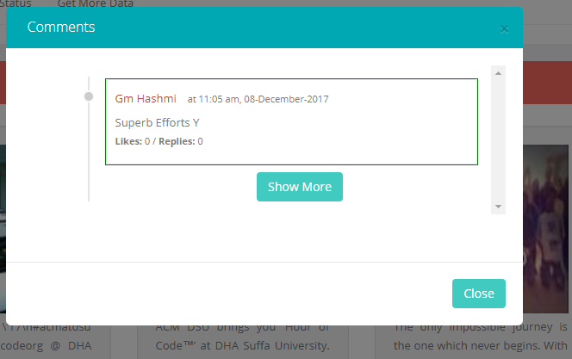

* **Comparision Dashboard**

Software allows you to compare your online social profile with those of your competitors on the basis of several key metrics like engagement and popularity scores as well as performance trends.

* **Comparison by Value:**

User can compare different companies on number of Fans, Talking about, Positive Comments and Engagements

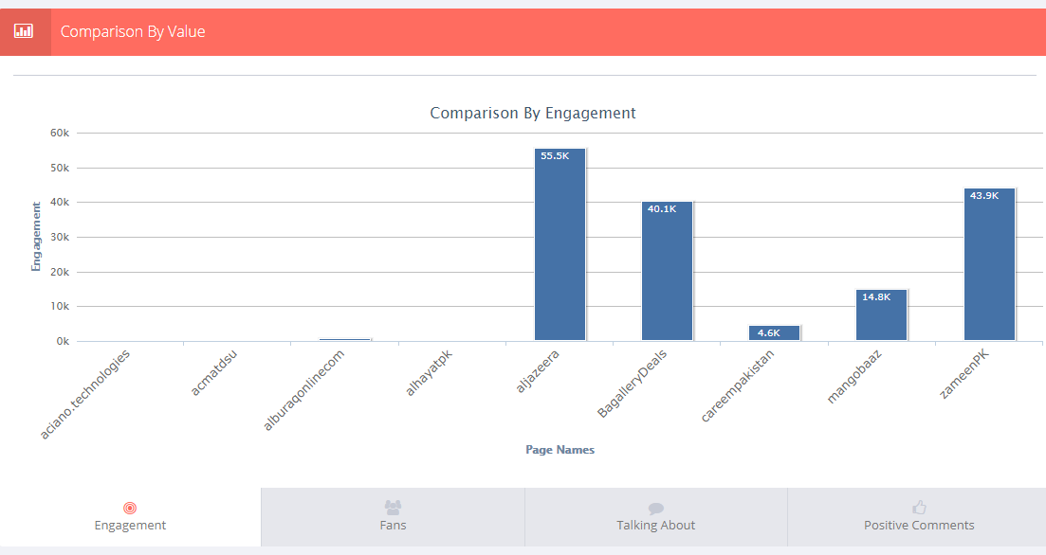

It offers deeper insights about your competitors’ social media activities.

* **Comparison by days**

Software helps you in developing quick reports on daily/weekly/month about the comparative activities of your company with your competitors.

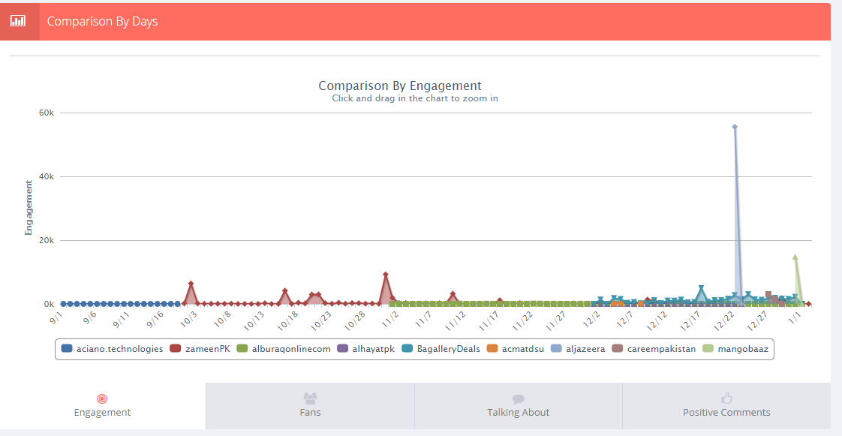

* **Reports Dashboard**

User shall be able to view the trends reports based on change over time, fans over time, engagement over time, talking about of the page over time, sentiments over time.

* Change over time:

User can view the percentage of the following from time to time.

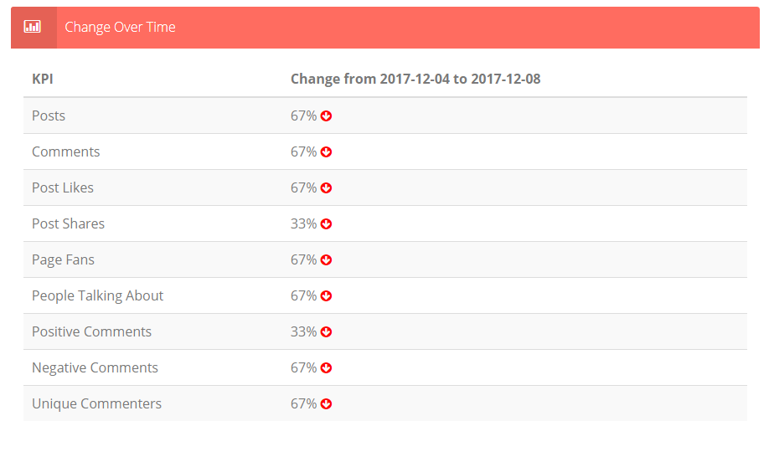

* **Page Fans Over Time:**
  + User can view the number of fans
  + Increased/decreased from time to time.
  + By pointing a corsair on a point it shows date and number of fans on that date.

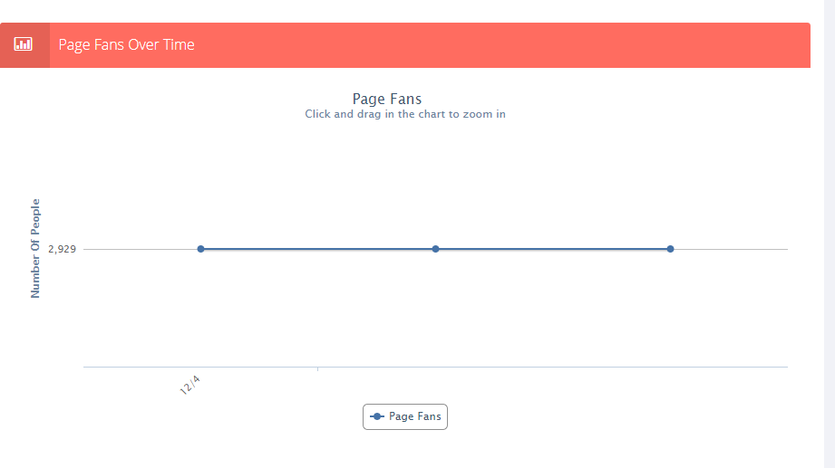

* **People talking about page over time:**
  + It shows the number of people talking about page over time.
  + By pointing a corsair on a point it shows date and people talking about.

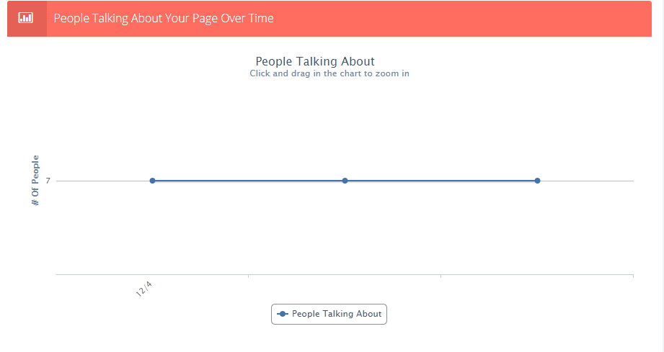

* **Sentiments used over time:**
  + It shows the number of positive and negative comments from time to time.
  + By pointing a corsair on a point it shows the number of positive and negative comments on particular date.

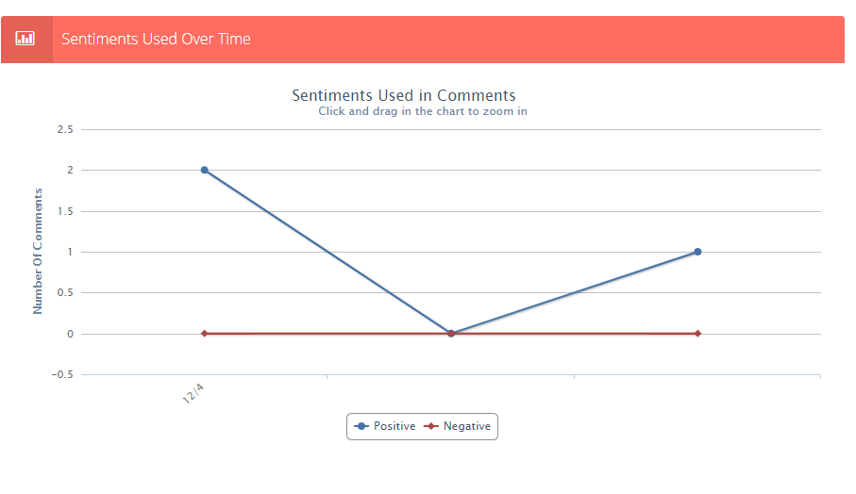

* **Topic Search Dashboard**

User will be able to search important keywords mentioned on his social media profile page that he wish to stay updated on for.

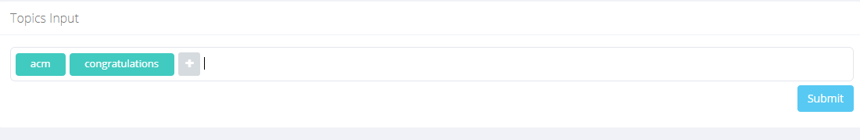

* + User enter keyword in search bar.
  + Press Submit button.

