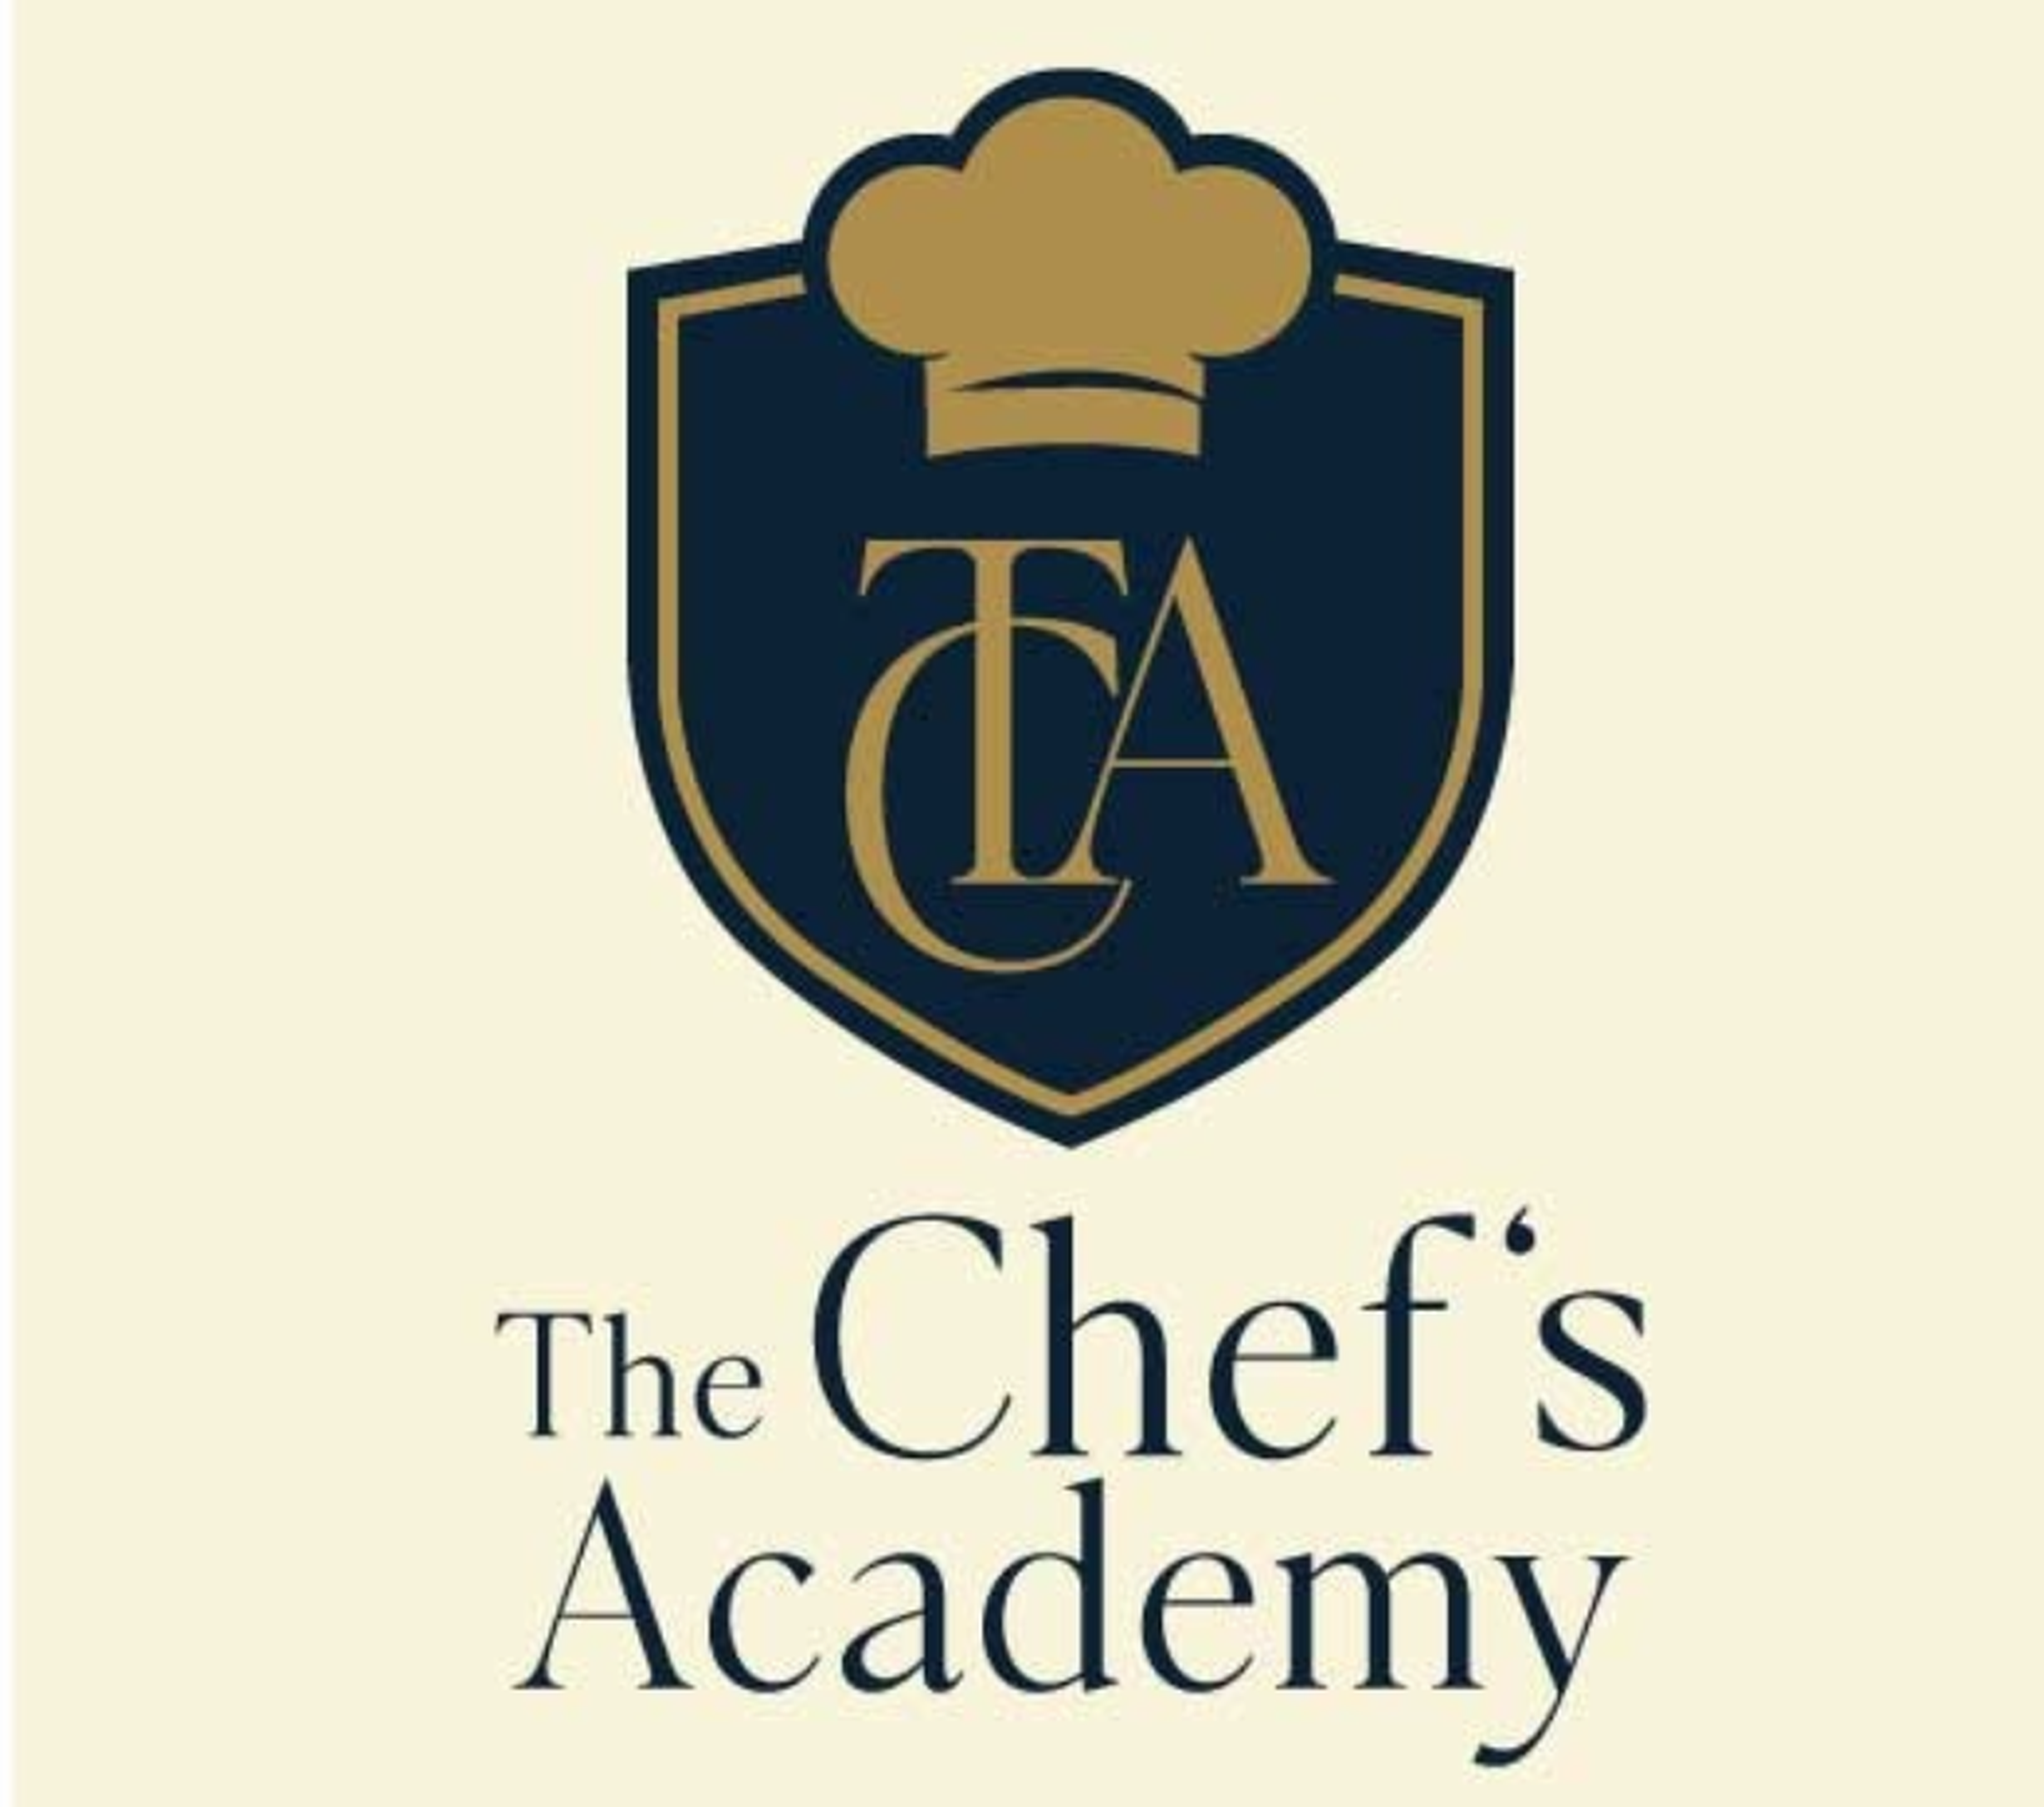
4-WEEK AUGUST INTENSIVE PROGRAM
CULINARY ARTS / PROFESSIONAL COOKING
Hands-on cooking skills, modern recipes, market-relevant dishes and professional kitchen foundations.
Start Date | End Date | Duration | Format
10 August 2026 | 3 September 2026 | 4 Weeks | 16 Classes | Monday to Thursday | 3 Hours per Class
Course Overview
This course is designed for beginners, food enthusiasts and aspiring chefs who want to build strong practical cooking skills in a short, focused format. The program combines culinary foundations with popular, market-relevant dishes that students can recreate at home, use for small food ventures or build upon for a professional kitchen career.
What Students Will Learn  - Kitchen hygiene, safety and professional discipline  - Knife skills, cuts, mise en place and workflow  - Stocks, soups, mother sauces and modern sauce applications  - Grilling, roasting, sautéing, frying and wok-based cooking  - Pakistani, Chinese, Continental and fast-casual cooking foundations  - Plating, presentation, costing basics and final practical assessment | Market-Relevant Dishes Included  - Creamy Alfredo Pasta, Pink Sauce Pasta and Arrabbiata  - Chicken Karahi, Tawa Qeema and modern Pakistani sides  - Chicken Manchurian, Dragon Chicken and Fried Rice  - Peri-Peri Grilled Chicken and Chicken Steak with Mushroom Sauce  - Smash Burger, Crispy Chicken Burger, Loaded Fries and house sauces  - Pizza, tacos, wraps, fish and chips, modern rice bowls and signature plating

Detailed Weekly Course Outline
Week 1: Culinary Foundations & High-Demand Basics
Class | Focus | Dishes / Practical Work | Skills Covered
Class 1 | Kitchen orientation, hygiene, safety, knife skills and mise en place | Knife-cutting practice, herb garlic butter, fresh salsa, bruschetta bites and basic salad preparation | Professional kitchen conduct, chopping techniques, workstation setup, ingredient handling and presentation basics.
Class 2 | Stocks, soups and sauce foundations | Creamy Chicken Mushroom Soup, Tomato Basil Soup, Béchamel Sauce, Marinara Sauce and Mushroom/Pepper Sauce | Roux, stock base, seasoning balance, sauce consistency, soup texture and safe hot-food handling.
Class 3 | Pasta and modern café-style sauces | Fettuccine Alfredo, Pink Sauce Pasta and Spicy Arrabbiata Pasta | Pasta boiling, sauce finishing, emulsification, garnish, plating and portion control.
Class 4 | Rice, noodles and wok-style cooking | Chicken Fried Rice, Chow Mein and Korean-style Spicy Chicken Noodles | Wok control, vegetable cuts, flavour layering, quick cooking, texture balance and service timing.
Week 2: Restaurant Favourites & Fast-Casual Skills
Class | Focus | Dishes / Practical Work | Skills Covered
Class 5 | Pakistani restaurant-style cooking | Chicken Karahi, Tawa Qeema, Raita, Fresh Kachumber and finishing techniques | Spice blooming, masala balance, meat cooking, oil control and Pakistani restaurant-style presentation.
Class 6 | Chinese takeout favourites | Chicken Manchurian, Dragon Chicken, Egg Fried Rice and Stir-Fried Vegetables | Sauce building, frying, tossing, sweet-spicy balance, batch preparation and plating for service.
Class 7 | Grilling, marinades and sautéed sides | Peri-Peri Grilled Chicken, Herbed Mashed Potatoes and Sautéed Seasonal Vegetables | Marination, grill marks, doneness, resting, vegetable sautéing and side-dish coordination.
Class 8 | Modern fast-casual menu items | Crispy Chicken Burger, Smash Burger, Loaded Fries and House Garlic/Mayo Sauce | Frying control, burger assembly, sauce development, fries topping balance and café-style plating.

Week 3: Professional Mains, Dough Basics & Trending Food Concepts
Class | Focus | Dishes / Practical Work | Skills Covered
Class 9 | Chicken steak and classic sauce service | Chicken Steak with Mushroom Sauce, Pepper Sauce, Mashed Potatoes and Grilled Vegetables | Pan-searing, deglazing, sauce finishing, plate structure, timing and temperature control.
Class 10 | Pizza and dough basics | Deep Pan Pizza, Thin Crust Pizza, Garlic Bread and Basic Pizza Sauce | Dough handling, proofing basics, topping balance, oven control, slicing and service presentation.
Class 11 | Tacos, wraps and modern bowl concepts | Chicken Tacos, Loaded Rice Bowl, Crunch Wrap, Salsa and Spicy Yogurt Sauce | Layering flavours, filling balance, assembly techniques, modern casual plating and menu versatility.
Class 12 | Meat, poultry and marinade application | Sizzling Chicken, Beef/Chicken Kebabs, Herb Butter and Seasonal Sides | Marinade science, protein preparation, cooking methods, smoke/flavour notes and garnish work.
Week 4: Modern Plates, Costing & Final Assessment
Class | Focus | Dishes / Practical Work | Skills Covered
Class 13 | Seafood and modern plated dishes | Fish & Chips, Tartar Sauce, Slaw and Lemon Butter Fish demo | Fish handling, coating, frying, sauce pairing, freshness, texture and plating.
Class 14 | Plating, presentation and signature dish development | Signature Pasta or Steak Plate with Sauce, Side and Garnish | Plating composition, colour, height, garnish placement, sauce control and food photography basics.
Class 15 | Menu planning, costing and prep planning | Mini-menu development, portion costing, recipe standardization and sauce/product prep planning | Food costing, portion control, basic pricing logic, waste control and production planning.
Class 16 | Final practical assessment and certificate evaluation | Students prepare one market-ready main dish with side, sauce and final plating | Practical assessment, time management, hygiene, taste, presentation and instructor feedback.
Course Experience
- The course is practical-first and designed around dishes that are attractive, current and useful for both home cooking and food-business ideas.
- Each class includes demonstration, guided practical work and instructor feedback.
- Students will be encouraged to maintain hygiene, discipline, teamwork and professional kitchen standards throughout the program.
- Final assessment will evaluate taste, technique, hygiene, presentation and time management.

