**E-Sports Store**

**Introduction:** Welcome to our E-Commerce Sports Store, your one-stop destination for all things sports-related. In the fast-paced world of online shopping, we stand out as a premier platform catering to sports enthusiasts, athletes, and fitness aficionados. Our store is designed to provide you with a seamless and exhilarating shopping experience, offering an extensive range of sports gear, apparel, and accessories.

**Key Features:**

**Wide Product Range:**

Explore an extensive collection of sports equipment, apparel, and accessories for various sports and activities.

**Quality Assurance:**

We prioritize quality, offering products from renowned brands to ensure durability, performance, and style.

**User-Friendly Interface:**

Our website and mobile app feature an intuitive interface, making navigation and product discovery a breeze.

**Personalized Recommendations:**

Receive tailored product recommendations based on your preferences, ensuring a personalized shopping journey.

**Secure Transactions:**

Shop with confidence, as we employ the latest security measures to safeguard your transactions and personal information.

**Timely Delivery:**

Enjoy prompt and reliable delivery services, bringing your favorite sports products right to your doorstep.

**Customer Support:**

Our dedicated customer support team is ready to assist you with any inquiries, ensuring a smooth shopping experience.

**E-R Diagram**

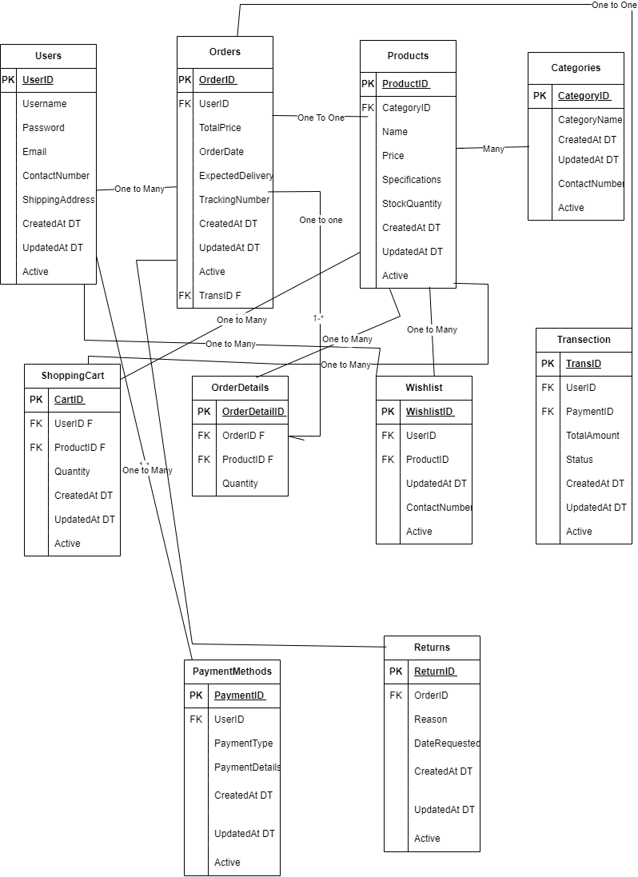

**:Entities:**

**User:**

Represents individuals who access the e-commerce platform.

**Product:**

Encompasses a variety of sports-related items such as equipment, apparel, and accessories.

**Brand:**

Denotes the different brands associated with the products available in the store.

**Order:**

Captures information related to user transactions and purchases.

**Cart:**

Temporarily holds selected items for users before checkout.

**Payment:**

Represents the financial transactions made by users to complete their orders.

**:Relationships:**

**User-Order:**

Indicates that a user can place multiple orders, but each order belongs to a single user.

**Order-Product:**

Illustrates that an order can consist of multiple products, and a product can be part of various orders.

**User-Cart:**

Depicts that a user can have one active shopping cart at a time.

**Product-Brand:**

Represents the association between a product and the brand manufacturing it.

**Order-Payment:**

Connects an order to the payment made for it.

**:Attributes:**

**User Attributes:**

UserID, Username, Email, Password, etc.

**Product Attributes:**

ProductID, Name, Description, Price, etc.

**Brand Attributes:**

BrandID, Name, Country, etc.

**Order Attributes:**

OrderID, Date, Status, TotalAmount, etc.

**Cart Attributes:**

CartID, CreationDate, Status, etc.

**Payment Attributes:**

PaymentID, Amount, PaymentDate, Method, etc.

**Network Diagram**

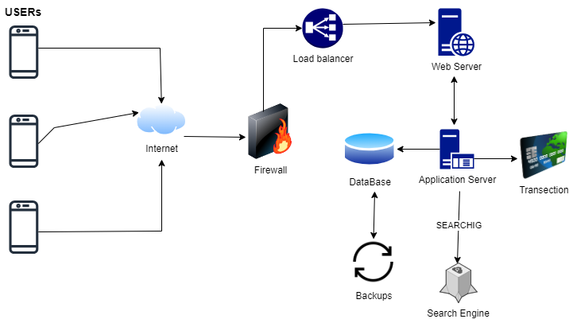

In this diagram we show how data get when user request for any product/route through internet it can access sever like over Firebase and return the response to user the user instructions save on the database with its matched identity. User also have a backup when they login its profile.

**Use Case Diagram**

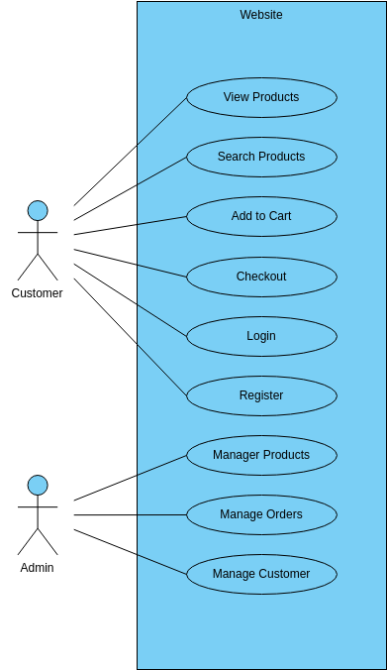

**Project Best Practices and Tools Used**

**Communication Tool:** Slack

Explanation: Utilized Slack for effective communication with the client. Slack offers real-time messaging, file sharing, and collaboration features, enhancing efficient communication between team members and clients.

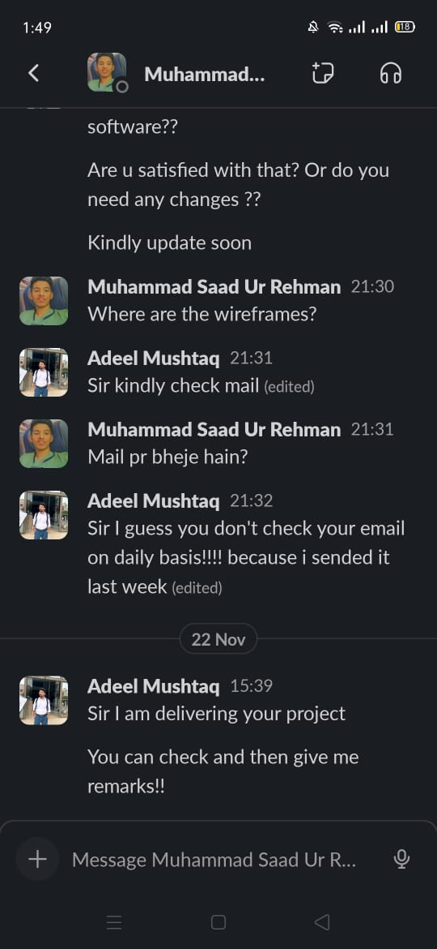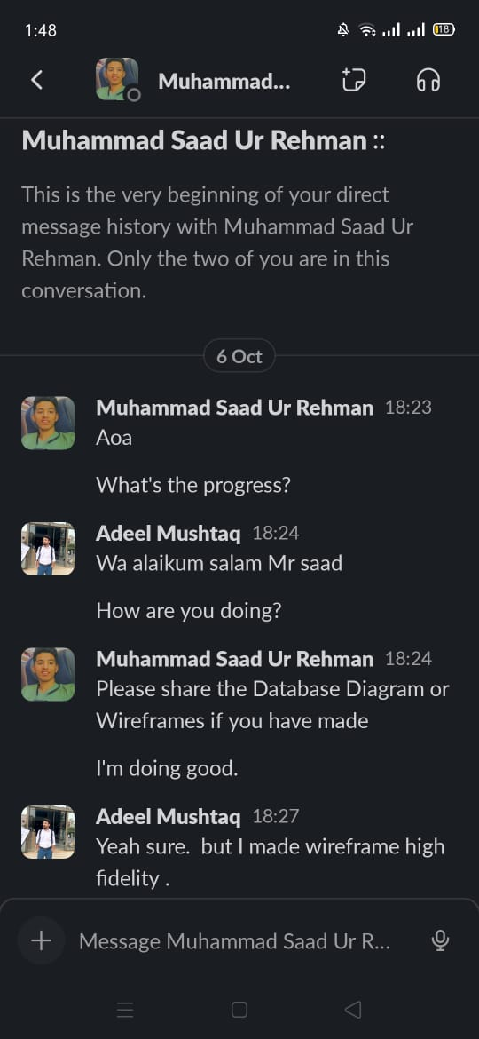 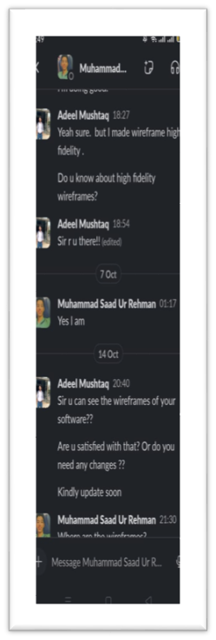

**Task Management Tool:** ClickUp

Explanation: Employed ClickUp for task management, enabling the team to organize, prioritize, and track project tasks. ClickUp provides a centralized platform for task assignments, due dates, and progress monitoring.

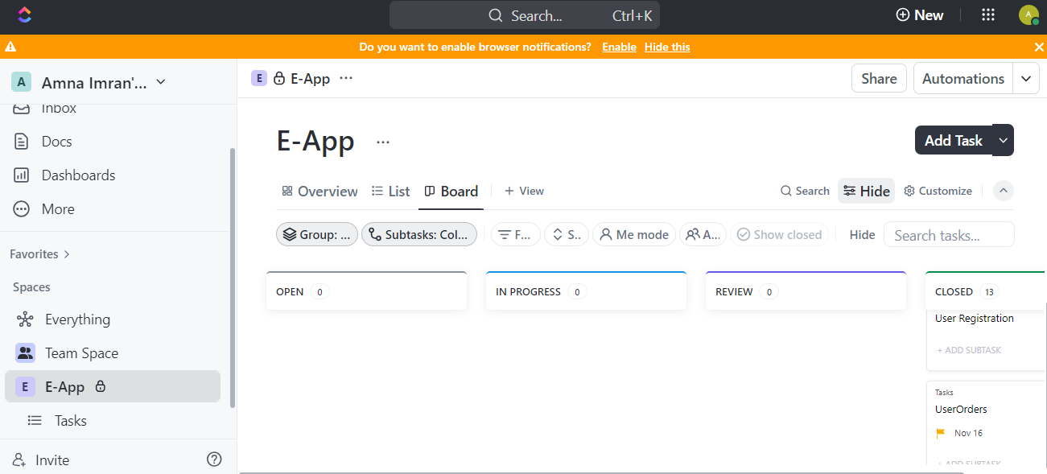

**Version Control:** GitHub

Explanation: Implemented GitHub for version control, allowing collaborative development, code review, and version tracking. GitHub ensures a streamlined process for managing code changes and maintaining a centralized repository.

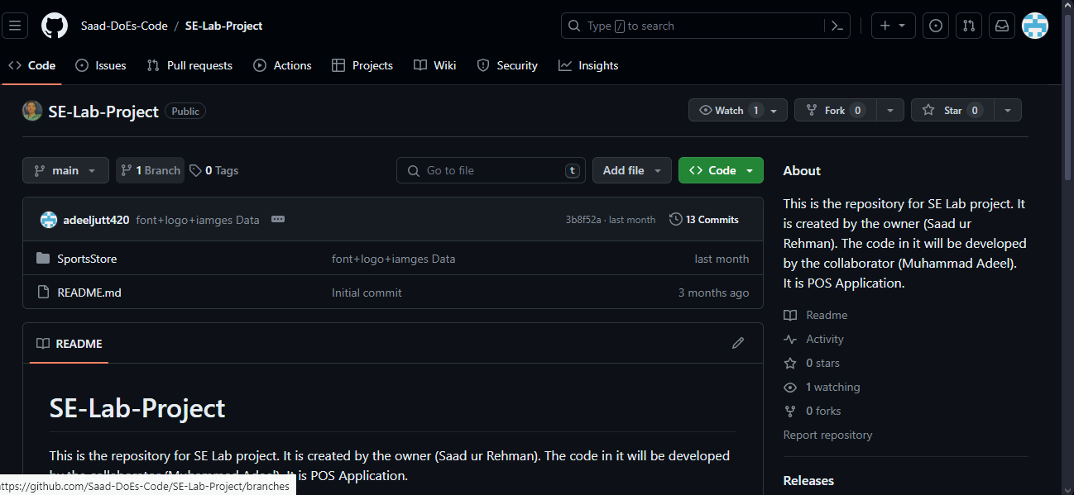

**Application Working**

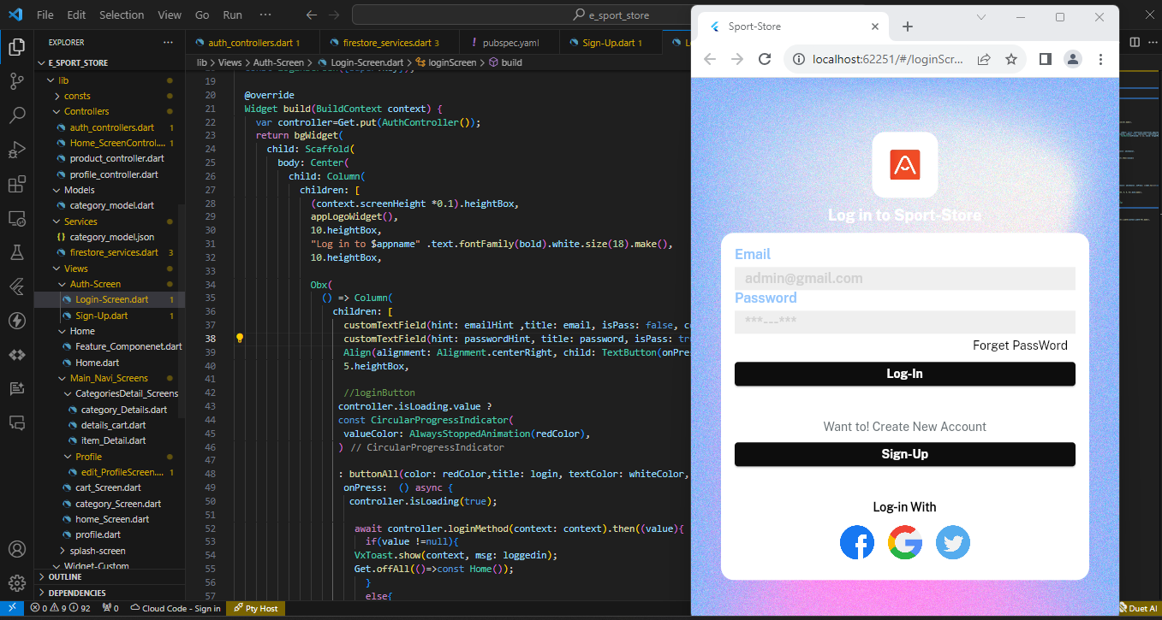

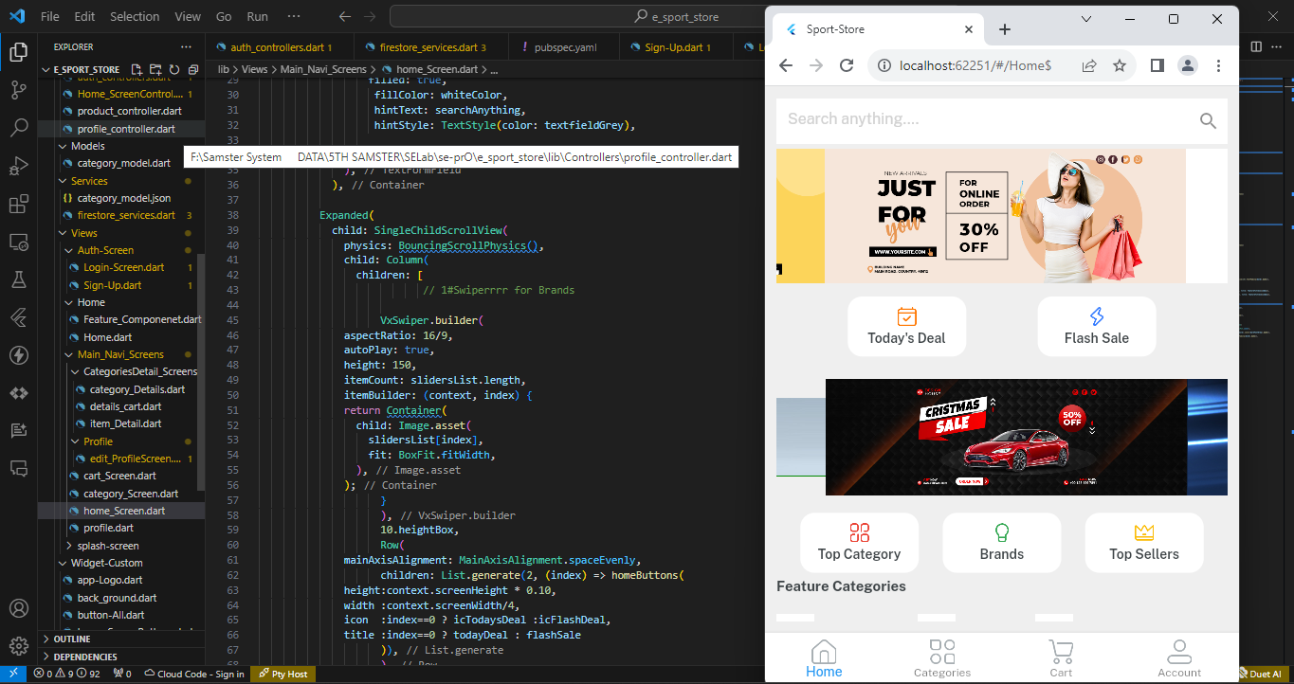

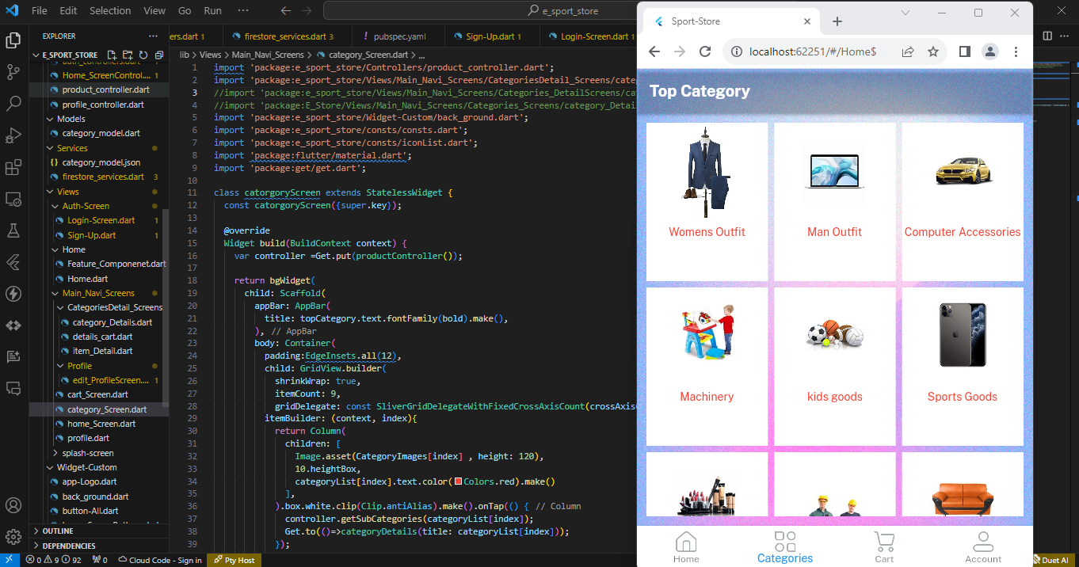

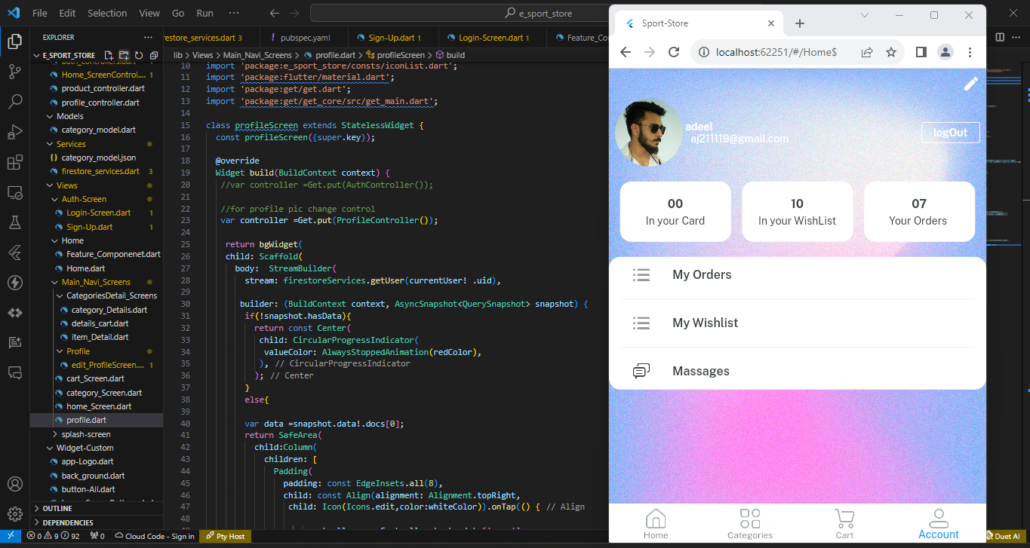

**Software Engineering**



**Submitted by:**

M.Adeel 2021/R-2020-CS48

**Supervised by:**

Mr. Aatif Hussain

Department of Computer Science

**University of Engineering and Technology**

**Lahore Pakistan**