**Research Protocol: Selection of Flower Size in *Iris atropurpurea***

**1. Introduction and Hypothesis**

Flower size is a key advertisement trait in insect-pollinated plants, influencing pollinator attraction and plant reproductive success. Larger flowers tend to be more visible and are often preferred by pollinators, leading to directional selection favoring larger flower sizes (Lavi and Sapir, 2015). However, larger flowers also have costs, particularly through increased water loss, which may lead to selection pressures favoring smaller flowers in water-limited environments.

We hypothesize that: **Flower size is subject to balancing selection**, with pollinators selecting for larger flowers and water stress selecting for smaller flowers.

**2. Study Design**

Study Timeline and Experimental Treatments

* **2023 (First Year):** Flowers were measured in both populations without any treatment to assess overall selection.
* **2024 (Second Year):** Pollinator-mediated selection was studied by introducing two treatments: supplementary pollen (hand-pollinated) and open pollination (natural pollination by insects).
* **2025 (Third Year):** In addition to pollinator-mediated selection, water-mediated selection was also tested by adding a supplementary water treatment along with the pollination experiment. [Data not yet available]

Study Populations: We focus on two natural populations of *Iris atropurpurea*:

* **Netanya:** Includes both hand-pollinated and open-pollinated treatments.
* **Yavne:** Includes only open-pollinated flowers.

Data Collection: We measured floral traits in marked genotypes across two years (2023 and 2024):

**Flower projection size** = length × width

1. **Tunnel volume** = tunnel length × entrance length × entrance height
2. **Black patch area** (measured using ImageJ)
3. Total flowers in a genotype (plant)
4. 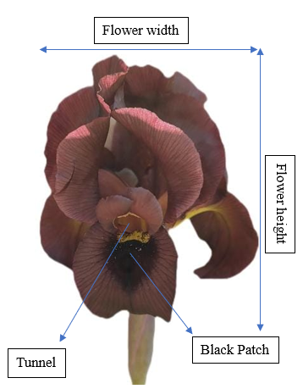Area of the genotype

**Figure 1:** Structure of flower and the measured floral traits

Female reproductive fitness was estimated using:

* **Fruit count** (binary response; whether a flower produces fruit or not).
* **Seed count** (Poisson-distributed response; number of seeds per fruit).

Sample Size

* **Netanya:**
  + 50 genotypes (25 open-pollinated, 25 hand-pollinated)
  + 120 flowers (50 open-pollinated, 70 hand-pollinated)
* **Yavne:**
  + 70 genotypes (all open-pollinated)
  + 160 flowers (all open-pollinated)

There are some missing values (NAs) for tunnel volume, black patch area, and seed count. Additionally, relative fitness deviates from normality, and the sample size for each treatment is relatively small (less than 50 per group).

**3. Statistical Analysis Plan**

Primary Statistical Inference Goals

* To conduct regression analysis to determine the relationship between standardized floral traits and relative fitness within each treatment and population.
* To estimate selection gradients to assess the strength and direction of pollinator-mediated selection on floral traits.
* To analyze the significance of selection gradients using statistical tests.
* To visualize selection gradients using regression plots.

**Regression model:**

Relative fitness~ (Flower size */+ tunnel volume */+ black patch) * treatment

Secondary Statistical Inference Goals

* To compare flower size between years (2023 vs. 2024) to detect significant temporal variation.
* To assess differences in reproductive fitness between hand-pollinated and open-pollinated treatments.

4. Expected outcome and its significance:

This study aims to provide insights into the selection pressures shaping flower size in *Iris atropurpurea*. To fully understand the evolution of flower size, it is crucial to disentangle the relative contributions of the selection forces. This study aims to partition the relative contribution of selection agents that drive flower size variation.

**Reference of papers with similar work:**

1. Lande, R., & Arnold, S. J. (1983). The measurement of selection on correlated characters. *Evolution*, 1210-1226.

<https://stevanjarnold.com/wp-content/uploads/2021/05/The_Measurement_of_Selection_on_Correlated_Charact.pdf>

1. Sletvold, N., Tye, M., & Ågren, J. (2017). Resource‐and pollinator‐mediated selection on floral traits. *Functional Ecology*, *31*(1), 135-141.

<http://besjournals.onlinelibrary.wiley.com/doi/full/10.1111/1365-2435.12757>

1. Lavi, R., & Sapir, Y. (2015). Are pollinators the agents of selection for the extreme large size and dark color in O ncocyclus irises?. *New phytologist*, *205*(1), 369-377.

<https://nph.onlinelibrary.wiley.com/doi/pdf/10.1111/nph.12982>