Question 7 — 23M.1.SL.TZ2.1
Part (a) — Explain two types of government intervention that could be used to correct the market failure arising from the consumption of demerit goods. [10]
Indirect tax is the first policy I will use. Cigarettes is a classic example of a demerit good, which mean a good that consumers over-consume because they don't realise the full costs. When people smoke, third parties suffer — non-smokers breathe the smoke, and the public hospital have to pay later for the lung diseases. This is what economists call a negative externality of consumption. So the marginal private benefit (MPB), the benefit one smoker get from one more cigarette, is higher than the marginal social benefit (MSB), the benefit to whole society. In free market the equilibrium is at Qm, where MPB cross MPC, but the socially optimum quantity is at Q*, where MSB cross MSC, and the triangle between Qm and Q* is the welfare loss (over-consumption). A specific excise tax — government add fix amount per packet — raise the cost of production, so the supply curve (MPC) shift upward by the amount of the tax, becoming a new curve MPC + tax. After the tax, the price paid by consumer rise from Pm to Pc, quantity fall from Qm down to Q*, and the welfare loss is eliminate. The government also collect tax revenue, which is the box between Pc and the producer's price P_prod, from 0 to Q*; this revenue can be spend on healthcare or anti-smoking campaign. One weakness, cigarettes have inelastic price elasticity of demand (PED) because they are addictive, so the tax must be very big to really change consumer behaviour.
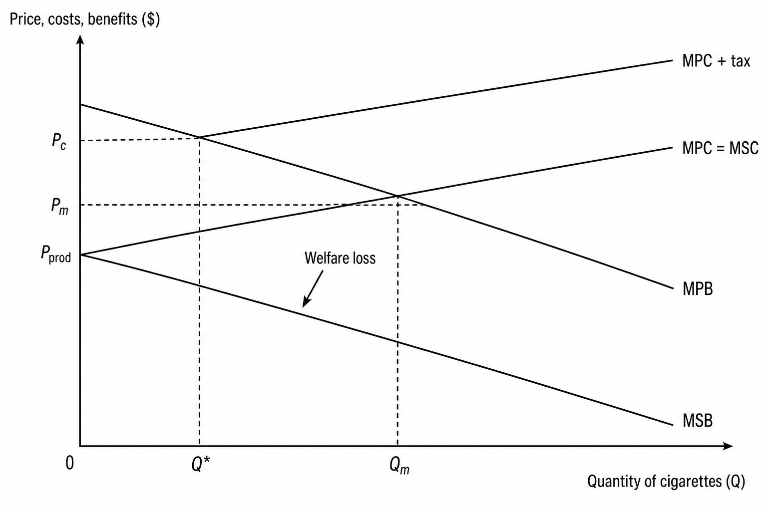
Diagram 1: Negative consumption externality (cigarettes) corrected by indirect tax
The second policy is a consumer subsidy on a close substitute. Here I take nicotine patches as the example, which is a merit good — a good consumer under-consume because they don't see the full benefit. When someone use patches instead of smoking, the society also gain (less second-hand smoke, lower public health cost), so this is a positive externality of consumption, and MSB is above the MPB. Free market equilibrium happen at Qm, where MPB cross MPC, but the socially optimum quantity is at Q*, where MSB cross MSC, and Q* is bigger than Qm because the patches are under-consumed; the welfare loss triangle is on the right side. A subsidy is money the government give to producers to lower their cost, so the supply curve (MPC) shift downward by the amount of subsidy, becoming a new curve MPC − subsidy. With the subsidy, the price for consumer fall to Pc, quantity rise from Qm up to Q*, and the welfare loss is removed. Because patches and cigarettes are substitutes in consumption, when patches become cheaper many consumers switch and the demand for cigarettes (the demerit good) shift left, so the demerit good market also move closer to its own socially optimum quantity. The main weakness is the high opportunity cost — the subsidy money come from the government budget that could be use for schools or hospitals — and also the substitute must really be a close substitute, otherwise consumer will not switch at all.
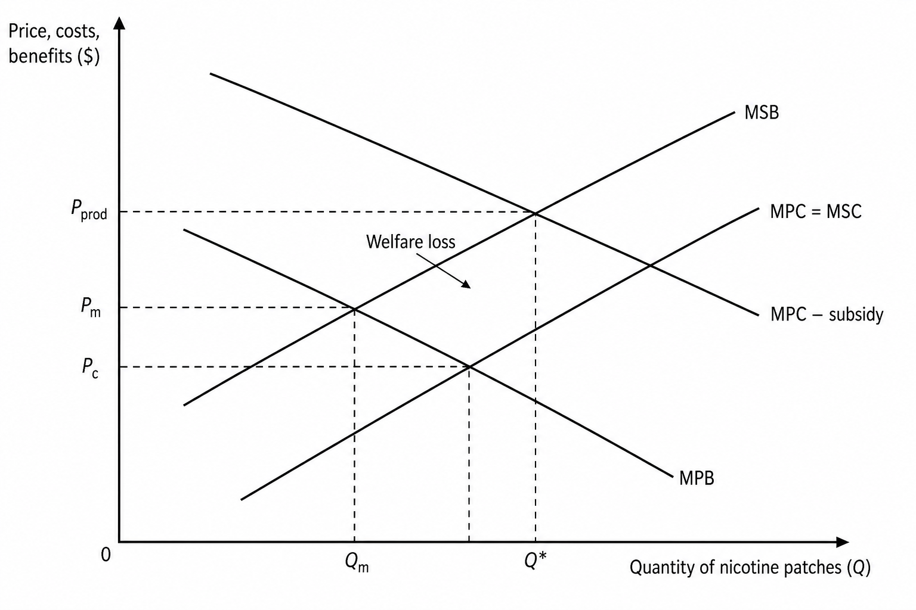
Diagram 2: Positive consumption externality (nicotine patches) corrected by consumer subsidy
Part (b) — Using real-world examples, discuss whether public goods should always be provided directly by the government. [15]
A public good is a good that is non-rivalrous (one person using it does not reduce the amount available for others) and non-excludable (you cannot stop people who don't pay from using it). Examples are national defense, street lighting and flood defenses. The free market under-provide them because of the free rider problem — since people can use without paying, private firms cannot earn profit and so they don't produce, which create a missing market, a form of market failure. The question is whether the government should always step in and provide directly.
On one hand, direct provision have real advantages. The government can collect tax from everybody, which solve the free rider problem — for example the UK government finance the Royal Air Force through tax, and every citizen benefit whether they pay or not. It also support equity, because every person have access regardless of income; Singapore's NParks public parks are free for all, but a private park would charge entry fee that poor families maybe cannot afford. Some goods are also too sensitive to give to private firms — almost no country let private companies run the army for security reasons, for example the US military is directly provided by the federal government even though USA is very market-based.
On the other hand, direct provision often suffer from government failure, which happen when the intervention create a worse outcome than the original problem. Without profit motive, public providers can be inefficient and bureaucratic; critics say the UK NHS have very long waiting time because there is no competition. There is also high opportunity cost, since the money could be use for schools or hospitals. Public-private partnerships (PPP) often work better, where the government finance and a private firm produce — Hong Kong's MTR is partly listed on the stock market but with the government as main shareholder, and it is one of the most efficient metro system in the world. Many goods are also actually quasi-public goods, meaning they only partly fit the definition. A road is non-rivalrous when empty but rivalrous in traffic, and with electronic tolls it become excludable, which is why in France private companies like Vinci and APRR operate the autoroutes. Ronald Coase also showed that English lighthouses were historically built and financed by private firms through port fees.
In my judgment, public goods do not always need to be provided directly. The key distinction is between provision (production) and finance (paying for it) — the government can finance and let private firms produce efficiently, as in Sweden's school voucher system where the government fund education but private schools (friskolor) deliver it. However, for pure public goods of national interest like national defense and the judicial system, direct provision is still the best because the risk of private abuse is too high. So the answer depend on the type of good (pure or quasi-public), the capacity of the government (efficient like Singapore vs weak with corruption), and how important equity is. A blanket “always” statement is too simplistic — a mixed approach work better in the real world.

