Practical no:7
Layer 2 Security
Network Topology:-
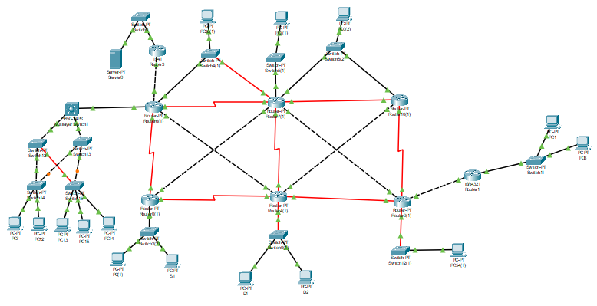

a)Assign the Central switch as the root bridge.
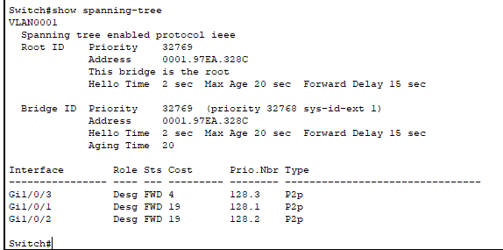

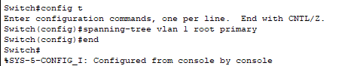

Assign Central as the primary root bridge.
Using the spanning-tree vlan 1 root primary command, and assign Central as the root bridge
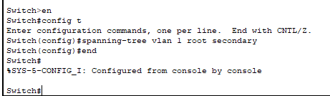

Assign switch13 as a secondary root bridge.
Assign switch13 as the secondary root bridge using the spanning-tree vlan 1 root secondary command.
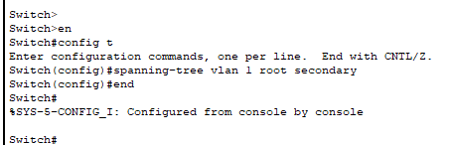

b)Secure spanning-tree parameters to prevent STP manipulation attacks.
Enable portfast and bpduguard for Access switches for the S3 and S4 :-

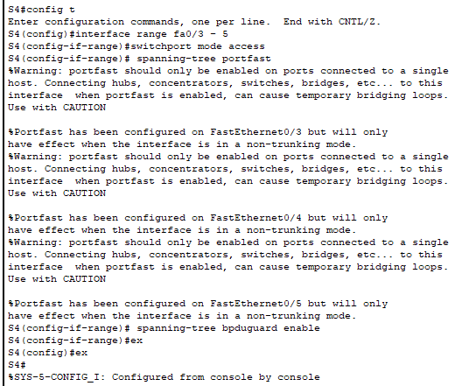

Disable BPDU guard on all trunk ports of S1 and S2 to avoid err disabled for unecessary loops state

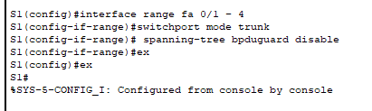

c) Configure Port Security and Disable Unused Port
S3:-
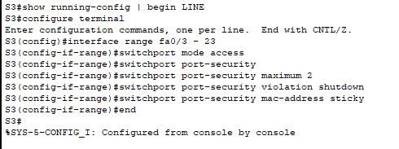

S4:-
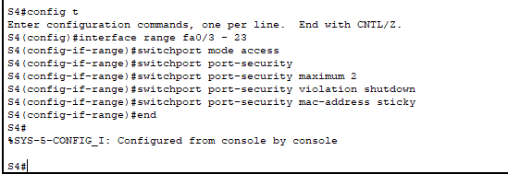

Disable Unused Ports:-
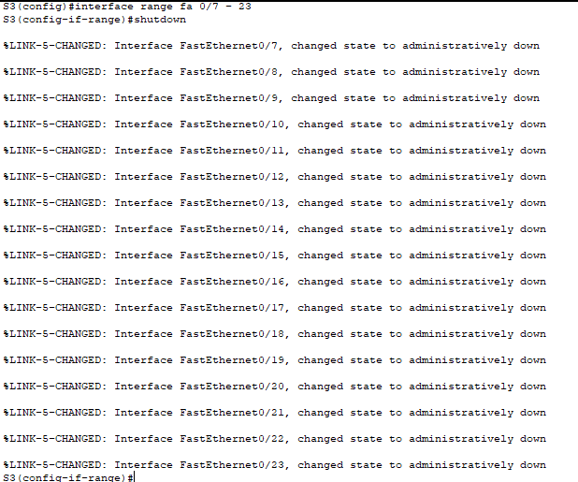

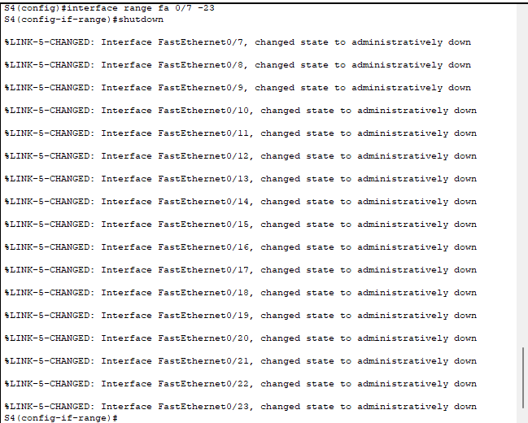

Verify :-
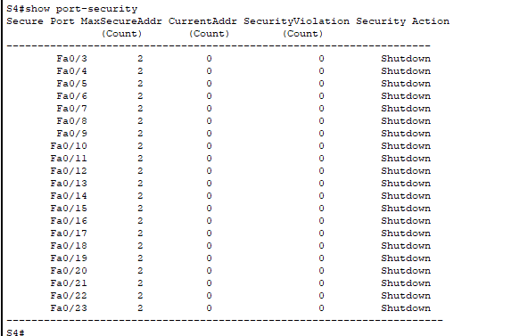

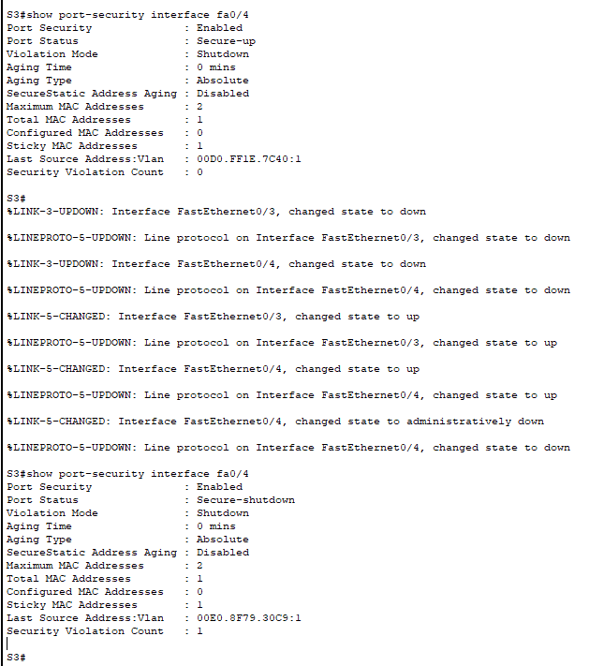
After changing the mac adress for fa 0/4 twice it automatically shutdown

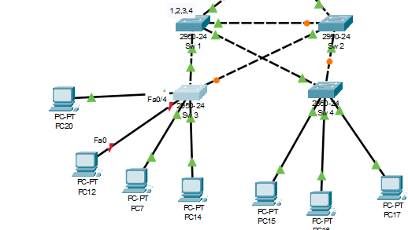
Fast ethernet 0/4 shuts down :-

