**使用方法**

1. 登陆<http://study3.biyouxue.com/ByxStudy/login/auth>

gjz80399

84081828

1. 获取元数据

Byx标点统计页面

<html>

<report-main>

<report-section-content>

<report-content-center>

<report-total-score-count>

<span id="TotalScoreCount">

<svg...>

<g class="fusioncharts-datalabels">

...

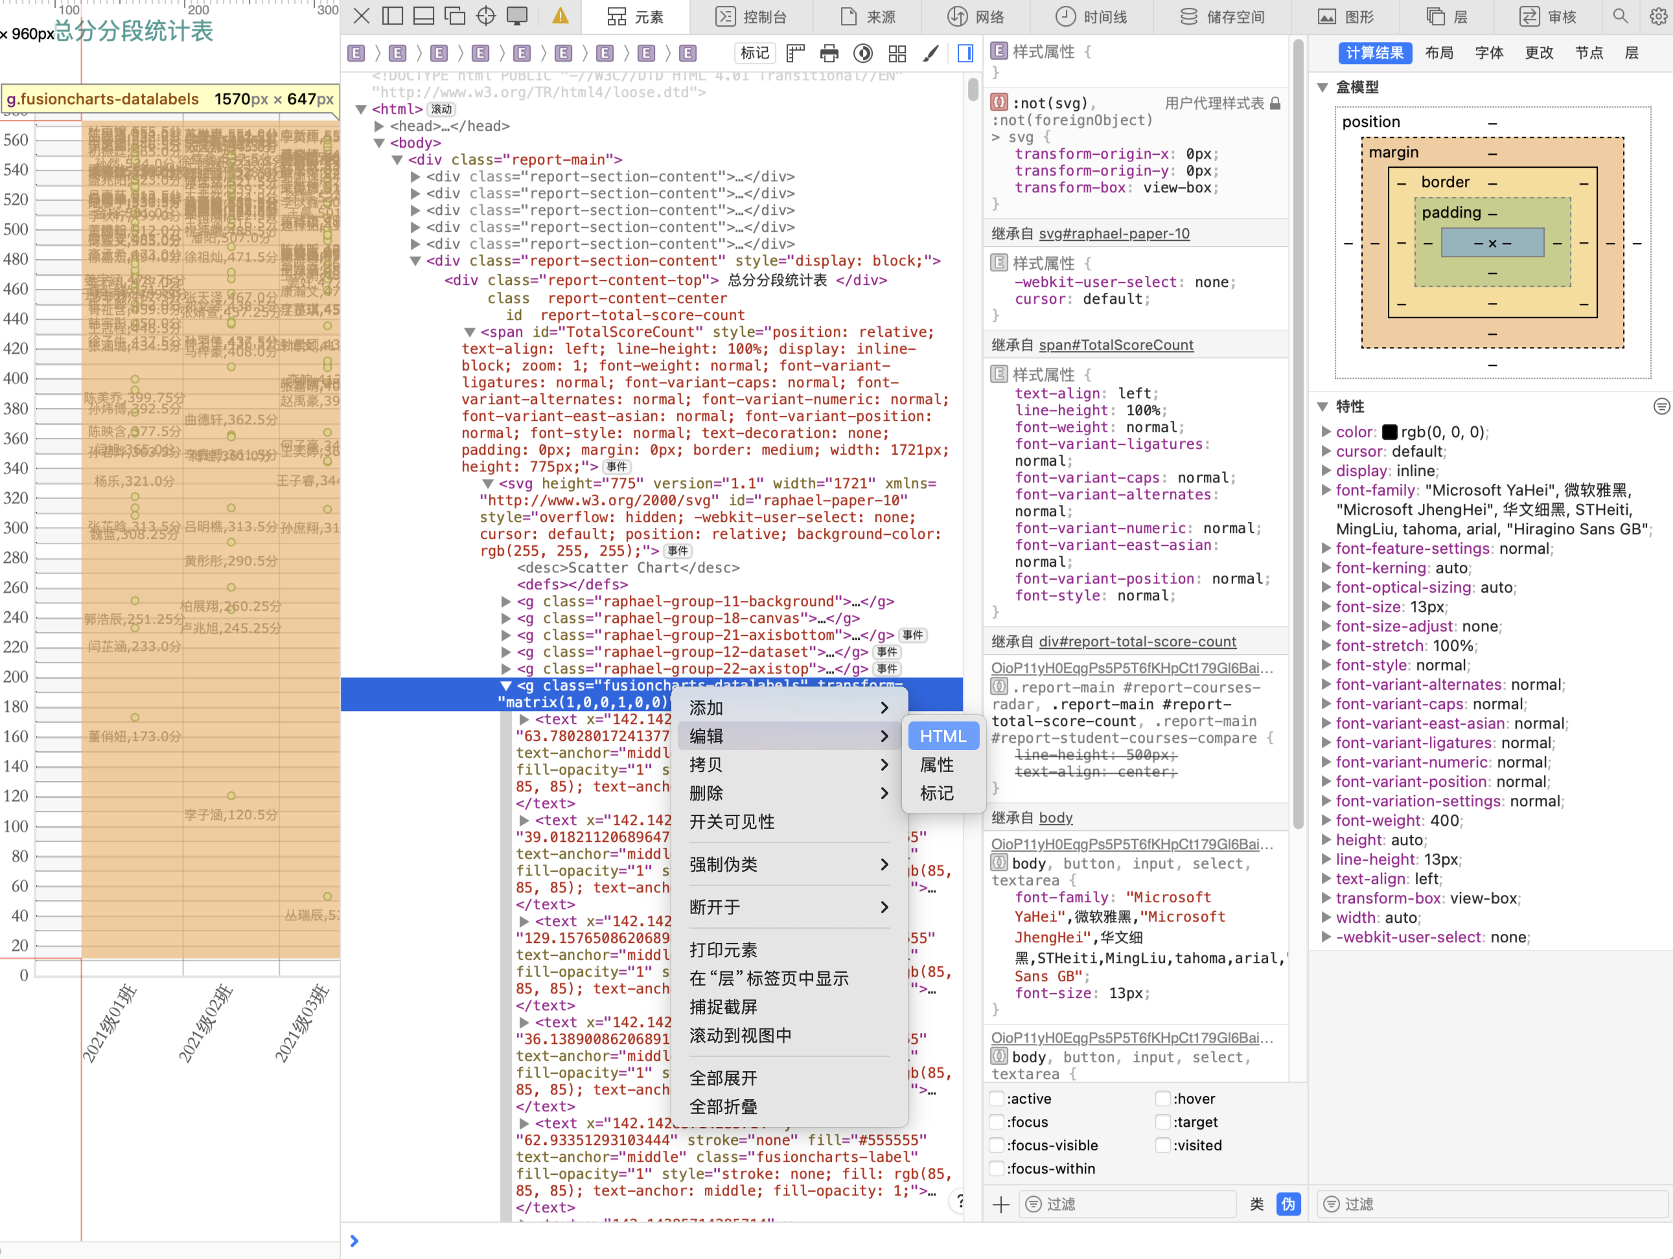

1. 复制到cssj.txt
2. 运行byxxp.py

cd /Users/yxq/Desktop/byxxp && python3 byxxp.py

5、在result中查看成绩单

*确保已经 pip3 install os re datetime chardet openyxl pandas