WEEK 4 – TAX POLICY IMPACT ANALYSIS AND REPORTING
Impact Assessment of India’s Income Tax Act, 2025 and the 2026 Transition
Virtual Income Tax Analysis Intern | YUVO Internship

Executive Summary
This report evaluates a major recent change in India’s income-tax policy environment: the replacement of the Income-tax Act, 1961 by the Income-tax Act, 2025, with the new Act coming into force from 1 April 2026. The policy change is primarily structural and administrative rather than a creation of a new tax. The Income Tax Department explains that the new Act is intended to simplify statutory language, reduce cross-referencing, improve readability, consolidate provisions, and make compliance more predictable. It also reports a reduction from 819 sections and 14 schedules in the 1961 Act to 536 sections and 16 schedules in the 2025 Act, while the Income-tax Rules reduce from 511 rules and 399 forms to 333 rules and 190 forms.
The analysis considers the likely effects on individual taxpayers, businesses, tax professionals, government administration, compliance behaviour, and the wider economy. It distinguishes direct effects, such as changes in the structure and presentation of tax law, from indirect effects, such as compliance costs, professional training, digital adoption, investment decisions, and taxpayer confidence. It also examines the transition risk created by the need to operate old and new legal provisions during a period in which earlier proceedings and transitional matters may continue under the previous framework.
The report uses official government and Income Tax Department materials as the principal evidence base. It also discusses the broader 2026 direct-tax environment, including the Finance Bill, 2026 and the continuing operation of the new tax regime for individuals for AY 2026–27. The purpose is not to recommend a political position, but to provide an evidence-based policy impact assessment that identifies potential benefits, costs, risks, and implementation considerations.

1. Policy Change Selected and Background
The selected policy change is the implementation of the Income Tax Act, 2025 from 1 April 2026. The Income Tax Department states that the Income-tax Act, 1961 was repealed from that date, subject to transitional provisions intended to prevent disruption in pending matters. The Department describes the replacement as a modernization of the legal framework rather than the introduction of a new tax. The policy objective includes simpler language, clearer structure, reduced interpretational difficulty, and a more taxpayer-centric compliance experience.
This change is important because income-tax administration affects almost every part of the formal economy. Individuals interact with the system through salary taxation, interest income, deductions, return filing, tax payments, refunds, and reporting requirements. Businesses interact with it through corporate taxation, withholding, advance tax, accounting records, assessments, notices, and transaction reporting. Tax professionals, software providers, payroll departments, finance teams, and government officers must all interpret and implement the law.
A tax code that is easier to navigate can potentially lower the time required to identify applicable provisions and reduce avoidable errors. However, a major legislative transition can also create short-term adjustment costs. Professionals must learn new section references and procedures; software must be updated; businesses must revise internal documentation; and taxpayers may temporarily face uncertainty when older and newer rules interact.
The 2026 policy environment also includes the Finance Bill, 2026, which contains proposals relating to direct-tax rates, ease of living, penalty and prosecution rationalisation, cooperatives, the IT sector, global business and investment, corporate tax rationalisation, and other direct-tax provisions. This means the new Act should be considered together with continuing policy amendments and implementation rules rather than as an isolated event.

2. Policy Objectives
- Improve readability and structural clarity of income-tax legislation.
- Reduce unnecessary cross-referencing and consolidate related provisions.
- Support easier voluntary compliance by taxpayers.
- Reduce interpretational disputes and compliance friction over time.
- Modernise forms, rules and digital processes around the new legal structure.
- Provide a more predictable framework for businesses, professionals and taxpayers.
- Maintain continuity through transitional provisions for matters arising under the earlier law.

3. Evidence of Structural Change
Indicator | Income-tax Act, 1961 framework | Income-tax Act, 2025 framework | Policy implication
Sections | 819 | 536 | More consolidated statutory structure
Schedules | 14 | 16 | Some material reorganised into schedules
Income-tax Rules | 511 | 333 | Fewer rules to navigate
Forms | 399 | 190 | Potentially simpler compliance architecture
The figures above are reported by the Income Tax Department in its explanation of the objectives and scope of the new Act. They should be interpreted as structural indicators, not as proof that every taxpayer will experience a proportional reduction in compliance effort. A smaller number of sections or forms does not automatically mean lower tax liability or fewer substantive obligations. The practical impact depends on drafting quality, rules, forms, digital systems, taxpayer awareness, and how effectively transitional issues are handled.
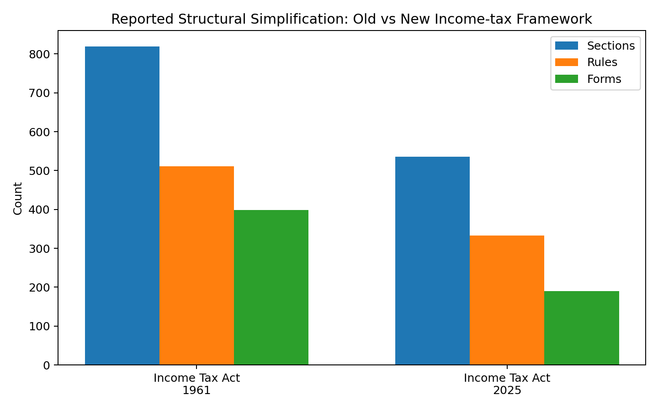
Figure 1. Structural counts reported by the Income Tax Department.

4. Direct Impacts on Individuals
For individual taxpayers, the most immediate impact is expected to be in the way tax provisions are located, interpreted, and used. The new Act is designed around clearer drafting and more consolidated provisions. For taxpayers who rely on professional assistance, this may gradually make discussions with accountants and tax advisers easier because the underlying law is intended to be more logically organised. For self-filers, clearer wording may reduce the need to search across multiple provisions to understand a basic requirement.
However, tax liability is not determined simply by the name of the Act. Individuals still need accurate income records, bank information, salary certificates, investment records, deduction evidence where applicable, and correct return selection. For AY 2026–27, the Income Tax Department continues to publish separate guidance for the old and new tax regimes. The Department states that the new regime is the default for eligible individuals and that the old regime remains available subject to the applicable rules. This means taxpayers must continue to understand both the legal framework and the practical consequences of regime selection.
A transition can also create confusion when people search online for section numbers or rely on older educational material. A taxpayer may encounter references to the 1961 Act even after the 2025 Act has become effective. Therefore, taxpayer education and updated digital guidance are critical to converting legislative simplification into real-world simplicity.

5. Direct Impacts on Businesses
Businesses may experience both efficiency opportunities and transition costs. Finance teams, tax departments and compliance professionals must update internal manuals, checklists, tax calculation logic, accounting workflows, contracts, templates, and training materials. Enterprise resource planning and tax software may also need updates to reflect new legal references and forms.
For large businesses, the principal short-term issue is change management. A tax provision may be conceptually familiar but appear under a new structure or wording. Teams therefore need controlled mapping between historical records and the new legal framework. This is particularly important for audits, assessments, notices, litigation, carried-forward matters, and transactions that span financial periods.
For small and medium enterprises, the impact may be more dependent on external advisers and software providers. Simplification can reduce reliance on complex interpretation in the long term, but the initial transition can still create professional-fee and training costs. Clear government FAQs, updated forms, online utilities, and timely notifications can reduce these costs.

6. Macroeconomic Impact Assessment
At the macroeconomic level, a more accessible tax system can influence formalisation, compliance and the perceived cost of doing business. If taxpayers can understand obligations more easily, voluntary compliance may improve. Better compliance can support revenue collection without requiring an equivalent increase in statutory tax rates. Government receipts can then support public expenditure and fiscal planning.
The 2026 Receipt Budget estimates taxes on income at ₹14.56 lakh crore for 2026–27, compared with a revised estimate of ₹13.12 lakh crore for 2025–26. These are budget estimates and should not be interpreted as evidence that the new Act itself will generate the increase. Revenue depends on economic growth, income levels, tax rates, compliance, enforcement, inflation, and many other factors.
For investment and business decisions, legal certainty can matter as much as the headline tax rate. A clearer law can reduce the time spent resolving interpretational questions and may improve planning confidence. Conversely, frequent amendments or unclear transition rules can increase uncertainty. Therefore, the economic impact depends on implementation stability as well as the wording of the legislation.

7. Microeconomic Impact by Stakeholder
Stakeholder | Potential positive effect | Potential challenge
Individual taxpayers | Easier navigation and clearer compliance guidance | Learning new structure; risk of relying on outdated material
SMEs | Simpler forms and processes over time | Transition and adviser/software costs
Large businesses | Better structured legal references | System migration, training and historical mapping
Tax professionals | More consolidated framework | Need for intensive retraining and updating opinions
Government | Potentially more efficient administration | Implementation, officer training and system migration
Software providers | Opportunity to modernise tax tools | Fast updates and testing required

8. Behavioural Effects
Taxpayer behaviour is influenced by the perceived probability of enforcement, the complexity of compliance, the cost of professional advice, and the ease of filing. Simplification may reduce accidental non-compliance because taxpayers can more easily understand what is required. Digital integration can reinforce this effect by presenting pre-filled or cross-checked information. The Income Tax Department has also continued to expand digital reporting and information availability, including Annual Information Statement functionality.
At the same time, policy changes can temporarily increase uncertainty. A taxpayer who is unsure whether an old reference still applies may postpone filing, seek professional advice, or make an incorrect assumption. The behavioural response therefore depends heavily on communication. Simple explanatory material, updated FAQs, examples, helplines, and consistent terminology can reduce avoidable confusion.
For businesses, compliance behaviour may become more systematic when internal controls are aligned with the new Act. Organisations can use tax calendars, responsibility matrices, document retention rules, reconciliation procedures, and periodic compliance reviews. These controls help convert legal requirements into repeatable operational processes.

9. Government Revenue and Administration
A modern tax law can affect government revenue through compliance and administration even where statutory tax rates are unchanged. Better-defined rules may reduce disputes and improve the speed of assessments. Consolidated provisions can potentially make it easier for tax officers to identify the relevant rule and apply it consistently. However, revenue outcomes cannot be attributed solely to legislative simplification.
The government also faces implementation costs. Officers require training, information systems must be updated, public guidance must be revised, and historical matters must be administered under transitional arrangements. The existence of the new Act therefore creates a multi-year implementation programme rather than a single-date change.
A key administrative requirement is consistency. If the law is simplified on paper but taxpayers receive conflicting instructions from different channels, the expected benefit is reduced. Centralised official guidance and timely notifications are therefore important parts of policy implementation.

10. Risk-Benefit Evaluation
Area | Potential benefit | Key risk | Mitigation
Legal clarity | Simpler structure and language | Misreading during transition | Official FAQs, examples and professional training
Compliance cost | Fewer forms/rules may reduce friction | Initial migration cost | Phased software and process updates
Revenue | Better voluntary compliance may support collections | Uncertainty could delay compliance | Clear communication and digital support
Business confidence | More predictable legal structure | Frequent amendments | Stable implementation and consolidated guidance
Administration | Potentially easier case handling | Officer retraining burden | Structured training and internal manuals
Taxpayer behaviour | Greater understanding of obligations | Outdated online information | Promote current official sources

11. Scenario Analysis
Scenario A – Smooth implementation: Government guidance is timely, tax software is updated quickly, professionals receive training, and taxpayers use official sources. Under this scenario, the long-term benefits of simplification are more likely to materialise, including reduced search time and fewer avoidable errors.
Scenario B – Moderate transition friction: Most systems are updated, but some taxpayers and small businesses continue to rely on older material. Compliance costs rise temporarily, especially for advisers and businesses with complex historical matters. The impact is manageable if official guidance remains accessible.
Scenario C – High transition friction: Significant delays in software updates, inconsistent interpretations, or insufficient taxpayer communication create uncertainty. Businesses may increase spending on professional advice and compliance controls, while taxpayers may make avoidable filing errors. In this scenario, the intended simplification benefits would be delayed.
Scenario | Main condition | Likely short-term effect | Long-term consideration
A: Smooth | High readiness | Low disruption | Benefits can emerge earlier
B: Moderate | Mixed readiness | Temporary extra compliance effort | Benefits depend on education
C: High friction | Low readiness | Higher uncertainty and cost | More support and clarification required

12. Policy Recommendations and Modifications
The following recommendations are implementation-focused rather than political endorsements. First, government communication should provide side-by-side explanations of commonly used concepts under the earlier and new frameworks, especially for taxpayers dealing with continuing or historical matters. Second, official digital tools should be updated promptly and should use plain-language explanations alongside statutory references. Third, tax professionals and business finance teams should receive structured learning material with worked examples.
Fourth, transition guidance should clearly distinguish tax years governed by the new Act from proceedings or matters that continue under earlier provisions. Fifth, small businesses should be given practical checklists covering software updates, employee payroll, withholding, return filing, document retention, and reconciliation. Sixth, feedback mechanisms should be used to identify recurring areas of taxpayer confusion and publish clarifications where needed.
Finally, impact measurement should continue after implementation. Useful indicators include filing errors, help-desk queries, processing times, number of revised returns, dispute volumes, software adoption, and taxpayer satisfaction measures. Measuring these indicators would allow administrators to determine whether the legal simplification is producing the intended operational results.

13. Implementation Roadmap
Period | Action | Responsible stakeholders | Output
0–3 months | Update FAQs, forms, software and internal manuals | Government, software providers, professionals | Updated guidance
3–6 months | Training and taxpayer awareness | Government, employers, advisers | Higher readiness
6–12 months | Monitor filing errors and recurring questions | Tax administration | Issue log and clarifications
12–24 months | Evaluate compliance cost and dispute trends | Government, researchers, industry | Impact assessment

14. Data and Evidence Limitations
This report relies primarily on official public sources. Structural counts, legal transition dates, tax-rate information and government budget estimates are therefore presented as reported facts rather than independent forecasts. A major limitation is that the new Act is recent, so long-term behavioural and economic effects cannot yet be measured with the same confidence as established tax reforms. Reported revenue changes also cannot be causally attributed to the new Act without a broader empirical study controlling for economic growth, income changes, enforcement and other policy measures.
Another limitation is that the impact differs across taxpayers. A salaried individual with straightforward income may experience the reform differently from a multinational company, a self-employed person, a taxpayer involved in litigation, or a business with complex cross-border transactions. Accordingly, the analysis uses stakeholder and scenario frameworks rather than claiming one uniform effect.

15. Overall Synthesis
The Income Tax Act, 2025 represents a significant structural reform of India’s direct-tax legal framework. Its stated objectives focus on simplification, consolidation, readability, and improved compliance. The reported reduction in sections, rules and forms indicates an effort to make the architecture more manageable, but numerical reduction alone does not guarantee a lower compliance burden. The real test is how taxpayers, professionals, businesses and administrators experience the law in practice.
The policy can produce positive administrative effects if implementation is supported by accurate digital tools, clear communication, training, stable procedures, and effective transitional guidance. The main short-term challenge is the cost of learning and migration. Over time, the success of the reform should be assessed through measurable outcomes such as filing accuracy, compliance time, dispute levels, processing efficiency, taxpayer queries, and administrative costs.
From an economic perspective, a clearer tax framework can contribute to a more predictable business environment and may support voluntary compliance. Nevertheless, tax policy has multiple objectives, including revenue mobilisation, fairness, investment incentives, administrative feasibility, and taxpayer convenience. A balanced impact assessment therefore needs to examine all of these dimensions rather than treating simplification as an automatic economic gain.

16. Conclusion
The 2026 transition to the Income Tax Act, 2025 is a major development in India’s income-tax policy environment. The reform replaces a long-amended legal framework with a more consolidated structure and is intended to make tax law easier to understand and administer. Its impact will be experienced differently by individuals, businesses, professionals and government agencies. The short-term period is likely to require learning, system updates and careful handling of transitional matters. The longer-term outcome will depend on the quality and consistency of implementation.
For this internship analysis, the central finding is that policy impact should be evaluated through both legal structure and real-world behaviour. A successful reform is not measured only by the number of sections removed; it is measured by whether taxpayers can understand their obligations, businesses can comply efficiently, administrators can apply the law consistently, and government can maintain reliable revenue collection. Continued monitoring and evidence-based review are therefore essential.

References – Official Public Sources
- Income Tax Department, Objective and Scope of the New Act – Income Tax Act, 2025.
- Income Tax Department, Salaried Individuals for AY 2026–27.
- Income Tax Department, ITR-1 and ITR-2 FAQs and filing guidance for AY 2026–27.
- Government of India, Finance Bill, 2026 – Provisions relating to Direct Taxes.
- Government of India, Receipt Budget 2026–27.

Appendix: Key Terms
Term | Meaning in this report
Tax policy | Government rules and decisions governing taxation and compliance.
Direct impact | An immediate effect on taxpayers, businesses or administration.
Indirect impact | A secondary effect transmitted through behaviour, investment, costs or revenue.
Compliance cost | Time, money and resources required to meet tax obligations.
Transition risk | Risk of errors, confusion or cost while moving from an old to a new framework.
Scenario analysis | Assessment of outcomes under different implementation conditions.

