WEEK 1 INTERNSHIP REPORT
Income Tax Framework and Fundamental Analysis

Virtual Income Tax Analysis Intern

Internship Task: Week 1
Topic: Foundations, Principles, Structure and Comparative Analysis of Income Tax Systems
Prepared for: YUVO Intern

Executive Summary
Income tax is one of the principal instruments through which governments finance public expenditure, redistribute resources, influence economic behaviour and maintain fiscal capacity. Although the basic idea is straightforward—taxing income according to rules established by law—modern income-tax systems are complex because they must distinguish among different sources of income, taxpayers, deductions, exemptions, credits, filing statuses and cross-border situations. This report examines the foundations of income-tax frameworks and compares selected systems in India, the United States, the United Kingdom, Australia and Canada.
The comparison shows that the jurisdictions share several broad characteristics: progressive marginal-rate structures, defined taxable-income concepts, allowances or deductions, compliance and reporting requirements, and administrative mechanisms for collection and enforcement. However, the detailed design differs substantially. India uses a dual-regime choice for many individual taxpayers, the United States combines federal income tax with state and local systems, the United Kingdom uses a personal allowance and separate bands including a distinct Scottish structure, Australia applies national individual rates with a tax-free threshold, and Canada combines federal brackets with provincial or territorial taxes.
The report also explains the economic rationale of income taxation, the principles of equity and efficiency, the role of deductions and credits, the effect of inflation indexing, digital administration, and the growing importance of international tax coordination. Current figures are included only as jurisdiction-specific illustrations and should be checked against the relevant authority before being used for an actual tax return.

1. Introduction to Income Tax
Income tax is a compulsory charge imposed by a government on specified forms of income earned by individuals and, in many jurisdictions, businesses and other entities. Unlike a transaction tax that is collected when a purchase occurs, income tax is generally linked to the taxpayer's capacity to earn or receive income. Common income categories include employment income, business or professional income, interest, dividends, rent, and certain gains from assets. The exact legal definition varies between countries.
A modern income-tax framework normally answers five questions: who is taxable, what income is taxable, which expenses or amounts may be deducted, what rates apply, and how the liability is assessed and collected. Residence and source rules are especially important for international taxpayers. A resident may be taxed on a broad range of worldwide income, while a non-resident may be taxed mainly on income connected with the jurisdiction. Tax treaties can modify these outcomes and reduce the risk of the same income being taxed twice.

2. Historical Evolution of Income Tax
Income taxation developed from earlier forms of tribute, customs duties, property taxes and temporary levies. Modern income tax became particularly important as governments needed predictable revenue to finance expanding public administration and large-scale public expenditure. During the nineteenth and twentieth centuries, income tax systems became more systematic, with formal definitions of taxable income, filing obligations, withholding mechanisms and progressive rates.
The twentieth century also brought wider taxpayer coverage and greater use of withholding at source. Employers could deduct tax from wages before employees received their pay, reducing collection risk and spreading payments throughout the year. Later, tax administrations introduced electronic filing, automated information matching and online taxpayer services. These developments changed income tax from a mainly paper-based process into an increasingly digital administrative system.
In the twenty-first century, cross-border commerce and digital business models have created new challenges. Tax authorities increasingly exchange information, use data analytics and coordinate through international forums. The evolution of income tax therefore continues to balance national fiscal needs with taxpayer convenience, international mobility and the prevention of tax avoidance.

3. Core Principles of Taxation
Several principles are commonly used to evaluate tax systems. The first is equity or fairness. Horizontal equity suggests that taxpayers with similar economic circumstances should face similar tax treatment, while vertical equity concerns how tax burdens change as ability to pay increases. Progressive taxation is one way of implementing the second concept.
The second principle is efficiency. Taxes can affect decisions about work, saving, investment, consumption and business activity. A well-designed system attempts to raise necessary revenue while limiting unnecessary distortions.
The third principle is simplicity and certainty. Taxpayers should be able to understand the basic rules, know when payment is due, and determine how liability is calculated. Complexity can increase compliance costs and create errors.
The fourth principle is administrative feasibility. A theoretically perfect tax is not useful if the government cannot administer it effectively. Withholding, electronic filing, taxpayer identification systems and information reporting can improve compliance.
Finally, transparency and accountability matter because tax policy involves public revenue and distributional effects. Clear legislation, published guidance and accessible administrative procedures help taxpayers understand their obligations and rights.

4. Major Components of an Income-Tax System
- Taxpayer and residence rules: determine who falls within the jurisdiction's tax net.
- Gross or total income: identifies income before permitted adjustments.
- Exemptions and exclusions: remove specified income from the tax base under defined conditions.
- Deductions and allowances: reduce taxable income for qualifying expenses or policy objectives.
- Taxable income: the amount to which the applicable rate schedule is applied.
- Tax brackets and marginal rates: divide taxable income into layers taxed at specified rates.
- Tax credits and rebates: reduce tax payable directly, subject to eligibility rules.
- Withholding and advance payments: collect tax during the year rather than only after filing.
- Assessment and filing: provide the process for reporting income and reconciling tax liability.
- Compliance and enforcement: audits, information reporting, penalties, appeals and dispute-resolution mechanisms.

5. Progressive Taxation, Brackets and Marginal Rates
A progressive income-tax structure applies higher marginal rates to higher layers of taxable income. It is important to distinguish a marginal rate from an average or effective rate. Moving into a higher bracket does not normally mean that all income is taxed at the new higher percentage. Instead, the higher rate applies only to the portion falling inside that bracket. The U.S. Internal Revenue Service explicitly explains this layered approach. [1]
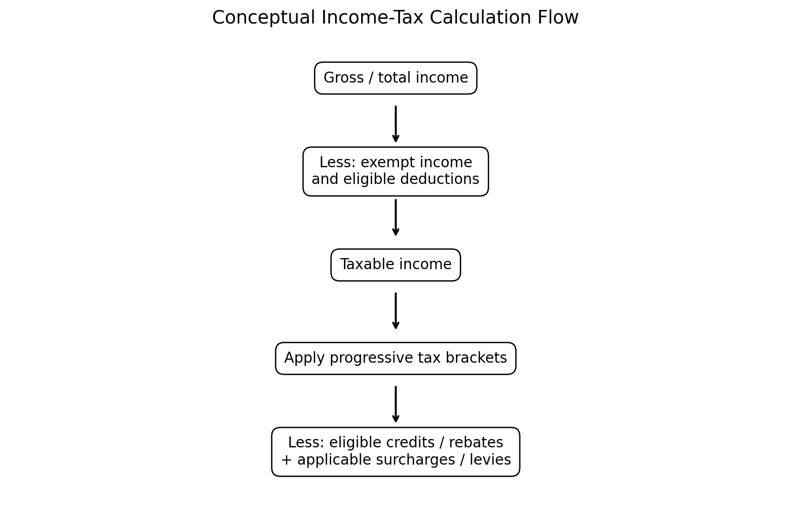
Figure 1. Conceptual flow of an income-tax calculation.
For example, if a system has a 10% first bracket and a 20% second bracket, a taxpayer whose taxable income reaches the second bracket does not pay 20% on the entire amount. The first layer remains taxed at 10%, and only the amount inside the second layer is taxed at 20%. This distinction is fundamental when comparing tax systems.

6. Exemptions, Deductions, Allowances and Credits
Exemptions and exclusions generally prevent specified income from entering the tax base. Deductions reduce taxable income before rates are applied. Allowances may function similarly by permitting a specified amount to be excluded or relieved. Tax credits, in contrast, reduce the tax calculated after applying the relevant rates. Because these mechanisms operate at different stages, two taxpayers with the same gross income can have different final liabilities.
Governments use these mechanisms for several reasons. Some reflect genuine costs associated with earning income; others encourage saving, retirement provision, education, charitable giving, home ownership or particular social objectives. The policy challenge is to keep reliefs targeted and understandable while preventing excessive complexity.

7. India: Income-Tax Framework
India's individual income-tax framework is administered under the Income-tax Act, 1961 and related rules. For Assessment Year 2026-27, the Income Tax Department's official guidance shows a new-regime slab structure of 0% up to ₹4 lakh, 5% from ₹4–8 lakh, 10% from ₹8–12 lakh, 15% from ₹12–16 lakh, 20% from ₹16–20 lakh, 25% from ₹20–24 lakh, and 30% above ₹24 lakh for the applicable individual category. The same official guidance also describes the section 87A rebate for eligible taxpayers under the new regime. [2]
India therefore provides an instructive example of how a tax system can offer different regimes with different rates and relief structures. Taxpayers must consider the applicable rules, eligible deductions, exemptions, rebates and filing requirements rather than looking at a single headline rate.
The Indian system also demonstrates the increasing importance of digital administration. Income-tax filing, taxpayer services, notices and other processes are increasingly delivered through electronic platforms. This can improve speed and transparency but also increases the importance of accurate digital records and taxpayer awareness.

8. United States: Federal Income Tax Framework
The United States operates a federal individual income-tax system with seven regular marginal rates. For tax year 2026, the IRS lists rates of 10%, 12%, 22%, 24%, 32%, 35% and 37%. For a single taxpayer, the 2026 thresholds begin with 10% up to $12,400 and rise through the brackets, with the 37% rate applying above $640,600. The IRS also lists a standard deduction of $16,100 for single taxpayers and married individuals filing separately, $32,200 for married couples filing jointly, and $24,150 for heads of household. [3]
The U.S. framework illustrates the importance of filing status. The same rate structure can have different thresholds depending on whether a taxpayer is single, married filing jointly, married filing separately or head of household. In addition to federal income tax, taxpayers may face state and local taxes depending on where they live or work.
The U.S. system also makes extensive use of tax credits, deductions, withholding and information reporting. This combination creates a large administrative framework in which employers, financial institutions and taxpayers all provide information that supports compliance.

9. United Kingdom: Income Tax Framework
The United Kingdom uses a personal allowance and income-tax bands. For the 2026–27 tax year, HM Revenue & Customs states that the standard Personal Allowance is £12,570. For England, Wales and Northern Ireland, the main rates are 20% basic rate, 40% higher rate and 45% additional rate, with taxable-income bands set by the government. Scotland has a separate income-tax structure with additional bands and rates. [4]
The UK example demonstrates that a single country can contain internal differences in tax rates. It also demonstrates how an allowance can operate before the marginal-rate bands are applied. Certain types of savings and dividend income have separate rules and allowances.

10. Australia: Income Tax Framework
Australia's resident individual income-tax structure uses a tax-free threshold followed by progressive rates. The legislative material associated with the Australian Taxation Office's 2024 reforms states that, for 2024–25 and later income years, resident individuals have no tax on taxable income up to $18,200, then face 16% on the amount from $18,201 to $45,000, 30% from $45,001 to $135,000, 37% from $135,001 to $190,000, and 45% above $190,000. [5]
Australia also uses PAYG withholding to collect tax through the year. The Australian Taxation Office's 2026 PAYG tables were updated for schedules applying from 1 July 2026, reflecting enacted personal income-tax changes. [6] This illustrates how statutory rates and administrative withholding mechanisms work together.

11. Canada: Income Tax Framework
Canada uses a federal income-tax schedule together with provincial or territorial income taxes. For 2026, the Canada Revenue Agency lists federal rates of 14% on the first $58,523 of taxable income, 20.5% on the next portion up to $117,045, 26% up to $181,440, 29% up to $258,482, and 33% above that level. Provincial or territorial rates apply in addition to the federal tax. [7]
The Canadian structure is therefore a useful example of tax decentralization: the federal government determines federal rates, while provinces and territories have their own income-tax rates. The Canada Revenue Agency also notes that federal brackets are adjusted for inflation. [7]

12. Comparative Analysis of Selected Jurisdictions
Jurisdiction | Broad structure | Illustrative top rate | Key feature | Main authority
India | Progressive slabs; regime-specific rules | 30% (new-regime ordinary slab) | Two regime structures for many individuals; rebates/deductions depend on rules | Income Tax Department
United States | Federal progressive brackets + state/local layers | 37% federal | Filing status, standard deduction, credits and federal/state interaction | IRS
United Kingdom | Personal allowance + progressive bands | 45% main rate | Scotland has a separate income-tax band structure | HMRC
Australia | National progressive rates | 45% | Tax-free threshold and PAYG withholding | ATO
Canada | Federal progressive brackets + provincial/territorial tax | 33% federal | Two-level personal income-tax system | CRA
Note: The rates above are not directly comparable as a measure of overall tax burden. They refer to selected individual income-tax rates and do not incorporate every allowance, deduction, credit, surtax, payroll contribution, state/provincial tax or special regime. They are included to demonstrate structural differences.
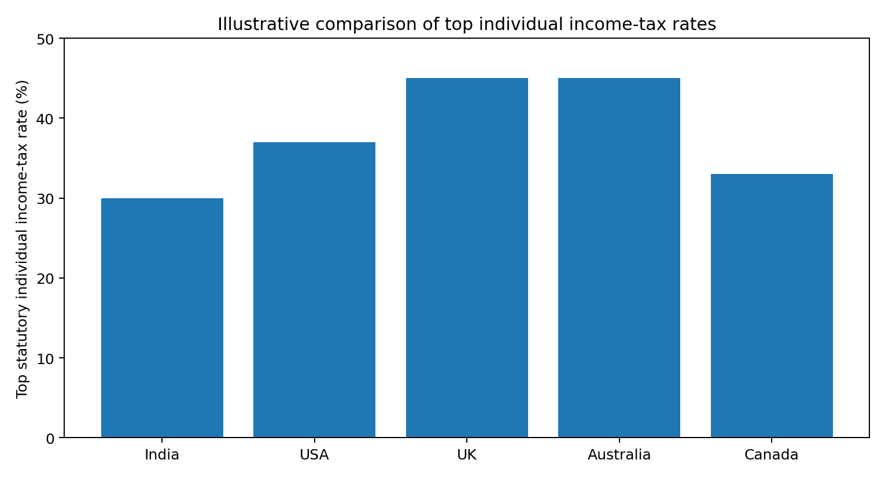
Figure 2. Illustrative top statutory individual income-tax rates from the official schedules reviewed.
The chart is a simplified visual comparison of the headline top rates cited in this report. It should not be interpreted as a ranking of countries or as a comparison of actual effective tax burdens.

13. Economic Rationale Behind Income Tax
The first economic rationale is revenue generation. Governments require resources for public services and infrastructure. Income tax provides a recurring revenue source linked to the taxpayer's economic capacity.
The second rationale is redistribution. Because higher-income taxpayers can contribute a larger share of income while retaining resources for essential consumption, progressive taxation can be used to transfer resources toward public programs. The precise distributional effect depends on the entire tax-and-benefit system, not only the income-tax rates.
The third rationale is stabilization. During periods of economic expansion, incomes may rise and tax collections may increase. During downturns, lower incomes can reduce tax liabilities. This automatic movement can interact with government spending to influence aggregate demand.
The fourth rationale is policy influence. Deductions, credits and preferential treatments can encourage behaviour such as retirement saving, investment, education or charitable activity. However, such incentives have fiscal costs and can increase complexity if too many exceptions are created.

14. Impact on Taxpayers and Governments
For taxpayers, income tax affects disposable income, saving and investment decisions. Compliance also creates time and record-keeping costs. Employers may bear administrative responsibilities through withholding and reporting.
For governments, income tax is both a revenue instrument and a policy tool. Governments must balance adequate revenue against economic incentives, administrative cost, taxpayer compliance and public acceptance. Poorly designed systems can create opportunities for avoidance, encourage informal economic activity or generate high compliance costs.
The distributional impact also matters. A tax system may appear progressive at the statutory rate level but produce a different outcome after deductions, credits, indirect taxes and transfers are considered. Therefore, serious tax analysis should distinguish statutory rates from effective tax burdens.

15. Modern Adaptations: Digital Tax Administration
Tax administration is increasingly digital. Online filing, electronic notices, digital payments, pre-filled information, data matching and automated risk analysis can reduce administrative costs and improve compliance. At the same time, taxpayers need reliable digital records, cybersecurity awareness and clear procedures for correcting errors.
Internationalization is another major adaptation. Employees, investors and businesses can earn income across borders, while digital business models can generate economic activity without a simple physical presence. Tax treaties, information exchange and international cooperation therefore play an increasing role in modern tax policy.

16. Key Findings
- Income-tax systems share common concepts but differ substantially in definitions, thresholds, reliefs and administration.
- Progressive tax brackets require analysis of marginal rates rather than assuming one rate applies to total income.
- Deductions and allowances reduce taxable income, whereas credits and rebates generally reduce tax payable directly.
- India, the United States, the United Kingdom, Australia and Canada demonstrate different ways of combining progressive taxation with reliefs and administrative mechanisms.
- Sub-national taxation is significant in the United States and Canada, while the UK has a distinct Scottish income-tax structure.
- Digital filing, withholding and information reporting are now central elements of modern tax administration.
- Statutory top rates should not be used alone to compare the overall tax burden between countries.
- Tax rules change over time, so official government sources should be consulted before making actual filing or planning decisions.

17. Conclusion
Income tax is more than a schedule of percentages. It is a legal and economic framework that determines how income is defined, how taxpayers are classified, how reliefs are granted, how liabilities are calculated, and how revenue is collected. The underlying objectives include revenue generation, equity, economic efficiency, administrative feasibility and support for public policy.
The comparison undertaken in this report demonstrates that there is no single universal model. India uses a modern dual-regime structure for individuals, the United States combines federal taxation with state and local systems, the UK uses a personal allowance and separate bands including a Scottish structure, Australia combines a tax-free threshold with progressive national rates, and Canada combines federal and provincial or territorial taxes. Despite these differences, all five systems rely on concepts such as taxable income, marginal rates, reliefs, compliance and administrative enforcement.
For students and future tax professionals, the most important lesson is to analyse a tax system as an integrated framework. A correct understanding requires attention to the taxpayer, tax base, rate schedule, deductions, credits, filing status, residence, withholding and administrative rules. Because tax laws change regularly, professional analysis should always verify current requirements against official government publications.

