WEEK 3 INTERNSHIP REPORT
Income Tax Computation and Compliance Simulation

Virtual Income Tax Analysis Intern
Simulated Resident Individual Case Study
Assessment Year 2026–27
Prepared for: YUVO Intern

Executive Summary
This report presents an execution-focused simulation of individual income-tax computation and compliance for Assessment Year 2026–27. The case is hypothetical and is designed to demonstrate the complete process from identifying income sources through calculating taxable income, applying tax slabs, adding health and education cess, reconciling tax deducted at source (TDS), and assessing major compliance risks. The taxpayer is assumed to be a resident individual below 60 years of age with salary income of ₹18,00,000 and bank-interest income of ₹1,20,000.
Two scenarios are computed: the default new tax regime under section 115BAC and the old tax regime. Under the new regime, the salary standard deduction of ₹75,000 is used, producing taxable income of ₹18,45,000. Applying the official AY 2026–27 new-regime slabs gives tax of ₹1,69,000 before cess and ₹1,75,760 after 4% health and education cess. Under the old regime, the ₹50,000 standard deduction, a simulated ₹1,50,000 section 80C deduction and ₹25,000 eligible medical-insurance deduction produce taxable income of ₹16,45,000. The resulting illustrative tax is ₹3,08,500 before cess and ₹3,20,840 after cess. The simulation therefore demonstrates how the interaction between tax rates and available deductions can materially change the liability.
The report also examines TDS reconciliation, advance-tax concepts, return filing, record keeping, compliance checkpoints, potential errors and risk mitigation. The purpose is educational: the calculations are based on stated assumptions and official tax guidance available for AY 2026–27. Actual taxpayers must verify the exact applicability of deductions, special rate income, rebates, surcharge, interest and filing requirements before submitting a return.

1. Task Objective and Scope
The objective of Week 3 is to apply theoretical tax knowledge to a simulated case and document the computation process step by step. The task requires a detailed hypothetical case with income sources, allowed deductions and applicable credits; a clear methodology and formulas; documented calculations; analysis of the results; and an evaluation of compliance and potential tax risks.
The scope of this report is deliberately limited to a straightforward resident individual case so that the computational logic can be demonstrated transparently. The simulation does not attempt to model every possible tax provision. In particular, it excludes capital gains, foreign income, business income, lottery income, complex house-property losses and other items that may be subject to special rates or additional rules.

2. Hypothetical Taxpayer Profile
Parameter | Assumption
Taxpayer | Mr. A, hypothetical resident individual
Age | Below 60 years
Assessment Year | 2026–27
Employment | Private-sector salaried employee
Annual salary income | ₹18,00,000
Bank interest | ₹1,20,000
Total gross income | ₹19,20,000
Old-regime standard deduction | ₹50,000
Simulated eligible 80C investment | ₹1,50,000
Simulated eligible 80D premium | ₹25,000
New-regime standard deduction | ₹75,000
TDS assumed during year | ₹1,75,000 (simulation)

3. Relevant AY 2026–27 Tax Rules Used
The Income Tax Department's current AY 2026–27 guidance lists the new-regime slabs for individuals below 60 as: nil up to ₹4 lakh; 5% from ₹4–8 lakh; 10% from ₹8–12 lakh; 15% from ₹12–16 lakh; 20% from ₹16–20 lakh; 25% from ₹20–24 lakh; and 30% above ₹24 lakh. The same official material identifies the new regime under section 115BAC. citeturn0search0turn0search2
The Department also states that the section 87A rebate under the new regime is increased to ₹60,000 for eligible total income up to ₹12 lakh from AY 2026–27. Since the simulated taxpayer's income exceeds ₹12 lakh, the report does not apply that rebate. citeturn0search3
For comparison, the old-regime rates for a person below 60 are nil up to ₹2.5 lakh, 5% for ₹2.5–5 lakh, 20% for ₹5–10 lakh, and 30% above ₹10 lakh. The old regime permits specified deductions and exemptions subject to their individual conditions. The simulation uses only the deductions expressly listed in the case assumptions. citeturn0search0
The report also treats 4% health and education cess as applicable to the computed income tax in the illustrative calculation. No surcharge is applied because the simulated income is below the relevant surcharge threshold.

4. Income Classification
The taxpayer has two income sources. The first is salary income of ₹18 lakh. Salary is the primary source and is assumed to be supported by employer payroll records and Form 16. The second is ₹1.20 lakh of bank interest, assumed to be supported by bank statements and interest certificates. The combined gross income is therefore ₹19.20 lakh.
The Income Tax Department explains that Form 16 records salary income, deductions or exemptions and TDS, while Form 16A is used for TDS on income other than salary. These documents are important for reconciliation between taxpayer records and information available to the tax department. citeturn0search0

5. Computation Methodology
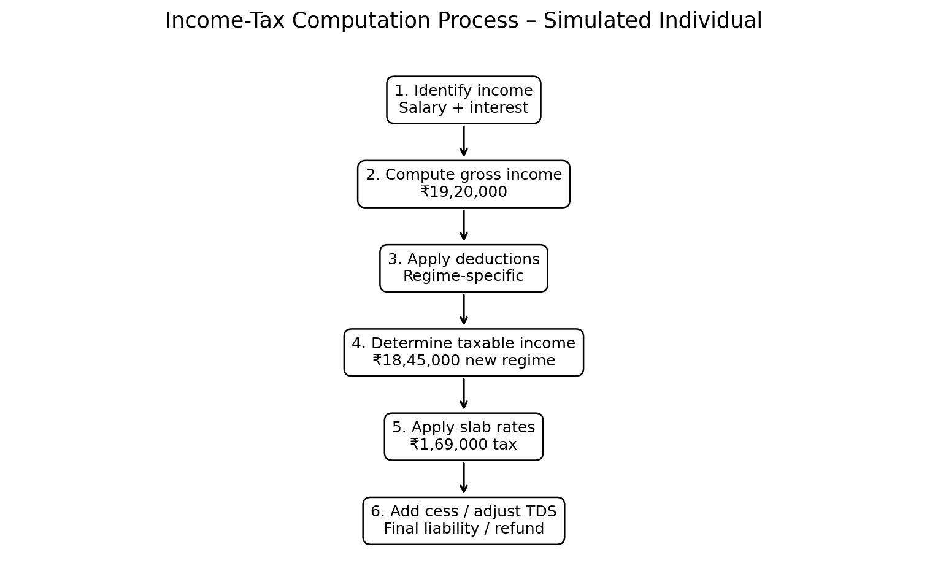
Figure 1. Step-by-step income-tax computation flow.
The basic formula used in the simulation is: Gross Total Income minus eligible deductions and permitted adjustments equals taxable income. Taxable income is then divided across the applicable slabs. Tax after slab computation is increased by applicable surcharge, if any, and health and education cess. Finally, TDS and eligible advance-tax payments are credited to determine the balance payable or refund.

6. New Tax Regime: Step-by-Step Calculation
Step 1 – Gross income:
Salary ₹18,00,000 + bank interest ₹1,20,000 = ₹19,20,000.
Step 2 – Standard deduction:
New-regime salary standard deduction assumed = ₹75,000.
Step 3 – Taxable income:
₹19,20,000 − ₹75,000 = ₹18,45,000.
Step 4 – Apply slabs:
Slab | Rate | Tax on slab
Up to ₹4,00,000 | 0% | ₹0
₹4,00,001–₹8,00,000 | 5% | ₹20,000
₹8,00,001–₹12,00,000 | 10% | ₹40,000
₹12,00,001–₹16,00,000 | 15% | ₹60,000
₹16,00,001–₹18,45,000 | 20% | ₹49,000
Total | — | ₹1,69,000
Step 5 – Cess: ₹1,69,000 × 4% = ₹6,760.
Step 6 – Total illustrative tax liability = ₹1,75,760.
Step 7 – Less simulated TDS of ₹1,75,000 = balance payable ₹760.

7. Old Tax Regime: Step-by-Step Calculation
Step 1 – Gross income = ₹19,20,000.
Step 2 – Standard deduction = ₹50,000.
Step 3 – Simulated section 80C deduction = ₹1,50,000.
Step 4 – Simulated section 80D deduction = ₹25,000.
Step 5 – Taxable income = ₹19,20,000 − ₹50,000 − ₹1,50,000 − ₹25,000 = ₹16,45,000.
Slab | Rate | Tax
Up to ₹2,50,000 | 0% | ₹0
₹2,50,001–₹5,00,000 | 5% | ₹12,500
₹5,00,001–₹10,00,000 | 20% | ₹1,00,000
₹10,00,001–₹16,45,000 | 30% | ₹1,93,500
Total | — | ₹3,06,000
Step 6 – Cess: ₹3,06,000 × 4% = ₹12,240.
Step 7 – Total illustrative tax liability = ₹3,18,240.
Step 8 – Less simulated TDS of ₹1,75,000 = balance payable ₹1,43,240.

8. Comparison of the Two Scenarios
Measure | New regime | Old regime | Observation
Gross income | ₹19,20,000 | ₹19,20,000 | Same income base
Major deductions used | ₹75,000 standard deduction | ₹50,000 standard + ₹1,50,000 80C + ₹25,000 80D | Old regime has more simulated deductions
Taxable income | ₹18,45,000 | ₹16,45,000 | Old regime produces lower taxable income
Income tax before cess | ₹1,69,000 | ₹3,06,000 | New-regime slab structure produces lower tax here
4% cess | ₹6,760 | ₹12,240 | Cess applied to tax
Illustrative total liability | ₹1,75,760 | ₹3,18,240 | New regime lower in this case
TDS assumed | ₹1,75,000 | ₹1,75,000 | Same assumed credit
Balance payable | ₹760 | ₹1,43,240 | Subject to actual TDS and final return data
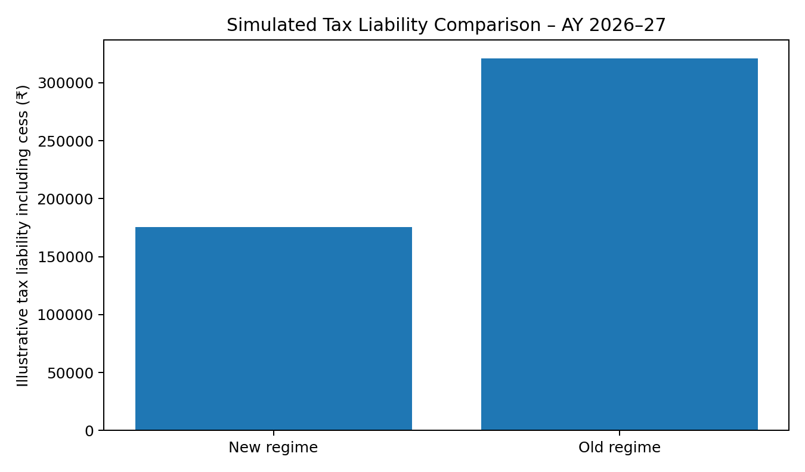
Figure 2. Simulated tax liability comparison including 4% cess.
On the assumptions used, the new regime results in lower tax despite providing fewer of the traditional deductions used in the old-regime scenario. The reason is the substantially different slab structure. This does not establish that the new regime is always preferable; taxpayers with different income types, deductions, exemptions or special-rate income can have a different result.

9. TDS Reconciliation and Compliance Simulation
TDS is an important compliance mechanism because tax can be collected during the year rather than only when the annual return is filed. In this simulation, TDS of ₹1,75,000 is assumed to have been deducted and deposited. The taxpayer should reconcile the amount with Form 16 and the tax information available through the income-tax portal.
Reconciliation item | New regime | Old regime
Final simulated liability | ₹1,75,760 | ₹3,18,240
Less: TDS | ₹1,75,000 | ₹1,75,000
Balance tax payable | ₹760 | ₹1,43,240
If actual TDS were higher than the final liability, the difference could generally become a refund after successful return processing. If TDS were lower, the taxpayer would need to pay the balance subject to the applicable rules. The actual position should be determined from official records rather than an assumed amount.

10. Advance Tax Considerations
Advance tax is designed to collect tax during the year. Where a taxpayer has a sufficient tax liability after considering TDS and other credits, the taxpayer may have advance-tax obligations. The exact applicability, instalment schedule and interest consequences must be checked against the taxpayer's circumstances and the applicable provisions. For this simulation, the assumed TDS almost fully covers the new-regime liability, so the example does not create a separate advance-tax payment schedule. This is intentional: the exercise focuses on demonstrating the computation and reconciliation process rather than inventing an advance-tax obligation where the facts are insufficient.

11. Return-Filing and Documentation Checklist
- Verify PAN, residential status and basic personal details.
- Collect Form 16 from the employer and reconcile salary, deductions and TDS.
- Collect bank interest certificates/statements and reconcile interest income.
- Review eligible deductions under the chosen tax regime.
- Check AIS/other available information and investigate material differences.
- Calculate taxable income and tax liability using the applicable slabs.
- Add surcharge, health and education cess and other applicable amounts where required.
- Credit TDS and eligible advance-tax/self-assessment-tax payments.
- Pay any remaining tax before filing where required.
- Select the correct ITR form and submit the return within the applicable deadline.
- Complete verification and retain acknowledgement and supporting records.

12. Compliance Risk Assessment
Risk | Potential consequence | Risk level | Control
Income omitted | Under-reporting, tax demand, interest and possible penalty | High | Reconcile AIS, bank statements and Form 16
Incorrect deduction | Disallowance and additional tax | Medium/High | Retain proof and verify eligibility
TDS mismatch | Return processing delay or demand/refund mismatch | Medium | Reconcile Form 16/26AS/AIS
Wrong ITR form | Return may be defective or require correction | Medium | Check eligibility before filing
Missed deadline | Interest, late fee or other consequences | Medium/High | Use a compliance calendar
Calculation error | Incorrect tax payment/refund | Medium | Use step-by-step working and independent review
Unverified special-rate income | Incorrect tax rate | High | Identify capital gains and other special-rate items separately

13. Regulatory and Practical Pitfalls
The first major pitfall is treating accounting income as identical to taxable income. Tax law can provide deductions, disallowances, exemptions and special rules that change the final taxable amount. The second is assuming that every deduction is available under every regime. The third is failing to distinguish ordinary slab-rate income from income taxed under special provisions. Capital gains are a common example of an area that requires separate treatment.
Another pitfall is relying only on an employer's TDS figure. TDS is a credit, not necessarily the final tax liability. Other income such as bank interest must be included, and the taxpayer must reconcile tax credits with official records. Finally, a taxpayer should not rely on outdated slab rates. The Income Tax Department's current AY 2026–27 pages show the new-regime slabs that apply for the assessment year used in this simulation. citeturn0search0turn0search2

14. Quality-Control Procedure for the Computation
A reliable computation should be independently checked. First, recalculate gross income from source documents. Second, recalculate each deduction separately and confirm the applicable regime. Third, check each slab calculation using a second method, such as a spreadsheet. Fourth, recompute cess and any surcharge. Fifth, reconcile TDS and other tax credits. Sixth, review the final return data against the working paper. This six-step process reduces arithmetic and classification errors.
For an internship simulation, every figure should be traceable to an assumption or source. This makes the report auditable and demonstrates that the student understands not only the final answer but also how the answer was produced.

15. Sensitivity Analysis
The result is sensitive to changes in income and deductions. If salary increased substantially, more income could move into higher marginal-rate bands. If eligible old-regime deductions were reduced, the old-regime taxable income would increase. Conversely, if a taxpayer had substantial eligible deductions and exemptions, the difference between regimes could narrow. If the taxpayer received capital gains or other special-rate income, the calculation would require a separate tax-rate analysis. Therefore, a regime comparison should be updated whenever income or major deductions change.
Change in assumption | Expected effect | Control response
Salary increases | Higher taxable income; potentially higher marginal tax | Update forecast and TDS
Eligible 80C/80D claims decrease | Old-regime taxable income rises | Verify proofs before choosing regime
Additional bank interest | Gross income rises | Reconcile all bank accounts
Capital gains arise | Special-rate computation may be needed | Separate capital-gain working
TDS differs from assumption | Balance payable/refund changes | Reconcile official tax-credit records

16. Findings and Compliance Evaluation
The simulation meets the principal computational objectives. The income sources were identified, taxable income was calculated under two regimes, slab-by-slab tax was computed, cess was added, and TDS was reconciled. The analysis also identified compliance risks and proposed controls. The new-regime calculation is ₹1,75,760 including cess, while the old-regime calculation is ₹3,18,240 including cess under the stated assumptions. The difference is ₹1,42,480.
The comparison demonstrates the value of scenario analysis. A taxpayer should not choose a regime merely by looking at the number of deductions available or the highest marginal rate. The complete taxable-income calculation and final tax liability must be compared using the taxpayer's actual facts.

17. Conclusion
This Week 3 simulation demonstrates the practical process of computing and reviewing individual income tax. Starting with gross income, the computation moves through deductions, taxable income, slab rates, cess and tax credits. The report shows how the same gross income can lead to different liabilities under different regimes because the rate structure and deduction rules differ.
The exercise also demonstrates that accurate tax computation is inseparable from compliance. Form 16, bank statements, tax-credit information and supporting documents provide the evidence needed to substantiate the return. A well-designed working paper should allow another reviewer to reproduce every important figure.

