`ICollection`, `IEnumerable`, and `IQueryable` are interfaces in .NET that are used to represent collections of objects. Each of these interfaces has a different purpose and provides different capabilities.

**1. IEnumerable:**

`IEnumerable` is the simplest of the three interfaces and is used to represent a sequence of objects that can be enumerated. An object that implements `IEnumerable` provides a method called `GetEnumerator()` that returns an `IEnumerator` object. This `IEnumerator` object can be used to iterate through the sequence of objects.

Example:

**2. ICollection:**

`ICollection` is a more advanced interface that extends `IEnumerable`. It represents a collection of objects that can be modified, such as adding, removing or modifying elements. In addition to the methods inherited from `IEnumerable`, `ICollection` provides additional methods like `Add()`, `Remove()`, `Clear()`, etc.

Example:

**3. IQueryable:**

`IQueryable` is an interface that is used to represent a queryable data source. It provides capabilities for filtering, sorting, and paging data. An object that implements `IQueryable` represents a query that is executed against a data source when it is enumerated.

Example:

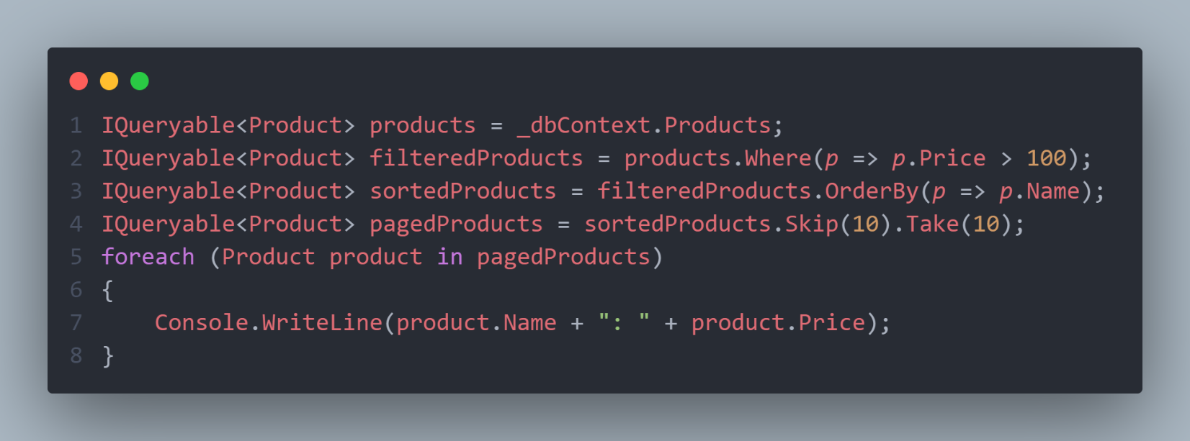

In this example, the `products` variable represents an `IQueryable` data source. The `Where()`, `OrderBy()`, and `Skip()`/`Take()` methods each return a new `IQueryable` object that represents a query that is executed when the data is enumerated in the `foreach` loop.

In summary, `IEnumerable` is used for simple enumeration of a collection, `ICollection` is used for collection manipulation, and `IQueryable` is used for querying data sources that can be remotely executed, like a database.

**Use Cases**

`IEnumerable`, `ICollection`, and `IQueryable` are interfaces in C# that are used to work with collections of data, but they have different use cases and characteristics:

**1. IEnumerable:**

- Use Case: `IEnumerable` is the most basic and widely used interface for iterating over collections of data, such as arrays, lists, and other collections. It represents a forward-only cursor for reading data.

- Characteristics:

- It provides read-only access to a collection.

- It supports simple iteration using `foreach` loops.

- It is suitable for in-memory collections where you need to iterate over the data sequentially.

**2. ICollection:**

- Use Case: `ICollection` extends the functionality of `IEnumerable` by adding methods for adding, removing, and checking for the presence of elements in a collection. It's a good choice when you need to work with collections that require modification.

- Characteristics:

- It inherits from `IEnumerable`.

- It includes methods like `Add`, `Remove`, and `Contains` for modifying and checking the collection.

- It's useful for scenarios where you need to both iterate over and modify a collection, such as lists, sets, or queues.

**3. IQueryable:**

- Use Case: `IQueryable` is primarily used in LINQ (Language Integrated Query) to query data from different data sources, such as databases, web services, or in-memory collections. It allows you to write queries that are executed against the data source rather than fetching all data into memory.

- Characteristics:

- It extends `IEnumerable` and is designed for deferred execution, meaning the query is not executed until you enumerate the results.

- It's used with data sources that support querying, like Entity Framework for databases.

- It enables efficient data retrieval by generating optimized SQL queries (in the case of databases) or applying filtering and projection to reduce data transfer.

**In summary:**

- Use `IEnumerable` for basic read-only iteration of in-memory collections.

- Use `ICollection` when you need to modify or check for the presence of elements in a collection.

- Use `IQueryable` when you want to write queries that can be executed against various data sources with deferred execution for efficient data retrieval and filtering.