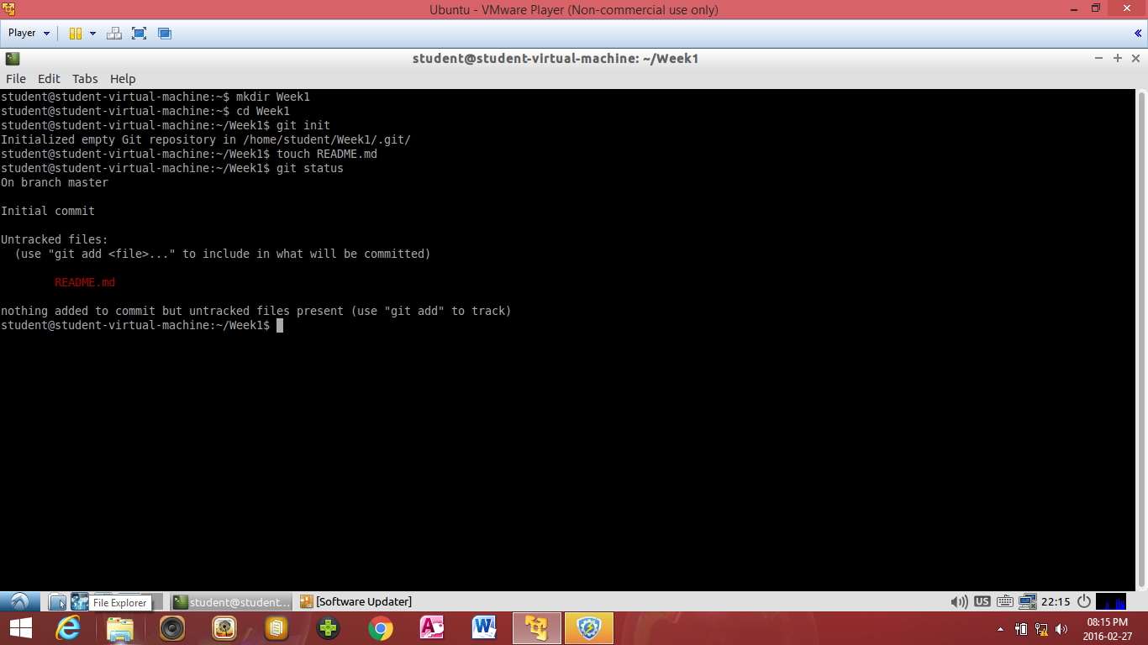

The Read me file I have created is not yes commited but is being tracked that is why it appears Red.

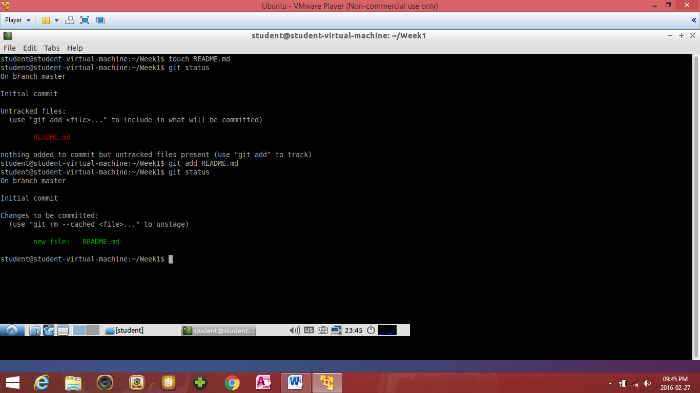

I have commited the tracked file that is why it appears Green.

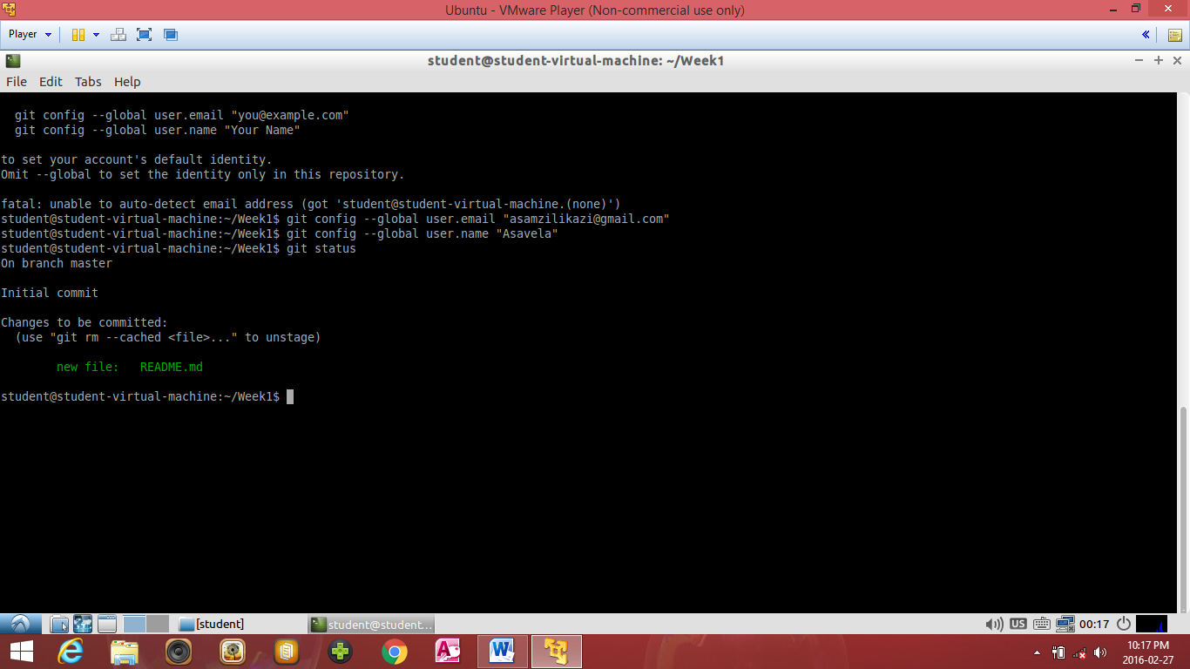

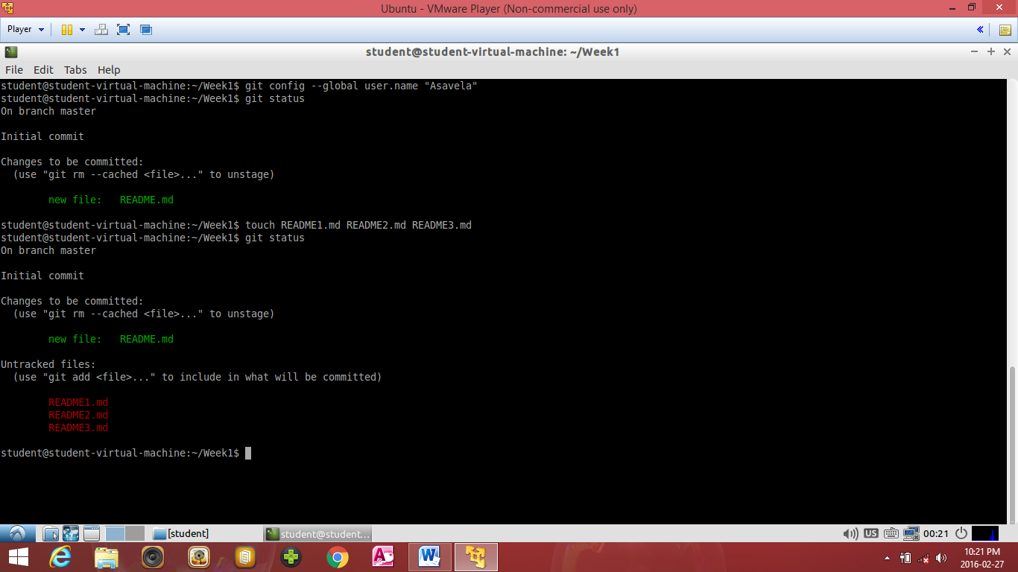

The three files appear Red since I only tracked them. They are not commited.

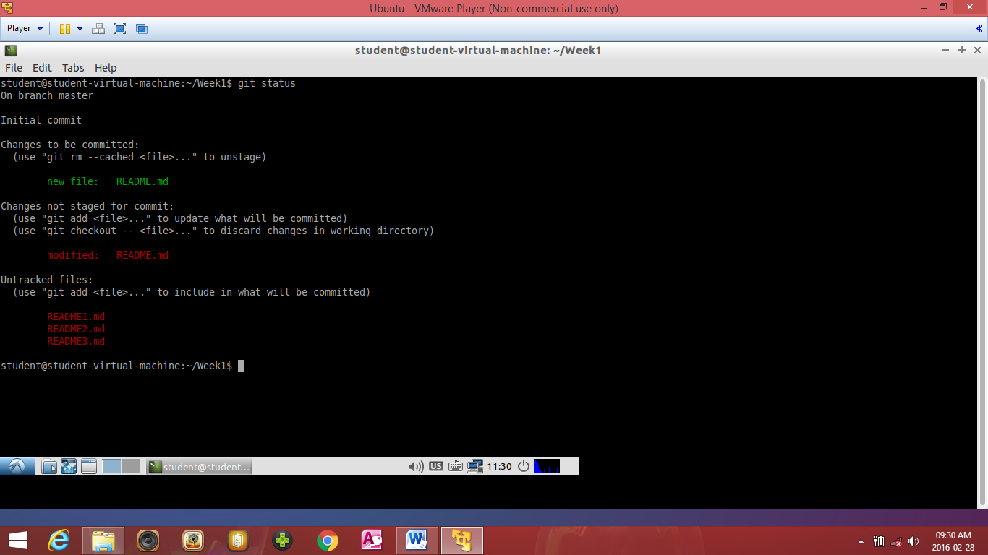

I have made changes to the README.md file .

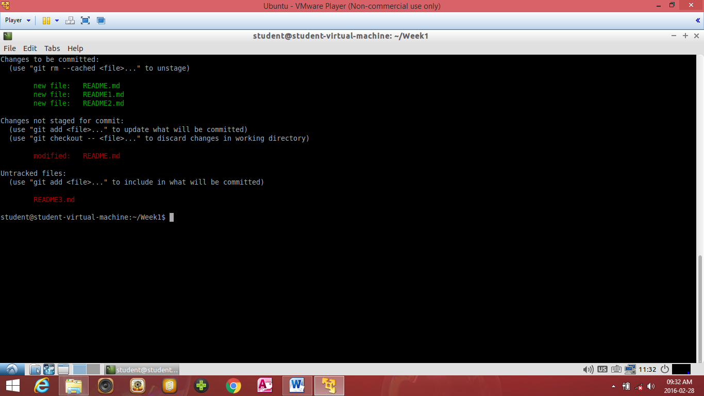

Two more files have been committed. They moved from the tracked files to committed files.

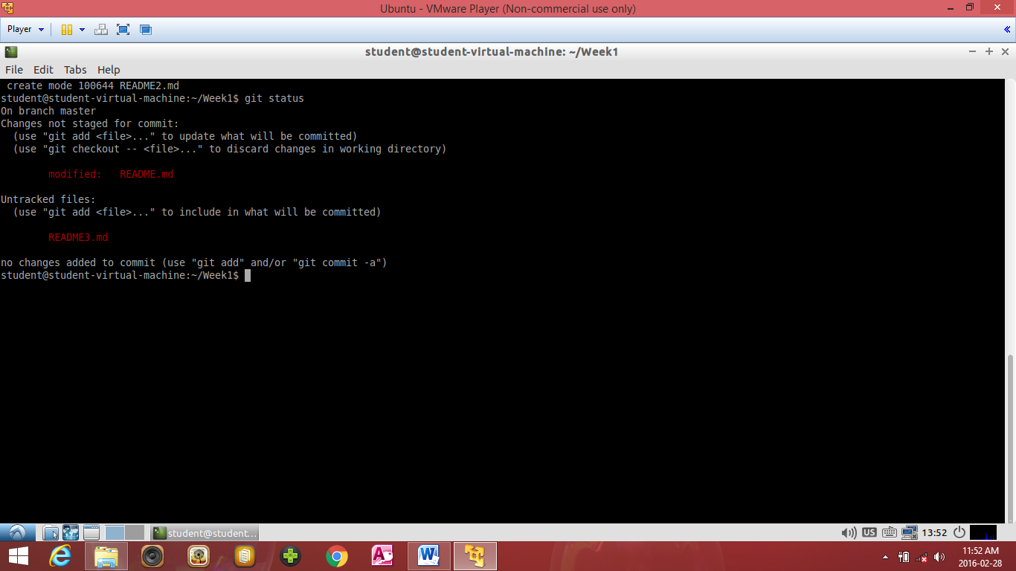

After committing the modified files the other two files disappeared .

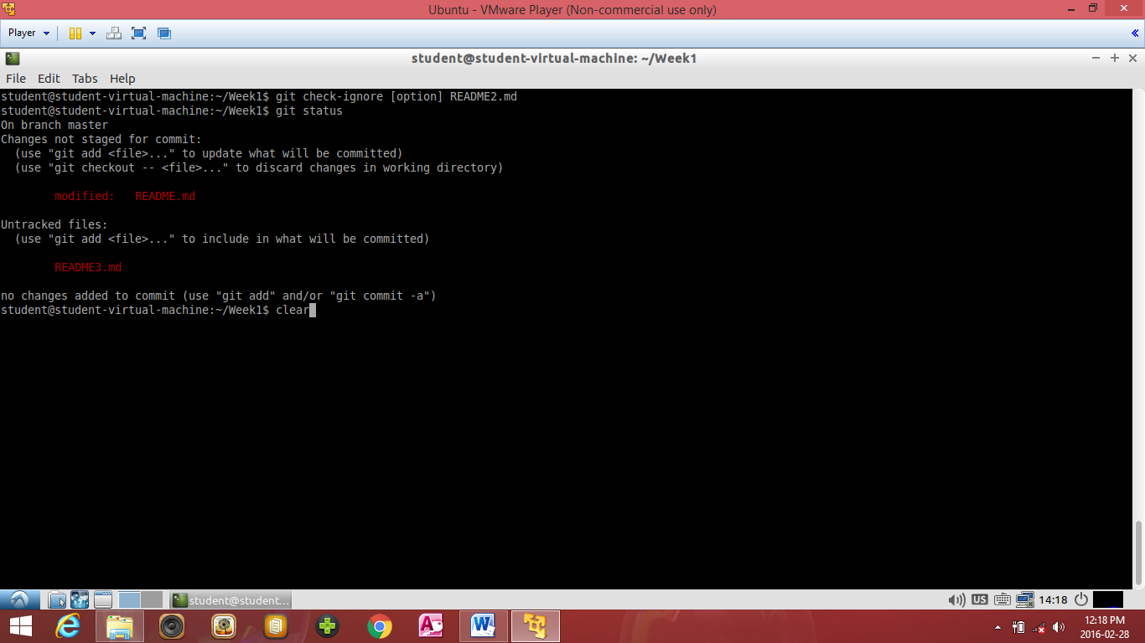

README2.md has been ignored by Git.

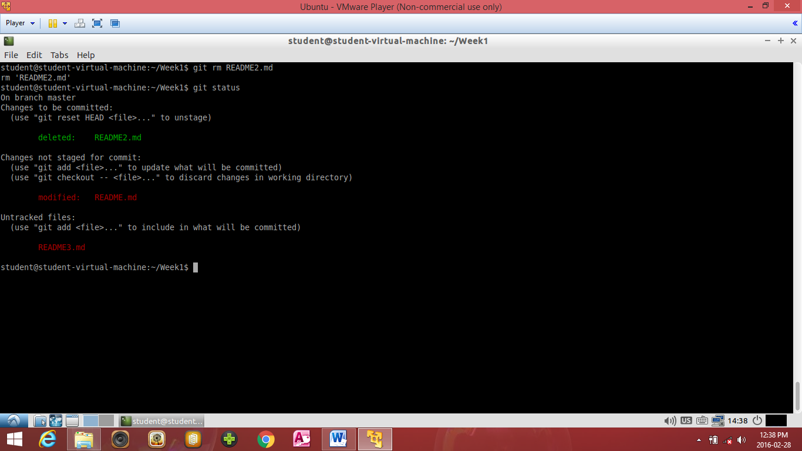

README2.md has been deleted.

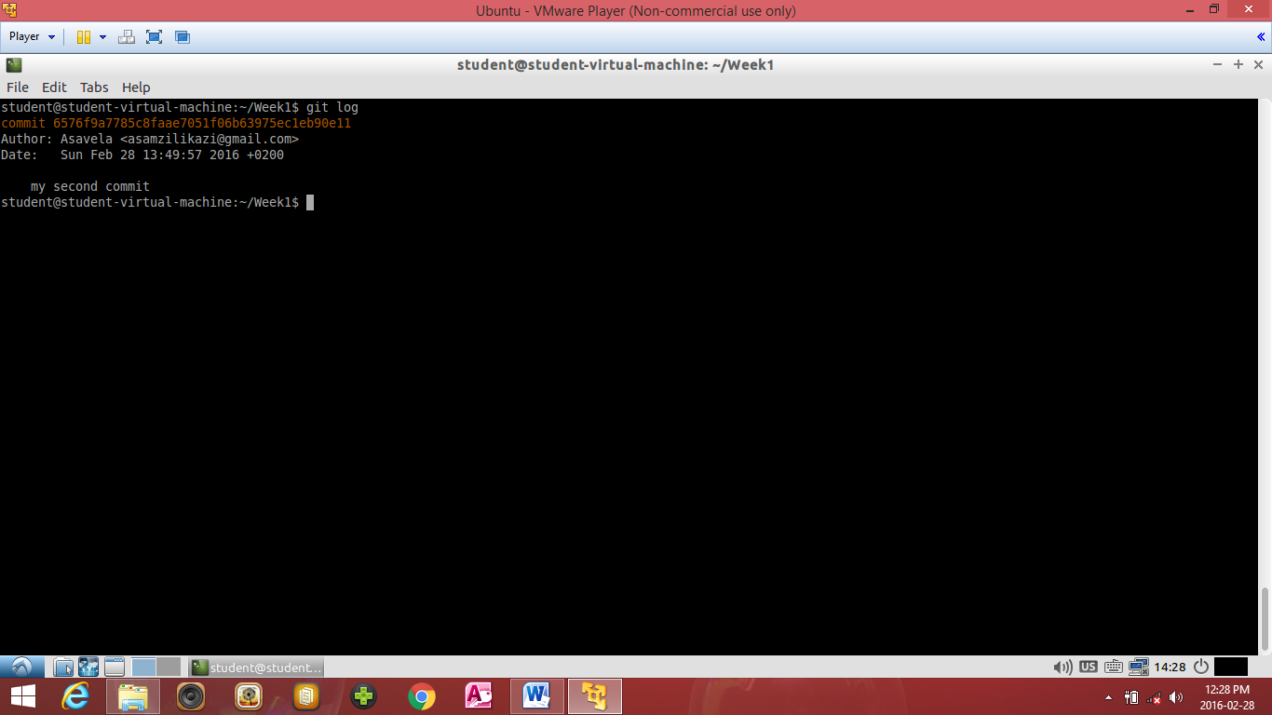

This is my commit history.

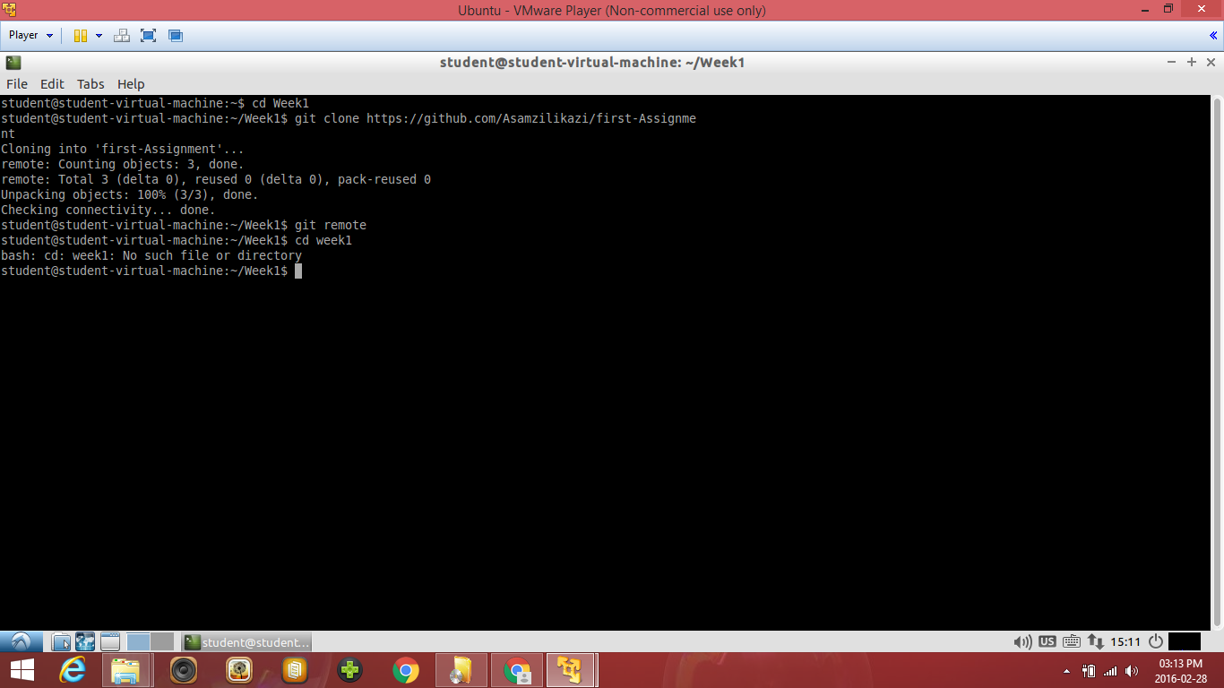

This shows my remotes

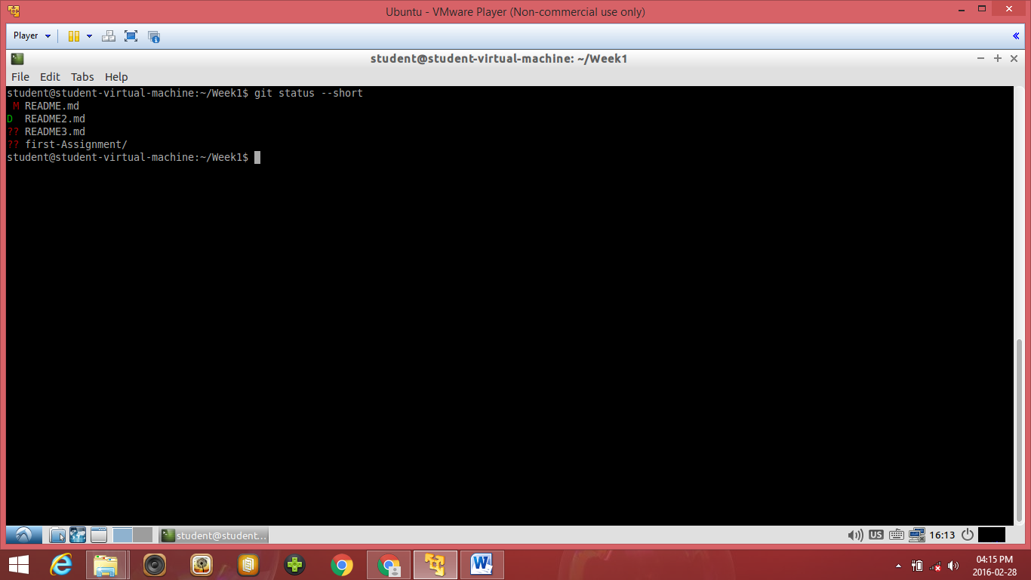

This is my short status results, README.md has been modified, README2 has been deleted and the other two file have not been changed.