POSTGRADUATE DIPLOMA IN ICT
Capstone Project — Design Phase Submission

Project Title | Machine Learning-Based Phishing URL Detection Using Feature Engineering
Student Full Name | Asanda Mbangata
Student Number | 222927259
Supervisor Name | Dr Kabaso
Stream Category | AI and Data Science
Academic Year | 2026
Submission Date | 02 August 2026

Declaration
I declare that this submission is my own original work and has been prepared in accordance with the academic integrity policies of the institution.
Student Signature: A.Mbangata | Date: ______02 August 2026____

Table of Contents
1. Introduction 4
1.1 Project Problem Statement 4
1.2 Project Scope 4
1.3 Project Objectives 5
2. Design Overview 6
2.1 Summary of Design Approach 6
2.2 Justification of Chosen Approach 6
3. Design Documents 7
3.1 High-Level Design (HLD) 7
3.1.1 System / Solution Architecture 7
3.1.2 Component Roles and Interactions 8
3.2 Detailed Design (DDD) 12
3.2.1 Module / Component Specifications 12
3.2.2 Algorithms and Logic 17
3.2.3 Interface Specifications 19
4. Diagrams and Visual Aids [25 Marks] 20
4.1 System / Architecture / Topology Diagram 20
4.2 Flowchart / Process Flow / Model Flow Diagram 21
4.3 Sequence / Interaction Diagram 24
4.4 Data Flow Diagram 25
4.5 Additional Diagrams (Use Case Diagram) 25
5. Prototypes and Mockups 26
5.1 Prototype Description 26
5.2 Prototype Screenshots 27
5.3 Explanation of Prototype Functionality 29
5.4 Prototype Limitations and Next Steps 30
6. Requirements Traceability 30
8. Stream-Specific Design Requirements 31
8.3 AI and Data Science 31
8.3.1 Model Architecture 31
8.3.2 Data Pipeline 32
9. Evaluation of Design 33
9.1 Feasibility Assessment 33
9.2 Scalability Considerations 34
9.3 Security Considerations 34
9.4 Risks and Mitigation 35
10. Conclusion 36
10.1 Summary of Design Readiness 36
10.2 Transition to Implementation 36
11. References 37
12. Appendices 38
Appendix A — Additional Diagrams 38
Appendix B — Code Snippets (if applicable) 38
Appendix C — Tools and Software Used 38

1. Introduction

1.1 Project Problem Statement
Phishing websites remain a major cybersecurity threat because they are designed to imitate legitimate online platforms and deceive users into disclosing sensitive information, such as login credentials, financial information, and other personal data (Tang and Mahmoud, 2021). These attacks may affect individuals, businesses, financial institutions, and public organisations that rely on online services. The increasing reliance on online banking, e-commerce, and digital communication has given cyber attackers more opportunities to take advantage of ignorant users through phishing websites. As a result, identifying potentially fraudulent websites remains an important cybersecurity concern (Kulkarni, Balachandran and Das, 2025; Ahmad et al., 2025).
Traditional phishing detection methods, such as blacklists and manually defined rules, can be effective for identifying websites that have been reported or known to be malicious (Tang and Mahmoud, 2021). Nonetheless, if phishing websites are newly created or modified and have not yet been included in existing databases, these approaches may be less effective (Tang and Mahmoud, 2021; Asiri et al., 2023). This has increased interest in machine-learning approaches that can learn patterns from historical examples of phishing and legitimate websites and use those patterns to classify previously unseen websites (Tang and Mahmoud, 2021; Ahmad et al., 2025).

According to Tang and Mahmoud (2021), the performance of machine-learning-based phishing detection is influenced by the quality and relevance of the features used to represent websites. Kustiawan and Ghauth (2025) state that URL structure, domain characteristics, technical properties, and website behaviour are important features for distinguishing phishing websites from legitimate websites. Simply increasing the number of features does not necessarily improve classification performance, as irrelevant or redundant features may increase model complexity and reduce its efficiency (Nanda, Saraswat and Sharma, 2024). For this reason, feature engineering and feature selection are important aspects of developing machine-learning solutions for phishing detection. Previous research has investigated machine-learning models, deep-learning techniques, and feature-engineering approaches for detecting phishing websites (Tang and Mahmoud, 2021; Nanda, Saraswat and Sharma, 2024; Kustiawan and Ghauth, 2025). Despite previous research, there is still a need to determine how the preparation and selection of website-related features influence the performance of different machine-learning classifiers when they are evaluated using the same dataset and experimental process.

This project addresses the problem by designing and developing a machine-learning-based phishing URL detection solution using the publicly available phishing website dataset introduced by Vrbančič, Fister Jr., and Podgorelec (2020). The dataset contains labelled phishing and legitimate website instances represented by website-related features, providing a suitable foundation for supervised classification and feature analysis. The project will investigate dataset preparation, feature engineering and selection, and the comparative performance of selected machine-learning classification models. The expected outcome is a working proof-of-concept system that uses engineered website features to classify websites as phishing or legitimate. The prototype will also allow the internet user to enter a website URL. A defined subset of compatible URL-based features will be extracted from the submitted URL and provided to the trained classification model.

1.2 Project Scope
This project focuses on the design and development of a supervised machine-learning classification solution for detecting phishing websites using a publicly available labelled phishing website dataset. The project includes dataset quality assessment, data preprocessing, exploratory data analysis, feature engineering and selection, machine-learning model development, model evaluation, and comparative analysis of classification performance. Logistic Regression, Random Forest, and Support Vector Machine classifiers will be investigated using consistent data-preparation, training, and evaluation procedures.

The project will produce a documented machine-learning pipeline, trained classification models, evaluation results, visualisations, design artefacts, and a proof-of-concept prototype. Through the prototype, internet users will be able to enter a website URL for analysis. After receiving the URL, the system will extract a predefined subset of URL-based features and use the selected trained classification model to predict whether the submitted URL is associated with a phishing or legitimate website. The system will then display the classification results to the user.
The scope of this project is limited to the development and evaluation of a proof-of-concept system within a controlled academic environment. The system boundary extends from dataset preparation and machine-learning model development to URL validation, feature extraction, classification, and the presentation of results. The intended users are internet users who wish to assess potentially suspicious website URLs before interacting with them, such as links received through emails, SMS messages, or online messaging platforms.
The project excludes the collection of new data from live websites, direct interaction with human participants, deployment as a production cybersecurity service, integration with web browsers or banking systems, and the development of a commercial-scale phishing prevention platform. The system will not perform real-time website crawling, analyse website content, or guarantee the detection of all current or future phishing attacks. Additionally, the prototype will be limited to features that can be extracted directly from the submitted URL and to the capabilities of the trained model.

1.3 Project Objectives

Objective 1: To assess and preprocess the selected phishing website dataset for machine-learning development.

Objective 2: To analyse, engineer, and select features that improve phishing website detection.
Objective 3: To design and develop a supervised machine-learning classification pipeline using Logistic Regression, Random Forest, and Support Vector Machine models for classifying website instances as phishing or legitimate.

Objective 4: To compare the performance of selected machine-learning classification models using accuracy, precision, recall, F1-score, ROC-AUC, and confusion-matrix analysis.

Objective 5: To develop a proof-of-concept phishing URL detection prototype.

2. Design Overview

2.1 Summary of Design Approach

This project proposes the design of a supervised machine-learning classification pipeline for detecting phishing websites. The system will use the publicly available Phishing Websites Dataset, which contains labelled examples of phishing and legitimate websites represented by website-related features. The design follows a sequential workflow consisting of dataset acquisition, data inspection, data cleaning and preprocessing, exploratory data analysis, feature engineering and selection, model training, model evaluation, and prototype-based classification.

The dataset will first be examined to identify its structure, data types, class distribution, missing values, duplicate records, and other relevant data-quality characteristics. The target label will then be separated from the input features, and the dataset will be divided into training and testing subsets. Training data will be used during feature analysis, model development, and model selection, while the testing data will be stored for the final evaluation of model performance on previously unseen data. Feature engineering and feature-selection techniques will be utilized to investigate which website-related attributes provide useful information for distinguishing phishing websites from legitimate websites.

The prepared feature data will be used to train and compare Logistic Regression, Random Forest, and Support Vector Machine classifiers. Preprocessing and feature-processing steps will be incorporated into a reproducible machine-learning pipeline to ensure that the same transformations are applied consistently during model development and evaluation. Model performance will be assessed using accuracy, precision, recall, F1-score, ROC-AUC, and confusion-matrix analysis.

The final design will include a proof-of-concept prototype that allows users to submit a website URL. The prototype will extract a predefined subset of supported URL-based features, apply the required preprocessing, and provide the extracted feature data to the selected trained model for classification. The resulting prediction will be displayed as either phishing or legitimate. The design will be supported by technical documentation, data-processing diagrams, model-flow diagrams, evaluation visualisations, and prototype outputs.

2.2 Justification of Chosen Approach

A supervised machine-learning approach was selected because the chosen dataset contains labelled examples of phishing and legitimate websites. These labels provide the known outcomes required to train classification models to learn relationships between website-related features and the target classes. The problem is therefore formulated as a binary classification task in which the model will predict whether a website is phishing or legitimate. Unlike traditional blacklist or rule-based detection methods, machine-learning models can learn patterns from historical data and use these patterns to classify previously unseen websites (Tang and Mahmoud, 2021; Ahmad et al., 2025).

Instead of relying on a single classification algorithm, the design compares Logistic Regression, Random Forest, and Support Vector Machine classifiers. Logistic Regression provides a simple and interpretable baseline for binary classification, while Random Forest can model complex and non-linear relationships between features through its ensemble structure. Support Vector Machine is suitable for high-dimensional feature spaces because it makes decision boundaries that separate different classes. Using the same prepared dataset and evaluation procedures for all three models supports a consistent comparison of their classification performance.

Feature engineering and feature selection form an important part of the design because characteristics used to represent phishing websites directly influence the effectiveness and efficiency of classification models. According to Kustiawan and Ghauth (2025), URL-based, domain, content, behavioural, and derived features all contribute to phishing website detection, while feature selection and dimensionality reduction help improve model performance when working with high-dimensional datasets. This project investigates which features provide the most valuable information for classification rather than assuming that all available features contribute equally.

A structured machine-learning pipeline was also selected to organise preprocessing, feature engineering, model training, and evaluation into repeatable stages. This approach ensures that the same preprocessing steps are consistently applied throughout model development and evaluation while reducing the risk of data leakage. Separating training and testing datasets further supports an unbiased evaluation by ensuring the final model is tested on previously unseen data.

Model performance will be evaluated using multiple performance metrics because accuracy alone does not always provide a complete assessment of classification performance. Precision, recall, F1-score, ROC-AUC, and confusion matrix analysis provide additional insights into classification errors and the models’ ability to distinguish between phishing and legitimate websites. Generally, this design provides a balance between model performance, interpretability, reproducibility, and practical implementation while remaining achievable within the available project timeframe and resources. It also aligns directly with the project objectives of feature analysis, model comparison, and prototype development.

3. Design Documents

3.1 High-Level Design (HLD)

3.1.1 System / Solution Architecture
The Machine Learning-Based Phishing URL Detection System consists of two main components: a machine-learning model development pipeline and a URL-based classification prototype. Figure 1 illustrates the overall architecture and shows how the phishing website dataset is used to develop and evaluate machine-learning models, and how the selected trained model is integrated into the prototype to classify user-submitted URLs.

Machine-learning model development pipeline begins with a publicly available phishing website dataset containing labelled phishing and legitimate website instances. The dataset is inspected, cleaned, and preprocessed before feature engineering and feature selection are performed. The prepared dataset is then divided into training and testing subsets. Training data is used to develop Logistic Regression, Random Forest, and Support Vector Machine models, while testing data is reserved for evaluating model performance using accuracy, precision, recall, F1-score, ROC-AUC, and confusion matrix analysis. The most suitable model is then selected for deployment within the prototype.

URL-based classification prototype provides an interface through which internet users can submit website URLs for analysis. Submitted URL is validated before compatible URL-based features are extracted. The same preprocessing and feature-processing steps used during model development are applied to extracted features to ensure consistency between training and prediction stages. Processed feature values are then supplied to selected trained model, which will predict whether the submitted URL is phishing or legitimate. The classification result is presented to the user through a prototype interface

The URL-based prototype is intended to support internet users who want to assess potentially suspicious website URLs before interacting with them. An internet user submits a website URL through the prototype interface. The system validates the submitted URL and extracts a predefined subset of URL-based features that are compatible with the selected trained model. The extracted features are processed using the same feature-processing approach applied during model development. The prepared feature values are then supplied to the trained model, which generates a prediction indicating whether the submitted URL is classified as phishing or legitimate. The classification result is displayed through the prototype interface.

Architecture separates data preparation, feature processing, model development, model evaluation, feature extraction, and prediction into independent components. This design improves maintainability, allows each component to be developed and tested independently, and supports future enhancement of individual modules without affecting the entire system.

3.1.2 Component Roles and Interactions
The system consists of interconnected components that support both the development of the machine-learning models and the classification of website URLs through the proof-of-concept prototype. The components communicate through structured data inputs and outputs. During model development, the phishing website dataset flows through data inspection and preparation, feature engineering and selection, model training, and model evaluation. The selected trained model is then integrated into the URL-based prototype, where it is used to classify website URLs submitted by internet users.
Components | Role | Input | Output | Interaction
Phishing Website Dataset | Provides labelled phishing and legitimate website instances used for machine-learning development and evaluation. | Publicly available dataset | Raw labelled website data | Supplies the raw dataset to the Data Inspection and Preparation component.
Data Inspection and Preparation | Inspects the dataset and performs data-quality assessment, cleaning, preprocessing, and preparation for machine-learning development. | Raw labelled website data | Prepared dataset | Receives the dataset and passes the prepared data to the Feature Engineering and Selection component.
Feature Engineering and Selection | Analyses website-related features, performs feature engineering where necessary, and selects relevant features for model development. | Prepared dataset | Processed and selected features | Supplies the selected features and corresponding class labels to the Machine-Learning Model Training component.
Machine-Learning Model Training | Trains Logistic Regression, Random Forest, and Support Vector Machine classification models using prepared training data. | Training data containing selected features and class labels | Trained classification models | Passes the trained models to the Model Evaluation and Selection component.
Model Evaluation and Selection | Evaluates and compares trained models using testing data and selected performance metrics to identify the most suitable model. | Trained models, testing data, predictions, and actual class labels | Model-performance results and selected trained model | Provides the selected trained model for integration into the URL-based prototype.
URL Input and Validation Interface | Allows internet users to submit a potentially suspicious website URL and validates the submitted input before feature extraction. | Website URL submitted by an internet user | Validated website URL | Passes the validated URL to the URL Feature Extraction and Processing component.
URL Feature Extraction and Processing | Will extract the predefined URL-based features required by the selected trained model and apply the same preprocessing and feature-processing steps used during model development. | Validated website URL | Processed URL-based feature values | Supplies the processed feature values to the selected trained model.
Classification and Results Interface | Uses the selected trained model to classify the URL and will display the result to the internet user. | Processed URL-based feature values and selected trained model | Phishing or legitimate classification result | Receives the model prediction and will display the classification result through the prototype interface.

Model development begins with the labelled phishing website dataset. The dataset is inspected, cleaned, and preprocessed before feature engineering and feature selection are performed. Selected features are then used to train Logistic Regression, Random Forest, and Support Vector Machine models. The trained models are evaluated using reserved testing data, and the most suitable model is selected for integration into a proof-of-concept prototype.

The prototype begins when an internet user submits a potentially suspicious website URL. The submitted URL is validated before predefined URL-based features are extracted and processed using the same feature-processing steps applied during model development. Processed feature values are then passed to selected trained model, which will predict whether the URL is phishing or legitimate. Classification result is finally displayed to the user.
3.1.3 Technology Stack Summary
Layer / Component | Technology / Tool | Justification
Frontend / Presentation | Streamlit | Streamlit will be used to develop a simple web-based prototype that allows internet users to submit a website URL and view the phishing classification result. It supports rapid development of interactive Python applications.
Backend / Application Logic | Python | Python will be used to implement URL validation, feature extraction, preprocessing, model integration, and classification logic.
Data Processing and Feature Engineering | pandas and NumPy | pandas will be used for loading, cleaning, transforming, and analysing the dataset, while NumPy will support numerical computations required during preprocessing and model development.
Machine Learning | scikit-learn | scikit-learn will be used to implement Logistic Regression, Random Forest, and Support Vector Machine models, together with preprocessing, feature selection, model evaluation, and hyperparameter tuning.
Data Visualisation | Matplotlib and Seaborn | These libraries will be used to create exploratory data analysis visualisations and evaluation charts, including class distributions, feature visualisations, confusion matrices, and model comparison graphs.
Model Storage | joblib | joblib will be used to save and load the trained machine-learning model and preprocessing pipeline for use in the prototype.
Development Environment | Jupyter Notebook and Visual Studio Code | Jupyter Notebook will be used for data exploration and model experimentation, while Visual Studio Code will be used to develop and organise the prototype application.
Version Control and Repository | Git and GitHub | Git will manage version control, while GitHub will provide a central repository for source code, documentation, and project artefacts.
Dataset / Data Source | Phishing Websites Dataset | Provides labelled phishing and legitimate website instances required for training and evaluating supervised machine-learning models.
Diagramming | diagrams.net (draw.io) | Used to create architecture, process flow, data flow, and UML diagrams required for the design documentation.
Prototype Design | Figma | Used to design the user interface mock-ups before implementation.
Infrastructure/ Hosting | Local Environment | The system will be developed, tested, and demonstrated in a controlled local environment during the project.
This technology stack was selected to support the complete development lifecycle of the project, from dataset preparation and feature engineering to model training, evaluation, and prototype development. Python serves as the primary programming language because of its extensive machine-learning ecosystem, while the supporting tools provide functionality for data processing, visualisation, version control, user-interface development, and documentation.

3.2 Detailed Design (DDD)

3.2.1 Module / Component Specifications

Module | Input | Key Processing Activities | Output | Dependencies
1. Data Acquisition and Inspection | Phishing Websites Dataset in CSV format | Loads the dataset; examines the number of records and features; identifies data types, missing values, duplicate records, invalid or inconsistent values, and class distribution. | Initial dataset profile and data-quality findings | Python, pandas, NumPy
2. Data Cleaning and Preprocessing | Raw dataset and data-quality findings | Addresses relevant data-quality issues; removes or handles duplicate, missing, invalid, or inconsistent values where applicable; separates the target label from the input features; prepares the data for machine-learning analysis. | Cleaned and prepared dataset | Python, pandas, NumPy, scikit-learn
3. Feature Engineering and Selection | Prepared feature data | Analysed the available website-related features; applied relevant transformations; evaluated feature relevance; removed unsuitable or redundant features where justified; identified the final feature set for model development. | Processed and selected feature set | Python, pandas, NumPy, scikit-learn
4. Data Splitting and Model Preparation | Selected features and target labels | Divides the data into stratified training and testing subsets; applies preprocessing procedures using the training data; prepares the data for model development while preserving the testing data for final evaluation. | Prepared training and testing datasets | scikit-learn
5. Machine-Learning Model Training | Prepared training data | Trains Logistic Regression, Random Forest, and Support Vector Machine classification models; applies cross-validation and relevant hyperparameter tuning during model development. | Trained classification models | Python, scikit-learn
6. Model Evaluation and Selection | Trained models, testing data, predicted values, and actual labels | Generates model predictions; calculates accuracy, precision, recall, F1-score, and ROC-AUC; produces confusion matrices; compares the performance of the models. | Model-evaluation results and selected trained model | scikit-learn, Matplotlib, Seaborn
7. Model and Preprocessing Storage | Selected trained model and associated preprocessing components | Saves the selected model, feature-selection information, and preprocessing components for reuse by the prototype. | Selected trained model and processing artefacts | joblib
8. URL Input and Validation | Website URL submitted by an internet user | Accepts the URL through the prototype interface; checks whether the input is present and follows a supported URL format; identifies unsupported or invalid input. | Validated URL or input-validation message | Streamlit, Python
9. URL Feature Extraction and Processing | Validated website URL | Will extract the predefined URL-based features that are compatible with the selected model; arranges the extracted values in the required feature order; applies the saved preprocessing procedures. | Processed feature vector | Python, pandas, NumPy, saved preprocessing components
10. URL Classification and Result Presentation | Processed URL-based feature vector and stored trained model | Loads the selected trained model; generates a phishing or legitimate prediction; presents the classification result through the prototype interface. | Phishing or legitimate classification result | Streamlit, Python, scikit-learn, joblib
The components are organised into two main phases: machine-learning model development and prototype-based URL classification. The first phase begins with data acquisition, inspection, cleaning, and preprocessing to ensure that the dataset is suitable for machine-learning analysis. Feature engineering and selection are then performed to identify relevant website-related attributes before the data is split into training and testing subsets.

The prepared training data is used to develop the Logistic Regression, Random Forest, and Support Vector Machine models. After training, the models are evaluated using the reserved testing dataset, and the most suitable model is selected based on the predefined evaluation metrics. The selected model, together with the preprocessing pipeline, is then stored for reuse during classification.

The second phase begins when an internet user submits a website URL through the prototype interface. The system will validate the input, extract the predefined URL-based features, and apply the same preprocessing steps used during model development. The processed feature vector is passed to the stored machine-learning model, which will predict whether the URL is phishing or legitimate. Finally, the classification result is displayed to the user.

3.2.2 Algorithms and Logic
The design consists of two main processes: the machine-learning model development process and the URL-based classification process. The model-development process prepares the phishing website dataset, trains and evaluates the selected classification models, and saves the most suitable model for use in the prototype. The URL-classification process accepts a website URL, extracts the predefined URL-based features, and uses the saved model to generate a classification result. The machine-learning development process is illustrated in Figure 2.

Pseudocode 1: Machine-Learning Model Development

BEGIN

Load and inspect the phishing website dataset

Clean and prepare the dataset

Separate:
Input features (X)
Target labels (y)

Split the dataset into:
Training data
Testing data

Apply feature engineering and feature selection
using the training data

FOR each selected model:

Logistic Regression
Random Forest
Support Vector Machine

Train the model

Generate predictions using the testing data.

Calculate:
Accuracy
Precision
Recall
F1-score
ROC-AUC

END FOR

Compare the model evaluation results.

Select and save the most suitable model.

END
The pseudocode above describes the process used to develop and evaluate the machine-learning models. The phishing website dataset is first inspected, cleaned, and prepared for analysis. The website-related input features are separated from the target labels, after which the dataset is divided into training and testing data. Feature engineering and feature selection are applied to prepare the final feature set used by the classification models. Logistic Regression, Random Forest, and Support Vector Machine models are then trained and evaluated using the same prepared data. Their performance is compared using the selected evaluation metrics, and the most suitable model is saved together with the required preprocessing components for use in the URL-based prototype.
Pseudocode 2: URL-Based Classification

BEGIN

Receive a website URL from the user.

Validate the submitted URL

IF the URL is invalid THEN

Display an error message.

ELSE

Extract the predefined URL-based features.

Apply the saved preprocessing procedures.

Load the selected trained model.

Predict whether the URL is phishing or legitimate.

Display:
Potentially Phishing
OR
Potentially Legitimate

END IF

END
The pseudocode above describes how the URL-based prototype generates a classification result. An internet user enters a website URL through the prototype interface, and the system first checks whether the submitted URL is valid and supported. If the URL is invalid, an appropriate error message is displayed. If the URL is valid, the system will extract the predefined URL-based features required by the trained model and apply the same preprocessing procedures used during model development. The processed features are then supplied to the saved classification model, which will predict whether the submitted URL is Potentially Phishing or Potentially Legitimate. The resulting classification is displayed to the internet user.

3.2.3 Interface Specifications
The system prototype will use a simple user interface that supports the movement of data between the machine-learning components and user-facing interfaces that support interaction with the URL-based prototype. The internal interfaces transfer structured data between different stages of the machine-learning pipeline, including dataset preparation, feature engineering, model development, and model evaluation. It provides a user interface that allows an internet user to submit a website URL and view the classification result generated by the trained machine-learning model.

Interface | Input | Output
Dataset → Data Inspection and Preparation | Phishing website dataset in CSV format | Dataset profile and data-quality findings
Data Preparation → Feature Engineering and Selection | Cleaned and prepared dataset | Processed and selected feature set
Feature Engineering and Selection → Model Training | Selected features and target labels | Prepared training data
Model Training → Model Evaluation | Trained models and testing data | Model predictions and evaluation results
Model Evaluation → Model Selection and Storage | Model-performance results | Selected trained model and associated preprocessing components
Model Storage → URL Classification | Stored trained model and preprocessing components | Loaded model ready for prediction
URL Input → URL Validation and Feature Extraction | User-submitted website URL | Validated URL and extracted URL-based features
Feature Extraction → Classification Model | Processed URL-based feature values | Phishing or legitimate prediction
Classification Model → Results Interface | Model prediction | User-readable classification result
The internal components communicate through structured data outputs. Each component receives data from the previous stage, performs its designated processing activities, and produces an output for the next stage. The selected trained model and its associated preprocessing procedures form the connection between the model-development process and the URL-based prototype. This approach supports modular development because individual components can be tested or modified without requiring changes to the entire system.
Prototype User Interfaces
Interface / Screen | User Input or Action | System Response / Output
Website URL Input Interface | The internet user enters a website URL and selects the Analyse URL button. | The system will validate the submitted URL and begin the feature-extraction and classification process.
Input Validation Message | The internet user submits an empty, invalid, or unsupported URL. | The system will display an appropriate message requesting a valid and supported URL.
Classification Result Interface | The internet user submits a valid website URL. | The system will display whether the URL is classified as Potentially Phishing or Potentially Legitimate.
Model Performance Interface | The internet user selects the model-performance view. | The system will display the evaluation results of the selected model, including accuracy, precision, recall, F1-score, and ROC-AUC.
The prototype uses a simple user interface that communicates directly with the internal Python processing modules responsible for feature extraction, preprocessing, and classification. The interface submits the entered URL to these processing components and will display the resulting classification to the user.

4. Diagrams and Visual Aids [25 Marks]

4.1 System / Architecture / Topology Diagram
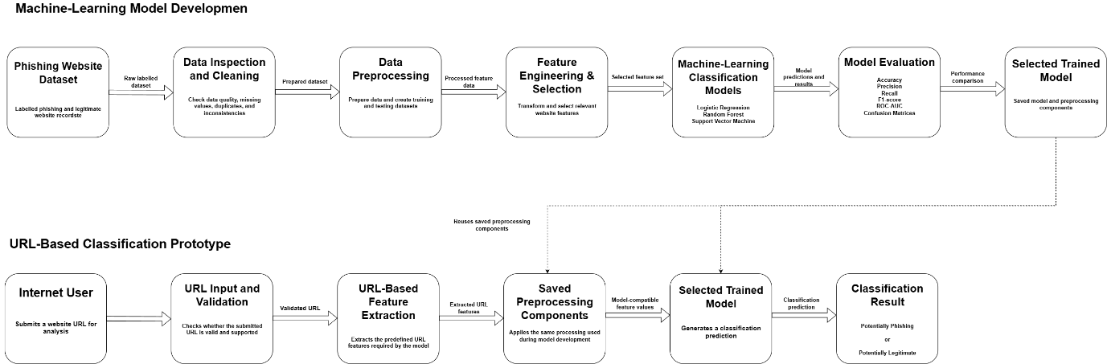
Figure 1: High-Level Architecture of the Machine Learning-Based Phishing Website Detection System
Figure 1 illustrates the high-level architecture of the machine-learning-based phishing website detection system. The architecture is divided into two connected sections: the machine-learning model development pipeline and the URL-based classification prototype.
The upper section illustrates how the publicly available phishing website dataset is inspected, cleaned, preprocessed, and analysed before being used for feature engineering, feature selection, model training, and model evaluation. Logistic Regression, Random Forest, and Support Vector Machine classifiers are trained and compared using the same prepared dataset. Their performance is assessed using accuracy, precision, recall, F1-score, ROC-AUC, and confusion-matrix analysis. The selected trained model and its associated preprocessing components are then saved for use in the prototype.
The lower section illustrates how the URL-based classification prototype operates. An internet user submits a website URL through the prototype interface. The URL is validated, and a predefined subset of URL-based features is extracted. The extracted features are processed using the same preprocessing components applied during model development to ensure compatibility with the selected trained model. The model then generates a classification result indicating whether the submitted URL is predicted to be potentially phishing or potentially legitimate.
The arrows represent the movement of data and processing outputs between components. The dashed connections indicate the reuse of the selected trained model and associated preprocessing components within the URL-based classification prototype. The architecture separates model development from URL classification while maintaining consistency between feature processing and classification through the reuse of the trained model and preprocessing pipeline.

4.2 Flowchart / Process Flow / Model Flow Diagram
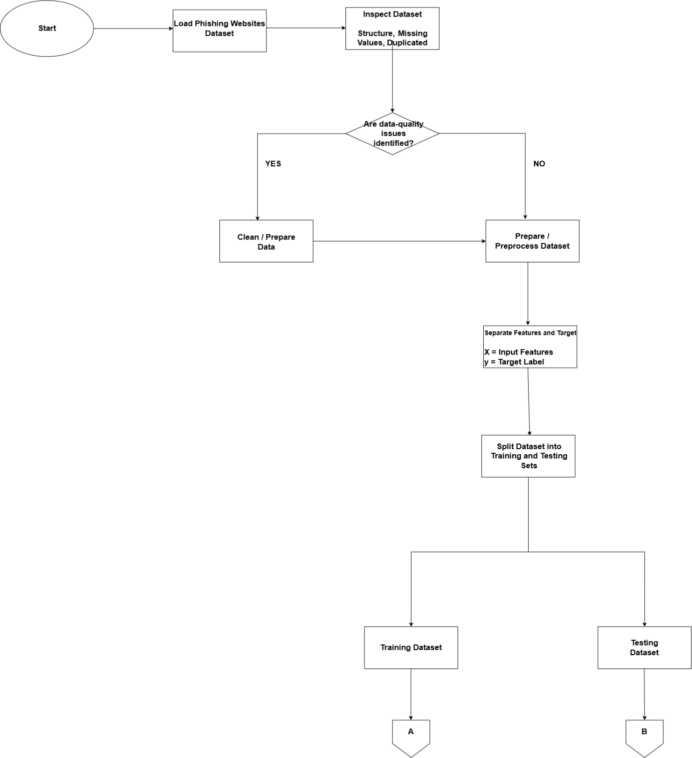

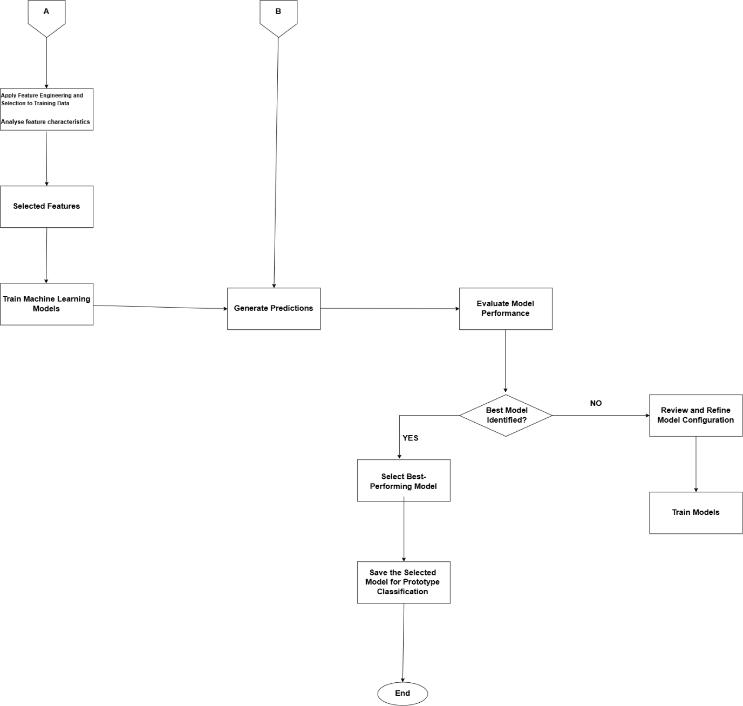
Figure 2: End-to-End Machine-Learning and URL Classification Process Flow
Figure 2 illustrates the end-to-end process for developing and using the phishing website detection solution. The process begins with the acquisition and loading of the publicly available phishing website dataset. The dataset is inspected to identify its structure, data types, class distribution, missing values, duplicate records, and other relevant data-quality issues. Any identified data-quality issues are addressed before preprocessing begins.

The prepared dataset is then divided into training and testing subsets. Feature engineering and feature selection are performed using the training data to identify and prepare the features used by the machine-learning models. Logistic Regression, Random Forest, and Support Vector Machine classifiers are trained and evaluated using consistent data-preparation procedures. Their performance is compared using accuracy, precision, recall, F1-score, ROC-AUC, and confusion-matrix analysis. The most suitable model is selected and saved together with the preprocessing components required to prepare new inputs.

The second part of the process represents the URL-based classification prototype. An internet user submits a website URL through the prototype interface. The URL is validated, and a predefined subset of URL-based features is extracted. These features are processed using the saved preprocessing components before being supplied to the selected trained model. The system will then display a result indicating whether the submitted URL is predicted to be potentially phishing or potentially legitimate.

The decision points in the flowchart represent the identification of data-quality issues during dataset preparation and the validation of the URL submitted through the prototype. If the submitted URL is invalid or unsupported, the system then displays an appropriate message rather than generating a classification result.

4.3 Sequence / Interaction Diagram
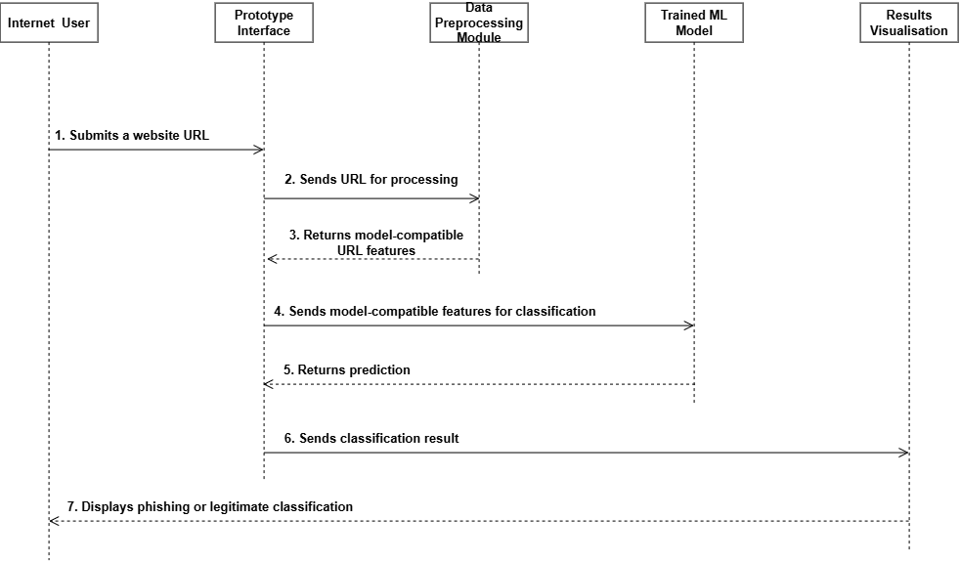
Figure 3: Interaction Sequence for Phishing Website Classification
Figure 3 illustrates the chronological interaction between an internet user and the major components of the URL-based phishing website detection prototype. The interaction begins when the internet user enters a website URL through the prototype interface and submits it for analysis. The interface sends the submitted URL to the URL validation and feature-extraction component.

The system first checks whether the submitted value is a valid and supported URL. If the URL is invalid, an error message is returned to the user through the interface. If the URL is valid, the system extracts the predefined URL-based features required by the selected trained model. The extracted features are then passed through the saved preprocessing components to ensure that they are represented in the same format used during model development.

The processed feature data is submitted to the selected trained classification model. The model generates a prediction indicating whether the submitted URL is potentially associated with a phishing or legitimate website. The prediction is returned to the prototype interface, where the classification result and relevant model information are displayed to the internet user.

This interaction sequence shows how the prototype connects user input, URL validation, feature extraction, preprocessing, machine-learning classification, and result presentation. The prototype provides a proof of concept and does not guarantee that every phishing website will be identified correctly.

4.4 Data Flow Diagram
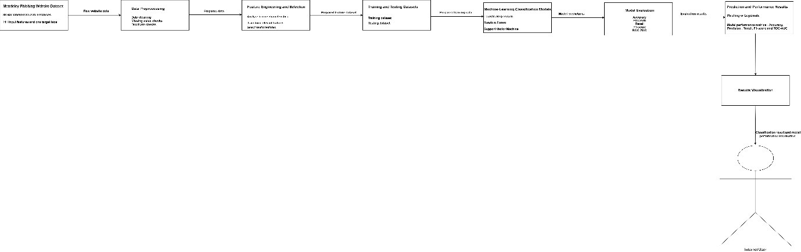
Figure 4: Data Flow and Machine-Learning Pipeline for Phishing Website Detection
Figure 4 illustrates the movement and transformation of data through the phishing website detection system. The model-development process begins with the labelled phishing website dataset. The dataset is passed through data inspection, cleaning, preprocessing, feature engineering, and feature-selection activities. The prepared data is divided into training and testing subsets, which are used to develop and evaluate the selected machine-learning classification models.

During model development, the training data is used to train the Logistic Regression, Random Forest, and Support Vector Machine classifiers. The testing data is used to evaluate the performance of the trained models. The resulting evaluation metrics and model-comparison results support the selection of the most suitable model. The selected trained model and its associated preprocessing components are saved for use in the URL-based classification prototype.

During prototype operation, an internet user provides a website URL. The submitted URL is validated, and the predefined URL-based features are extracted. The extracted features are processed using the saved preprocessing components and supplied to the selected trained model. The model generates a classification result, which is returned to the prototype interface and displayed as either potentially phishing or potentially legitimate.

This figure shows that the data used during model development is separate from the URL submitted during prototype operation.The same selected feature set and preprocessing procedures are used to maintain compatibility between the trained model and new URL inputs.

4.5 Additional Diagrams (Use Case Diagram)
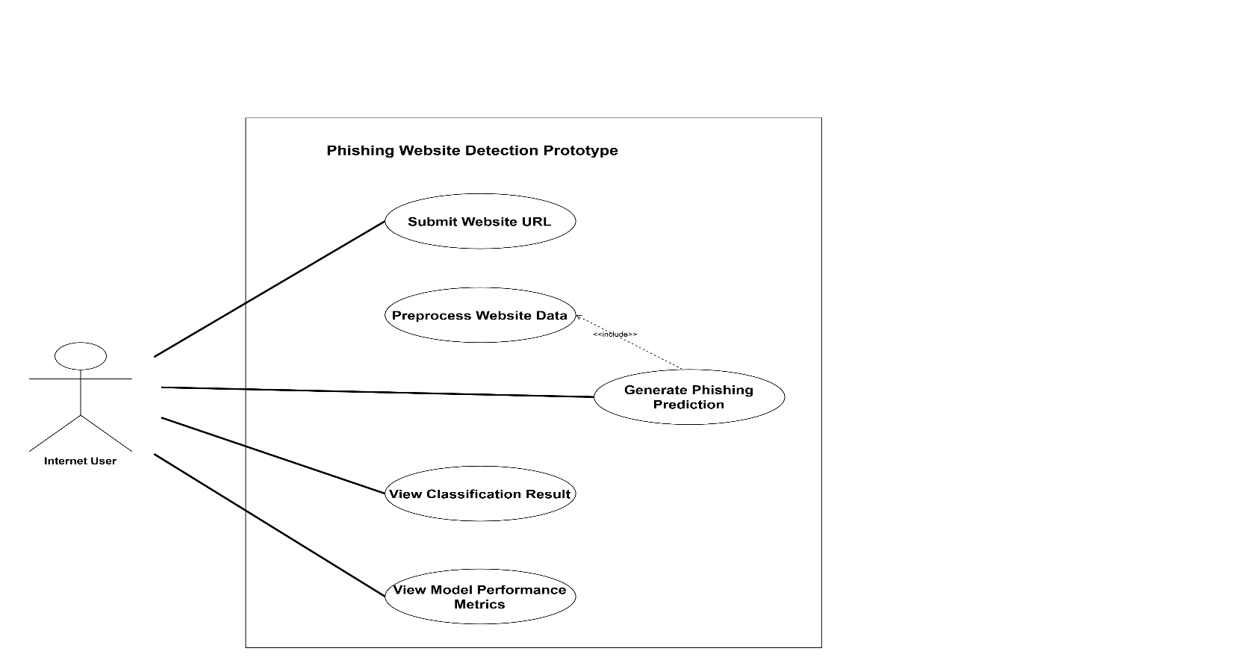
Figure 5: Use-Case Diagram for the Phishing Website Detection Prototype
Figure 5 presents the primary interactions between an internet user and the phishing website detection prototype. The internet user can enter a website URL, submit the URL for analysis, and view the resulting classification. Generating a phishing prediction includes URL validation, feature extraction, data preprocessing, and classification because each activity must be completed before a prediction can be produced.

The prototype also allows the internet user to view relevant information about the selected classification model and the model-performance results obtained during the evaluation stage. These performance results are intended to provide supporting information about the model used by the system rather than to guarantee the correctness of an individual prediction. The diagram defines the main functionality available through the prototype and demonstrates how the user interacts with the system without describing the internal technical implementation in detail.

5. Prototypes and Mockups

5.1 Prototype Description
The web-based interface demonstrates how the proposed machine-learning phishing website detection system will be used. It allows an internet user to enter a website URL, select a machine-learning classification model, and submit the URL for analysis. The proposed system will validate the submitted URL, extract the predefined URL-based features required by the trained model, apply the relevant preprocessing procedures, and generate a classification result.
The interface consists of three main screens: the Website URL Input Screen, the Classification Result Screen, and the Model Performance Screen. The Website URL Input Screen allows the user to enter a URL, select a classification model, and initiate the analysis process. The Classification Result Screen displays whether the submitted URL is predicted to be potentially phishing or potentially legitimate, together with the prediction probability or confidence value, where supported by the selected model. The Model Performance Screen presents and compares the evaluation results of Logistic Regression, Random Forest, and Support Vector Machine using the selected performance metrics. The prototype was designed using Figma to represent the proposed user interface and user workflow. The values currently displayed are illustrative and will be replaced with the actual model results during implementation and evaluation.

5.2 Prototype Screenshots
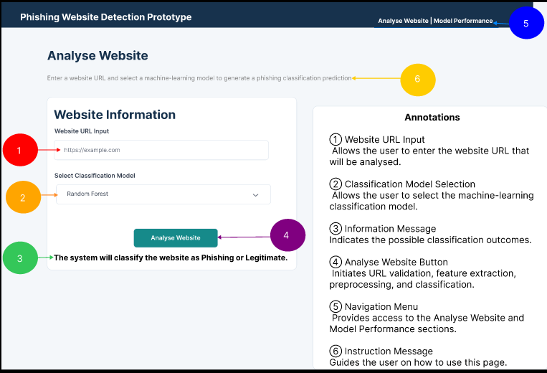
Figure 6: Website URL Input Screen(Analyse Website Page)
This screen allows the internet user to enter a website URL, select a machine-learning classification model, and initiate the phishing website analysis process.
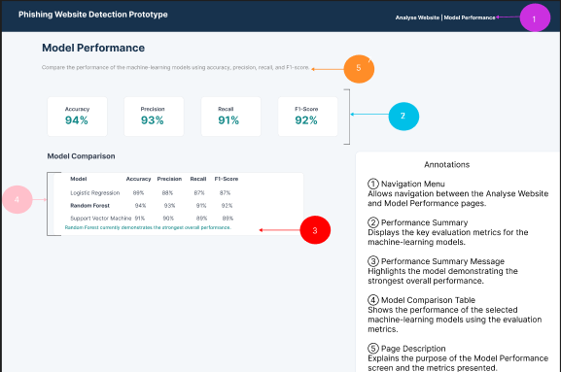
Figure 7: Model Performance Screen
This screen presents the evaluation results of the machine-learning models, including key performance metrics and a comparison of the selected classification models.
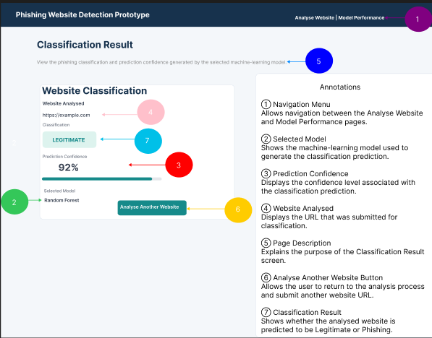
Figure 8: Classification Result Screen

This screen displays the classification result for the submitted website URL, including the predicted classification, prediction confidence, and machine-learning model used.

5.3 Explanation of Prototype Functionality
The user begins by entering a website URL and selecting a classification model on the Analyse Website screen. Selecting Analyse Website initiates the analysis process. The submitted URL will first be validated. If the URL is invalid or unsupported, an appropriate error message will be displayed. For a valid URL, the system will extract the predefined URL-based features required by the selected model and apply the preprocessing procedures used during model development.

The processed features will then be provided to the selected machine-learning model, which will generate a prediction indicating whether the URL is potentially phishing or potentially legitimate. The result will be displayed together with the selected model and, where supported by the model, the corresponding prediction probability or confidence value. The user can then select Analyse Another Website to submit another URL. The Model Performance screen allows the performance of Logistic Regression, Random Forest, and Support Vector Machine to be compared using accuracy, precision, recall, F1-score, and ROC-AUC. The values currently displayed are illustrative and will be replaced with the actual evaluation results during implementation.
The prototype validates the design requirements related to URL submission, model selection, URL validation, classification-result presentation, and model-performance comparison. The Website URL Input Screen demonstrates how an internet user will submit a supported URL and select a classification model, while the Classification Result Screen demonstrates how the predicted outcome will be communicated to the user. The Model Performance Screen validates the requirement to compare Logistic Regression, Random Forest, and Support Vector Machine using the selected evaluation metrics. These screens therefore provide a visual representation of the proposed system workflow and its alignment with the functional requirements defined in Section 6.

5.4 Prototype Limitations and Next Steps
The current screens are visual mockups and do not yet perform real-time URL analysis or machine-learning prediction. The URL input, classification result, and model-performance values are simulated to demonstrate the intended interface and user workflow. URL feature extraction, data preprocessing, model training, and prediction generation have not yet been integrated with a functional backend. The navigation and analysis controls are also not connected to the trained models.

During implementation, the preprocessing pipeline and selected machine-learning models will be developed and integrated with the interface. The illustrative performance values will be replaced with actual evaluation results. The URL analysis functionality will then be implemented so that a supported URL can be processed and classified using the trained model. Further testing and interface refinement will be conducted to improve functionality, clarity, and usability

6. Requirements Traceability

Requirement ID & Description | Design Element / Artefact | Justification
REQ-001: The system will use the selected phishing website dataset as input for model development and evaluation. | Figure 1: System Architecture Diagram; Figure 4: Data Flow Diagram; Data Acquisition and Inspection Module | The design includes the selected phishing website dataset as the primary source of labelled data. The dataset is inspected, prepared, and used for model training and evaluation.
REQ-002: The system will inspect and preprocess the dataset to identify and address relevant data-quality issues before model development. | Figure 2: Process Flow Diagram; Figure 4: Data Flow Diagram; Data Cleaning and Preprocessing Module | The design includes dataset inspection, cleaning, preparation, and transformation to produce suitable data for machine-learning model development.
REQ-003: The system will apply feature engineering and feature selection to prepare relevant website characteristics for classification. | Figure 1: System Architecture Diagram; Figure 4: Data Flow Diagram; Feature Engineering and Selection Module | The design includes a feature-engineering and feature-selection stage that analyses and prepares relevant website features before they are supplied to the classification models.
REQ-004: The system will train and compare Logistic Regression, Random Forest, and Support Vector Machine models for phishing website classification. | Figure 1: System Architecture Diagram; Figure 4: Data Flow Diagram; Model Training Module | The design uses three supervised machine-learning classification models to classify website records as phishing or legitimate and support comparative model analysis.
REQ-005: The system will evaluate model performance using accuracy, precision, recall, F1-score, ROC-AUC. | Figure 1: System Architecture Diagram; Figure 7: Model Performance Screen | The design includes multiple evaluation measures to assess and compare the performance of the selected machine-learning models.
REQ-006: The prototype will allow an internet user to submit a supported website URL and view the resulting classification. | Figure 3: Sequence Diagram; Figure 5: Use-Case Diagram; Figure 6: Website URL Input Interface; Figure 8: Classification Result Interface | The prototype allows an internet user to submit a website URL. The system will extract the selected compatible URL-based features, process them, and use the trained model to generate a classification result.
REQ-007: The system will validate submitted website URLs before attempting feature extraction and classification. | Figure 2: Process Flow Diagram; Figure 3: Sequence Diagram; URL Input and Validation Module | The design includes a URL validation stage that checks whether the submitted URL is valid and supported before further processing takes place.
REQ-008: The system will apply the same preprocessing procedures and selected feature structure to new URL inputs as those used during model development. | Figure 1: System Architecture Diagram; Figure 4: Data Flow Diagram; URL Feature Extraction and Processing Module | The design reuses the selected feature set and saved preprocessing components when processing new URL inputs to maintain compatibility with the trained model.
REQ-009: The system will store the selected trained model and associated preprocessing components for reuse during prototype classification. | Model and Preprocessing Storage Module; Figure 1; Figure 4. | The design includes model and preprocessing storage so the selected trained model can be reused during prototype classification.
REQ-010: The prototype will provide model-performance information using visual summaries of the selected evaluation metrics | Figure 7; Model Performance Interface | The Model Performance Screen provides visual summaries of the selected evaluation metrics to support model comparison.

8. Stream-Specific Design Requirements

8.3 AI and Data Science
Complete this section if your stream is AI and Data Science.

8.3.1 Model Architecture
The system uses a supervised machine-learning classification architecture to detect phishing websites based on website-related characteristics contained in the selected dataset. The classification task is binary, where the target variable represents two classes: legitimate websites (0) and phishing websites (1). Three classification algorithms will be developed and compared: Logistic Regression, Random Forest, and Support Vector Machine (SVM). The input to the models consists of the selected website-related features obtained from the phishing website dataset. Before model training, the data will undergo inspection, cleaning, preprocessing, feature engineering, and feature selection. These stages are intended to improve data quality, transform the input features into a suitable representation, and reduce the inclusion of irrelevant or redundant features.

Logistic Regression will be used as a baseline classification model because it provides a relatively simple and interpretable approach to binary classification. Random Forest will be used as an ensemble-learning model consisting of multiple decision trees, allowing the system to capture more complex relationships between website-related features. Support Vector Machine will be used as a classification model that identifies a decision boundary between phishing and legitimate website records. The three models will be trained using the same prepared training data to support a fair comparison. The dataset will be divided into training and testing subsets using a stratified split. The training subset will be used for model development, while the testing subset will remain separate and will only be used for final evaluation.

Model hyperparameters will be selected and refined during the implementation phase. Cross-validation will be applied to the training data to assess model consistency and support hyperparameter selection. The specific hyperparameter values will therefore be determined during implementation based on the characteristics of the prepared dataset and the performance of the models. The final models will be evaluated using accuracy, precision, recall, F1-score, ROC-AUC, and confusion-matrix analysis. The results will be compared to determine which model provides the most suitable performance for the phishing website classification task. The selected trained model, together with its final feature set and preprocessing components, will then be integrated with the URL-based classification interface. Only features that can be extracted directly from a submitted URL and are compatible with the selected model will be used during classification.

8.3.2 Data Pipeline
The data pipeline defines the end-to-end process through which the selected phishing website dataset will be prepared, used for model development, evaluated, and integrated with the URL-based classification interface. The pipeline begins with the acquisition and loading of the selected phishing website dataset. The dataset contains labelled website records and associated website-related features. The target variable represents two classes, where 0 indicates a legitimate website, and 1 indicates a phishing website. The dataset will first undergo data inspection to assess its structure, number of records and features, data types, missing values, duplicate records, class distribution, and other relevant data-quality characteristics. Identified data-quality issues will be addressed where applicable through appropriate cleaning and preprocessing procedures.

The target label will then be separated from the input features. The prepared dataset will be divided into training and testing subsets using a stratified train-test split to preserve the distribution of legitimate and phishing records across both subsets. Feature engineering and feature selection will be performed using the training data. Relevant transformations will be applied where required, and unsuitable or redundant features will be removed where justified. The resulting feature-processing procedures will then be applied consistently to the training and testing data. The prepared training data will be used to train the Logistic Regression, Random Forest, and Support Vector Machine models. Cross-validation will be applied during model development to assess model performance and support hyperparameter selection. The final trained models will then be evaluated using the previously unseen testing data.

Model performance will be assessed using accuracy, precision, recall, F1-score, ROC-AUC, and confusion matrices. The evaluation results will be compared to identify the most suitable model for the classification task. The selected model, final feature set, and associated preprocessing components will be stored for integration with the URL-based classification interface. When a user submits a supported website URL, the system will extract the selected URL-based features, apply the saved preprocessing procedures, and provide the resulting feature vector to the trained model for classification. The complete movement of data through the system is illustrated in Figure 4: Data Flow Diagram.
8.3.3 Data Visualisation Mockups
The system will include visual outputs to communicate model-performance results and classification outcomes clearly to users and other stakeholders. The Model Performance Screen will present the evaluation results of Logistic Regression, Random Forest, and Support Vector Machine. Key evaluation measures will include accuracy, precision, recall, F1-score, and ROC-AUC. The results will be presented using summary metrics and a model-comparison table to support comparison of the three classification models. Confusion matrices will also be generated during the model-evaluation stage to provide a more detailed representation of correct and incorrect classifications for each model. These evaluation outputs will support the analysis and selection of the most suitable model.

The Classification Result Screen will display the classification generated for a submitted website URL. The result will indicate whether the URL is predicted to be Potentially Phishing or Potentially Legitimate. Where supported by the selected model, a prediction probability or confidence value may also be displayed to provide additional information about the prediction. The visualisation mockups are presented in Section 5.2, specifically the Model Performance Screen and Classification Result Screen. The illustrative values currently displayed in the mockups will be replaced with the actual model evaluation results during the implementation phases.

9. Evaluation of Design

9.1 Feasibility Assessment
Technical feasibility: The technology stack is technically suitable for the development of the phishing detection system. Python provides a suitable environment for data processing and machine-learning development. Libraries such as pandas and NumPy can support data cleaning, transformation, and feature preparation, while scikit-learn can be used to implement and evaluate the Logistic Regression, Random Forest, and Support Vector Machine classification models. The use of a publicly available phishing website dataset also provides the required labelled data for model training and evaluation. A potential technical risk is that the selected models may perform differently depending on the quality and relevance of the input features. This risk will be addressed through data preprocessing, feature engineering, feature selection, cross-validation, and comparative model evaluation.

Operational feasibility: The system is operationally feasible because its intended functionality can be presented through a simple and understandable prototype interface. The system will allow internet users to submit website URLs, initiate the classification process, and view the resulting phishing or legitimate prediction. Model performance information will also be presented using evaluation metrics and visualisations. The workflow is designed to minimise unnecessary user interaction because the data preprocessing and classification processes will be performed by the system. However, the interpretation of model performance results may require basic knowledge of machine-learning evaluation metrics.

Economic feasibility: The system is economically feasible because the primary development tools and libraries are open source and do not require expensive software licences. Python, Jupyter Notebook, pandas, NumPy, scikit-learn, and Matplotlib can be used without additional licensing costs. The phishing website dataset is publicly available, which reduces the cost and time associated with collecting and manually labelling website data. The main resources required are a computer with sufficient processing capability, internet access for obtaining the dataset and relevant research sources, and the time required to develop, train, evaluate, and document the system.

9.2 Scalability Considerations
The design considers the potential growth in the volume of website data and the future expansion of the phishing detection system. The modular structure of the architecture separates data preprocessing, feature engineering and selection, machine-learning model development, model evaluation, and results visualisation. This separation allows individual components to be modified or improved without requiring major changes to the entire system.

As the volume of website data increases, the data preprocessing and feature engineering components can be adapted to process larger datasets. The use of selected features may also reduce the computational complexity of model training by removing irrelevant or redundant variables. The machine-learning models can be retrained using updated datasets to improve their ability to identify new or evolving phishing patterns.

The system can also be extended by incorporating additional classification algorithms or more advanced machine-learning techniques. New models can be integrated into the existing model comparison component and evaluated using the same performance measures. This supports future experimentation without changing the overall data pipeline.
Although the initial prototype is intended for a limited number of users and dataset-based analysis, the design could be expanded into a larger application in the future. For example, the trained model could be integrated into a web-based system or cybersecurity platform to support a greater number of users and more frequent classification requests. If the system is deployed at a larger scale, additional computing resources and more efficient data processing methods may be required to maintain acceptable performance.

9.3 Security Considerations

Security Risk | Likelihood (H/M/L) | Design-Level Mitigation
Unauthorised modification or corruption of the phishing website dataset | M | The dataset will be obtained from a trusted public source and stored in a controlled project environment. Data validation and integrity checks will be performed before preprocessing and model development.
Malicious or invalid website data being provided to the prototype | M | Input validation and data-format checks will be incorporated before the data is processed. Invalid, incomplete, or unsupported input will be identified and rejected or handled appropriately.
Exposure of sensitive website information or project data | L | Only the information required for model development and evaluation will be processed. Project datasets, trained models, and results will be stored in controlled locations with appropriate access restrictions.
Malicious or crafted URL input being submitted to the prototype | M | The prototype will treat submitted URLs as untrusted input. URL format validation and controlled feature extraction will be applied before processing. The implementation will avoid directly opening or executing content from submitted URLs.

9.4 Risks and Mitigation
Risk Description | Likelihood | Impact | Mitigation Strategy
The selected dataset may contain missing, duplicate, inconsistent, or unsuitable values that could affect model development. | M | M | The dataset will be inspected before model development. Relevant data-quality issues will be identified and addressed through data cleaning, preprocessing, and validation procedures.
The selected website features may not provide sufficient information to distinguish phishing websites from legitimate websites. | M | H | Feature analysis, feature engineering, and feature-selection techniques will be applied. Multiple machine-learning models will be compared to determine which model performs most effectively using the selected features.
The machine-learning models may produce biased or inconsistent results because of class distribution or differences in the dataset. | M | H | A stratified train-test split and cross-validation will be used to maintain class representation and assess the consistency of model performance. Multiple evaluation measures will also be used instead of relying only on accuracy.
The URL-input prototype may not be compatible with all features contained in the selected dataset. | H | M | The prototype will be limited to a predefined subset of URL-based features that can be extracted directly from a submitted URL and are compatible with the trained model.

10. Conclusion

10.1 Summary of Design Readiness
The design phase established the technical and functional foundation for the Machine-Learning-Based Phishing Website Detection System. The main design decisions focused on developing a supervised machine-learning solution that uses website-related features to classify website records as phishing or legitimate. The solution includes a structured data-processing pipeline, feature engineering and selection, the development and comparison of multiple machine-learning classification models, model evaluation, and a proof-of-concept URL-input prototype.

The required design artefacts were developed to illustrate the structure, processes, interactions, data flow, and intended functionality of the system. These artefacts include the high-level system architecture diagram, machine-learning process-flow diagram, sequence diagram, data-flow diagram, use-case diagram, and prototype mock-ups. The design also defines the roles and interactions of the major system components, the technology stack, the data-processing workflow, model architecture, evaluation measures, and prototype functionality. The machine-learning approach will compare Logistic Regression, Random Forest, and Support Vector Machine classifiers using consistent data-preparation and evaluation procedures. Model performance will be assessed using accuracy, precision, recall, F1-score, ROC-AUC, and confusion-matrix analysis. The prototype will allow an internet user to submit a supported website URL and view the classification generated by the selected trained model.

The design has considered technical feasibility, operational feasibility, economic feasibility, scalability, security, and implementation risks. Although some prototype features currently contain illustrative values and simulated interactions, the design provides sufficient technical and functional detail to guide the implementation phase. The completed design provides a structured foundation for developing, testing, evaluating, and refining the phishing website detection solution.

10.2 Transition to Implementation
The implementation phase will begin with the acquisition, preparation, and exploration of the selected phishing website dataset. This stage will include inspecting the dataset structure, identifying missing values, duplicate records, inconsistent values, data types, and class distribution. Relevant data-cleaning and preprocessing procedures will then be applied before the dataset is prepared for machine-learning development.

The dataset will be divided into stratified training and testing subsets. Feature analysis, feature engineering, and feature selection will be performed using the training data. The selected feature-processing procedures will then be applied consistently during model development and evaluation. Logistic Regression, Random Forest, and Support Vector Machine models will be implemented and trained using the prepared training data. Cross-validation and suitable hyperparameter-selection procedures will be used during model development. The final models will be evaluated using the previously unseen testing data. Their performance will be compared using accuracy, precision, recall, F1-score, ROC-AUC, and confusion-matrix analysis. The results will be used to identify the most suitable model for the phishing website classification task.

Following model evaluation, the selected trained model and its associated preprocessing components will be integrated with the prototype interface. The URL-input functionality will be implemented so that an internet user can submit a supported website URL. The system will extract the selected URL-based features, apply the required preprocessing procedures, and provide the processed features to the trained model for classification. The prototype will then display whether the submitted URL is predicted to be potentially phishing or potentially legitimate. The final implementation activities will include system testing, model validation, prototype testing, and interface refinement. The illustrative values currently displayed in the model-performance dashboard will be replaced with the actual evaluation results
.

11. References

Ahmad, S., Zaman, M., Al-Shamayleh, A.S., Ahmad, R., Abdulhamid, S.M., Ergen, I. & Akhunzada, A. 2025. Across the spectrum: In-depth review of AI-based models for phishing detection, IEEE Open Journal of the Communications Society, 6, 1-25. https://doi:10.1109/OJCOMS.2024.3462503
Asiri, S., Xiao, Y., Alzahrani, S., Li, S. & Li, T. 2023. A survey of intelligent detection designs of HTML URL phishing attacks, IEEE Access, 11, 1-23. https://doi:10.1109/ACCESS.2023.3237798

Kulkarni, A., Balachandran, V. and Das, T. 2025. Phishing webpage detection: Unveiling the threat landscape and investigating detection techniques, IEEE Communications Surveys and Tutorials, 27(2), 1-34. https://doi:10.1109/COMST.2024.3441752.
Kustiawan, Y.A. and Ghauth, K.I. 2025. Feature engineering for phishing website detection using machine learning: A systematic review, IEEE Access, 1-25 https://doi.org/10.1109/ACCESS.2025.3630334.
Nanda, M., Saraswat, M. & Sharma, P.K. 2024. Enhancing cybersecurity: A review and comparative analysis of convolutional neural network approaches for detecting URL-based phishing attacks, e-Prime – Advances in Electrical Engineering, Electronics and Energy, 8, 1-6. https://doi:10.1016/j.prime.2024.100533

Tang, L. and Mahmoud, Q.H. 2021. A survey of machine learning-based solutions for phishing website detection, Machine Learning and Knowledge Extraction, 3(3), 1-23 https://doi.org/10.3390/make3030034.

Vrbančič, G., Fister Jr., I. & Podgorelec, V. 2020. Datasets for phishing websites detection, Data in Brief, 33, 1-7
https://doi.org/10.1016/j.dib.2020.106438.

Vrbančič, G. 2020. Phishing Websites Dataset. Mendeley Data, Version 1. Available at: https://doi.org/10.17632/72ptz43s9v.1

12. Appendices
Include supporting materials that are too detailed for the body of the document but are necessary for a complete understanding of the design.

Appendix A — Additional Diagrams
No Additional Diagrams

Appendix B — Code Snippets (if applicable)
Not applicable

Appendix C — Tools and Software Used
Tool / Software | Version | Purpose / Use in Project
Figma | Web-based version | Used to design the user-interface prototype and create the website URL input, classification-result, and model-performance dashboard mockups.
diagrams.net (draw.io) | Web-based version | Used to create the system architecture, process-flow, sequence, data-flow, and use-case diagrams.
Python | 3.x | Planned for use in data preprocessing, exploratory data analysis, feature engineering, feature selection, machine-learning model development, and evaluation.
Jupyter Notebook | Current available version | Planned as the development environment for implementing, testing, documenting, and demonstrating the machine-learning workflow.
pandas | Current compatible version | Planned to use for dataset loading, manipulation, cleaning, transformation, and analysis.
NumPy | Current compatible version | Planned to support numerical operations and data preparation.
scikit-learn | Current compatible version | Planned for preprocessing, feature selection, machine-learning model development, cross-validation, and evaluation.
Matplotlib | Current compatible version | Planned for creating exploratory data analysis and model-performance visualisations.
Seaborn | Current compatible version | Planned for creating statistical visualisations and confusion-matrix visualisations.
Git and GitHub | Current version / Web-based | Planned for version control, source-code management, project documentation, and tracking implementation progress.

SELF-ASSESSMENT CHECKLIST — RUBRIC ALIGNMENT
Complete this checklist before submitting. Each criterion maps directly to the assessment rubric. Honest self-assessment supports reflection and learning.

Criterion | Completed? (Yes / Partial / No)
All required diagrams are clearly labelled with figure numbers and captions | [ Yes ]
At least three distinct diagram types have been included | [ Yes ]
Prototype screenshots are annotated and each image is captioned | [ Yes ]
Traceability matrix links every requirement to a design element | [ Yes ]
Stream-specific section (Section 8) has been fully completed | [ Yes ]
Security and risk evaluation has been addressed (Section 9) | [ Yes ]
All references are formatted consistently in the required citation style | [ Yes ]
Appendices are complete and referenced in the body text | [ Yes ]
Document has been proofread and uses formal academic language throughout | [ Yes ]

