**ASSIGNMENT 2**

*I am a computer science first year student so I had all the environments installed already in my machine.*

*The only environment I don’t have and not familiar with is Dart Flutter.*

*For Dart Flutter I managed to install it because I was doing along the instructors during the lesson so it did not give me any problems .Although I had challenges when it came to extracting the zip file but by the help of the lesson recording it was successful at last.*

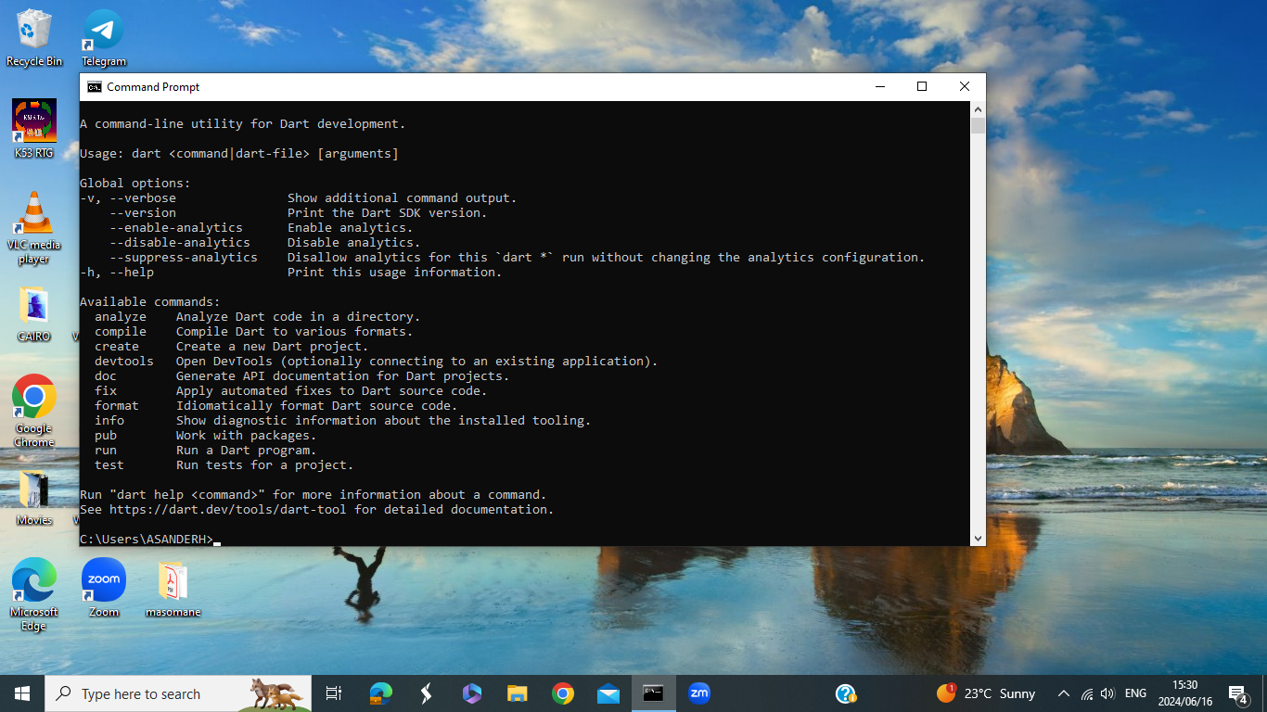

*For installing MYSQL I had no problem at all. It running in my machine perfectly.*

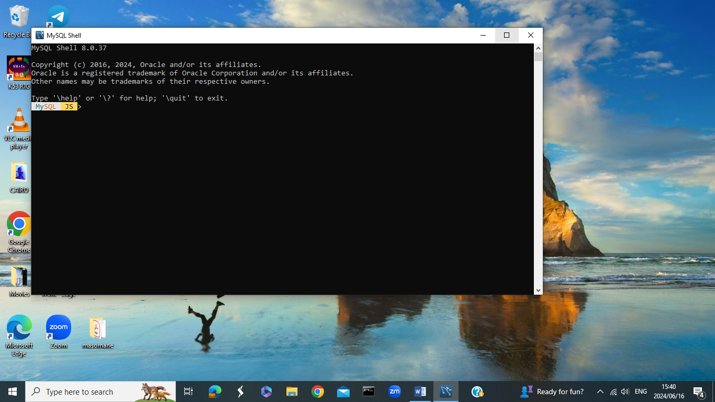

*Above is screenshot of MYSQL Shell showing the version that I have installed in my machine.*

*Installing GITBASH was not something new for me because I had installed it before for my Computer Science modules and lessons.*

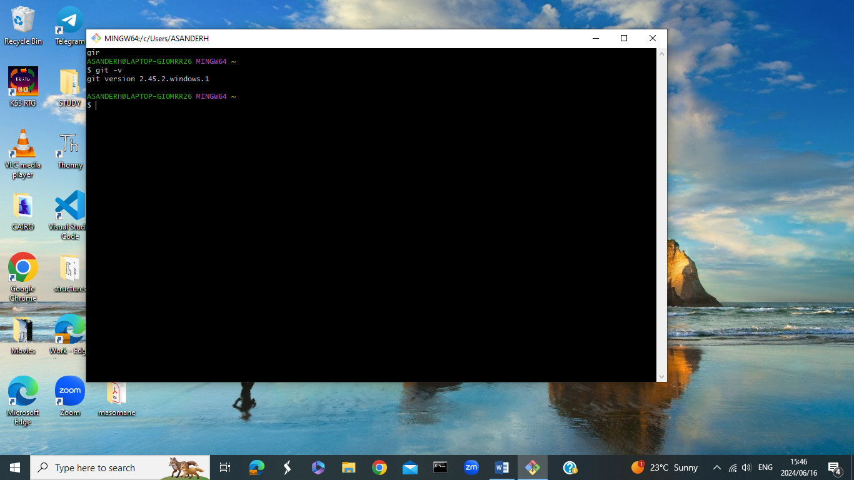

*This screenshot shows the version 2.45 of GIT Hub environment and it is operating perfectly.The only thing I that is left for me is to download all the required extensions on Visual Studio Code.*