**Lab Test 01**

**IE2031 – Structured Analysis and Design Semester 1, 2019**

**STUDENT** Name : JAYANA GAYATHRI D.M

LIYANAARACHCHI L.A.A.S

It17533942

IT17103978

* 1. Identify functional and non-functional requirements.

Functional Requirements

* Checking whether Applicant is a member of SA.

FR: Checking whether Applicant is a member of SA

INPUTS: Application.

PROCESS: check the application is certified as a SA member.

OUT PUT: Valid Applicant and Invalid Applicant.

* Record applications of valid competitors.

FR: Record applications of valid competitors.

INPUTS: Application Details.

PROCESS: record application details.

OUT PUT: Send notification to competitor.

* Record invalid applicant name and address.

FR: Record invalid applicant.

INPUTS: Name and Address.

PROCESS: Record invalid applicant details.

OUT PUT: Send Letter.

* Create heat structures.

FR: Create Heat Structure

INPUTS: Heat details.

PROCESS: Record the Heat details.

OUT PUT: Heat Structure.

* Allocate competitors to the heats.
* Record scores and identify winners.

Nonfunctional Requirements.

* Allocates judges to heats. There are between 2 and 4 judges per heat.
* Judges require a printed form
  1. Draw use case diagram for the given case study. *8 marks*

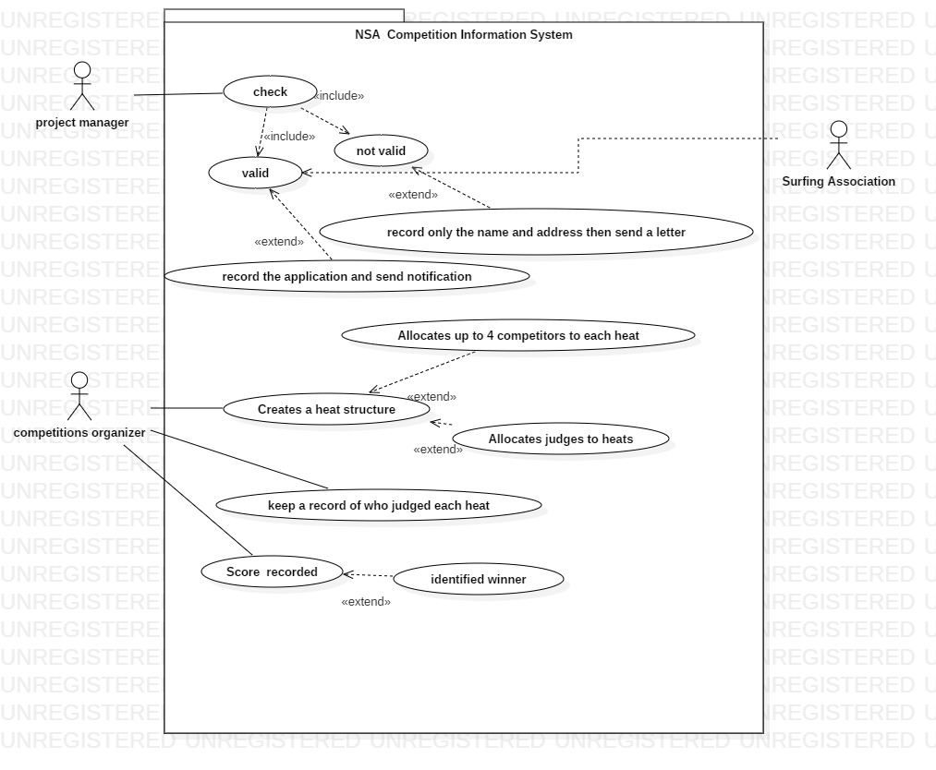

* 1. Write use case scenario for a main use case. *8 marks*

Use case scenarios.

1. Use Case ID: 001

Use Case Name: Project manger

Goal in context:

1.Check application.

Pre-Conditions:

1.1 If the applicant is valid record the application and send a notification to the applicant.

1.2If the applicant is not valid record name, address and send a letter.

1. Use Case ID: 002

Use Case Name: Competition Organizer

Goal in context:

1.Create heat structures

2. keep a record who judge each heats.

3. score record.

Pre-Conditions:

1.1 allocate up to 4 competitors for each heat.

1.2allocate judges to each heat.

3.1 identifying winner.