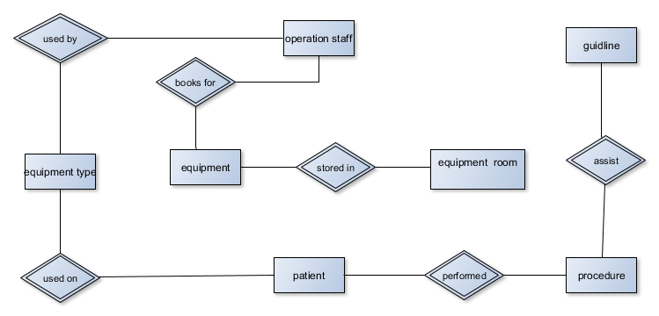

|  |  |  |  |
| --- | --- | --- | --- |
| EVENTS | STIMULUS | RESPONSE | OUTPUT |
| Operation staffs checking of equipment availability | Request for equipment | Equipment available | Display list of equipment |
| Patient cancelling booking | cancellation request | Note cancellation | Cancellation notice |
| Operation staffs checking of equipment availability | Checking equipment | Provide equipment | Give out equipment |
| Equipment type to the patient | Choosing the equipment | Equipment not found | Cancellation of |
| Operating staff request for Guideline | Request guideline | Provide guideline | Display guideline |
| Clinical engineering request for report | Request report | Provides report | Displays report |

Displays report

Provides report

Request report

Engineering department

Allocate book equipment

list equipment available

Books for equipment

Request equipment list

Operating Staff

Lakeside hospital equipment system