**Project Title: To Supply Leftover Food to Poor**

**Name:** Adapa Sasi Rekha

**Roll No:**322103210002

**College Name:** Gayatri Vidya Parishad college of Engineering for women

**Registered Email:** 322103210002.rekha@gvpcew.ac.in

**To Supply Leftover Food to Poor**

**1. Project Overview**

**Objective**

The project aims to minimize food wastage by connecting donors (restaurants, hotels, and individuals) with NGOs and organizations that supply food to the poor through the FoodConnect platform. The solution will use Salesforce’s cloud-based CRM to manage and optimize the entire process, ensuring transparency, accountability, and timely distribution.

**Scope**

* **Donors**: Restaurants, cafes, hotels, events, and households.
* **Recipients**: NGOs, shelters, and individuals in need.
* **Features**: Real-time tracking, donor-NGO communication, and data analytics for impact measurement.

**2. Key Features**

1. **Donor Registration**
   * Easy onboarding for donors with detailed profiles (location, capacity, food type).
   * Real-time donation forms via a Salesforce portal.
2. **NGO Registration**
   * Database of registered NGOs with their requirements, service areas, and food-handling capacities.
3. **Donation Management**
   * Automatic matching of food donations with NGOs based on proximity and capacity.
   * Real-time notifications to NGOs and donors upon match confirmation.
4. **Pickup and Delivery Coordination**
   * Integration with delivery services or NGO transport teams for seamless logistics.
   * Tracking of food pickup and delivery via Salesforce maps.
5. **Reporting and Analytics**
   * Dashboard to display donation statistics: total food donated, NGOs served, and number of meals provided.
   * Impact metrics for donor satisfaction and NGO efficiency.
6. **Feedback System**
   * Post-delivery feedback collection from NGOs and donors to ensure quality.

**3. Project Requirements**

**Technical Requirements**

* **Salesforce Tools**:
  + Service Cloud for donor and NGO management.
  + Sales Cloud for tracking food donation transactions.
  + Salesforce Maps for route optimization.
  + Salesforce AppExchange for integrating third-party logistics apps.
* **Other Technologies**:
  + Integration with SMS/Email APIs for communication.
  + Mobile-friendly user interface for accessibility.

**Human Resources**

* **Team Members**:
  + Salesforce Developer
  + UI/UX Designer
  + Project Manager
  + NGO Liaison Specialist

**4.Implementation**

**4.1 Salesforce developer account creation:**

1. Go to <https://developer.salesforce.com/signup>
2. On the sign up form, enter the following details: 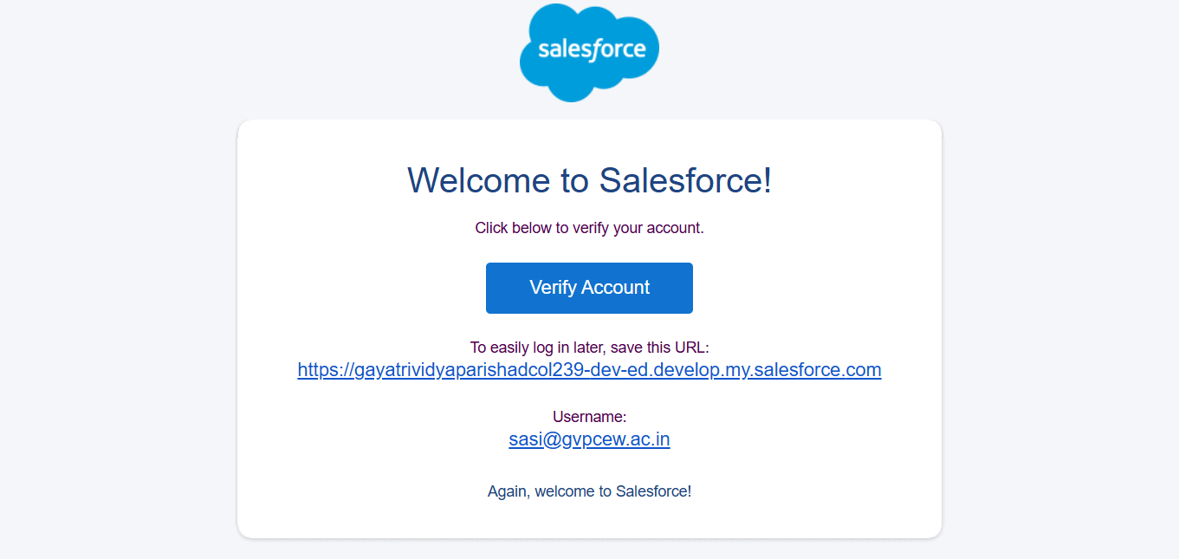
   1. First name & Last name
   2. Email
   3. Role : Developer
   4. Company : College or Company Name
   5. County : India
   6. Postal Code : pin code
   7. Username : should be a combination of your name and company

**4.2 Object:**

To Navigate to Setup page:

To create an object:

1. From the setup page > Click on Object Manager > Click on Create > Click on Custom Object.
2. On Custom object defining page:
3. Enter the label name, plural label name, click on Allow reports, Allow search.
4. Click on Save.

**4.2.1 Create Venue Object:**

Navigate to Object Manager: From the Setup page, click on Object Manager.

Create Custom Object: Click on Create and select Custom Object.

Enter Object Details:

* Label: Venue Plural
* Label: Venues
* Record Name: Venue Name
* Data Type: Text

Set Additional Options: Check Allow Reports, Track Field History, Allow Activities, and Allow Search.

Save: Click Save to create the Venue object.

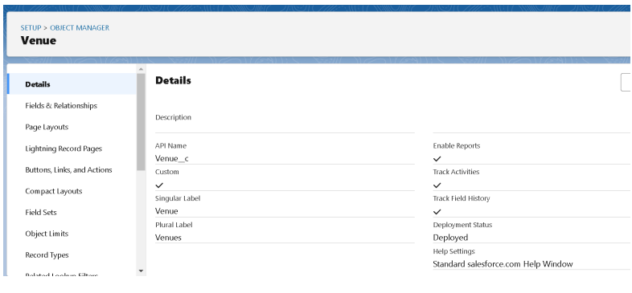

**4.2.2 Creating a Drop-Off Point Object in Salesforce:**

Navigate to Object Manager: From the Setup page, click Object Manager.

Create Custom Object: Click Create > Custom Object.

Enter Object Details:

* Label: Drop-Off Point
* Plural Label: Drop-Off Points
* Record Name: Drop-Off Point Name
* Data Type: Text

Set Options: Check Allow Reports, Track Field History, Allow Activities, and Allow Search.

Save: Click Save to create the Drop-Off Point object

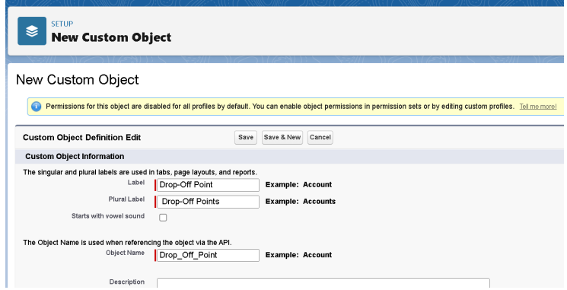

**4.2.3 Creating a Task Object in Salesforce**: \

Navigate to Object Manager: From the Setup page, click Object Manager.

Create Custom Object: Click Create > Custom Object.

Enter Object Details:

* Label: Task
* Plural Label: Tasks
* Record Name: Task Name
* Data Type: Text

Set Options: Check Allow Reports, Track Field History, Allow Activities, and Allow Search.

Save: Click Save to create the Task object.

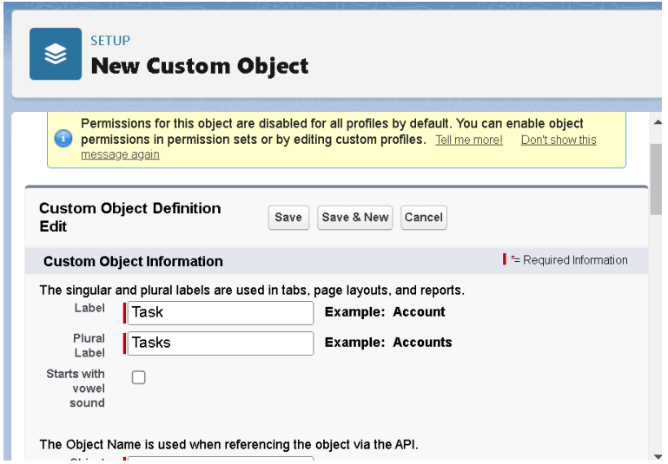

**4.2.4 Creating a Volunteer Object in Salesforce:**

Navigate to Object Manager: From the Setup page, click Object Manager.

Create Custom Object: Click Create > Custom Object.

Enter Object Details:

* Label: Volunteer
* Plural Label: Volunteers
* Record Name: Volunteer Name
* Data Type: Text

Set Options: Check Allow Reports, Track Field History, Allow Activities, and Allow Search.

Save: Click Save to create the Volunteer object

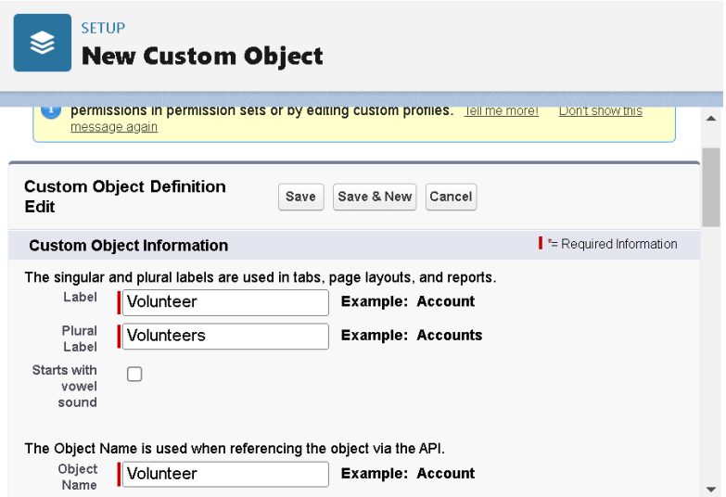

**4.2.5 Creating an Execution Details Object in Salesforce:**

Navigate to Object Manager: From the Setup page, click Object Manager.

Create Custom Object: Click Create > Custom Object.

Enter Object Details:

* Label: Execution Detail
* Plural Label: Execution Details
* Record Name: Execution Detail Name
* Data Type: Text

Set Options: Check Allow Reports, Track Field History, Allow Activities, and Allow Search.

Save: Click Save to create the Execution Details object

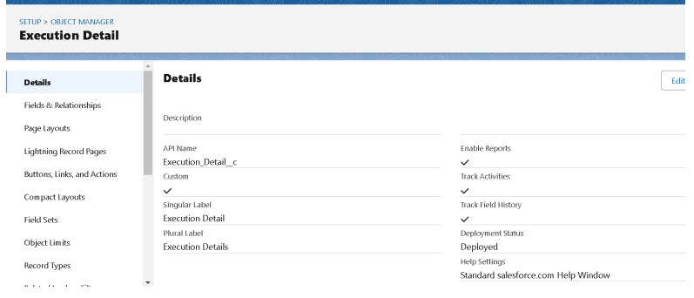

**4.3 Tabs**

**4.3.1 Creating a Custom Tab for Venue in Salesforce:**

Navigate to Tabs: Go to the Setup page, type Tabs in the Quick Find bar, and click on Tabs.

Create New Tab: Click New under the Custom Object Tabs section.

Select Object: Choose Venue from the object list.

Select Tab Style: Pick a tab style and click Next.

Add to Profiles: Keep the default settings and click Next

Add to Custom App: Uncheck Include Tab and ensure Append tab to users' existing personal customizations is checked.

Save: Click Save to create the custom tab.

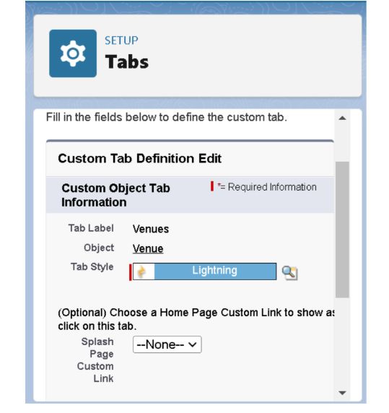

**4.4 The Lightning App**

**4.4.1 Creating a Lightning App:FoodConnect:**

Navigate to App Manager: Go to the Setup page, search for App Manager in the Quick Find bar, and select App Manager.

Create New Lightning App: Click New Lightning App.

* App Name: FoodConnect
* Developer Name: Auto-populated
* Image: Optional
* Primary Color Hex Value: Default

Set Navigation Style: Click Next, set Navigation Style to Standard Navigation, and click Next.

Utility Items: Keep defaults and click Next.

Add Navigation Items: Search for and add the following items using the arrow button: Home, Venue, Drop-Off Point, Task, Volunteer, Execution Details, Reports. Click Next.

Add User Profiles: Search for System Administrator, click the arrow butto then click Save & Finish.

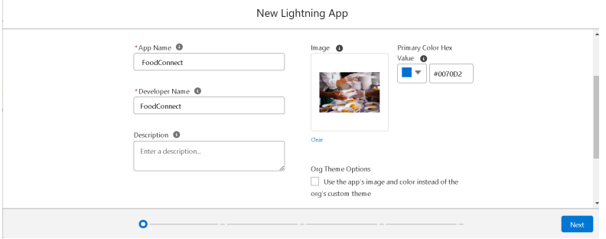

**4.5 Fields**

**4.5.1 Creation of Relationship Fields in Salesforce Objects:**

1. **Creating a Lookup Relationship Field on the Volunteer Object:**

Navigate to Volunteer Object: Go to Setup, click on Object Manager, and search for Volunteer.

Access Fields & Relationships: Click on Fields & Relationships, then click New.

Select Relationship Type: Choose Master-Detail Relationship and click Next.

Select Related Object: Choose Drop-Off Point and click Next.

Field Details:

* Field Name: Drop_Off_Point
* Field Label: Auto-generated

Finish: Click Next, then Next, and finally Save

**2.Creating a Master-Detail Relationship Field on the Execution Details Object:**

Navigate to Execution Details Object: Go to Setup, click on Object Manager, and search for Execution Details.

Access Fields & Relationships: Click on Fields & Relationships, then click New.

Select Relationship Type: Choose Master-Detail Relationship and click Next.

Select Related Object: Choose Volunteer and click Next.

Field Details:

* Field Name: Volunteer
* Field Label: Auto-generated

Finish: Click Next, then Next, and finally Save.

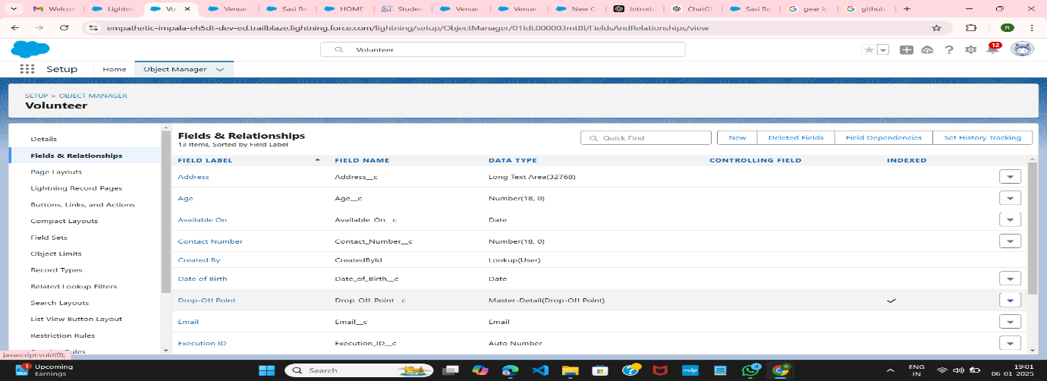

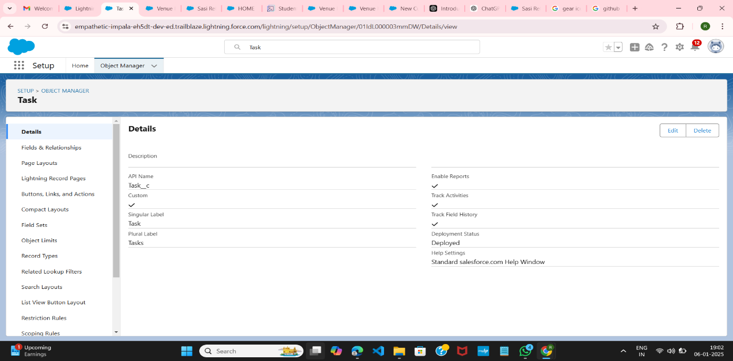

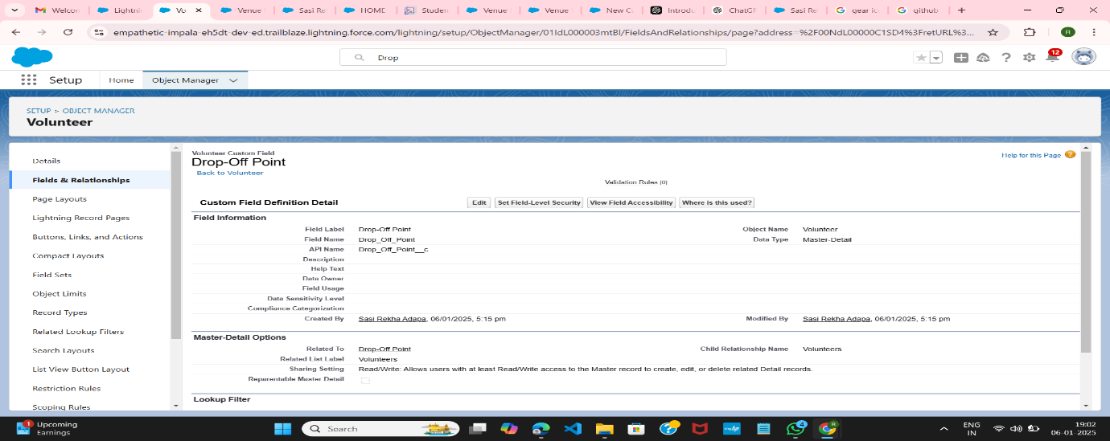

**4.6 Flows**

**4.6.1 Create Flow to Create a Record in Venue Object:** Navigate to Flow: Go to Setup, type Flow in the Quick Find box, and click on Flows.

Create New Flow: Click New Flow and select Screen Flow. Click Create.

Add Screen Element:

* Click the + icon between Start and End, then select Screen.
* Label: Venue Details
* API Name: Venue_Details

Add Components:

Text Component:

* Label: Venue Name
* API Name: Venue_Name

Email Component:

* Label: Email
* API Name: Contact_Email

Phone Component:

* Label: Phone
* API Name: Contact_Phone

Text Component:

* Label: Venue Location
* API Name: Venue_Location

Number Component:

* Label: Latitude
* API Name: Latitude

Number Component:

* Label: Longitude
* API Name: Longitude

Click Done.

Add Create Record Element:

* Click the + icon between Venue Details and End, then select Create Record.
* Label: Create Venue Record
* API Name: Create_Venue_Record How Many Records to Create: One
* How to Set the Record Fields: Use separate resources, and literal values
* Object: Venue

Set Field Values:

* Field: Contact_Email__c = {!Contact_Email.value}
* Field: Contact_Phone__c = {!Contact_Phone.value}
* Field: Name = {!Venue_Name}
* Field: Venue_Location__c = {!Venue_Location}
* Field: Location__Latitude__s = {!Latitude}
* Field: Location__Longitude__s = {!Longitude}

Save Flow:

* Flow Label: Venue Form Flow
* API Name: Venue_Form

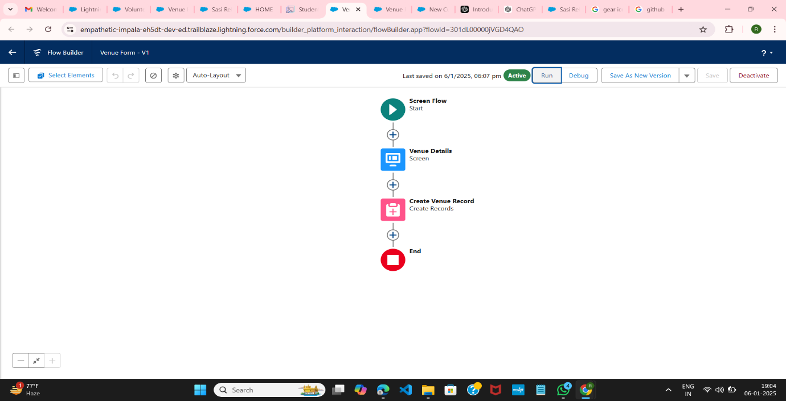

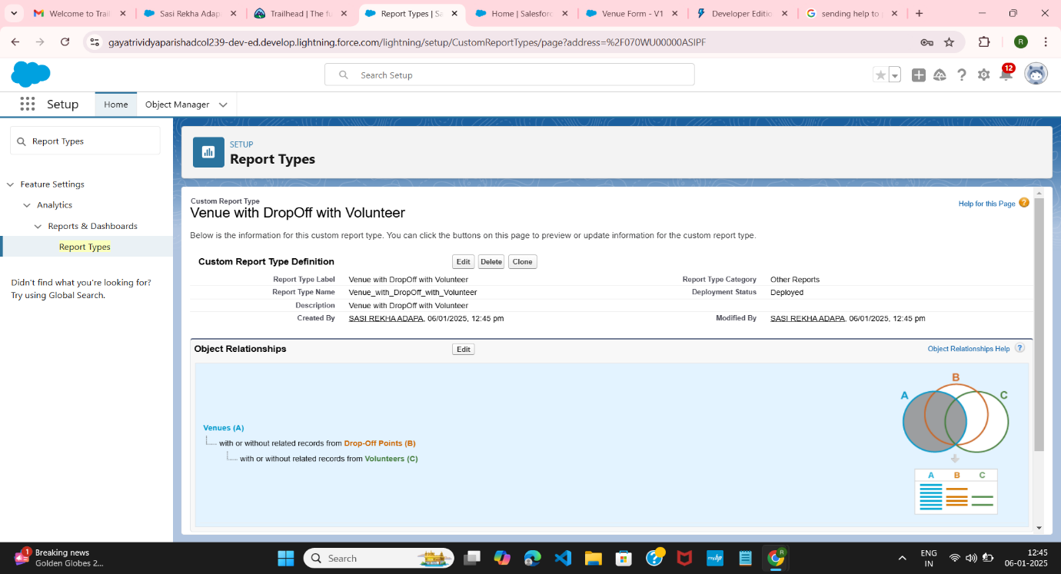

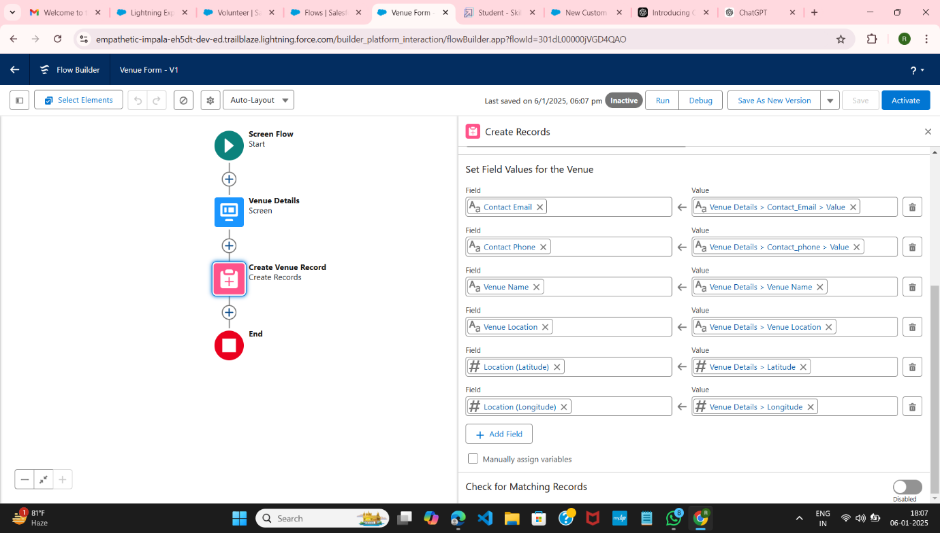

**4.7 Trigger**

**4.7.1 Create a Trigger in Salesforce:**

Log In: Log into your Trailhead account.

Open Developer Console: Click on the gear icon in the top right corner and select Developer Console.

Create New Trigger:

* Click on the File menu in the toolbar.
* Select New > Trigger.

Enter Trigger Details:

* Name: DropOffTrigger
* sObject: Drop-Off Point

Click on Submit

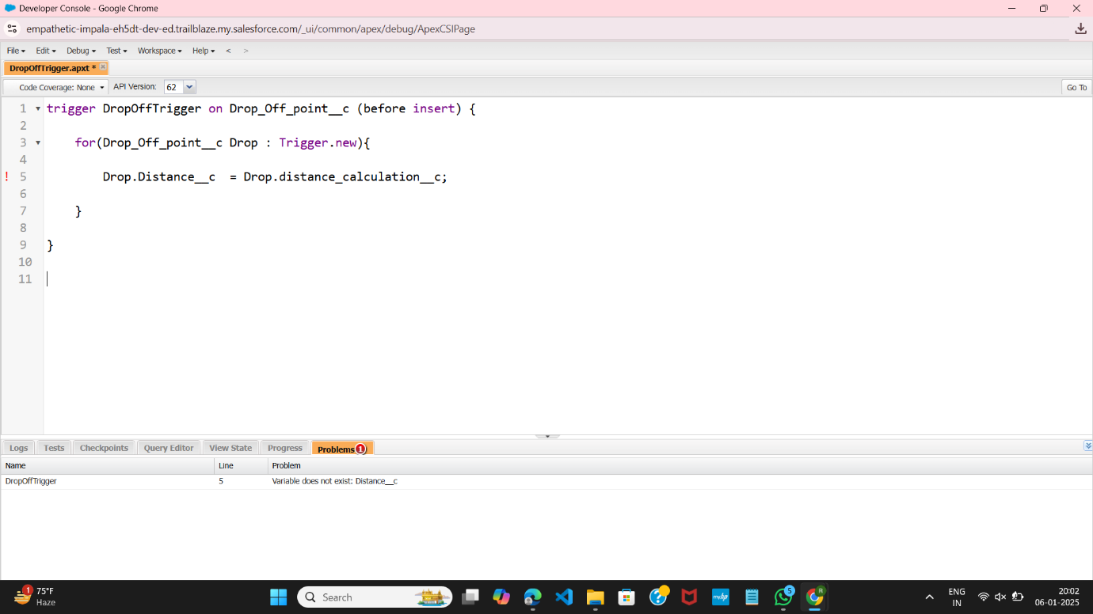

**4.8 Profile**

**4.8.1 Creation of Users:**

Navigate to Users: Go to Setup, type Users in the Quick Find bar, and click on Users.

Create New User: Click New User.

General Information:

* First Name: Iksha Foundation
* Last Name: Iksha_Foundation
* Alias: iiksh
* Email: (Your Email)
* Username: [ikshafoundation@sb.com](mailto:ikshafoundation@sb.com)
* Nickname: (Auto Populated)
* User License: Salesforce Platform
* Profile: NGOs Pro
* Active: Check

Click Save.

Follow the same steps to create two additional users with different first last names based on different NGOs, ensuring each has a unique username and alias.

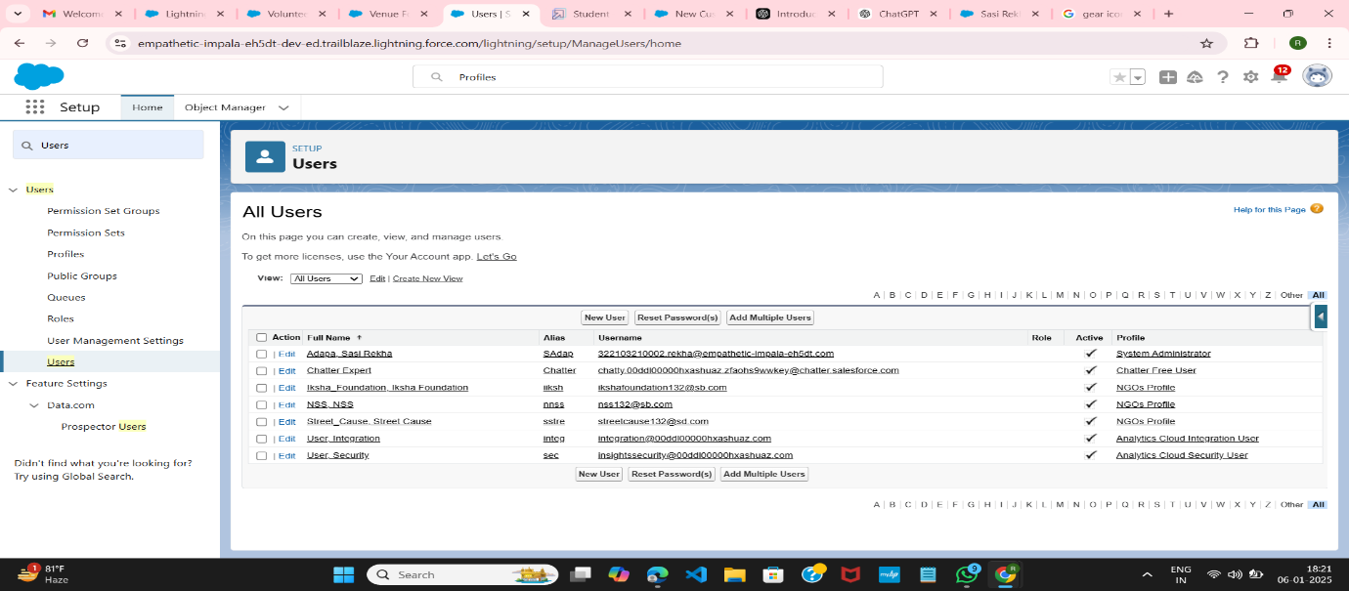

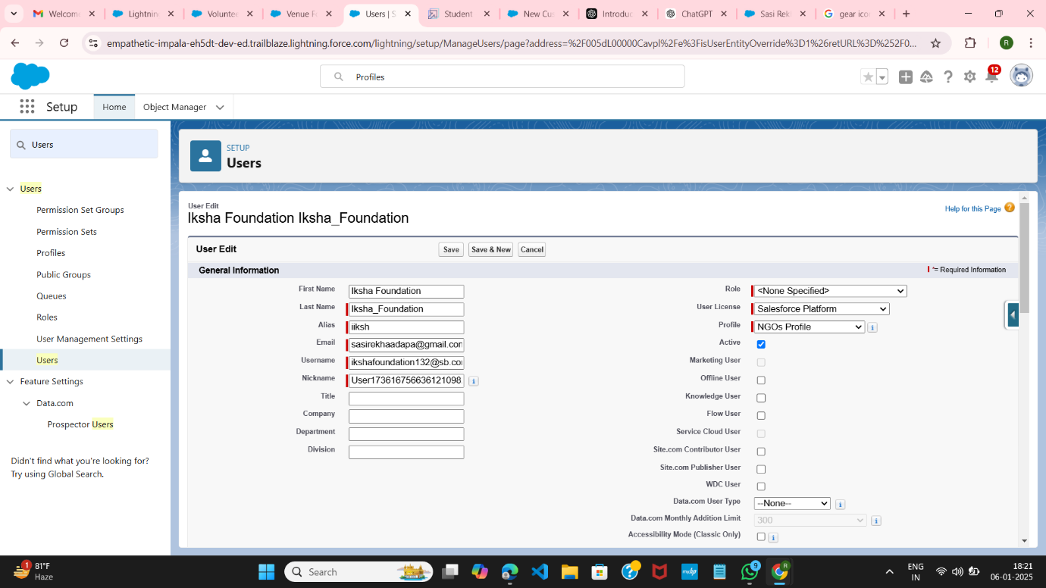

**4.9 Public Groups:**

**4.9.1 Creation of Public Groups:**

Navigate to Public Groups: Go to Setup, type Public Groups in the Quick Find bar, and click on Public Groups.

Create New Group: Click New.

Group Information:

* Label: Iksha
* Group Name: Iksha
* Grant Access Using Hierarchies: Check

Select Members:

* In the Search box, select Users.
* In Selected Members, add Iksha Foundation and System Administrator.

Click Save.

Follow the same steps to create two additional public groups with different labels and group names based on different NGOs, ensuring each group includes the appropriate users and has the "Grant Access Using Hierarchies" option checked.

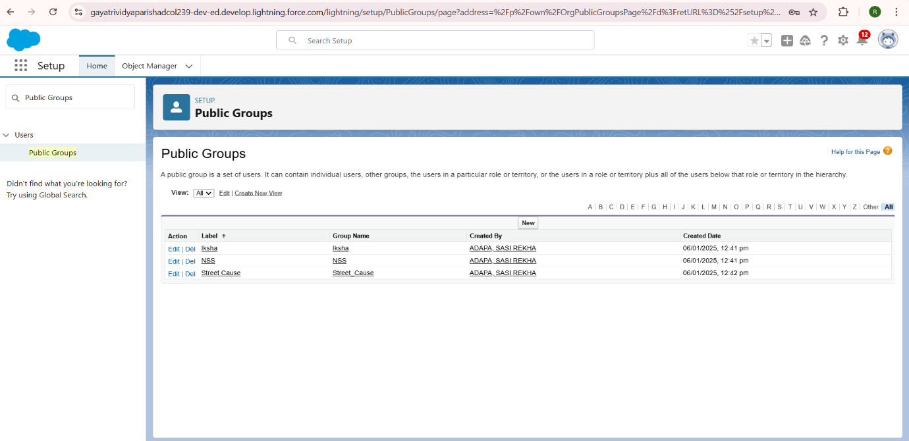

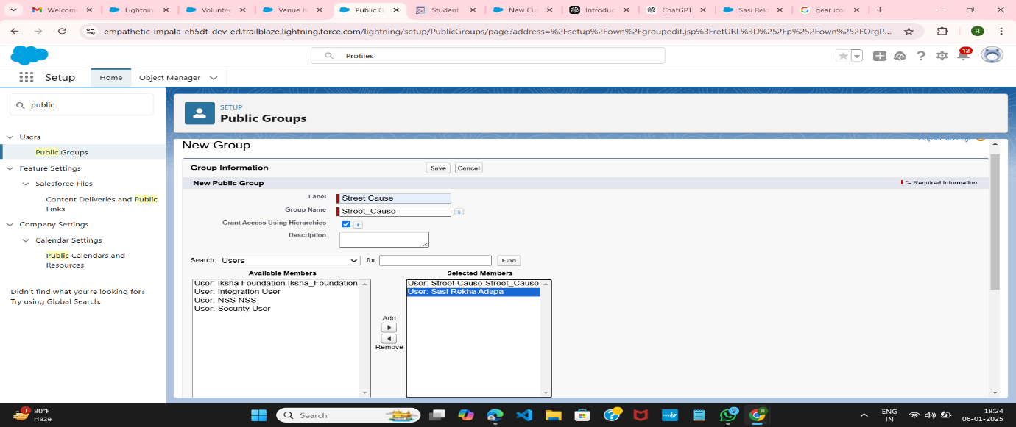

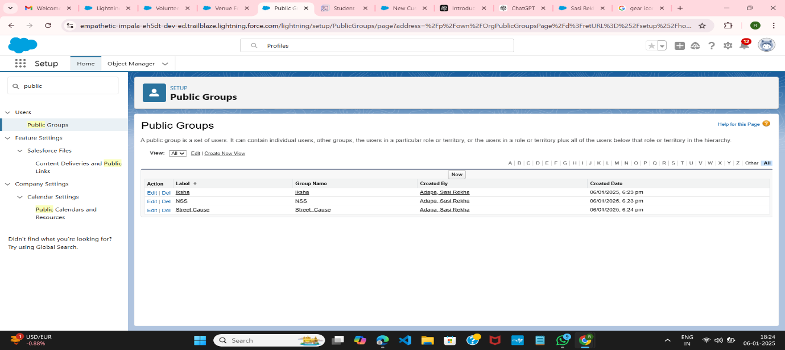

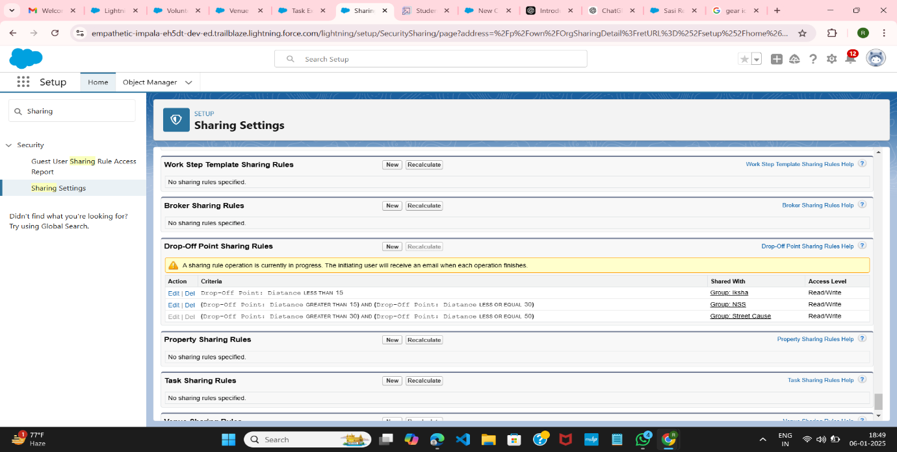

**4.10 Report Types:**

**4.10.1 Creation of Report Types:**

Navigate to Report Types: Go to Setup, type Report Types in the Quick Find bar, and click on Report Types.

Continue: Click on Continue.

Create New Custom Report Type: Click on New Custom Report Type.

Define the Custom Report Type

* Primary Object: Select Venues
* Report Type Label: Venue with DropOff with Volunteer
* Report Type Name: Venue_with_DropOff_with_Volunteer
* Description: Venue with DropOff with Volunteer
* Store in Category: Select Other Reports
* Deployment Status: Deployed

Click Next.

Relate Another Object:

* Near Click to relate another Object, select Drop-Off Points.
* Choose "A" records may or may not have related "B" records.

Relate Another Object:

* Near Click to relate another Object, select Volunteers.

Click Save.

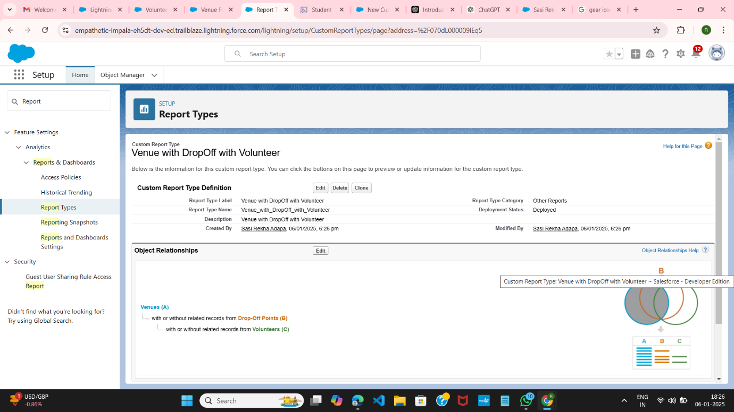

**4.11 Dashboard**

**Adding Venue and Drop-Off Point Report to the Dashboard**

Navigate to App: Go to the FoodConnect app.

Access Dashboards Tab: Click on the Dashboards tab.

Create New Folder:

* Click on New Folder.
* Folder Label: Custom Dashboards
* Folder Unique Name: (Auto Populated)

Open Custom Dashboards: Click on the Custom Dashboards folder and then click on New Dashboard.

Name the Dashboard:

* Name: Organization Details.

Add Widget:

* Click on Widget and select Chart or Table.
* Select Report: Choose Venue and Drop Off Point Report.
* Click on Select.

Add Component:

* Display As: Select Lightning Table.
* Component Theme: Select Dark (Optional).

Save Dashboard: Click on Save.

**Adding Volunteer Task Report to the Dashboard:**

Access Dashboard: Open the dashboard where you want to add the report.

Add Widget:

* Click on Widget and select Chart or Table.

Select Report:

* In Select Report, choose Volunteer Task Report.
* Click on Select.

Add Component:

* Display As: Select Line Chart.
* Component Theme: Select Dark (Optional).

Save Dashboard: Click on Save.

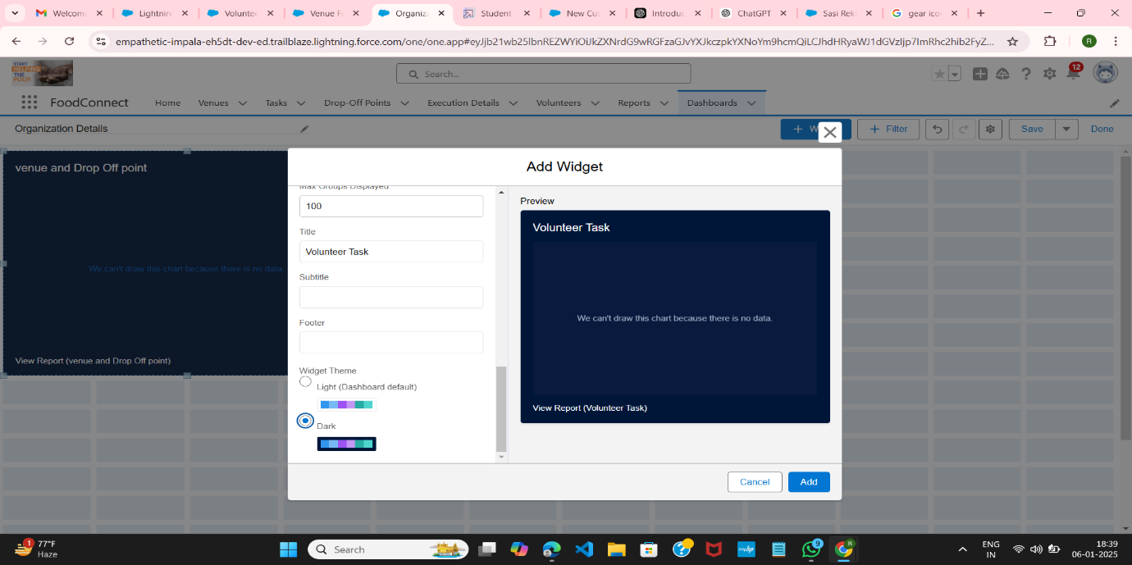

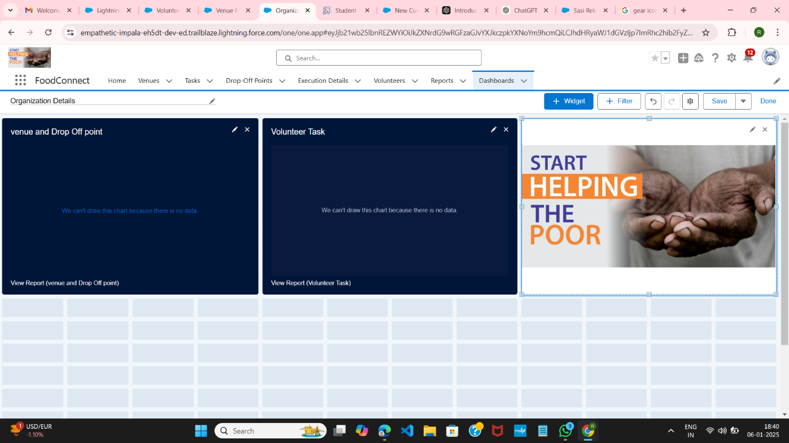

**4.12 Sharing Rules**

**Rule 1: Distance Less Than 15:**

Navigate to Sharing Settings: Go to Setup, type Sharing Settings in the Quick Find box, and click on Sharing Settings.

Find Drop-Off Point Sharing Rules: Scroll down to find Drop-Off Point Shari Rules.

Create New Rule:

* Click on New near Drop-Off Point Sharing Rules.
* Label: Rule 1
* Rule Name: Rule_1
* Select Rule Type: Based on criteria.

Select Records to Share:

* Field: Distance
* Operator: less than Value: 15

Select Users to Share With:

* Public Groups: Iksha

Click Save.

**Rule 2: Distance Greater Than 15 and Less Than or Equal to 30:**

Create New Rule:

* Click on New near Drop-Off Point Sharing Rules.
* Label: Rule 2
* Rule Name: Rule_2
* Select Rule Type: Based on criteria.

Select Records to Share:

* Field: Distance
* Operator: greater than Value: 15
* Field: Distance
* Operator: less or equal Value: 30

Select Users to Share With:

* Public Groups: NSS

Click Save.

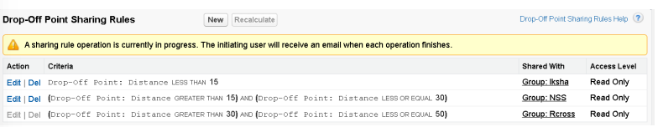

**4.13 Home Page**

**4.13.1 Creation of Home Page:**

Navigate to Setup: Go to Setup, type Lightning App Builder in the Quick Find box, and click on Lightning App Builder.

* Create New Home Page:
* Click on New. Select Home Page and give it a Label: HOME Page.
* Select Standard Home Page

Add Components:

* In the Components section, search for Flow and drag it to the right side section.
* On the right side, set the Flow to: Venue Flow.
* Search for Dashboard in the Components section, then drag and drop it into the first section

Save and Activate:

* Click on Save and then Activation.
* Click on App Default and then Add Assignments.
* Add FoodConnect App and then click on Save.

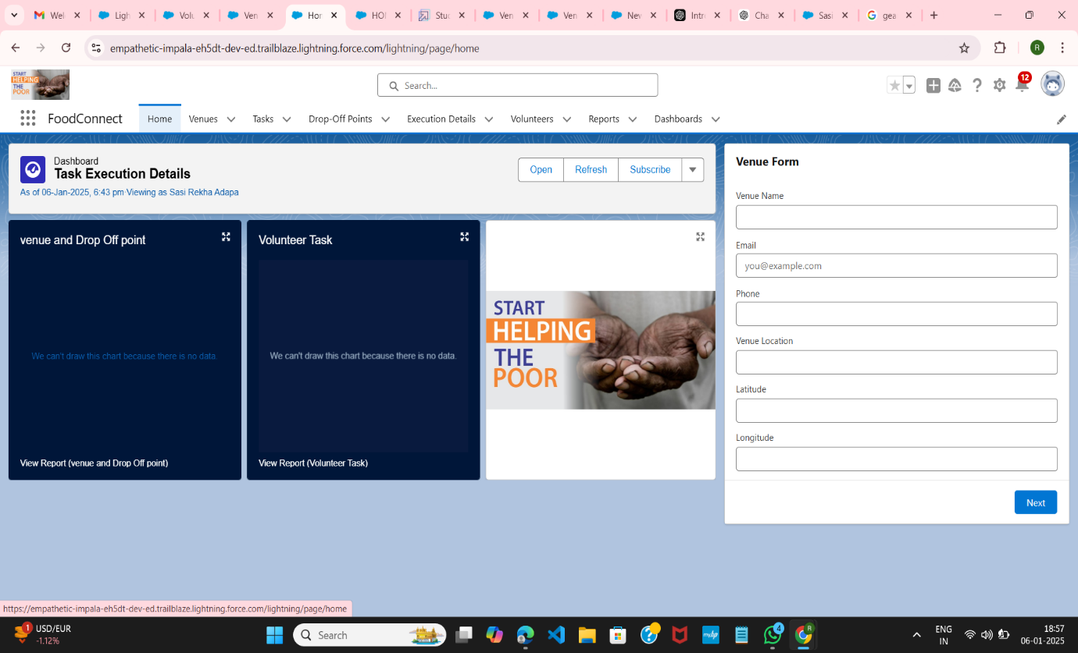

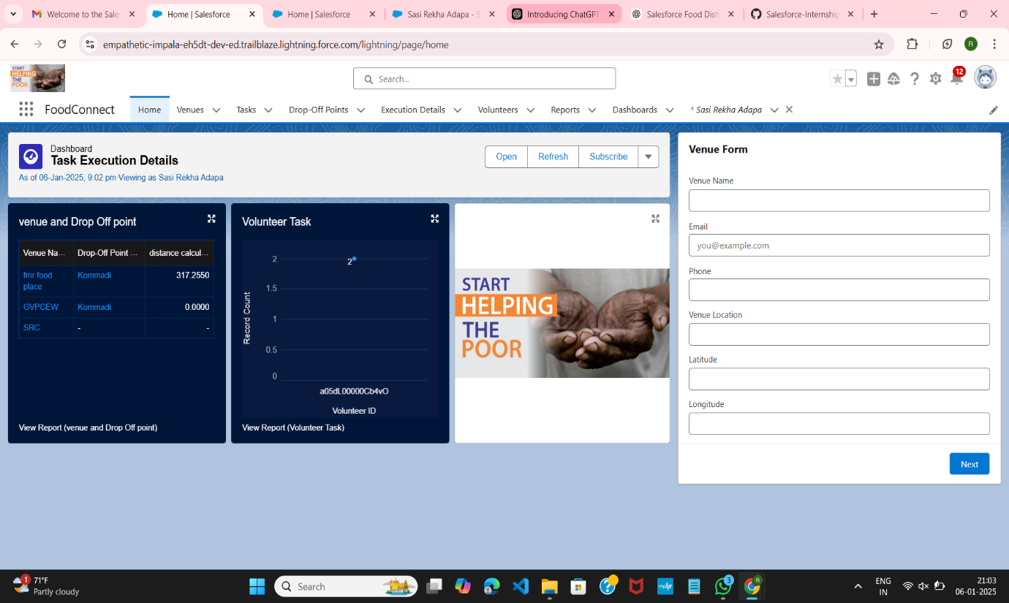

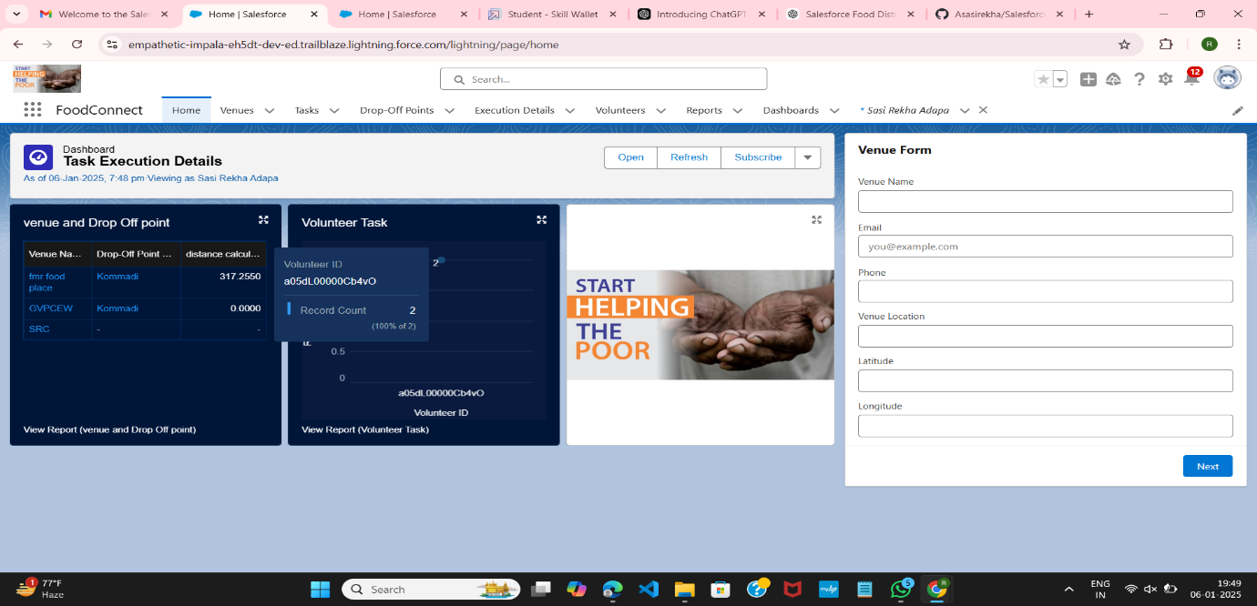

**Conclusion**

By leveraging the Salesforce platform, the project successfully established a streamlined and transparent system for managing surplus food donations. Through efficient coordination with volunteers and timely delivery beneficiaries, the project effectively addressed food insecurity while maximize the utilization of available resources. This approach not only enhanced operational efficiency but also fostered community engagement, ultimate contributing to a more sustainable and impactful solution to food waste and hunger