Work Plan

Keen Koalas – Nautical Narwhals

INFM600 - Section 0101

Saba Aldughaither

Mayuresh Amdekar

Eris Mei

Himanshu Sawant

**Dataset Information**

Our team, Keen Koalas - Nautical Narwhals, is working with pesticide residue data from the Pesticide Data Program managed by the Agricultural Marketing Service of the USDA (URL: <https://www.ams.usda.gov/datasets/pdp/pdpdata>). Given the database size, we will likely work with the most recent data from the 2014 dataset. We may also consider expanding the range to the most recent five-year period if it is necessary for our analysis.

**Research Questions**

There are currently two sets of questions we would like to investigate: What are the most common pesticide residues found on organic products, and which particular types have more residue compared to others? How well do our food test results fare compared against the Maximum Residue Level regulations of the European Union and/or Canada?

**Target Audience**

Our target audience for this study is health-conscious consumers. As we can relate to the people in that group, we will be able to look into issues that are of interest to them on the topic of pesticide residues in our food supply. The results from our analysis may help them make more educated food purchasing decisions and perhaps even point out possible areas for concern.

**Timeline**

Our team is basing our timeline around the due dates outlined in the syllabus for the different stages of the project. Printouts of the table and Gantt chart for our timeline projection are included at the end of this document. In general, our plan is to have the team members who are responsible for a particular portion of the project finish their work a few days before the due date for that stage to allow time for a team review and quality assurance prior to delivery. More specifically, the data cleaning and documentation are scheduled for completion by October 28th, the R script by November 15th, the R plot by November 29th, the presentation materials by December 9th, and the final Git package by December 14th.

**Projected Effort Allocation**

Our team has decided to divide the work by the different project deliverables with a review by the entire team at each stage. Himanshu and Mayuresh will be in charge of data cleaning and documentation, Saba and Eris will construct the R script and R plot, and Eris will put together the work plan, the presentation materials, and the final Git package. We will make adjustments to the workload allocation if any portion is more labor intense than previously estimated, or if additional help from other members is needed at any stage.

Total word count: 412

**Gantt Chart Printout - Table Portion:**

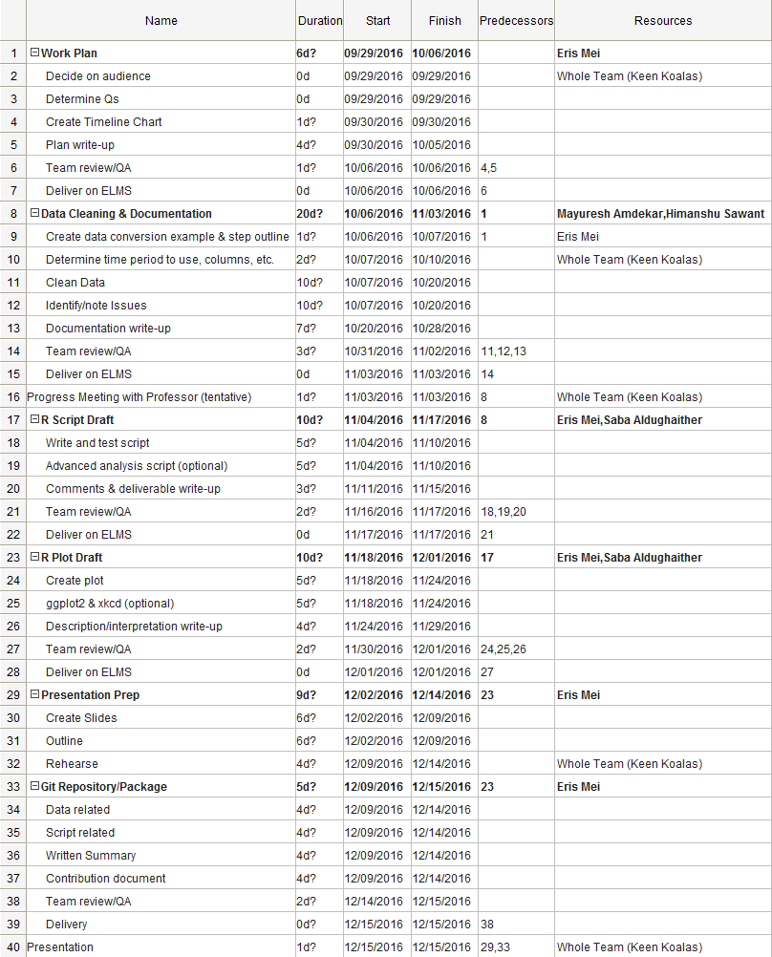

**Gantt Chart Printout - Chart Portion (rotated to improve readability due to graph size):**

