Sample Persona

Keen Koalas – Nautical Narwhals

INFM600 - Section 0101

Saba Aldughaither

Mayuresh Amdekar

Eris Mei

Himanshu Sawant

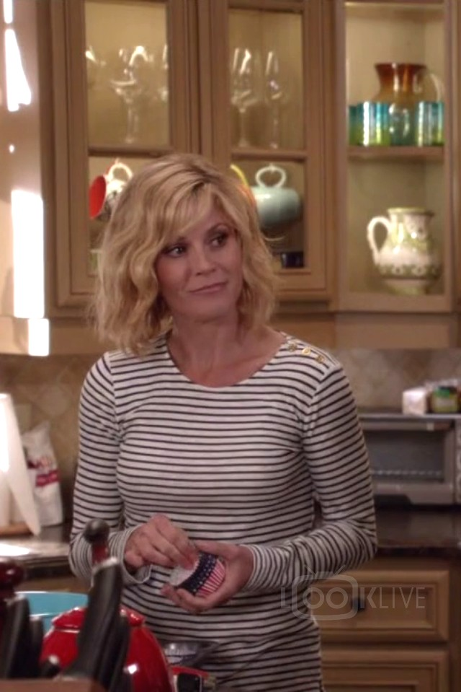

**Background:**

Name: Clare

Age: 38

Gender: Female

Family: Married with a husband, and two kids (4 and 6)

Economic status: middle class

Location: suburban Maryland (Bethesda)

Education: BA in Psychology

Career: High school counselor

Favorite Food: Fruit desserts and smoothies

**Description:**

Clare is a middle-class, married 38-year-old mother of two living in Suburban Bethesda, Maryland. Her children are 4 and 6. She has a bachelor's degree in Psychology, and works as a counselor at a local high school.

She read about the Dirty Dozen in the Food & Nutrition magazine. After reading the article, she became aware of the potential harmful effects of chemicals used in the production of foodstuffs, and would like to become more educated about the specifics.

She's especially worried about the effects on the health of her children as they consume fruits as a part of their meals on a regular basis. Also, since she likes to make herself a fruit smoothie after her workouts, she wants to know if they impact her health negatively in any way.

She heard that organic produce is not actually much healthier, so she wants to know if they are worth the extra cost.

Total Word Count: 194