Written Summary

Keen Koalas – Nautical Narwhals

INFM600 - Section 0101

Saba Aldughaither

Mayuresh Amdekar

Eris Mei

Himanshu Sawant

**Audience & Decisions:**

Health conscious mothers with (young) children in middle-class families with enough money to consider more expensive produce options if they are better for their family. But, who still have budget constraints so they need to make educated and selective decisions. Maybe in suburban areas with access to health food stores.

Our analysis aims to provide easy to understand pesticide residue analysis information to these mothers to help them make educated decisions when make food purchases, especially of fresh produce.

**Source Data & Processing:**

Our analysis utilized pesticide residue testing results datasets from the Pesticides Data Program (PDP) for the years 2014 and 2004.

Due to data size, we focused our analysis on only apples, frequently named as the most pesticide-laden produce. During data cleaning, variables with minimal data and/or irrelevant to our analysis were dropped, and certain missing values were filled in as “unknown” for unification. Subsets were then created in R with our script according to the criteria of our analysis (year, variety, state, pesticide claims, etc.) to answer our questions.

**Plots & Interpretation:**

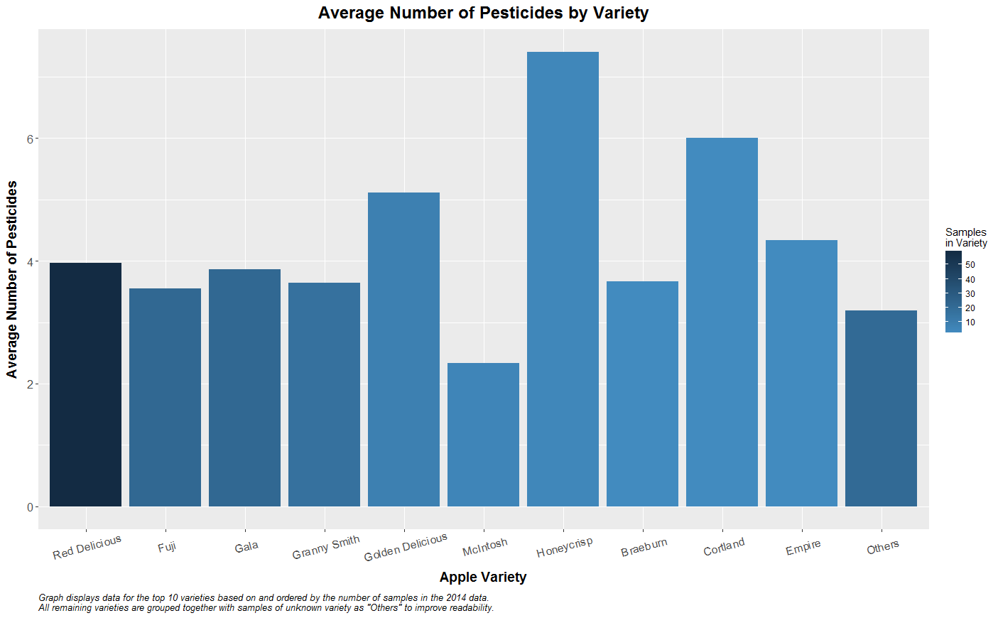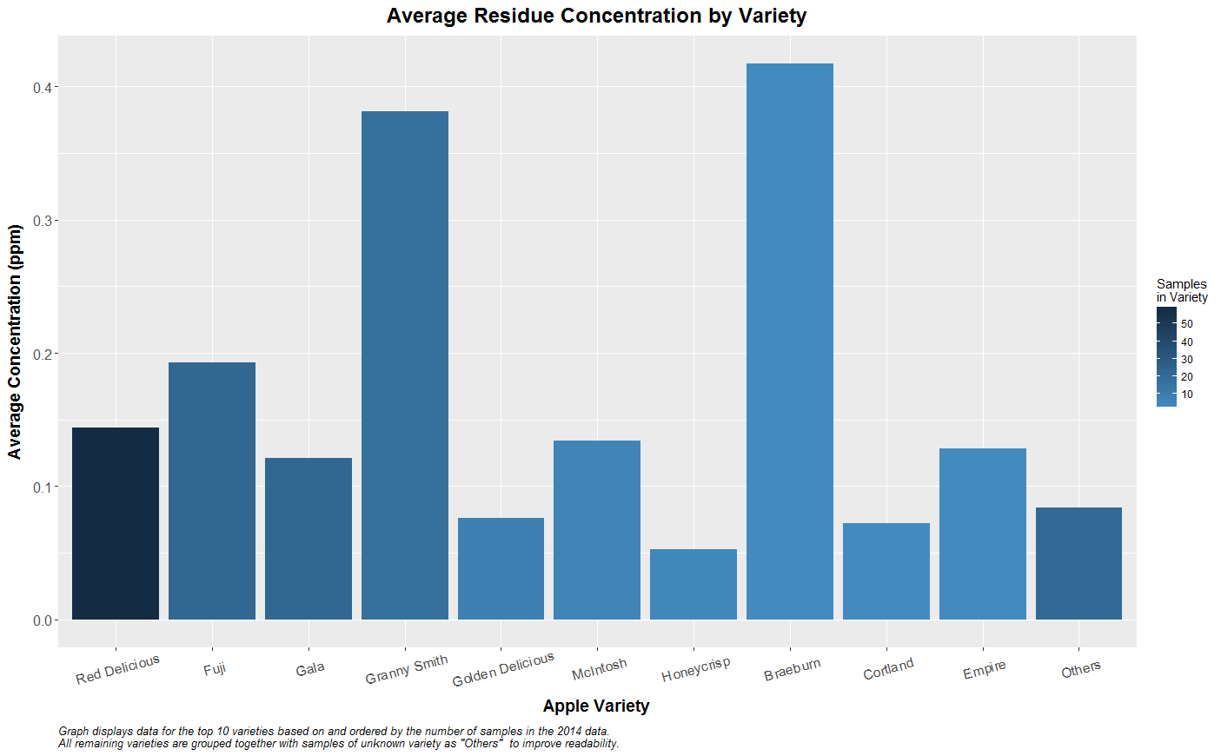

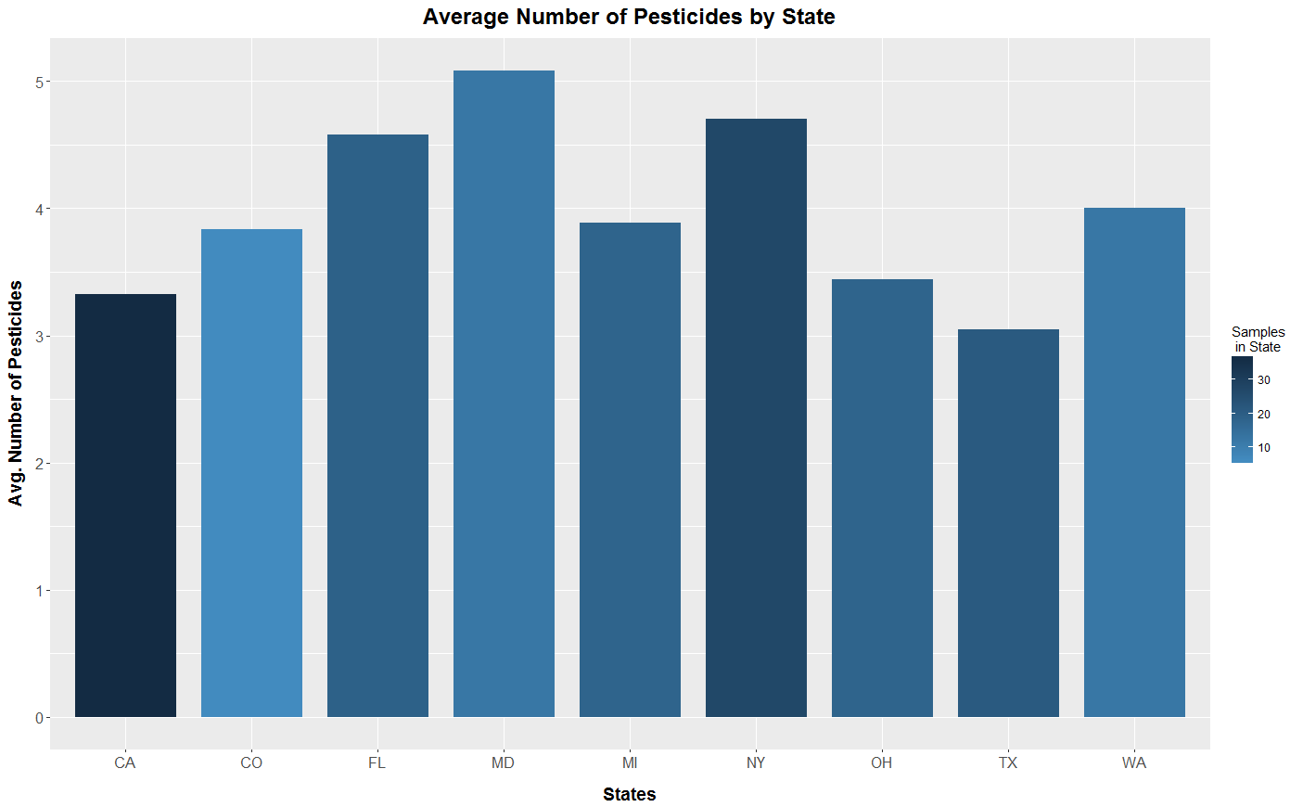

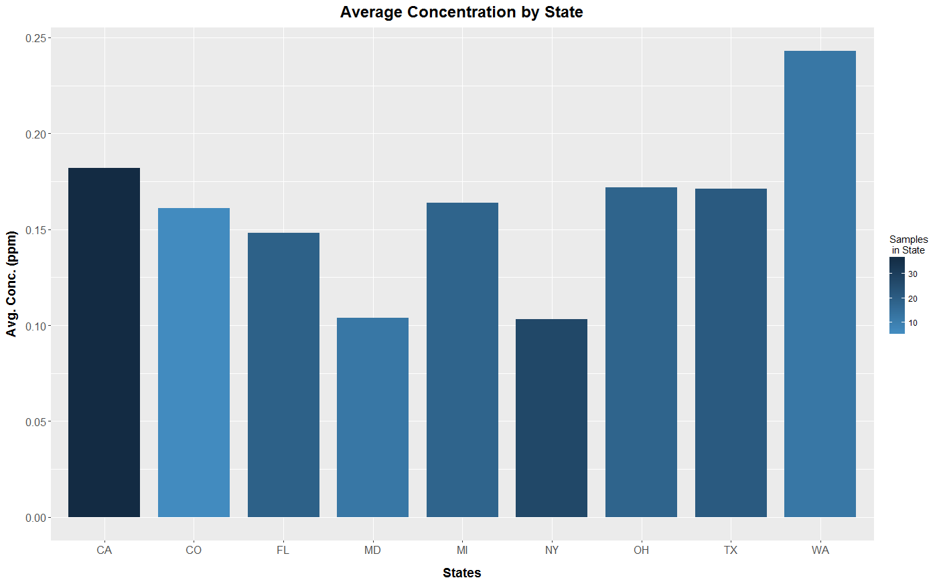

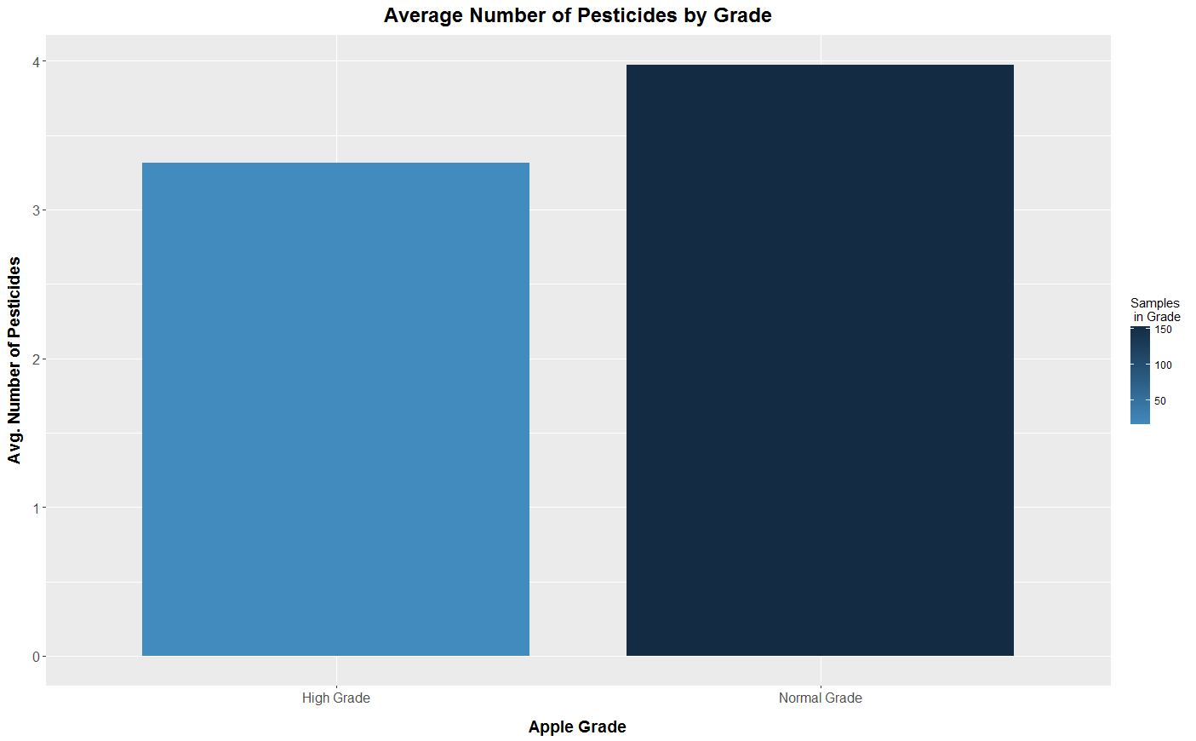

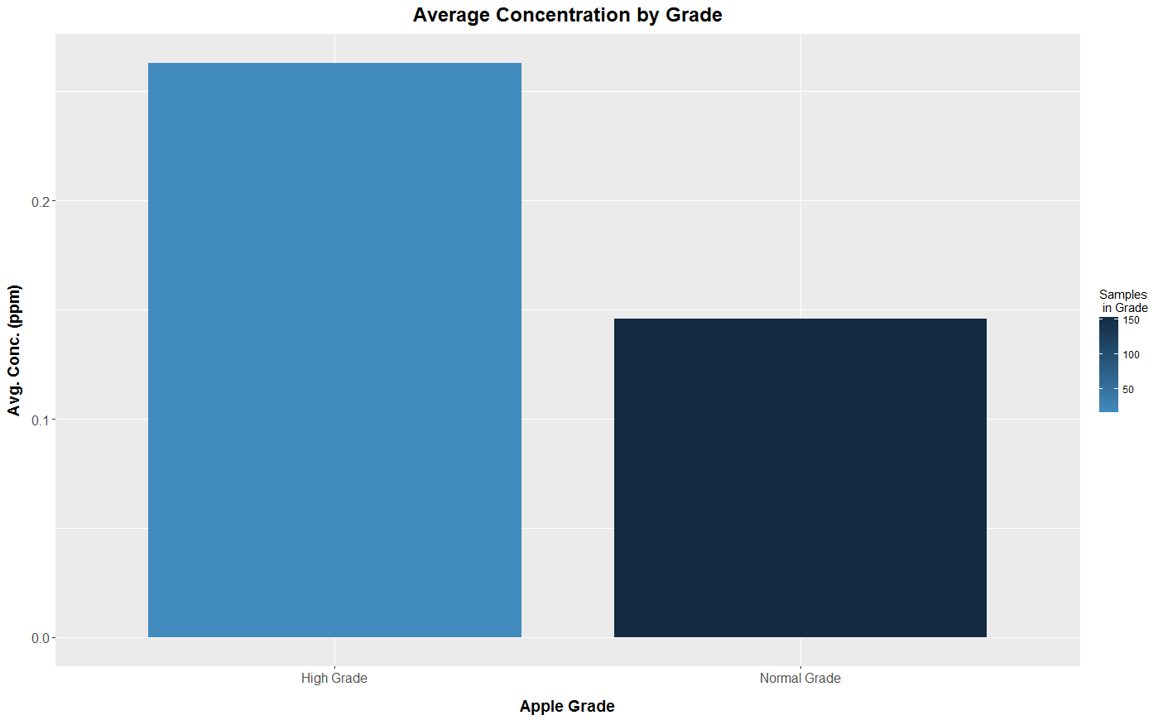

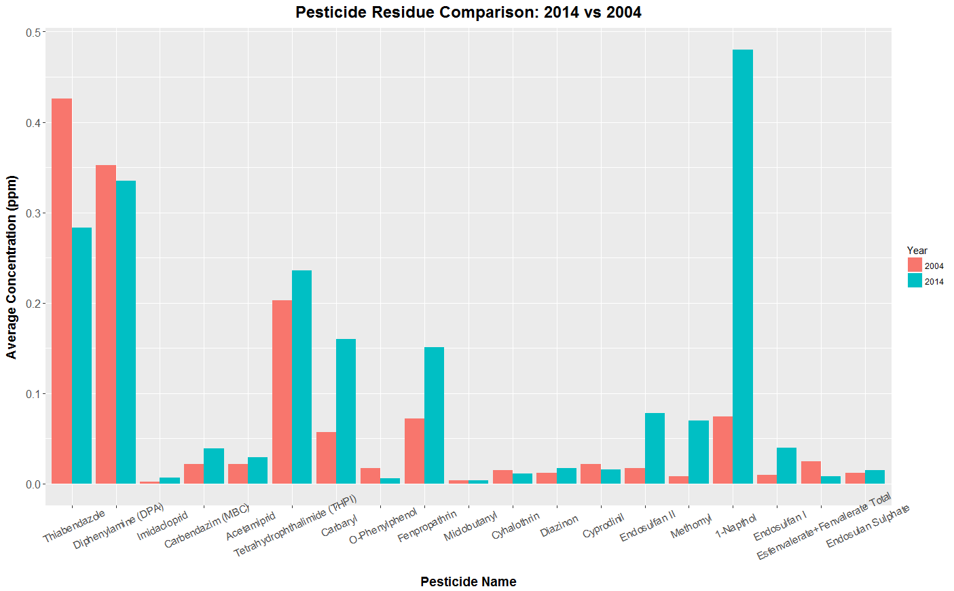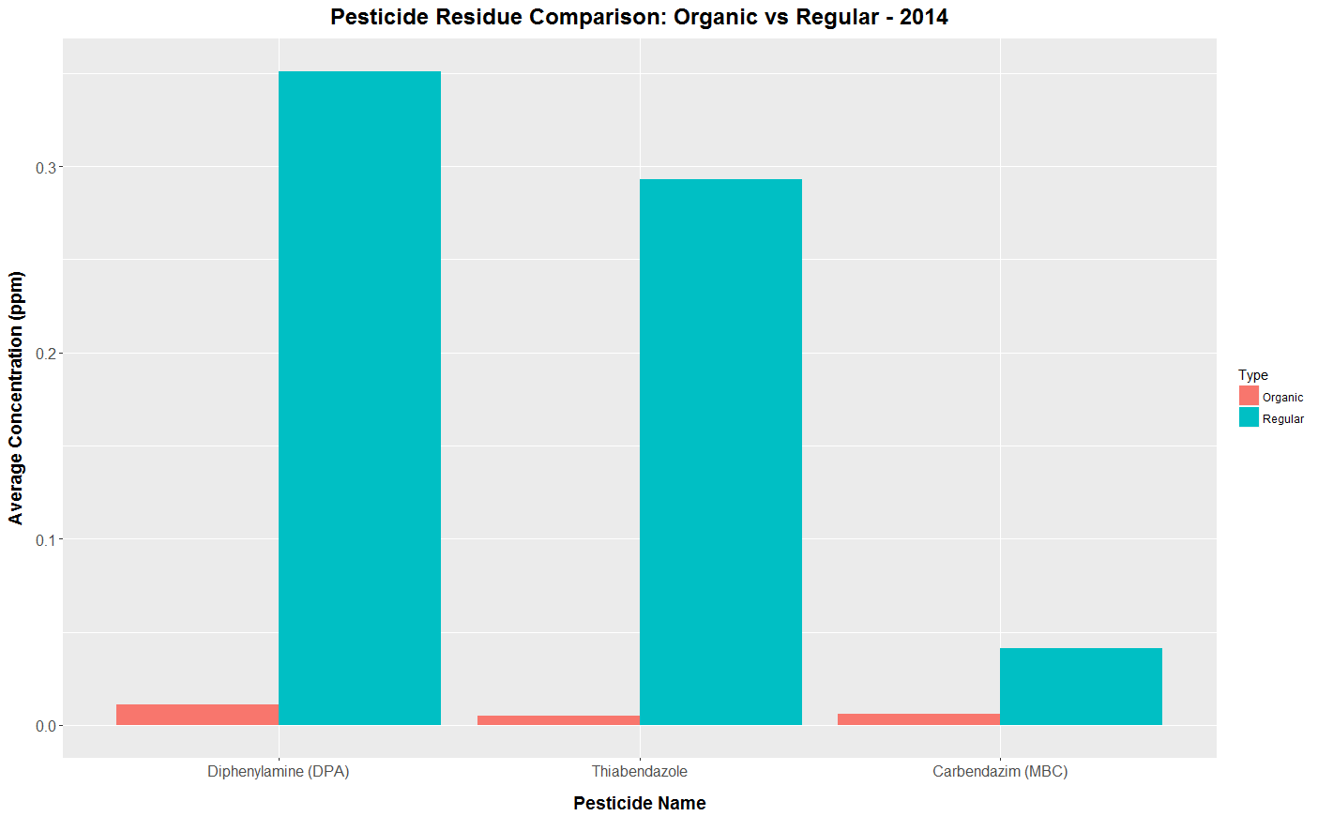

By graphing our data, we confirmed that, while not pesticide-free, organic apples had significantly fewer numbers and average concentrations of pesticides found compared to conventional ones. We also noticed that there appears to be a general increase in the average residue concentration from 2004 to 2014 for the majority of pesticides found on samples from both years. Honeycrisp and Cortland apple varieties had the highest average types of pesticides detected, while Granny Smith and Braeburn had the highest average residue concentrations. There appears to be an inverse correlation where samples with more pesticide types detected actually had lower average residue concentration. Apples with higher grade labels had a slighter lower average number of pesticides but at almost double the concentration.

**Argument:**

Based on the observations from our data, we highly recommend purchasing organic produce if the health effects of pesticides is a concern, especially for children conception. If organic is not an option due to availability or cost, we recommend avoiding premium grade apples due to the much higher average residue concentration compared to normal grade apples and certain apple varieties with significantly higher average number of pesticides detected (Honeycrisp and Cortland) due to potential risks of additional dangers from pesticide chemical mixtures. We also suggest not purchasing non-organic Granny Smith and Braeburn apples due to their exceedingly high average residue concentrations. McIntosh apples may be a variety to consider when buying conventional due to its low number of pesticides and not excessively high average concentration.

**References:**

United States Department of Agriculture, Agricultural Marketing Service. (2016). PDP Databases, 1992-2014. [ZIP archives with data files]. Retrieved September 9, 2016, from: <https://www.ams.usda.gov/datasets/pdp/pdpdata>

Total Word Count: 448