Data CLeaning Report

Keen Koalas – Nautical Narwhals

INFM600 - Section 0101

Saba Aldughaither

Mayuresh Amdekar

Eris Mei

Himanshu Sawant

**Data Source:**

The Pesticides Data Program (PDP) is a national pesticide residue monitoring program which is implemented by United States Department of Agriculture and it produces the most comprehensive pesticide residue database in the U.S. This dataset contains PDP sampling and residue testing data and results along with file layouts and reference lists that can be used to interpret the standardized codes used in the PDP dataset. The dataset contains the data for the years ranging from 1992-2014. The Agricultural marketing service has tested for pesticide residue on over ten thousand samples of agricultural goods sold in the U.S every year. These datasets include details such as where and when the item samples were collected, the types of processing the products had undergone, the types and amounts of residue, and whether the products had organic or pesticide-free claims. The monitoring program division administers PDP activities, including the sampling, testing, and reporting of pesticide residues on agricultural commodities in the U.S. food supply, with an emphasis on those commodities highly consumed by infants and children. The program is implemented through cooperation with state agriculture departments and other federal agencies.

Dataset Citation:

United States Department of Agriculture, Agricultural Marketing Service. (2016). PDP Databases, 1992-2014. [ZIP archives with data files]. Retrieved September 9, 2016, from: <https://www.ams.usda.gov/datasets/pdp/pdpdata>

**Licensing:**

The Agricultural Marketing Service (AMS) of the USDA specifies on its privacy page that all information on its site is public and can be copied or distributed if credit is given.

United States Department of Agriculture, Agricultural Marketing Service. (2016). Privacy Statement. Retrieved November 2, 2016, from: <https://www.ams.usda.gov/about-ams/privacy>

**Metadata:**

This dataset consists of the details of the food samples which were tested from 1992-2014. There are standardized codes in the dataset which are explained in the metadata. The metadata consists of:

1. An Instructions file which explains how to load the dataset in Microsoft Excel or Microsoft Access and also a description of all the files which are included in the data for a particular year such as the samples file, results file, data dictionary, etc.

2. The Data Dictionary file for the samples and results for each year which describes the column headers, the data type of the column and the number of samples and results for each year.

2. The Reference Tables Dictionary file which can be used to interpret the standardized codes in the dataset (for example. there are reference tables describing the codes for commodity names, commodity type, country name, origin of sample, pesticide name, etc.)

**Rationale:**

The dataset contains the year wise PDP sampling and residue testing data from year 1993 to 2014. However, for a single year, say 2014, the sampling data contains 10619 rows and the results data contains 2210744 rows. To limit the scope of the project, we have decided to work with the samples and results for only one commodity type: Apples (often ranked #1 on the Dirty Dozen list for pesticide residue) for only the latest year: 2014. However, to answer one research question related to the trend of concentrations, we are using the data from another year: 2004 along with that of 2014, to plot a trend over the 10-year interval. Also, we have decided to drop the columns with majority blank values which are not used in any of the analysis questions. We also combined two columns to aggregate their data into one column to create a leaner database. Lastly, the missing values in few rows were filled by comparing the data for the same attribute in corresponding data for a different year.

**Issues encountered with the data:**

1. Extraction of data into format usable into R: -

The dataset is available in the form of a MS Access database. This data can be extracted into only the formats ".xls*". However, to use the dataset in R, the dataset needs to be in CSV (Comma Separated Value) format. Following is the error when we try to import an ".xlsx" file as dataset into R:

Data Snapshot: -

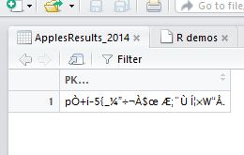

Console: -

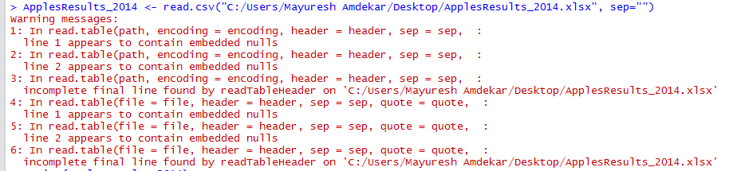

1. Blank/NULL values

There are a few columns in the dataset which have considerable number of blank/NULL values. Following are the columns for "Samples" and "Results" that have maximum blank values:

* Samples Data:
  + The attribute "SOURCE_ID" is blank for 158 rows / 177 rows of the Samples Data for 2014. It is used to make a sample unique, however, all the samples have a unique value in the SAMPLE_PK attribute, which is a primary key. This attribute can be dropped from the table.
  + The attribute "COUNTRY" will contain a value only when the "ORIGIN" attribute has value '2' i.e. the variety is imported from another country. If ORIGIN has value '2', the COUNTRY attribute will have the country code of the country of origin for e.g. '660' for New Zealand. As most of the samples have origin as United States, "COUNTRY" column has many blank/NULL values. For 2014 data, 176 rows/177 rows have value for Country attribute as blank. We can replace the name of country for e.g. "United States" for '1’, "New Zealand" for '2' if its corresponding COUNTRY value is '660' directly into the "ORIGIN" attribute and drop the column "COUNTRY".
  + The fields GROWST, PACKST, DISTST have large number of blank values. As these fields are not used in answering of the research questions, they can be safely dropped.
* Results Data:

The attributes CONFMETHOD2, ANNOTATE, QUANTITATE have blank values for all the 38792 rows for data of year 2014. As these attributes are not used in analysis, they can be dropped from the data set.

**There are similar observations for the "Samples" & “Results” data for 2004 year.**

1. Missing Values

Considerable number of rows (106/744) have null value for the "VARIETY" attribute for the Samples data of year 2004. The data for the year 2014 contains a few rows with value "Unknown" for the attribute "VARIETY". The same value can be used to fill the empty attributes of the data for year 2004.

**Steps followed to clean the data: -**

Data Cleaning is done in two phases:

1. Creation of CSV File for the data
   1. Open a blank CSV file.
   2. Under the "Data" tab, click in "import from text".
   3. Select the Samples.txt file under the "Import from text option", give delimiter as "|"
   4. Add appropriate headers for each column.
   5. Save the CSV file with **temporary name**.
   6. Filter the data for apples by selecting value for attribute "COMMOD (Commodity type)" as 'AP'.
   7. Copy the complete data after filter is applied and paste it into another blank CSV file.
   8. Save the new CSV file with an **appropriate name**.

Above steps are followed for creating CSV files for Samples and Results data for both years: 2004 and 2014.

1. Execution of R Script