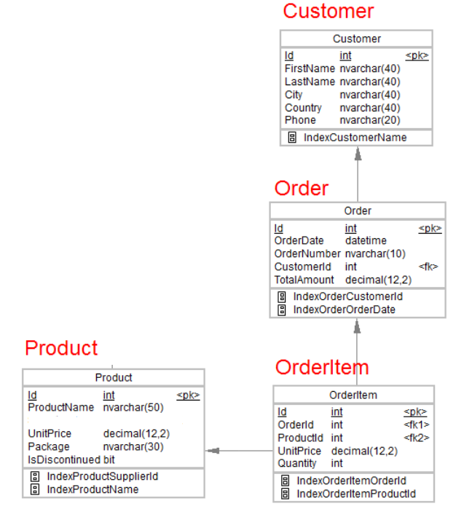

1.Desgin the above database with following table by applying Primary key and foreign key.

2.Insert Records in all tables.

3.In Customer table FirstName Attribute should not accept null value.

4.In Order table Order Date should not accept null value.

5.Display all customer details.

6.Write a query to display Country whose name starts with A or I.

7.Write a query to display whose name of customer whose third character is i.

create Database Shop

select * from Customer

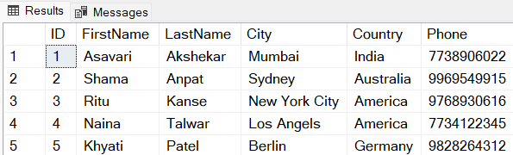

select * from [Order]

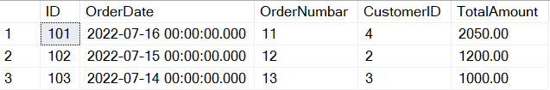

select * from OrderItem

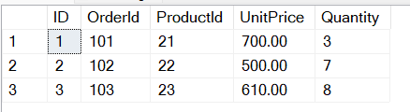

select * from Product

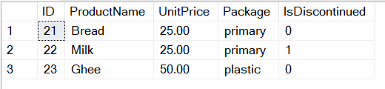

create Table [Order]

(

ID int NOT NULL Primary Key,

OrderDate datetime NOT NULL,

OrderNumbar nvarchar(10),

CustomerID int,

TotalAmount decimal(12,2)

)

Alter table [Order] add constraint Order_CustomerID_FK

Foreign Key (CustomerID) references Customer (ID)

create Table OrderItem

(

ID int NOT NULL Primary Key,

OrderId int,

ProductId int,

UnitPrice decimal(12,2),

Quantity int

)

Alter table OrderItem add constraint OrderItem_OrderID_FK

Foreign Key ([OrderID]) references [Order] (ID)

Alter table OrderItem add constraint OrderItem_ProductID_FK

Foreign Key (ProductID) references Product (ID)

Insert into OrderItem values(1,101,21,700,3)

Insert into OrderItem values(2,102,22,500,7)

Insert into OrderItem values(3,103,23,610,8)

create Table Product

(

ID int NOT NULL Primary Key,

ProductName nvarchar(50),

UnitPrice decimal(12,2),

Package nvarchar(30),

IsDiscontinued bit

)

Insert into Product values(21,'Bread',25,'primary',0)

Insert into Product values(22,'Milk',25,'primary',1)

Insert into Product values(23,'Ghee',50,'plastic',0)

**Write a query to display Country whose name starts with A or I**

SELECT * FROM Customer

WHERE Country LIKE 'A%' OR Country LIKE 'I%';

SELECT * FROM Customer

WHERE Country LIKE '[AI]%';

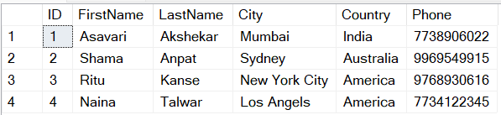

**Write a query to display whose name of customer whose third character is i.**

SELECT * FROM Customer

WHERE FirstName LIKE '__i%';

