1. Display the details from the Customer Table who is from country Germany

SELECT * FROM Customer

WHERE Country = 'Germany';



2. Display the Full Name of the Employee

select Employee_FirstName+' '+Employee_LastName as [Employee Full Name] from Employee

select CONCAT(Employee_FirstName,' ',Employee_LastName) as [Full Name] from Employee

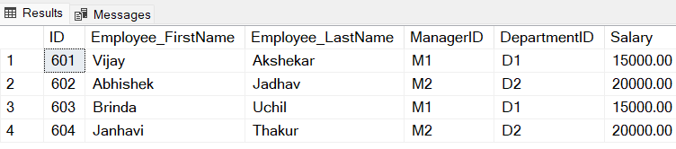

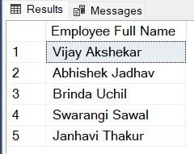

3. Display the customer details who has Fax number ‘+44 41 444-5555’

4. Display the customer details whose name holds second letter as H

select * from Customer where FirstName LIKE '_H%'

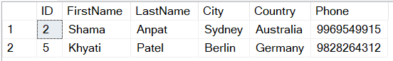

5. Select order Details where unit price is greater than 10 and less than 20.

select * from Product where UnitPrice > 10 AND UnitPrice < 20



6. Display order details which contains shipping date and arrange the order by date.

**Initial table:**

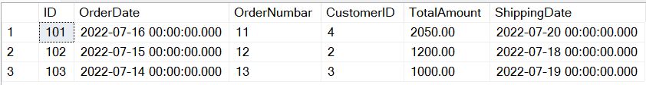

select * from [Order] order by ShippingDate

**After query:**

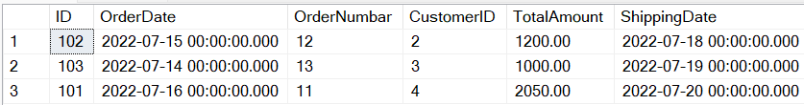

7. Print the orders shipped by ship name 'La corne d'abondance' between 2 dates (Choose dates of your choice).

select * from [Order] where ShippingName = 'La corne d''abondance' and

ShippingDate BETWEEN '2022-07-15' AND '2022-07-20'

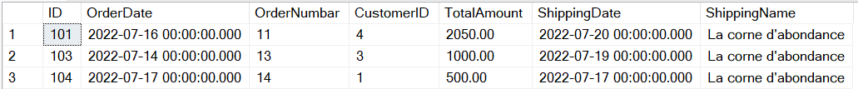

8.Print the products supplied by 'Exotic Liquids'.

select * from Product where Supplied= 'Exotic Liquids'

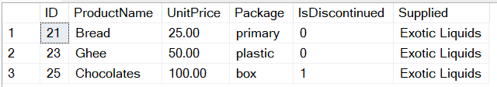

9.Print the average quantity ordered for every product

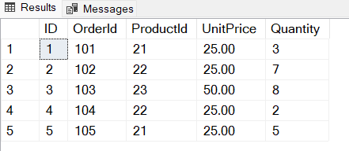

select ProductID, AVG(Quantity) as AverageQuantity

from OrderItem Group By ProductID

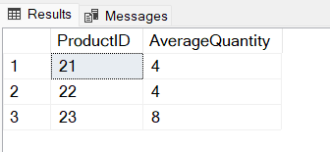

10.Print all the Shipping company name and the ship names if they are operational.

select ShippingName from [Order] WHERE Operational = 1

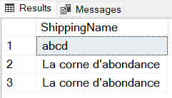

11.Print all Employees with Manager Name.

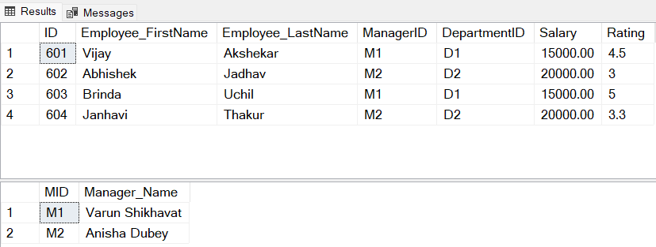

select E.Employee_FirstName+' '+E.Employee_LastName as [Employee Name], M.Manager_Name as [Manager Name]

from Employee E

INNER JOIN Manager M

ON E.ManagerID = M.MID

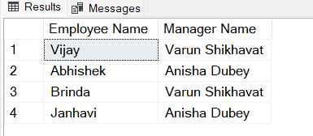

12.Print the bill for a given order id. Bill should contain Productname, Categoryname, price after discount.

create table ProductFinal

(

PID int NOT NULL PRIMARY KEY,

ProductName nvarchar(50),

UnitPrice decimal(12,2),

Discount decimal(12,2),

Price_After_Discount AS ((100 - Discount)/100) * UnitPrice

)

SELECT OI.OrderID , P.ProductName, P.Category, P.UnitPrice,P.Price_After_Discount

from ProductFinal P

INNER JOIN OrderItem OI

ON P.PID = OI.ProductID

WHERE OI.OrderID = 105

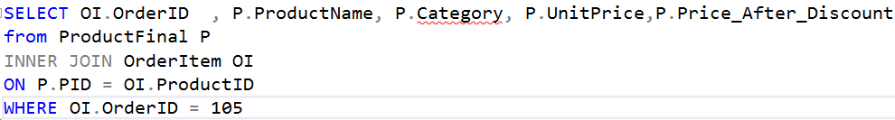

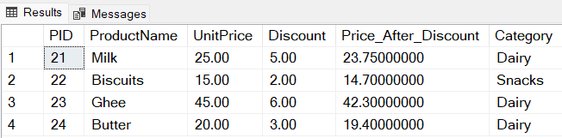



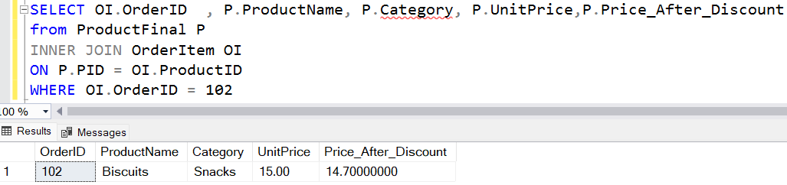

13. Print the Total price of orders which have the products supplied by 'Exotic Liquids' if the price is > 50 and also print it by Shipping company's Name.

select O.TotalAmount as [Total Price of Orders], P.Supplied, O.ShippingName, P.UnitPrice

from [Order] O

Join OrderItem OI

ON O.ID = OI.OrderID

Join Product P

ON P.ID = OI.ProductID

WHERE P.UnitPrice > 50 AND P.Supplied = 'Exotic Liquids'

