1.Write a query to display the orders placed by customer with phone number 7738906022.

select O.ID as [Number of Orders],P.ProductName, C.FirstName+' '+C.LastName as Customer, C.Phone, OI.ProductID

from [Order] O

JOIN Customer C

ON C.ID = O.CustomerID

JOIN OrderItem OI

ON O.ID = OI.OrderID

JOIN Product P

ON P.ID = OI.ProductID

where C.Phone = '7738906022'

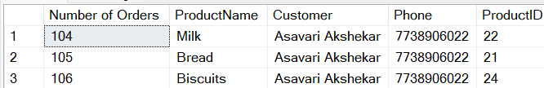

2.Fetching all the products which are available under Category ‘Dairy’.

select * from Product where Category = 'Dairy'

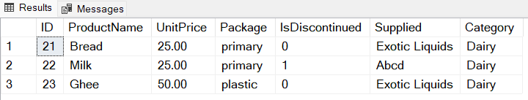

3.Display the orders placed by customers not in India.

select O.ID as Orders, OI.ProductID, P.ProductName, C.FirstName+' '+C.LastName as Customer, C.Country

FROM [Order] O

JOIN Customer C

ON C.ID = O.CustomerID

JOIN OrderItem OI

ON O.ID = OI.OrderID

JOIN Product P

ON P.ID = OI.ProductID

WHERE C.Country != 'London'

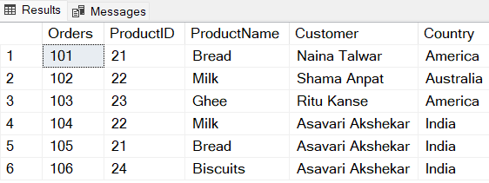

4.Selects all the order which are placed for the product Milk.

select O.ID as Orders, P.ProductID, P.ProductName, C.FirstName+' '+C.LastName as Customer

from [Order] O

JOIN Customer C

ON C.ID = O.CustomerID

JOIN OrderItem OI

ON O.ID = OI.OrderID

JOIN Product P

ON P.ID = OI.ProductID

Where P.ProductName = 'Milk'

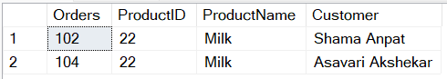

5.Write a query to display the name, department name and rating of any given employee.

select E.Employee_FirstName+' '+E.Employee_LastName as [Employee Name] , D.Department_Name, E.Rating

from Employee E

INNER JOIN Department D

ON E.DepartmentID = D.DID

