1. Print the Total price of orders which have the products supplied by 'Exotic Liquids' if the price is > 50 and also print it by Shipping company's Name.

select O.TotalAmount as [Total Price of Orders], P.Supplied, O.ShippingName, P.UnitPrice

from [Order] O

Join OrderItem OI

ON O.ID = OI.OrderID

Join Product P

ON P.ID = OI.ProductID

WHERE P.UnitPrice > 50 AND P.Supplied = 'Exotic Liquids'

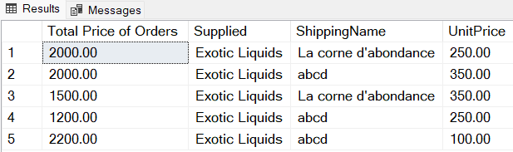

2. Display the employee details whose joined at first.

select \* from Employee order by [Joining Date] ASC

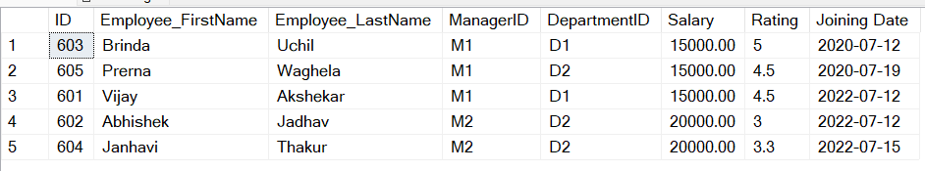

3. Display the employee details whose joined at recently.

select \* from Employee order by [Joining Date] DESC

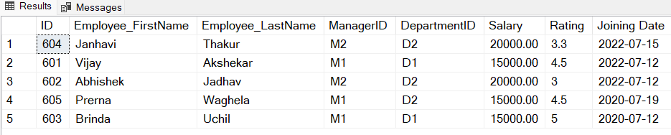

4. Write a query to get most expense and least expensive Product list (name and unit price).

--Using subquery

SELECT ProductName as [Most Expensive Product], UnitPrice

FROM Product

WHERE UnitPrice = ( SELECT MAX(UnitPrice) from Product)

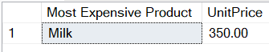

SELECT ProductName as [Least Expensive Product], UnitPrice

FROM Product

WHERE UnitPrice = ( SELECT MIN(UnitPrice) from Product)

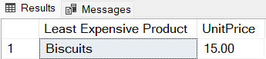

5. Display the list of products that are out of stock.

select ProductName as [Out of Stock Products] from Product where Quantity = 0

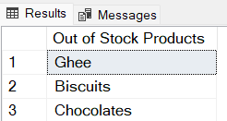

6.Display the list of products whose unit in stock is less than unit on order.

select P.ProductName, P.Quantity as [Unit in Stock], OI.Quantity [Unit in Orders]

from Product P

join OrderItem OI

on P.ID = OI.ProductID

where P.Quantity < OI.Quantity

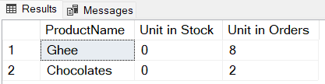

7.Display list of categories and suppliers who supply products within those categories.

select Supplied,Category from Product

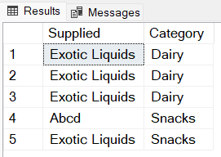

8.Display complete list of customers, the Order ID and date of any orders they have made.

select C.FirstName+' '+C.LastName as [List of Customers], O.ID as [Order ID], O.OrderDate

from Customer C

JOIN [Order] O

ON C.ID = O.CustomerID

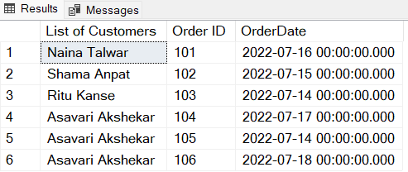

9.Write query that determines the customer who has placed the maximum number of orders.

select C.FirstName, COUNT(CustomerID) as [Maximum Orders]

FROM [Order] O

JOIN Customer C

on O.CustomerID = C.ID

group by C.FirstName

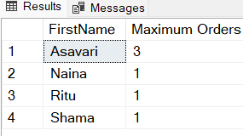

10.Display the customerid whose name has substring ‘AS’.

select \* from Customer

where SUBSTRING(FirstName,1,2) = 'AS'

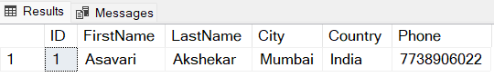

11.Display the first word of all the company name

Select LEFT(ShippingName,CHARINDEX(' ',ShippingName+' ')-1) AS CompanyName from [Order]

