**EXPERIENTIAL LEARNING ACTIVITY:**

**MOBILE APP DEVELOPMENT**

..

**BY**:

**Asavri Kaur**

**Batch CO25 (COE)**



# Thapar Institute of Engineering & Technology

## Year - 2022-2023

**AIM:**

* To get an understanding of basic process steps involved in creation of a mobile application for an android based device self-learning opportunities.
* Implement learnings to develop a basic app and gain practical exposure to app development activity.

* Share outcomes with my guide, seek inputs and get prepared for a bigger group activity on app development addressing real life problems.

**Undertaking:**

I Asavri Kaur student of Batch CO25 (COE) Semester 1 2022 of TIET have undertaken this learning initiative to get accustomed to basics of mobile app development leveraging self-learning resources available on internet, have taken inspiration from work done by other developers and have self-developed this app as a proof of concept to validate my learning of steps involved in android-based app development.

**Problem statement:**

Scientific calculators cost anywhere between 500 to 1000 rupees. Calculator apps provide an affordable solution to this problem. They are either free or can be downloaded for a nominal fee.

**Existing Solution:**

Scientific Calculators are available in the market.

**Issues in the existing solution which form basis of my work:**

They are better than physical calculators as they erase the need for various parts required in manufacturing like- electronic chips, plastic, metal, etc. They also provide users with a more convenient and portable alternative to physical calculators.

**Specification of my App:**

The basic specifications are-

* A user-friendly interface
* Accuracy
* Basic operators like- addition, subtraction, multiplication, and division.
* Input and output box

**Compare the need with the existing solutions:**

The existing solutions are more complicated for the common person to understand. For example- a street hawker or small shopkeeper would find it much easier to use the basic calculator without the additional options.

**Find the related software and hardware:**

Here's the shortlist of the 7 best scientific calculators:

* Casio FX-115ES PLUS.
* Texas Instruments TI-36X Pro.
* Sharp EL-W516TBSL 16-Digit Advanced.
* Texas Instruments TI-30XS MultiView.
* HP 35s Scientific Calculator.
* Helect 2-Line Engineering Scientific Calculator.
* Casio FX-991EX.

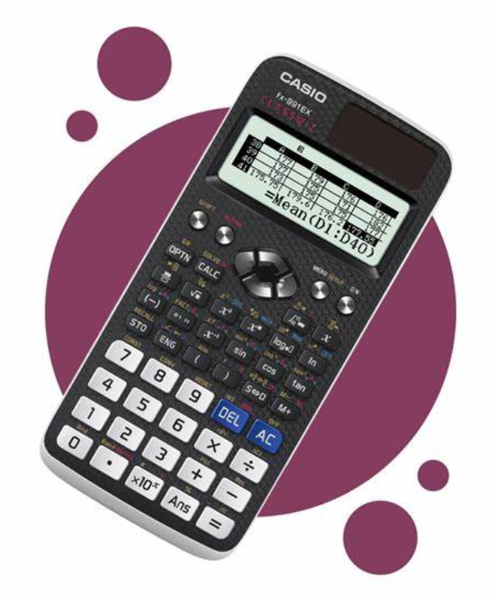

**Code Snippets:**

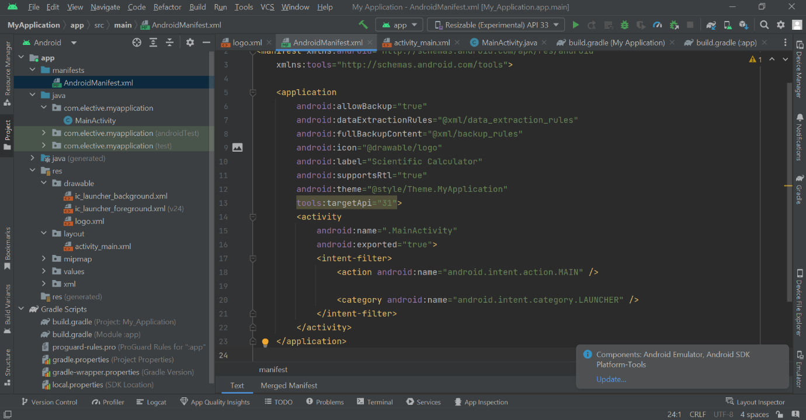

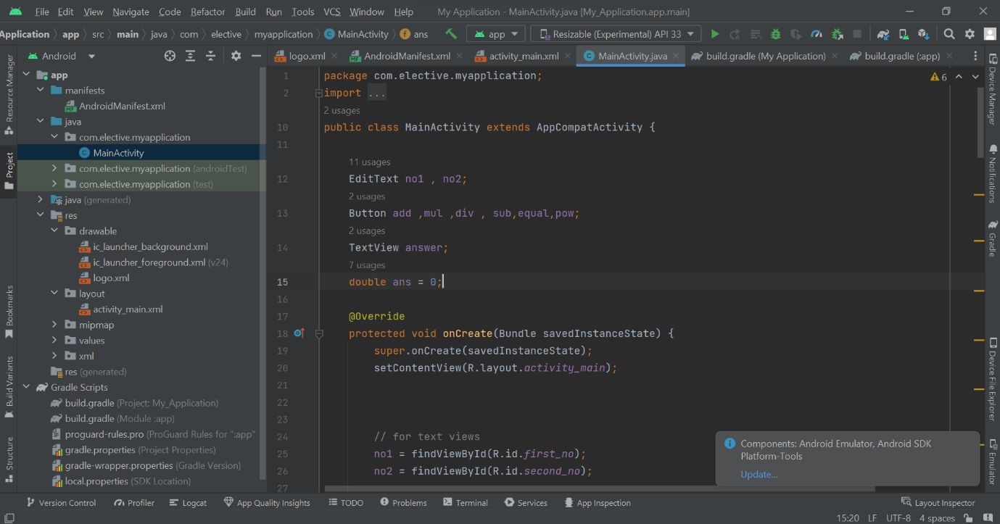

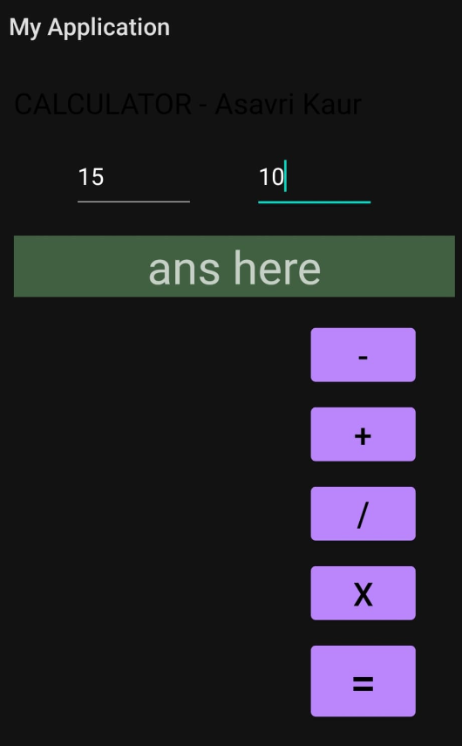

**Flowchart:**

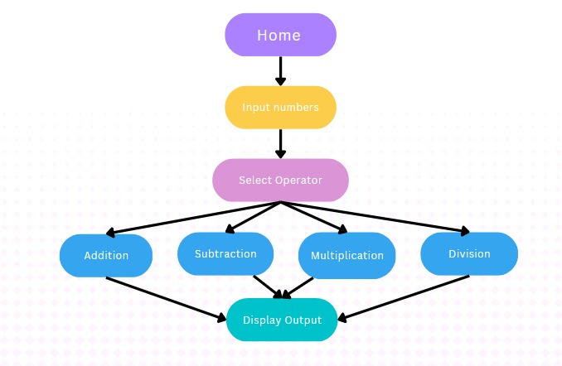

**Thank You**