**Lab Assignment–2**

**By: Asavri Kaur 102203940**

**Based on Emp table**

**Columns are EmpNo, Ename, Job, Salary, Commission, DeptNO**

**Insert 5 records by storing Null value in some records for commission column.**

**Q1) Get employee no and employee name who works in dept no 10?**

select EmpNo, Ename from EmpTable where DeptNO=10;

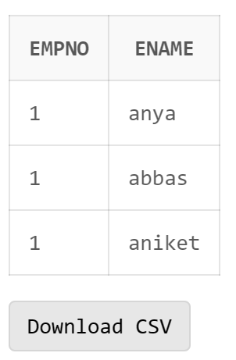

**Q2) Display the employee names of those clerks whose salary > 2000?**

select Ename from EmpTable where Job='clerk' and salary>2000;

**Q3) Display name and job of Salesperson & Clerks?**

select Ename, Job from EmpTable where Job='clerk' or Job='salesperson';

**Q4) Display all details of employees whose salary between 2000 and 3000?**

select * from EmpTable where salary between 2000 and 3000;

**Q5) Display all details of employees whose dept no is 10, 20, or 30?**

select * from EmpTable where DeptNo in (10,20,30)

**Q6) Display name of those employees whose commission is NULL?**

select Ename from Emptable where Commission is NULL;

**Q7) Display dept no & salary in ascending order of dept no and with in each dept no salary should be in descending order?**

select DeptNO,Salary from EmpTable order by DeptNO, Salary Desc;

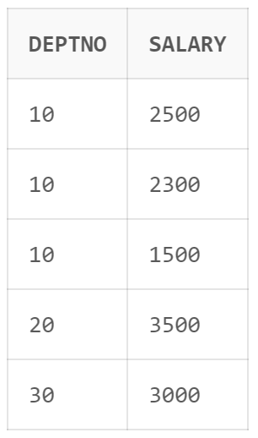

**Q8) Display name of employees having two ‘a’ or ‘A’ chars in the name?**

select Ename from EmpTable where Ename like '%aa%' or Ename like '%AA%';

**Q9) Display the name of the employees whose second char is‘b’ or ‘B’?**

select Ename from EmpTable where Ename like '%_b%' or Ename like '%_B%';

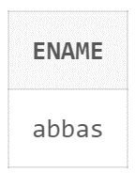

**Q10) Display the name of the employees whose first or last char is ‘a’ or ‘A’?**

select Ename from EmpTable where Ename like 'a%' or Ename like 'A%' or Ename like '%a' or Ename like '%A';

**Q11) Display maximum, minimum, average salary of deptno 10 employees.**

select max(Salary), min(Salary), avg(Salary) from EmpTable where DeptNO=10;

**Q12) Display total number of employees working in deptno 20**

select count (*) from EmpTable where DeptNO=20;

**Q13) Display total salary paid to clerks**

select sum(Salary) from EmpTable where Job='clerk';

**Q14) Display system date**

select sysdate from dual;

**Q15) Display the result of (12*12)/13**

select 12*12/13 from dual;

**Q16) Display info of ‘raj’ irrespective to the case in which the data is stored.**

select * from EmpTable where Ename='raj';

