Lab Assignment–3

**Q1) Use the following functions**

1. **chr (n):**

SELECT chr(67) FROM DUAL;

1. **cancat(char1,char2):**

SELECT concat('asavri','kaur') FROM DUAL;

1. **instr(string,char):**

SELECT INSTR('I am Asavri','vr') FROM DUAL;

1. **length(n):**

SELECT length('asavri') FROM DUAL;

1. **lpad(char1 ,n [,char2]):**

SELECT lpad('asavri',10,'*') FROM DUAL;

1. **ltrim(string [,char(s)]):**

SELECT ltrim('asavri','a') FROM DUAL;

1. **rpad(char1 ,n [,char2]):**

SELECT rpad('asavri',10,'*') FROM DUAL;

1. **rtrim(string [,char(s)]):**

SELECT rtrim('asavri','i') FROM DUAL;

1. **replace(char ,search_string , replacement_string):**

SELECT replace('hardware','hard','soft') FROM DUAL;

1. **substr(string ,position ,substring length):**

SELECT substr('hardware',2,3) FROM DUAL;

1. **initcap(char):**

SELECT initcap('asavri kaur') FROM DUAL;

1. **lower(string):**

SELECT lower('ASAVRI') FROM DUAL;

1. **upper(string):**

SELECT upper('asavri') FROM DUAL;

1. **translate(char ,from string ,to string):**

SELECT translate('abc','ab','ed') FROM DUAL;

1. **abs(n):**

SELECT abs(-43) FROM DUAL;

1. **ceil(n):**

SELECT ceil(4.3) FROM DUAL;

1. **cos(n):**

SELECT cos(2) FROM DUAL;

1. **exp(n):**

SELECT exp(3) FROM DUAL;

1. **floor(n):**

SELECT floor(4.3) FROM DUAL;

1. **mod(m ,n):**

SELECT mod(13,3) FROM DUAL;

1. **power(x ,y):**

SELECT power(2,3) FROM DUAL;

1. **round(x [,y]):**

SELECT round(23.1254,3) FROM DUAL;

1. **sign(n):**

SELECT sign(-12) FROM DUAL;

1. **sqrt(n);**

SELECT sqrt(12) FROM DUAL;

1. **trunc(x ,n):**

SELECT trunc(602.1122,2) FROM DUAL;

1. **sysdate:**

SELECT sysdate FROM DUAL;

1. **add_months(d ,n):**

SELECT add_months(DATE '2024-02-02',1) FROM DUAL;

1. **last_day():**

SELECT last_day(DATE '2024-02-02') FROM DUAL;

1. **months_between(date1 ,date2):**

SELECT months_between(DATE '2024-02-02', DATE '2024-04-05') FROM DUAL;

1. **next_day(date ,char):**

SELECT next_day(DATE '2024-02-02', 'THURSDAY') FROM DUAL;

1. **greatest(expr):**

SELECT GREATEST(2,4,3,1) FROM DUAL;

1. **least(expr):**

SELECT LEAST(2,4,3,1) FROM DUAL;

**Q2) Display current time in hour : min : sec format**

SELECT TO_CHAR(sysdate, '"Hours: "hh", Minutes: "mi" Seconds: "ss') FROM DUAL;

**Q3) Display salary + commission of emp table**

update emp set emp.commission=emp.commission + emp.salary;

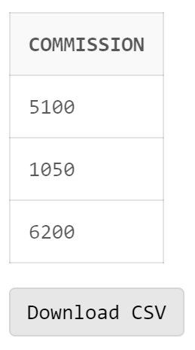

**Q4) Store any date value in hiredate column of table ?**

UPDATE emp

SET hiredate='22 February 1990'

WHERE ename='Bob';

**Q5) Display name of employee(s) who join the company in 1985?**

SELECT * FROM emp WHERE hiredate >='01 JANUARY 1985' AND hiredate < '01 JANUARY 1986';

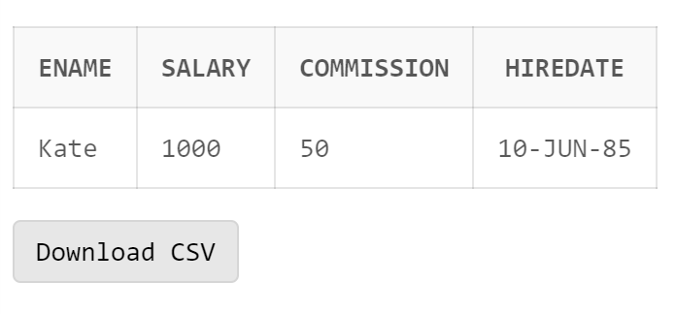

**Q6) Display name of the employee(s) who join the company this year?**

SELECT * FROM emp WHERE hiredate >='01 JANUARY 2024' AND hiredate < '01 JANUARY 2025';

