**Assignment-4**

**(Working on Date Functions)**

**Write queries to:**

1. **Display the system date**

SELECT sysdate FROM DUAL;

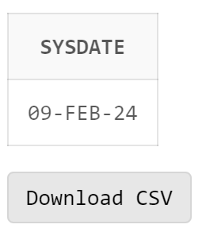

1. **Display current day**

SELECT to_char(sysdate,'day') FROM DUAL;

1. **Display current month and spell out year**

SELECT to_char(sysdate, 'yyyysp'), to_char(sysdate,'month') FROM DUAL;

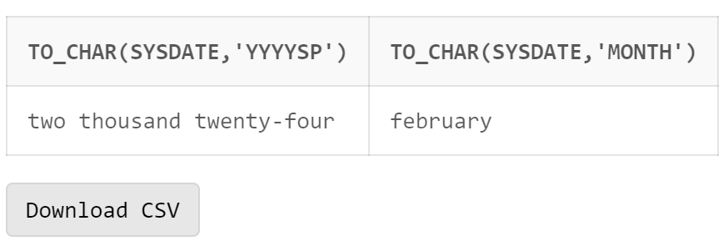

1. **Display spell out current date**

SELECT to_char(sysdate, 'ddsp') FROM DUAL;

1. **Check whether it is AM or PM right now**

SELECT to_char(sysdate,'am') FROM DUAL;

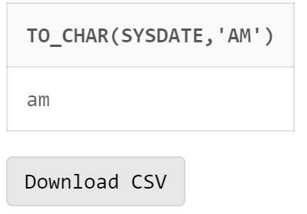

1. **Display the date of next Friday**

SELECT next_day(sysdate,'Friday') FROM DUAL

1. **Round the system date on month**

SELECT round(sysdate,'month') FROM DUAL**;**

1. **Truncate the system date on month**

SELECT trunc(sysdate,'month') FROM DUAL;

1. **Round the system date on year**

SELECT round(sysdate,'year') FROM DUAL;

1. **Truncate the system date on year**

SELECT trunc(sysdate,'year') FROM DUAL;

1. **Find the day after three days**

SELECT to_char(sysdate+3,'day') FROM DUAL;

**Queries Based on EMP table**

1. **Create an EMP table (Empno number, Name Varchar2(20),** **date_of_joining date)**

CREATE TABLE EMP2(

Empno NUMBER,

Name VARCHAR(20),

date_of_joining DATE

);

insert into EMP2 values (1, 'Abc', '05-Feb-2017');

insert into EMP2 values (2, 'Def', '01-Feb-2024');

insert into EMP2 values (3, 'Ghi', '10-Jan-2024');

insert into EMP2 values (4, 'jkl', '21-Jul-2020');

insert into EMP2 values (5, 'mno', '12-April-2010');

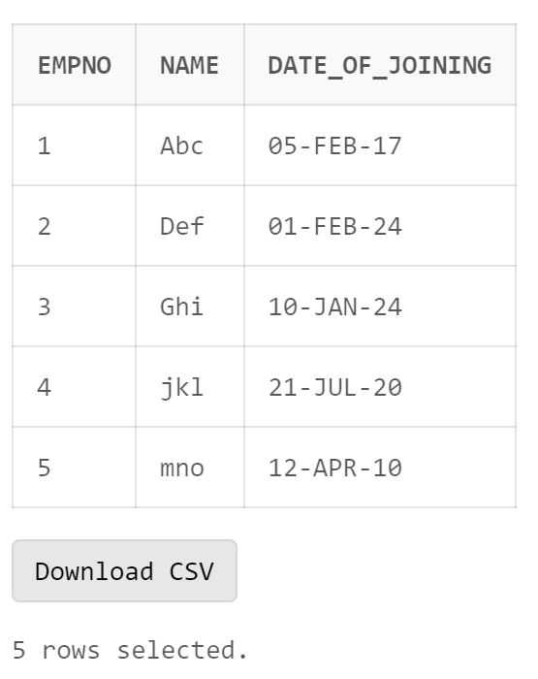

1. **Display day of date of joining column**

SELECT to_char(date_of_joining,'day') FROM EMP2;

1. **Display those employees who join the company on Monday**

SELECT Name FROM EMP2 WHERE to_char(date_of_joining,'fmday')='monday';

1. **Display those employees who join the company this month**

SELECT Name FROM EMP2 WHERE to_char(date_of_joining,'fmmon')='feb';

1. **Display those employees who join the company in last 30 days**

SELECT Name FROM EMP2 WHERE date_of_joining between sysdate-30 and sysdate;

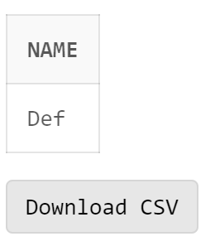

**Queries based on Train Arrival and Departure**

1. **Create a table Train having four columns (TrainNo Number (6) primary key, date of departure, time of departure, time of arrival)**

Create table Train(TrainNo Number(6) primary key,

departure date,

time_arrival timestamp,

time_departure timestamp

);

1. **Insert five records into the table Train.**

insert into train values(123,'12-jan-2024','12-Jan-2024 09:45:32pm','12-Jan-2024 11:34:10pm');

insert into train values(132,'09-jan-2024','09-Feb-2024 09:45:32am','09-Feb-2024 09:54:10am');

insert into train values(340,'21-jan-2024','21-May-2023 10:45:32pm','21-May-2023 10:54:10pm');

insert into train values(140,'23-jan-2024','12-Jan-2024 09:45:32pm','23-Jan-2024 11:34:10pm');

insert into train values(143,'25-jan-2024','12-Jan-2024 09:45:32pm','25-Jan-2024 11:34:10pm');

1. **Display all the three records**

select * from train;

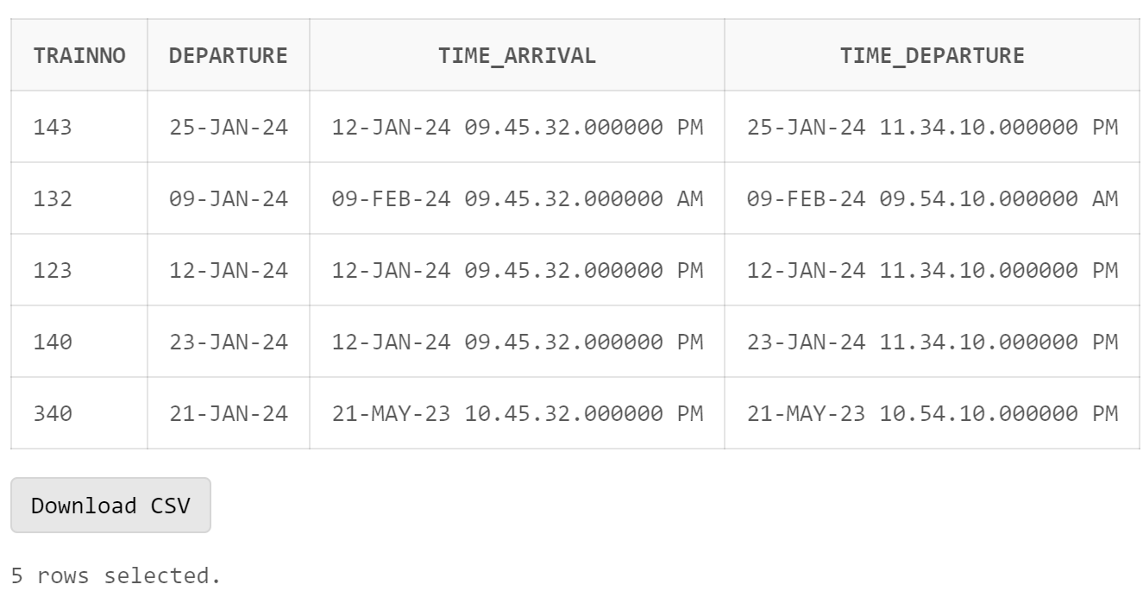

1. **Display the time values inserted in the columns**

select to_char(time_arrival,'hh:mm:ss'),to_char(time_departure,'hh:mm:ss') from train;

1. **Display those trains which arrived on PM**

select * from Train where to_char(time_arrival, 'pm')='pm';

1. **Display train number who are going to depart in next one hour.**

insert into Train values (193,'','09-Feb-2024 06:58:41pm','09-Feb-2024 06:59:41pm');

select * from Train where time_departure between sysdate and sysdate+1/24;

