**Assignment-5**

**(Constraints in SQL)**

**1. Create table dept which has the following attributes (department table)**

**(deptno, dept_name) where deptno is primary key, dept_name in (Acc, comp, elect)**

create table dept(

deptno number,

dept_name varchar(20) constraint dept_name_check check(dept_name in ('acc','comp','elect')),

constraint d_pk primary key (deptno)

);

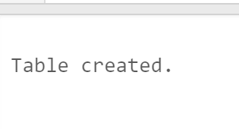

**2. Create table emp which has the following attributes (employee table)**

**(empno, emp_name, job, sal, deptno, mgr_no) where empno is primary key, emp_name is unique,**

**job in (Prof, AP, and Lect), sal is NOT NULL, deptno is foreign key, mgr_no is a self-referential**

**foreign key.**

create table emp(

empno number,

emp_name varchar(20),

job varchar(20),

sal number not null,

deptno number,

mgr_no number,

constraint empno_pk primary key(empno),

constraint emp_name_unique unique(emp_name),

constraint check_job check(job in ('prof','ap','lect')),

constraint deptno_fk foreign key (deptno) references dept(deptno),

constraint mgr_no_fk foreign key (mgr_no) references emp(empno)

);

**3. Create table S which has the following attributes (Salesperson table)**

**(sno, sname, city) where sno is primary key**

create table s(

sno number,

sname varchar(20),

city varchar(20),

constraint s_pk primary key(sno)

);

**4. Create table P which has the following attributes (Part table)**

**(pno, pname, color) where pno is primary key**

create table p(

pno number,

pname varchar(20),

color varchar(20),

constraint p_pk primary key(pno)

);

**5. Create table J which has the following attributes (ProJect table)**

**(jno, jname, city) where jno is primary key**

create table j(

jno number,

jname varchar(20),

city varchar(20),

constraint j_pk primary key(jno)

);

**6. Create table SPJ which has the following attributes**

**(sno, pno, jno, qty) where combination of (sno, pno, jno) is a composite primary key. Also,**

**sno, pno, jno are foreign keys.**

create table spj(

sno number,

pno number,

jno number,

qty number,

constraint spj_pk primary key(sno,pno,jno),

constraint spj_sfk foreign key (sno) references s(sno),

constraint spj_pfk foreign key (pno) references p(pno),

constraint spj_jfk foreign key (jno) references j(jno)

);

**7. Insert at least 5 appropriate records in the above tables.**

insert into dept values(101,'acc');

insert into dept values(102,'elect');

insert into dept values(103,'comp');

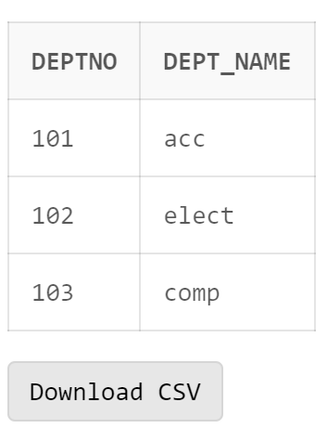

insert into emp values(111,'Ramesh','prof',1000,101,null);

insert into emp values(114,'Suresh','ap',2000,101,111);

insert into emp values(112,'Ravi','lect',3000,102,null);

insert into emp values(113,'Harish','ap',4000,102,112);

insert into emp values(100,'Manish','prof',5000,103,111);

insert into s values(1,'A','delhi');

insert into s values(2,'B','patiala');

insert into s values(3,'C','gurgaon');

insert into s values(4,'D','amritsar');

insert into s values(5,'E','ludhiana');

insert into p values(11,'AA','orange');

insert into p values(12,'BB','blue');

insert into p values(13,'CC','red');

insert into p values(14,'DD','yellow');

insert into p values(15,'EE','green');

insert into j values(101, 'AAA', 'delhi');

insert into j values(102,'BBB','patiala');

insert into j values(103,'CCC','gurgaon');

insert into j values(104,'DDD','amritsar');

insert into j values(105,'EEE','ludhiana');

insert into spj values(1,11,101,1);

insert into spj values(2,12,102,2);

insert into spj values(3,13,103,3);

insert into spj values(4,14,104,4);

insert into spj values(5,15,105,5);

select * from spj;

**8. Drop the NOT NULL constraints from EMP table.**

alter table emp modify(sal null);

--here, empno cannot be made null as it is the primary key

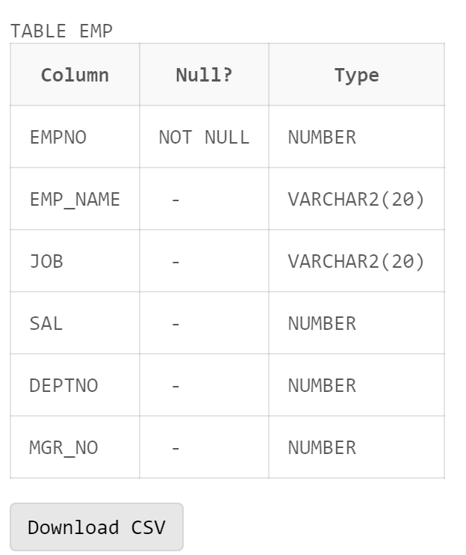

**9. Check all the constraints name and their type of EMP table.**

SELECT * FROM user_constraints WHERE table_name='EMP';

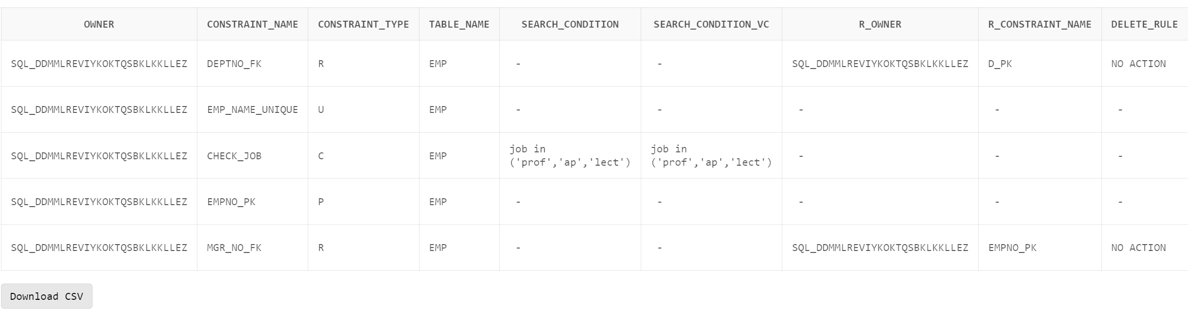

**10. Drop the unique constraint on EMP_NAME of EMP table.**

alter table emp drop constraint emp_name_unique;

**11. Drop the Foreign Key constraint on DEPTNO**

alter table emp drop constraint deptno_fk;

**12. Add Foreign Key constraint on DEPTNO as a table label constraint.**

alter table emp add constraint deptno_fk foreign key (deptno) references dept(deptno);

**13. Drop the Check constraint from DEPT table.**

alter table dept drop constraint dept_name_check;

**14. Add COMM column in EMP table (default value 0).**

alter table emp add (comm number);

alter table emp modify comm number default 0;

**15. Drop Default constraint from EMP.**

alter table emp modify comm default null;

**16. Create duplicate copy of EMP table.**

create table new_emp_table as select * from emp;

select * from new_emp_table;

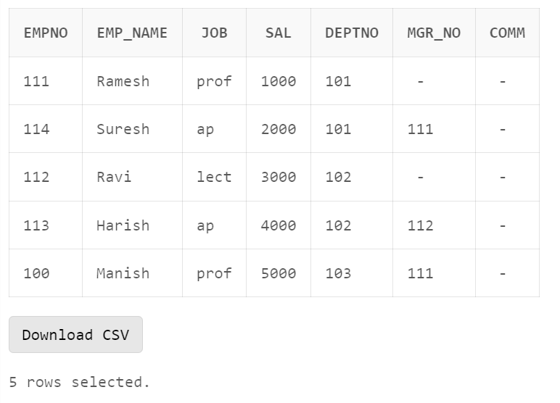

**17. Copy the structure of DEPT table to a new table with different column names.**

create table n_dept_table as select

deptno as A,

dept_name as B

from dept

where 1=1;

desc n_dept_table;

select * from n_dept_table;

**18. Copy the structure of DEPT table to a new table with different column names without any**

records copied from DEPT.

create table new_dept_table as select

deptno as A,

dept_name as B

from dept

where 1=2;

desc new_dept_table;

select * from new_dept_table;

**19. Change the name and job of the employee whose EMPNO =100.**

update emp set emp_name='Leena',job='lect' where empno=100;

select * from emp where empno=100;

**20. Delete the record of employee who belong to computer department.**

delete from emp where deptno =

(select deptno from dept where dept_name='comp');

select * from emp;

**21. Delete deptno 101 from Dept table and set NULL to the corresponding deptno in EMP table.**

alter table emp drop constraint deptno_fk;

alter table emp add constraint deptno_fk foreign key (deptno) references dept(deptno) on delete set null;

delete from dept where deptno=101;

select * from emp;

**22. Delete deptno 102 from Dept table and its corresponding record from EMP table.**

delete from dept where deptno=102;

select * from emp;

select * from dept;

**23. Delete the empno 111 who is the manager of the employee whose empno is 114.**

alter table emp drop constraint mgr_no_fk;

alter table emp add constraint mgr_no_fk foreign key (mgr_no) references emp(empno) on delete set null;

delete from emp where empno=111;

select * from emp;

**24. Delete the record of ‘Ravi’ whose empno is 112 and set the mgr_no to NULL for all the employees for whom Ravi is the manager.**

update emp set mgr_no = null where mgr_no=112;

delete from emp where empno=112;

select * from emp;

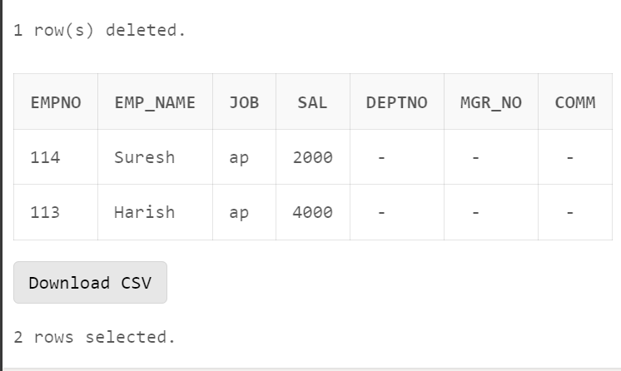

**25. Drop the duplicate table of EMP.**

drop table new_emp_table;

