**LAB ASSIGNMENT-6**

**Group By and Joins in SQL (Part-I)**

**TABLE DEPT (DEPTNO, DEPTNAME)**

**TABLE EMP (EMPNO, EMPNAME, DEPTNO, JOB, SALARY): DEPTNO is a foreign**

**key w.r.t to DEPT Table.**

**Answer the following SQL Queries**

1. **Insert 10 appropriate records in each table as per the SQL queries mentioned below.**

insert into emp values(101,'A','salesman',1000,10);

insert into emp values(102,'B','salesman',1000,20);

insert into emp values(103,'C','clerk',1000,20);

insert into emp values(104,'D','clerk',2000,20);

insert into emp values(105,'E','salesman',3000,20);

insert into emp values(106,'F','engineer',4000,20);

insert into emp values(107,'G','engineer',5000,20);

insert into emp values(108,'H','engineer',4000,30);

insert into emp values(109,'I','salesman',3000,30);

insert into emp values(110,'J','salesman',2000,10);

select * from emp;

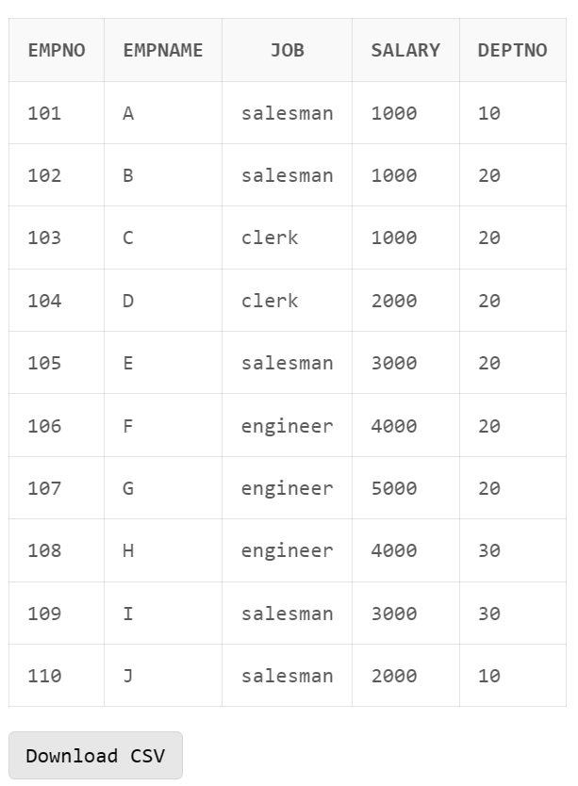

1. **List the total number of employees?**

select count(*) from emp;

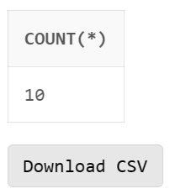

1. **List the total no of departments?**

select count(*) from dept;

1. **Display the employee details of each department for which they are working.**

select * from emp order by deptno;

1. **List the total, maximum, & minimum salary for deptno 30?**

select min(salary), max(salary), sum(salary)

from emp

where deptno=30;

1. **Display the name of the employee getting maximum salary?**

select empname

from emp

where salary = (

select max(salary)

from emp

);

1. **Display the total salary for each department?**

select sum(salary), deptno

from emp

group by deptno;

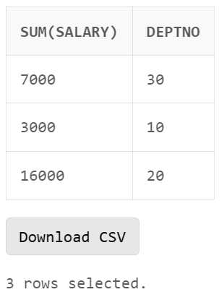

1. **Display the total salary for each job.**

select sum(salary), job

from emp

group by job;

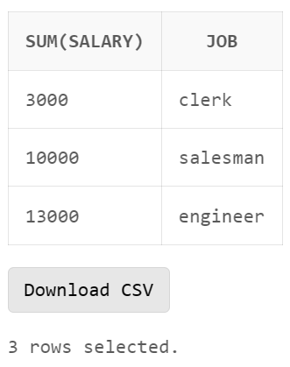

1. **Display the total salary for each job within each department.**

select sum(salary),job,deptno

from emp

group by deptno,job

order by deptno desc;

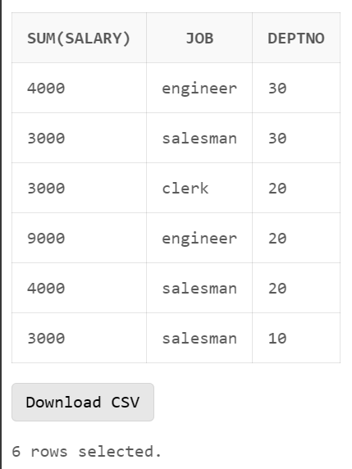

1. **Display the average salary for each job in deptno 20.**

select avg(salary), job

from emp

where deptno=20 AND job in (

select distinct job

from emp

where deptno=20

)

group by job;

1. **Display the total salary for each job excluding the ‘manager’ and ‘salesman’ job.**

select job, sum(salary) from emp

where job not in (

'salesman',

'manager'

)

group by job;

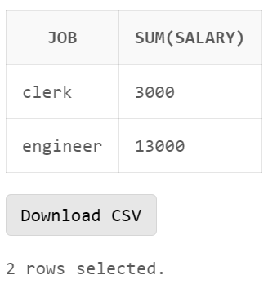

**12. Display the average salary for each job in deptno 20, but only display those jobs where**

**average salary is greater than 2000 & display the output in descending order of salary?**

select avg(salary), job

from emp

where deptno=20

group by job

having avg(salary)>2000

order by avg(salary) desc;

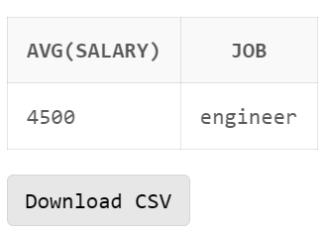

**13. Display the total no of employees for each department excluding the deptno 10 & display**

**only those departments where more than five employees work. Display the output in**

**descending order of total no of employees?**

select count(*),deptno

from emp

where deptno <> 10

group by deptno

having count(*)>5

order by count(*) desc;

**14. Display the total no of employees for each department excluding the ‘comp’ dept & display**

**only those departments where more than five employees work. Display the output in**

**descending order of total no of employees?**

select count(*),deptno

from emp

where deptno <> (

select deptno

from dept

where deptname = 'comp'

)

group by deptno

having count(*)>5

order by count(*) desc;

**15. Display total number of emp working in each job in each dept.**

select count(*),deptno, job

from emp

group by deptno,job

order by deptno desc;

**16. List all the department name and their employees name even if for a department there is no**

**employees (A newly created department).**

insert into dept values(40,'data science');

select dept.deptname, emp.empname

from dept

left join emp

on dept.deptno = emp.deptno;

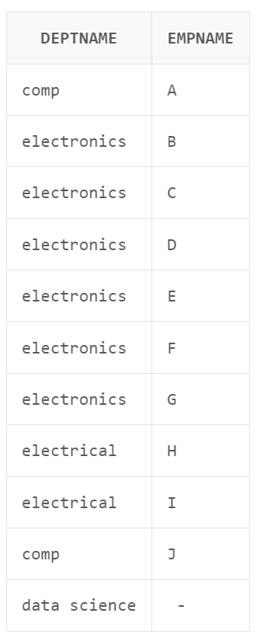

**17. List all the employees name and their department name even if for an employee there is no**

**department assigned (A newly joined employee).**

insert into emp values(112,'H','engineer',1000,null);

select dept.deptname, emp.empname

from emp

left join dept

on dept.deptno = emp.deptno;

**18. List all the departments name and their employees name irrespective whether for a**

**department any employees are there are not, and irrespective whether for an employee**

**there is any department assigned or not.**

select dept.deptname, emp.empname

from emp

full outer join dept

on dept.deptno = emp.deptno;

