**PLSQL (LAB Assignments-1)**

1. **WAP to find the greatest of three numbers.**

declare

a number:=20;

b number:=10;

c number:=30;

m number:=a;

begin

if (b>m) then

m:=b;

end if;

if (c>m) then

m:=c;

end if;

dbms_output.put_line(m);

end;

/

1. **WAP to check whether number is odd or even.**

declare

a number;

begin

a:=&a;

if mod(a,2)=1 then

dbms_output.put_line('odd');

else

dbms_output.put_line('even');

end if;

end;

/

**3) WAP to find the grade. Consider the following:**

**Marks > 80 A grade**

**Marks >70 B grade**

**Marks >50 C grade**

**Marks > 40 D grade**

**Marks < 40 E grade**

declare

marks number;

begin

marks:=&marks;

if (marks > 80) and (marks < 100) then

dbms_output.put_line('A grade');

elsif (marks>70) and (marks<=80) then

dbms_output.put_line('B grade');

elsif (marks>50) and (marks<=70) then

dbms_output.put_line('C grade');

elsif (marks>40) and (marks<=50) then

dbms_output.put_line('D grade');

elsif (marks<=40) and (marks>=0) then

dbms_output.put_line('E grade');

else

dbms_output.put_line('invalid');

end if;

end;

/

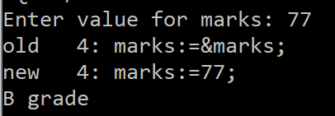

1. **WAP to print the table of a given number.(use for loop)**

declare

n number;

m number;

counter number;

begin

n:=&n;

for counter in 1..10 loop

m:=n*counter;

dbms_output.put_line(n||' * '||counter||' = '||m);

end loop;

end;

/

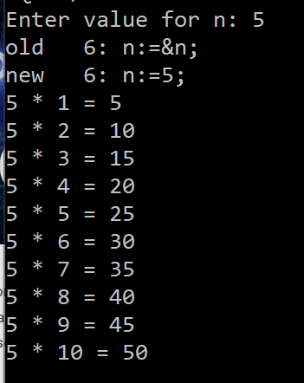

1. **WAP to find out the factorial of a given number.(use while loop)**

declare

n number;

ans number;

begin

n:=&n;

ans:=n;

while n>2

loop

n:=n-1;

ans:=ans*n;

end loop;

dbms_output.put_line(ans);

end;

/

1. **WAP to find out the Fibonacci series.**

declare

n number;

n1 number;

n2 number;

n3 number;

i number;

begin

n:=&n;

n1:=0;

n2:=1;

for i in 1..n loop

n3:=n1+n2;

dbms_output.put_line(n3);

n1:=n2;

n2:=n3;

end loop;

end;

/

1. **WAP to find the reverse of a number**

declare

n number;

n1 number;

a number;

p number:=0;

i number:=0;

digits number:=0;

begin

n:=&n;

n1:=n;

while n1>0 loop

digits:=digits+1;

n1:=trunc(n1/10,0);

end loop;

while (n>0) loop

i:=i+1;

a:=mod(n,10);

p:=(a*power(10,(digits-i)))+p;

n:=trunc(n/10,0);

end loop;

dbms_output.put_line(p);

end;

/

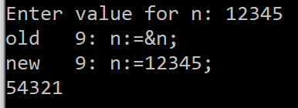

**8) Write PL/SQL block that performs addition (+), subtraction (-), multiplication (*) and**

**division (/) of two numbers as choice by the user.**

declare

op1 number;

op2 number;

ans number;

operand varchar2(1);

c varchar2(1);

begin

op1:=&op1;

op2:=&op2;

operand:=&operand;

case operand

when '+' then

ans:=op1+op2;

when '-' then

ans:=op1-op2;

when '*' then

ans:=op1*op2;

when '/' then

ans:=op1/op2;

else

ans:=(-1);

end case;

dbms_output.put_line(ans);

end;

/

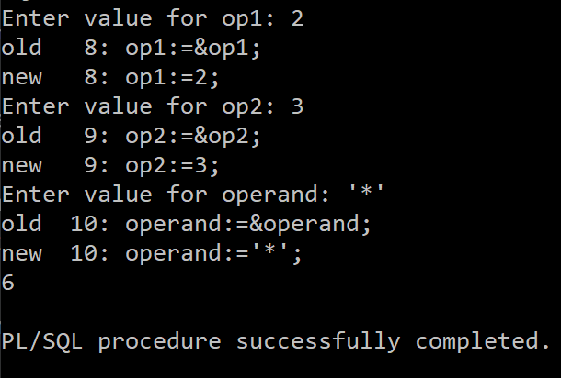

**9) Write PL/SQL block to print 5, 10, 15,20 by using For Loop.**

declare

i number;

counter number;

begin

for counter in 1..4 loop

i:=5*counter;

dbms_output.put(i||',');

end loop;

dbms_output.new_line;

end;

/

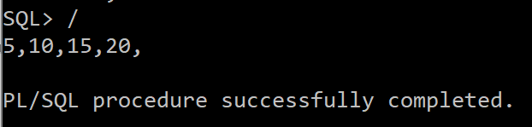

**10) Write Pl/SQL block to display welcome message like good morning, good afternoon, good night depending on system time.**

declare

t timestamp:=systimestamp;

begin

if t>3 and t<12 then

dbms_output.put_line('gm');

elsif t>=12 and t<=16 then

dbms_output.put_line('ga');

else

dbms_output.put_line('gn');

end if;

dbms_output.put_line(t);

end;

