ASSUMPTION:

I am assuming user who wants a high speed car.I am plotting graphs between horsepower,mpg and displacement,mpg.

> attach(mtcars)

> plot(hp, disp, xlab="Horse Power", ylab="MPG", main="HORSE POWER COMPARED WITH MPG")

> text(hp, disp, row.names(mtcars), cex =1.0 , pos = 4, col="purple")

> detach()

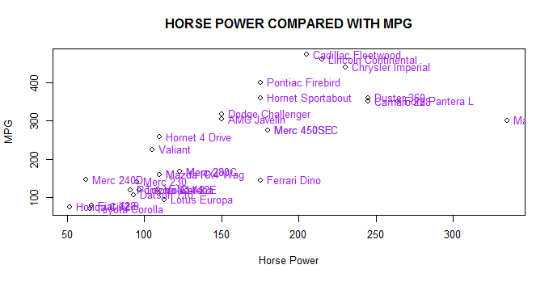

> attach(mtcars)

> plot(hp, disp, xlab="DISPLACEMENT", ylab="MPG", main="DISPLACEMENT COMPARED WITH MPG")

> text(hp, disp, row.names(mtcars), cex =1.0 , pos = 4, col="purple")

> detach()

