GWSB Ranking Predictor — Technical Documentation
  - Data flow, model training, frontend integration, deployment
GWSB Operations & Strategic Initiatives
Table of Contents

1. System overview
The GWSB Ranking Predictor is a static-served single-page web app backed by a one-shot Python training pipeline. The Python side runs once per data refresh and writes nine JSON artifact files; the JavaScript side fetches those artifacts on page load and runs all inference (including a 10,000-iteration Monte Carlo simulation) entirely in the browser. There is no backend server, no database, no API, and no per-user state.
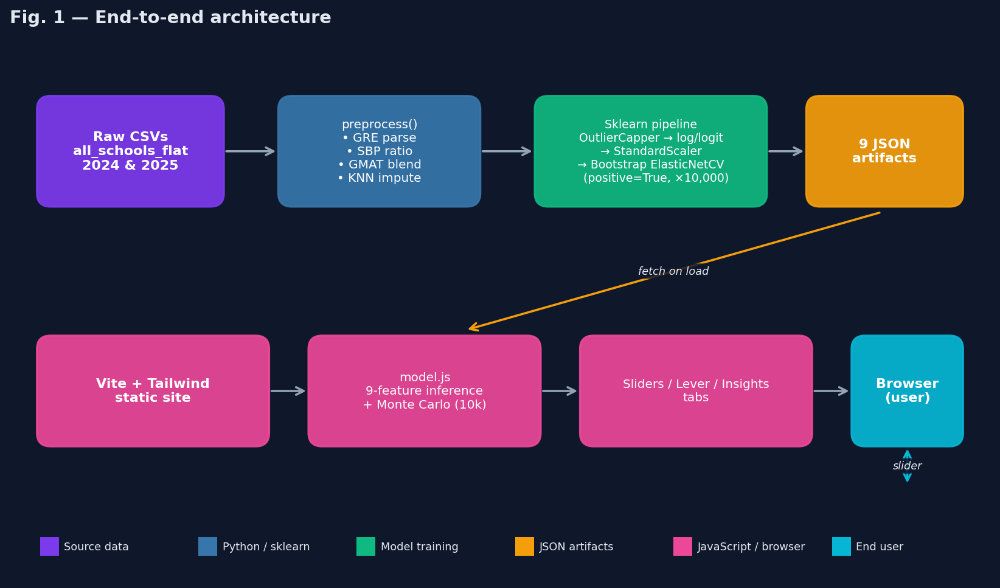
End-to-end architecture
This separation means:
- Predictions are deterministic from the artifacts. Any deployed instance with the same artifacts produces the same numeric outputs.
- Training is reproducible. Given the same two CSVs and the same Python environment, python train_model.py produces bit-identical artifacts modulo bootstrap RNG.
- Hosting is trivial. The whole app is a static directory (dist/) deployable to any CDN, S3 bucket, or Vercel project. No env vars, no secrets.

Repository layout
webapp-v2/
├── index.html # 4-tab layout
├── package.json # vite, tailwindcss, chart.js, postcss
├── vite.config.js # dev port 3100
├── tailwind.config.js # custom indigo/cyan palette
├── postcss.config.js
├── vercel.json # framework=vite
├── styles/
│ └── index.css # tailwind + custom components
├── src/
│ ├── main.js # bootstrap; await loadModel + loadCfmArtifacts
│ ├── tabs.js # tab nav + tab:activated CustomEvent
│ ├── model.js # 9-feature inference + Monte Carlo
│ ├── sliders.js # Tab 1 direct sliders + SBP + GMAT/GRE composite
│ ├── lever-predictor.js # Tab 2 indirect levers (CFM-driven)
│ ├── score-model.js # Tab 3 explainability
│ ├── explainability.js # Tab 4 CFM cards + hover popover
│ ├── cfm-models.js # CFM artifact loader + JS inference
│ └── results.js # rank/score/CI/Chart.js renderer
├── public/
│ ├── model_artifacts/ # 9 JSON files — output of train_model.py
│ └── cfm_artifacts/ # 9 JSON files — output of core_feature_models/
├── scripts/
│ ├── train_model.py # data → artifacts (single command)
│ └── requirements.txt
└── docs/
├── user-guide.md # business-facing
├── technical-docs.md # this document
└── img/ # fig01..fig06 referenced here

2. Data layer

2.1 Sources
Two CSVs supplied by US News, both with identical schemas (~437 columns):
File | Path relative to scripts/ | Rows | Use
2024 panel | ../../all_schools_flat_2024.csv | 121 | Historical year
2025 panel | ../../all_schools_flat_2025.csv | 122 | Current year
Each row is one school for one ranking year. After stacking with a synthetic Year column, we have 243 school-year observations. The same school appears once per year it was ranked. The Python pipeline never modifies these files.

2.2 Columns we consume
train_model.py renames a small subset of the 437 columns to short identifiers via COLUMN_RENAME_MAP:
Role | Raw column → Renamed
Identity | school_info.school_name → School, school_info.us_news_rank → Rank
Target | school_info.us_news_overall_score → OverallScore
Indicator inputs | ranking_scores_two_year_averages.fulltime_employed_at_graduation_two_yr_avg → EmployedAtGrad, ..._3_months_after_two_yr_avg → Employed3Mo, ..._avg_starting_salary_and_bonus_two_yr_avg → AvgSalaryBonus, ..._median_undergraduate_gpa → MedianGPA, ..._acceptance_rate → AcceptanceRate, ..._peer_assessment_score_out_of_5 → PeerScore, ..._recruiter_assessment_score_out_of_5 → RecruiterScore
Test medians | ..._median_gmat_score_fulltime_old → GMAT_Old, ..._median_gmat_score_fulltime_new → GMAT_New
Test submission % | gmat_data.percent_new_entrants_providing_gmat_old → Pct_GMAT_Old, _new → Pct_GMAT_New, gre_data.percent_new_entrants_providing_gre → Pct_GRE
GRE range string | gre_data.gre_score_range_10th_90th → GRE_Range_Str
Salary by profession | 8 indexed slots base_salary_by_occupation[i].{occupation,average_salary,number_reporting_jobs} (kept under original names)
Everything else is ignored.

2.3 The 9 final indicators
The score model and all artifacts work in terms of these 9 names:
Indicator | Type | Domain | Source
EmployedAtGrad | proportion | [0, 1] | Direct column
Employed3Mo | proportion | [0, 1] | Direct column
AvgSalaryBonus | dollars | ~$60k – $220k | Direct column
SalaryByProfession | cohort ratio | ~[0.4, 1.4] | Computed — see §3.3
MedianGPA | GPA | [3.0, 4.0] | Direct column
AcceptanceRate | proportion | [0, 1] | Direct column; lower is better
PeerScore | 1–5 rating | [1.7, 4.8] | Direct column
RecruiterScore | 1–5 rating | [1.8, 4.6] | Direct column
GMAT_Combined | percentile | [0, 100] | Computed — see §3.4
The target is OverallScore (US News’ published 0–100 score, anchored at 100 for the rank-1 school).

3. Preprocessing pipeline (preprocess() in train_model.py)
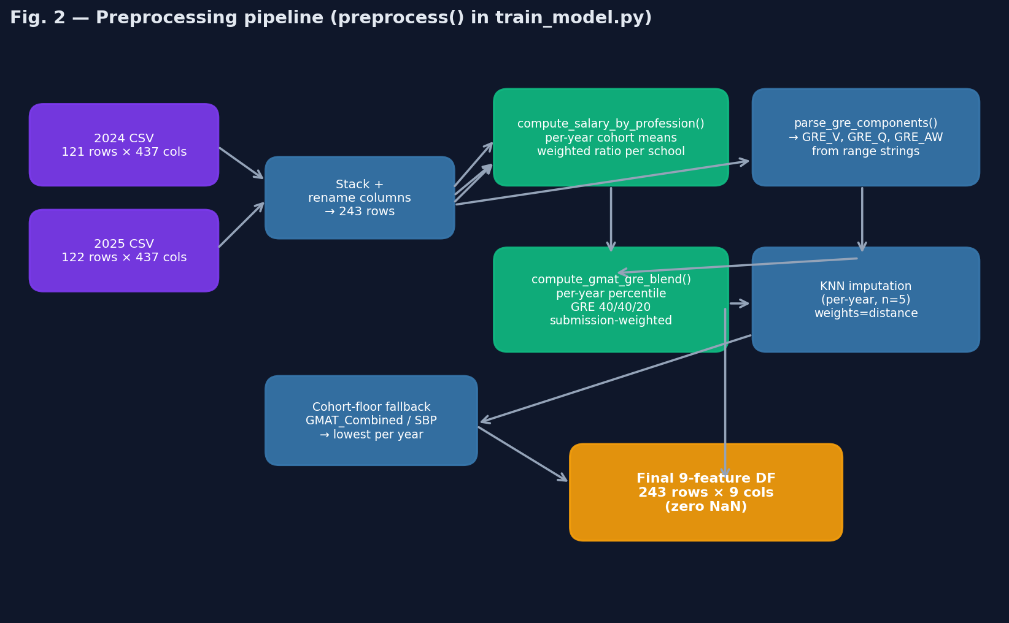
Preprocessing pipeline
The pipeline is deterministic. Every step takes the dataframe in, returns it modified, never drops rows. At exit, all 9 indicator columns have zero NaN values and the dataframe is ready for the sklearn Pipeline.

3.1 Stacking and renaming
frames = []
for year, p in DATA_PATHS.items():
d = pd.read_csv(p, low_memory=False)
d = d.rename(columns=COLUMN_RENAME_MAP)
d['Year'] = year
frames.append(d)
df = pd.concat(frames, ignore_index=True, sort=False)
Produces a 243 × ~437 dataframe with a Year column. The low_memory=False flag avoids pandas’ chunked-inference type confusion on the large schema.

3.2 GRE range parsing (parse_gre_components)
US News publishes GRE only as a range string in the form
"152-163 verbal, 148-161 quantitative, 3.5-4.5 writing"
rather than as three separate median columns. There are no true medians per school in the dataset.
The parser regex (\d{1,3}(?:\.\d+)?)\s*[-–]\s*(\d{1,3}(?:\.\d+)?)\s*([a-z]+)? extracts every numeric range pair plus its label, then routes each pair to one of verbal / quant / writing. We take the midpoint of each range as the estimated median:
Section | Mid-point formula | Used as proxy for
Verbal | (lo + hi) / 2 | Median GRE Verbal
Quantitative | (lo + hi) / 2 | Median GRE Quant
Analytical Writing | (lo + hi) / 2 | Median GRE AW
Output: three columns GRE_V, GRE_Q, GRE_AW. Empty / malformed strings yield (None, None, None) and are handled by the cohort-floor fallback later. About 162 / 243 rows parse successfully.
Caveat. The range midpoint is a biased estimator of the median (it equals the median only if the GRE distribution is symmetric in the 10th–90th band). In practice GRE Verbal and Quant are nearly-symmetric, so the bias is small (<1 point). This is the single biggest source of approximation error in the pipeline.

3.3 Salary by Profession (compute_salary_by_profession)
US News’ methodology computes this as: per school, per profession, the school’s average salary divided by the cohort-weighted average salary, then averaged across professions weighted by the school’s count of grads in each. Implementation:
for year, sub in df.groupby(year_col):
# First pass: build cohort weighted-mean salary per occupation
per_occ = {}
for i in range(8):
# ... for each school row, append (school_idx, school_avg, n_reporting)
per_occ[occ.strip()].append((idx, float(sal), float(n)))
cohort_means = {
k: sum(s*n for _, s, n in rows) / sum(n for _, _, n in rows)
for k, rows in per_occ.items() if rows
}
# Second pass: per-school weighted-mean of ratios
for idx, row in sub.iterrows():
ratio_sum, n_sum = 0.0, 0.0
for i in range(8):
# ... collect ratio = sal / cohort_means[occ], weighted by n
if n_sum > 0:
sba.loc[idx] = ratio_sum / n_sum
Inclusion rules: - Excluded occupation labels: {"Other"}. - Minimum reporters per occupation: n ≥ 3 (constant MIN_OCCUPATION_REPORTERS). - A school with zero eligible occupations gets NaN here and is filled by the cohort-floor fallback.
Output: a single column SalaryByProfession whose value is roughly 1.0 for a cohort-average school, > 1.0 for above-average earners across professions, < 1.0 for below.

3.4 GMAT / GRE blended percentile (compute_gmat_gre_blend)
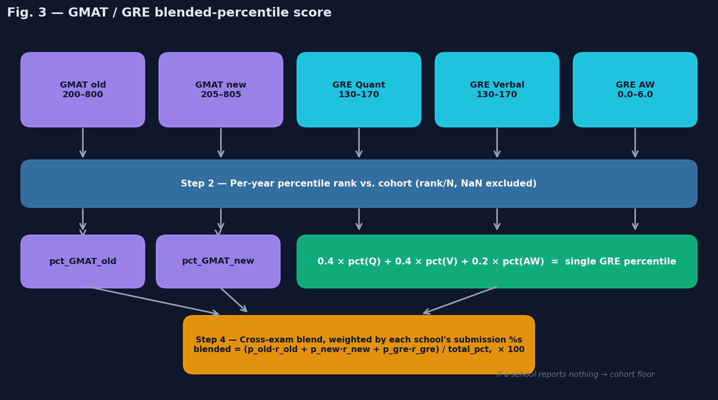
GMAT/GRE blend
This indicator is the most algorithmically dense piece of preprocessing. It maps five raw distributions (GMAT old, GMAT new, GRE Quant, GRE Verbal, GRE AW) into a single 0–100 score per school, matching US News’ published methodology.
# Step 1: per-year percentile rank for each test
score_to_rank = [
('GMAT_Old', 'rank_gmat_old'), ('GMAT_New', 'rank_gmat_new'),
('GRE_Q', 'rank_gre_q'), ('GRE_V', 'rank_gre_v'), ('GRE_AW', 'rank_gre_aw'),
]
for year, sub in df.groupby(year_col):
for sc, rc in score_to_rank:
df.loc[sub.index, rc] = _percentile_rank(sub[sc].astype(float).values)
# Step 2: GRE-internal blend (40/40/20)
gre_pct = 0.4 * df['rank_gre_q'] + 0.4 * df['rank_gre_v'] + 0.2 * df['rank_gre_aw']
df['rank_gre'] = gre_pct.where(gre_pct.notna(), 0.5 * df['rank_gre_q'] + 0.5 * df['rank_gre_v'])
# Step 3: submission-weighted cross-exam blend
total = p_old_eff + p_new_eff + p_gre_eff
weighted = p_old_eff * r_old_eff + p_new_eff * r_new_eff + p_gre_eff * r_gre_eff
blended = np.where(total > 0, weighted / total, np.nan)
df['GMAT_Combined'] = blended * 100.0
Where p_*_eff is the school’s submission proportion for that exam (or zero if the percentile rank for that exam is NaN — meaning we couldn’t compute it from the raw data).

Edge cases
- Per-year percentiles. Ranks are computed within each year’s cohort, not pooled, so a 700 GMAT in 2024 is compared only against 2024’s GMAT distribution.
- GRE fallback. If AW is missing but Q and V are not, the GRE-internal blend falls back to 0.5·Q + 0.5·V.
- No-submission floor. If total = 0 (school reported zero submitters across all three exams), GMAT_Combined is left as NaN here and gets the per-year cohort floor in §3.6.
- No fabricated penalties. Earlier internal drafts applied a sub-25%-submission penalty multiplier; this is not in US News’ methodology and was removed.
About 176 / 243 rows produce a non-NaN blended value; the other 67 are NaN-then-floored.

3.5 KNN imputation (per-year)
Most of the 9 indicators have small gap counts (≤ 3% nulls). They’re filled with a per-year sklearn KNNImputer:
for year, sub in df.groupby('Year'):
sub = sub.copy()
cols = [c for c in impute_cols if c in sub.columns]
if sub[cols].isnull().sum().sum() > 0:
imp = KNNImputer(n_neighbors=5, weights='distance')
sub[cols] = imp.fit_transform(sub[cols])
parts.append(sub)
df = pd.concat(parts, ignore_index=True, sort=False)
Per-year imputation matters because cohort distributions shift year-over-year — pooled KNN would impute a 2024 school with a 2025 neighbour. weights='distance' gives nearer neighbours more influence than further ones.

3.6 Cohort-floor fallback
For GMAT_Combined and SalaryByProfession only, any row still NaN after KNN gets the per-year minimum of its column among reporting schools. This matches US News’ rule: schools that report no usable test data get the lowest-scoring school’s value, not the cohort mean.
After this step, df[ALL_FEATURES + [TARGET]].isnull().sum().sum() == 0 is asserted.

4. Model training

4.1 Pipeline structure
The RegressionRanker class wraps a 3-stage sklearn Pipeline plus the bootstrap loop:
OutlierCapper(limits=(0.05, 0.05), columns=ALL minus {GMAT_Combined, SalaryByProfession})
↓
FeatureTransformer:
log1p: AvgSalaryBonus
logit: EmployedAtGrad, Employed3Mo, AcceptanceRate (with 0.001/0.999 clipping)
↓
StandardScaler (zero mean, unit variance per column)
↓
Bootstrapped ElasticNetCV (×10,000)
↓
mean coefficient vector
↓
calibration intercept (rank-1 school = 100)
Two indicators are deliberately excluded from the outlier cap (OUTLIER_EXCLUDE): - GMAT_Combined is already bounded to [0, 100] by construction. - SalaryByProfession is a cohort-ratio with bounded support; capping would distort already-bounded values.
The log1p on AvgSalaryBonus compresses the long-tailed dollar distribution toward Gaussianity. The logit on the three rate features (EmployedAtGrad, Employed3Mo, AcceptanceRate) maps bounded proportions to the real line, making them more linearly related to the target. The 0.001/0.999 clipping inside logit prevents log(0) and log(∞).

4.2 Sign-constrained bootstrap
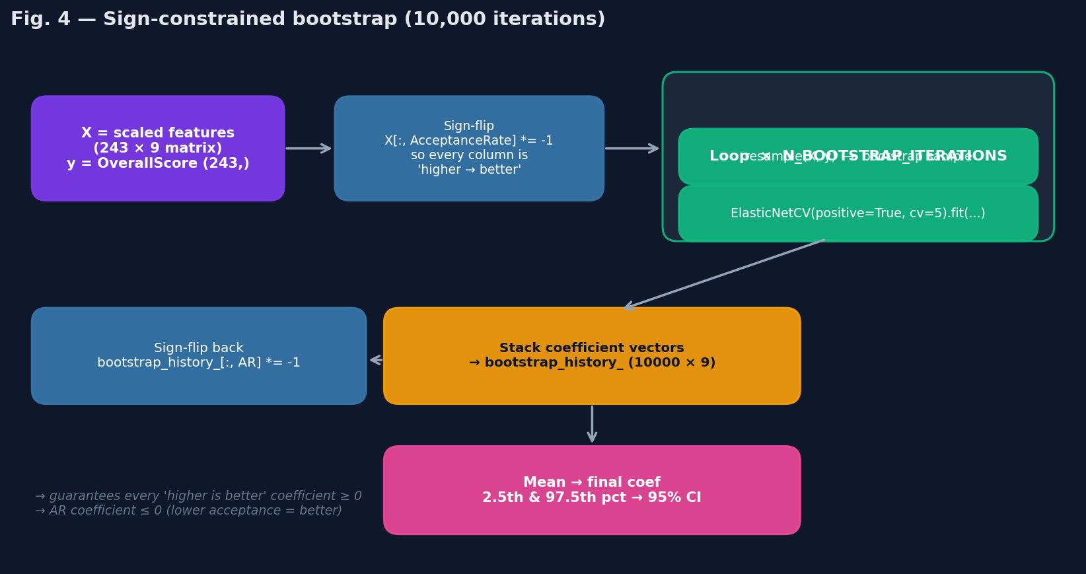
Sign-constrained bootstrap
The headline trick: the regression’s coefficients are forced to respect domain direction by construction. Without this constraint, GMAT_Combined’s coefficient lands at −0.221 (CI [−0.99, +0.38]) — slightly negative, not significant — purely because of collinearity with the bigger signals (salary, peer/recruiter, GPA). That would let the GMAT slider push the predicted rank the wrong way under certain inputs, which is misleading for a what-if tool.
Implementation in RegressionRanker.fit_and_calibrate:
SIGN_FLIP_FEATURES = ['AcceptanceRate'] # "lower is better" features
Xp = self.pipeline.fit_transform(df[self.features])
flip_idx = [i for i, f in enumerate(self.features) if f in SIGN_FLIP_FEATURES]
# Step 1: flip the sign of "lower is better" columns BEFORE fit
Xp_train = Xp.copy()
for i in flip_idx:
Xp_train[:, i] = -Xp_train[:, i]
# Step 2: bootstrap N times with positive=True
coefs = Parallel(n_jobs=N_JOBS)(
delayed(_run_single_bootstrap)(Xp_train, y)
for _ in range(self.n_iterations)
)
self.bootstrap_history_ = np.array(coefs)
# Step 3: flip the coefficients back so the final model uses the original sign convention
for i in flip_idx:
self.bootstrap_history_[:, i] = -self.bootstrap_history_[:, i]
self.engine.coef_ = np.mean(self.bootstrap_history_, axis=0)
_run_single_bootstrap is the parallelisable unit of work:
def _run_single_bootstrap(X, y):
Xb, yb = resample(X, y) # sklearn bootstrap sample
en = ElasticNetCV(
l1_ratio=[.1, .5, .7, .9, .95, .99, 1],
cv=5, max_iter=10000, n_jobs=1,
positive=True, # <-- the constraint
)
en.fit(Xb, yb)
return en.coef_
Why positive=True after the sign flip works: 1. After flipping AcceptanceRate, every column is conceptually “higher → better OverallScore”. 2. ElasticNetCV(positive=True) constrains all coefficients to be ≥ 0 in this representation. 3. After we flip the AR coefficient back, it becomes ≤ 0 in the original representation — exactly what we want. 4. All other coefficients are unchanged and ≥ 0.
This guarantees direction by construction; it does not guarantee any particular magnitude. Small or zero coefficients still happen when the data doesn’t carry strong signal (e.g. GMAT_Combined → +0.035 after the fix).

4.3 The bootstrap, in numbers
- 10,000 resamples per training run.
- Each resample fits ElasticNetCV with 5-fold inner CV over an l1_ratio grid of [.1, .5, .7, .9, .95, .99, 1]. (At l1_ratio=1 this is Lasso; at .1 it’s mostly Ridge.)
- Each individual ElasticNetCV scans its own automatic alpha grid. max_iter=10000 is generous; the solver typically converges in well under that.
- Parallelism: N_JOBS=4 workers via joblib. End-to-end runtime is ~10 minutes on a 4-core CPU.
- Output: a 10000 × 9 coefficient matrix bootstrap_history_. The mean across rows is the deployed coefficient vector; the 2.5th and 97.5th percentiles bound the 95% CI used in the explainability artifact.

4.4 Calibration
After the mean coefficient is computed, the intercept is calibrated so that the rank-1 school in the most recent year (Stanford, 2025) receives a predicted score of exactly 100:
x_top = self.pipeline.transform(top_anchor[self.features])
raw_top = float(np.dot(x_top, self.engine.coef_)[0])
self.engine.intercept_ = 100.0 - raw_top
This anchors all predictions on the published 0–100 scale. Other schools’ predictions deviate from their published score by typically ~3 points (MAE), but the rank-1 anchor is always exact.

4.5 Performance summary
5-fold cross-validated metrics on the full 243-row panel:
Metric | Value | What it means
MAE | 3.08 | Typical miss on the 0–100 published score
RMSE | 4.05 | Slightly larger because RMSE penalises big misses more
R² | 0.964 | The model explains 96.4% of the variance in OverallScore
Spearman ρ | 0.980 | Rank order agrees with US News’ ranking ~98% of the time
Per-feature coefficients (mean, 95% CI, significance):
Indicator | Impact weight | 95% CI | Confidence
AvgSalaryBonus | +7.27 | [+5.38, +9.58] | sig
PeerScore | +7.04 | [+5.87, +8.23] | sig
RecruiterScore | +3.24 | [+2.42, +3.98] | sig
MedianGPA | +3.13 | [+2.52, +3.74] | sig
SalaryByProfession | +2.96 | [+0.77, +4.87] | sig
Employed3Mo | +2.53 | [+1.66, +3.46] | sig
EmployedAtGrad | +1.55 | [+0.59, +2.44] | sig
AcceptanceRate | −0.91 | [−1.62, −0.16] | sig
GMAT_Combined | +0.04 | [+0.00, +0.39] | n.s.
GMAT_Combined is non-significant — its 95% CI just barely clears zero — but is now strictly non-negative, so the slider can never move the rank the wrong way.

5. Artifact export
export_artifacts(df, regression, perf, OUTPUT_DIR) writes nine JSON files to public/model_artifacts/. Each is read by exactly one frontend module.
File | Bytes | Producer | Consumer | Contents
model_config.json | 0.4 KB | train_model.py | model.js | Feature list, target name, log/logit configs
capper_bounds.json | 0.5 KB | train_model.py | model.js | 5%/95% caps per non-excluded indicator
transformer_config.json | 0.2 KB | train_model.py | model.js | Which features get log1p / logit
scaler_params.json | 0.7 KB | train_model.py | model.js | StandardScaler mean/scale + feature names
model_weights.json | 0.3 KB | train_model.py | model.js | 9 coefficients + calibration intercept
data_snapshot.json | 52 KB | train_model.py | model.js | 122 rows × {school, rank, score, 9 features} for snapshot year
gmat_inference_curves.json | 3.6 KB | train_model.py | model.js | Sorted score arrays for GMAT_Old/New/GRE_Q/V/AW
feature_ranges.json | 5.4 KB | train_model.py | model.js, sliders.js | Slider min/max + GWU’s current values + SBP cohort means
model_explainability.json | 7.6 KB | train_model.py | score-model.js | Coefficients with CIs + per-feature contribution percentages + performance metrics
Three additional artifacts live in public/cfm_artifacts/ and feed the Lever Predictor + Tab 4 — those are produced by a separate, unrelated training pipeline (core_feature_models/) and are out of scope for this document.

6. Frontend integration
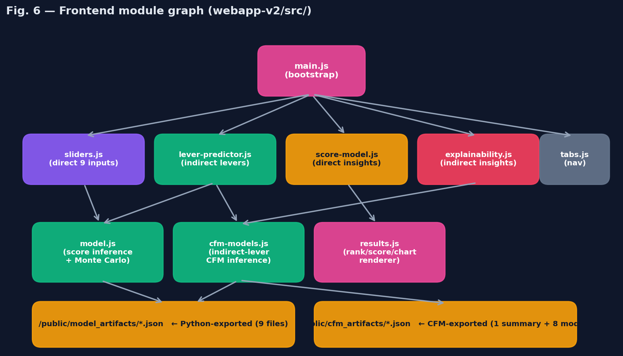
Frontend module graph

6.1 Module roles
Module | Responsibility
main.js | App entry. Awaits loadModel() and loadCfmArtifacts() in parallel, registers lazy tab-init handlers, then triggers the initial direct-predictor render.
tabs.js | Tab navigation. Toggles .active on .tab-btn and .hidden on .tab-pane. Dispatches a tab:activated CustomEvent so consumers can lazy-init.
model.js | The score engine. Loads 9 JSON artifacts, exposes predictScore(row) (capper → log/logit → scaler → dot product), simulateRank(customMetrics) (10k Monte Carlo), computeBlendedGMAT(...), computeSBPRatio(...).
sliders.js | Tab 1’s input panel. Renders 7 simple sliders + a composite SBP control (7 industries × salary + n_reporting) + a composite GMAT/GRE control (Old/New scale toggle, optional GRE Q/V/AW). Debounces user input by 300 ms before firing the onChange callback.
lever-predictor.js | Tab 2. Loads indirect-lever metadata + the 8 CFM models. On lever change, predicts all 9 core features then calls simulateRank on the predicted set.
score-model.js | Tab 3. Renders the explainability artifact: performance tiles, coefficients table, contribution chart with avg / GWU-only toggle, methodology blurb.
explainability.js | Tab 4. Renders nine CFM cards with confidence pills + top-coefficient bar charts + adaptive hover popovers (positions next to the hovered card with viewport collision detection).
cfm-models.js | CFM artifact loader + JS inference. Each CFM is a small linear pipeline (impute → scale → linear → inverse target transform) over 74 features.
results.js | Rank/score/CI/Chart.js histogram rendering used by both Tab 1 and Tab 2’s sticky results panel.

6.2 Score inference (predictScore in model.js)
The browser exactly mirrors the Python pipeline:
function applyCapper(row) { /* Math.min/max each col to capper_bounds */ }
function applyTransformer(row) { /* log1p / logit per transformer_config */ }
function applyScaler(row) { /* (x - mean) / scale per scaler_params */ }
function predictScore(row) {
const capped = applyCapper(row);
const transformed = applyTransformer(capped);
const scaled = applyScaler(transformed);
let s = modelWeights.intercept;
for (let i = 0; i < scaled.length; i++) {
s += scaled[i] * modelWeights.coef[i];
}
return s;
}
For a single row this is microseconds; the Monte Carlo runs it 122 schools × 10,000 iterations = 1.22M times per slider change — still well under 100 ms on modern hardware because everything is plain arrays.

6.3 GMAT/GRE blend in the browser
computeBlendedGMAT({ scale, gmat_score, gre_q, gre_v, gre_aw, gre_enabled, gmat_enabled }) mirrors compute_gmat_gre_blend from Python. Each user-provided raw test score is mapped to a percentile by binary-searching the sorted cohort score array loaded from gmat_inference_curves.json:
function percentileRank(score, sortedArr) {
let lo = 0, hi = sortedArr.length;
while (lo < hi) {
const mid = (lo + hi) >>> 1;
if (sortedArr[mid] < score) lo = mid + 1;
else hi = mid;
}
let upper = lo;
while (upper < sortedArr.length && sortedArr[upper] === score) upper++;
return (lo + upper + 1) / 2 / sortedArr.length;
}
Submissions are then weighted: total = p_old + p_new + p_gre, weights renormalise to sum to 1, and the per-exam percentile ranks are blended.
When both gmat_enabled and gre_enabled are false (total = 0), the function falls back to gmatCohortFloor() — the minimum GMAT_Combined across all schools in data_snapshot.json. This implements the official US News missing-data rule client-side.

6.4 SBP ratio in the browser
computeSBPRatio(perOccupation) takes {Consulting: {salary, n}, Finance/Accounting: {...}, ...} and replays the Python formula with the cohort means shipped in feature_ranges.json._sbp_cohort:
export function computeSBPRatio(perOccupation) {
const cohort = featureRanges?._sbp_cohort || {};
const MIN_N = 3;
let ratio_sum = 0, n_sum = 0;
for (const [occ, info] of Object.entries(perOccupation || {})) {
const cm = cohort[occ]?.cohort_mean;
if (!cm || cm <= 0) continue;
const sal = Number(info?.salary);
const n = Number(info?.n);
if (!isFinite(sal) || sal <= 0 || !isFinite(n) || n < MIN_N) continue;
ratio_sum += (sal / cm) * n;
n_sum += n;
}
return n_sum > 0 ? ratio_sum / n_sum : null;
}
Same n ≥ 3 exclusion rule as Python, same weighted average, same Other-excluded set.

6.5 Monte Carlo simulation
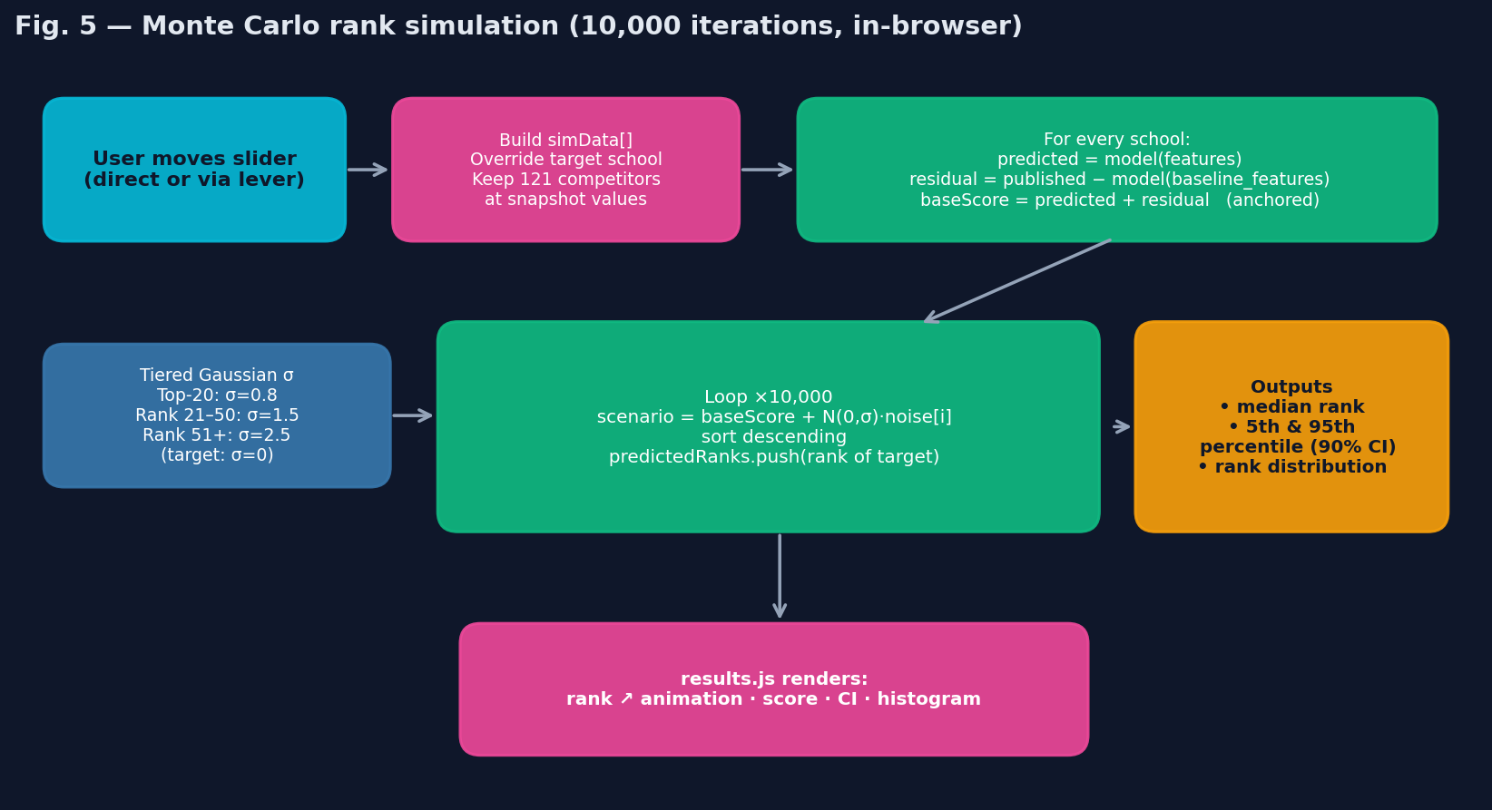
Monte Carlo
simulateRank(customMetrics) in model.js is the only call that touches all 122 schools. It runs in a few steps:

Step 1 — Build the simulation cohort
Copy the snapshot, overriding the target school’s features with the user’s overrides:
const simData = dataSnapshot.map((school, i) => {
if (i === targetIdx) {
const modified = { ...school };
for (const [k, v] of Object.entries(customMetrics)) {
if (k === 'GMAT_Combined' && typeof v === 'object') {
modified[k] = computeBlendedGMAT(v);
} else if (k === 'SalaryByProfession' && typeof v === 'object') {
const ratio = computeSBPRatio(v);
if (ratio !== null) modified[k] = ratio;
} else {
modified[k] = v;
}
}
return modified;
}
return { ...school };
});

Step 2 — Residual-anchored scoring
The regression doesn’t predict the published score perfectly (MAE ~3 points). To prevent this systematic miss from contaminating the simulation, we compute each school’s “anchored” base score:
const baseScores = simData.map((school, i) => {
const trueScore = dataSnapshot[i].OverallScore;
const baselinePred = predictScore(baseline features);
const residual = trueScore - baselinePred; // bias per school
const simPred = predictScore(school features);
return simPred + residual; // anchored
});
The residual is each school’s idiosyncratic published-vs-predicted gap. For the target school, only the predicted component changes when sliders move; the residual is baked in. For all other schools, both predicted and residual are constants because their features are not touched.

Step 3 — Tiered Gaussian noise
Year-to-year ranking volatility is tier-dependent. Top schools rarely move; lower-ranked schools shuffle more. We model this as a tiered Gaussian:
const noiseScale = simData.map((s, i) => {
if (i === targetIdx) return 0; // target is deterministic
const r = s.Rank;
if (r <= 20) return 0.8; // tight top-tier
if (r <= 50) return 1.5; // mid-tier
return 2.5; // long tail
});
These σ values are empirical — calibrated to roughly match the observed year-over-year rank variance for each tier.

Step 4 — 10,000-iteration loop
for (let sim = 0; sim < nSimulations; sim++) {
const scenario = baseScores.map((s, i) => s + gaussianRandom() * noiseScale[i]);
const idx = Array.from({ length: n }, (_, i) => i);
idx.sort((a, b) => scenario[b] - scenario[a]);
predictedRanks.push(idx.indexOf(targetIdx) + 1);
}
gaussianRandom() is a textbook Box–Muller transform with two Math.random() draws per call.

Step 5 — Aggregation
After sorting predictedRanks:
Field | Computation
medianRank | predictedRanks[Math.floor(n/2)]
range90 | [predictedRanks[Math.floor(n*0.05)], predictedRanks[Math.floor(n*0.95)]]
scenarioScore | baseScores[targetIdx] (rounded)
rankDistribution | Histogram {rank: probability} for the chart

6.6 User-input flow (end-to-end)
When the user drags any slider on Tab 1, the following happens in ~50–100 ms:
- sliders.js debounces the input event 300 ms.
- sliders.js calls onChangeCallback({ ...currentValues }).
- main.js → handleSliderChange(values) → simulateRank(values).
- model.js:
  - If customMetrics.GMAT_Combined is an object, computeBlendedGMAT collapses it to a number.
  - If customMetrics.SalaryByProfession is an object, computeSBPRatio collapses it to a number.
  - Copy snapshot, override target school.
  - Score all 122 schools (residual-anchored).
  - Apply tiered Gaussian noise 10,000 times, sort, record target rank.
  - Return median rank, 90% CI, scenario score, full distribution.
- results.js animates the rank, updates the score and CI tiles, and Chart.js re-renders the histogram.
The same flow applies on Tab 2, except step 3 is replaced by a CFM pre-step that turns indirect-lever values into predicted core features before calling simulateRank.

7. Build & deploy

7.1 Local development
cd webapp-v2
npm install # one-time
npm run dev # → http://localhost:3100/
Vite serves the dev bundle with HMR. The public/ directory is served at /, so artifacts are reachable at /model_artifacts/....

7.2 Production build
npm run build # outputs to dist/
vite.config.js defines the build root and rollup entry. Output:
- dist/index.html (~15 KB)
- dist/assets/index-{hash}.css (~25 KB; ~5.5 KB gzipped)
- dist/assets/index-{hash}.js (~248 KB; ~83 KB gzipped)
- dist/model_artifacts/*.json (and dist/cfm_artifacts/*.json)
Total deployable bundle: ~330 KB uncompressed, ~95 KB gzipped (without artifacts), plus ~70 KB of JSON artifacts.

7.3 Vercel deploy
vercel.json is minimal — the framework is auto-detected from Vite:
{
"buildCommand": "npx vite build",
"outputDirectory": "dist",
"framework": "vite"
}
To deploy to a new Vercel project:
cd webapp-v2
# Initial: push the repo to a new GitHub remote, then import on vercel.com
gh repo create GWSB-Ranking-Predictor --public --source=. --remote=origin --push
# Then on vercel.com → Add New Project → import the repo.
# Subsequent deploys are automatic on every push to main.
Nothing else is required. No env vars, no build secrets, no third-party services.

7.4 Re-training procedure
When fresh US News data arrives (typically annually):
# 1. Drop the new CSVs in their canonical locations:
# ../all_schools_flat_2024.csv
# ../all_schools_flat_2025.csv
# 2. Optional: bump the year config in train_model.py if you want a different
# snapshot year for the data_snapshot artifact.
cd webapp-v2/scripts
pip install -r requirements.txt # one-time
python train_model.py # ~10 minutes on 4 cores
# 3. The 9 JSON artifacts in webapp-v2/public/model_artifacts/ are now refreshed.
cd ..
npm run build # rebuild the static bundle
Push the resulting changes to the deployment repo. The webapp picks up the new artifacts on the next page load.

8. Reference

8.1 Constants & configuration
Defined in scripts/train_model.py:
Constant | Value | Meaning
DATA_PATHS | {2024: ..., 2025: ...} | Source CSVs
INFERENCE_CURVE_YEAR | 2025 | Year used for snapshot + percentile curves
ALL_FEATURES | 9-tuple | The 9 indicator names in canonical order
TARGET | 'OverallScore' | Column name of the trained target
LOG_VARS | ['AvgSalaryBonus'] | log1p transform
LOGIT_VARS | ['EmployedAtGrad', 'Employed3Mo', 'AcceptanceRate'] | logit transform
OUTLIER_EXCLUDE | {'GMAT_Combined', 'SalaryByProfession'} | Not subject to 5%/95% capping
SIGN_FLIP_FEATURES | ['AcceptanceRate'] | “Lower is better” indicators
EXCLUDED_OCCUPATIONS | {'Other'} | Dropped from SBP calculation
MIN_OCCUPATION_REPORTERS | 3 | Minimum n per occupation in SBP
N_BOOTSTRAP_ITERATIONS | 10000 | Number of resamples
N_JOBS | 4 | joblib parallel workers
GMAT_INPUT_CONFIG | dict | Slider ranges for GMAT/GRE composite
SBP_OCCUPATIONS | 7-tuple | Industries shown in the UI
SBP_SLIDER | {min:60000, max:260000, step:1000, format:'dollar'} | Per-industry salary slider
SLIDER_RANGES | dict | Per-indicator slider min/max + display format

8.2 Artifact schemas (abbreviated)
// model_config.json
{
"features": ["EmployedAtGrad", "...", "GMAT_Combined"],
"target": "OverallScore",
"log_vars": ["AvgSalaryBonus"],
"logit_vars": ["EmployedAtGrad", "Employed3Mo", "AcceptanceRate"],
"outlier_exclude": ["GMAT_Combined", "SalaryByProfession"]
}
// model_weights.json
{
"coef": [1.55, 2.53, 7.27, 2.96, 3.13, -0.91, 7.04, 3.24, 0.04],
"intercept": 55.48
}
// feature_ranges.json (excerpt)
{
"EmployedAtGrad": { "min": 0.20, "max": 1.00, "step": 0.01, "label": "...", "format": "percent",
"data_min": ..., "data_max": ..., "data_mean": ..., "data_median": ... },
"_gmat_input_config": { "gmat_scale_default": "old", "gmat_old_range": {...}, ... },
"_sbp_cohort": { "Consulting": { "cohort_mean": 171096, "cohort_n_total": 2037 }, ... },
"_sbp_occupations": ["Consulting", ...],
"_sbp_slider": { "min": 60000, "max": 260000, "step": 1000, "format": "dollar" },
"_gwu_current": { "EmployedAtGrad": 0.477, ..., "sbp_per_occupation": {...}, "fulltime_enrollment": 73 },
"_gwu_school_name": "George Washington University",
"_gwu_current_rank": 69,
"_gwu_current_score": 51.0
}
// model_explainability.json (excerpt)
{
"regression": {
"coefficients": [
{ "feature": "AvgSalaryBonus", "mean_weight": 7.27,
"lower_95_ci": 5.38, "upper_95_ci": 9.58, "is_significant": true },
...
],
"intercept": 55.48,
"avg_abs_contribution_pct": [ {"feature": "...", "pct": ...}, ... ],
"gwu_contribution_pct": [ {"feature": "...", "signed_pct": ...}, ... ],
"performance": { "mae": 3.08, "rmse": 4.05, "r2": 0.964, "spearman": 0.980,
"n_observations": 243, "n_bootstrap_iterations": 10000,
"training_years": [2024, 2025] }
},
"methodology": { "regression": "...", "gmat_blend": "..." }
}

8.3 Known limitations
- GRE medians are approximated as range midpoints; true medians are not in the published dataset. Bias is < ~1 point per GRE section for symmetric distributions.
- Cohort changes year-to-year affect cross-year comparisons. Schools that drop in/out shift the relative percentile rankings even when nothing about a given school changes.
- Sign-constrained coefficients may understate the true magnitude of an effect when the data carries no signal in the constrained direction. The fix prevents wrong-direction errors but doesn’t add information.
- Monte Carlo noise model is heuristic — tiered Gaussian σ values are calibrated to match observed inter-year volatility but are not derived from a formal hierarchical model.
- CFM artifacts are produced separately. Re-training the CFMs is out of scope for this pipeline. The Lever Predictor + Tab 4 will degrade gracefully if public/cfm_artifacts/ is missing (those tabs render an empty state).

8.4 Versioning
The codebase follows a simple convention: every change to the artifacts or model code is committed atomically (artifacts + code together). To roll back, git checkout any prior commit and re-build. The deployed Vercel project can also use the Vercel rollback feature for instantaneous reverts.

