cDay 0:
- Setup AWS instance and connected through pycharm
- Assessed the code files for train and test. Also observed some images from each target class. It looks like these are collectible cards from a bygone era.
- Fixed some bugs in the train and test scripts and successfully ran them
- There is a severe class imbalance in the training split
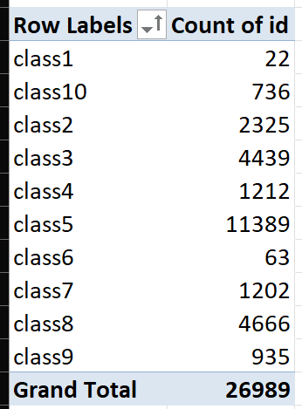
- Initial baseline f1 score of 0.059 was realized for the test set

Day 1:
- Implemented the following changes to improve model performance:
- Increased training epochs from 1 to 100
- Increased batch size from 2 to 32 (note: 32 batch size was almost filling up the GPU memory, change to larger instance if using bigger batch size)
- Added data shuffling to emulate random selection
- Added pixel normalization by dividing the pixel values by 255
- Added data prefetch to the data loader to decrease training time
- Network architecture was modified to Input-300-200-100-100-80-50-Output with 6 hidden layers. The activation function employed is ReLU.
- Added He initialization which is optimal for ReLU: Maintains consistent variance of activations and gradients across layers
- Switched to Adam optimizer with all default parameters
- Added learning rate scheduler with a factor of 0.5 meaning LR is halved everytime plateau is detected
- Added validation split by splitting training data into train (80%) and val (20%)
- Added early stopping to prevent overfitting and restore best weights. Changed model monitor from accuracy to val_loss
- Test Results: (Improvement of f1 macro from ~0.06 to 0.25 i.e 4x increase)
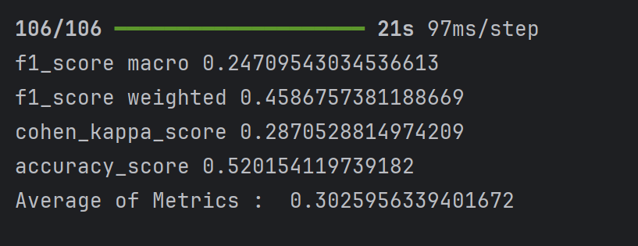
Day 2:
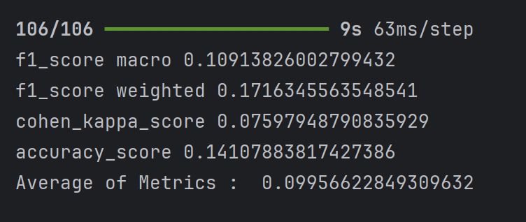

Day 3:
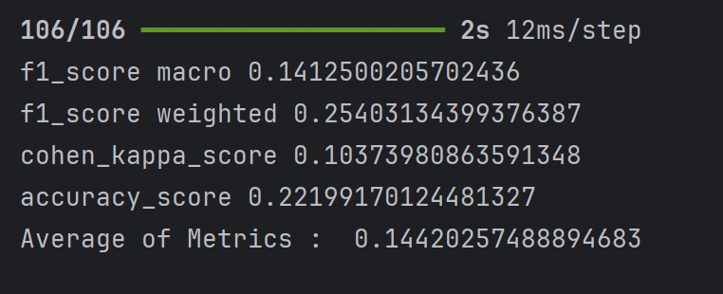

Day 6: Mixed MLP architecture
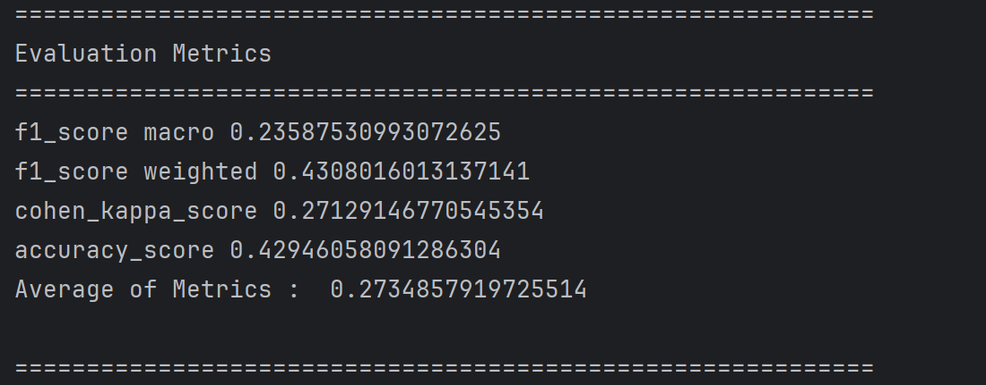

Autoencoder MLP variant (big model):
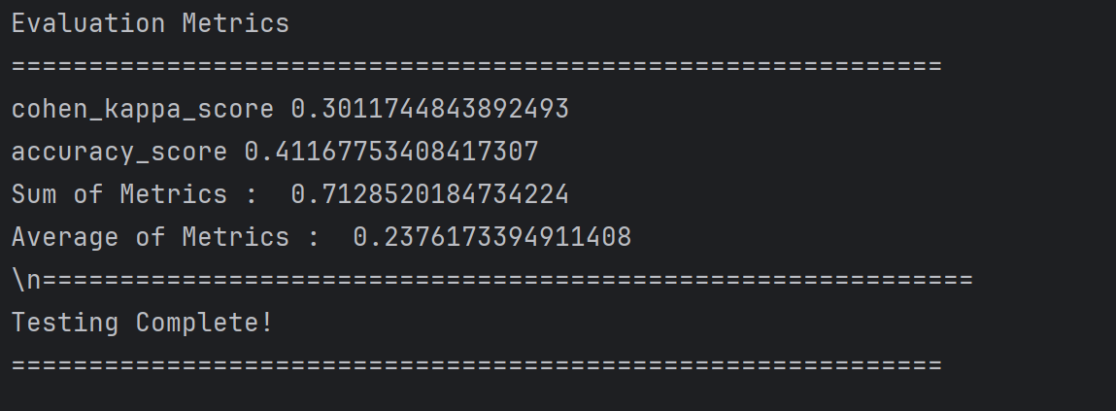

Autoencoder MLP variant (narrow deep model):
Train:
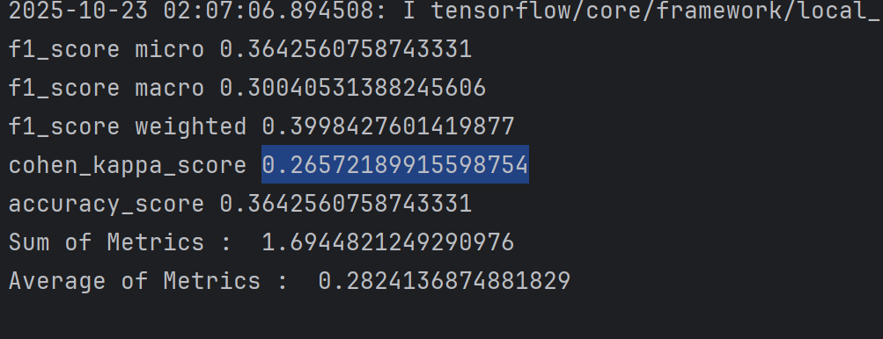
Test:
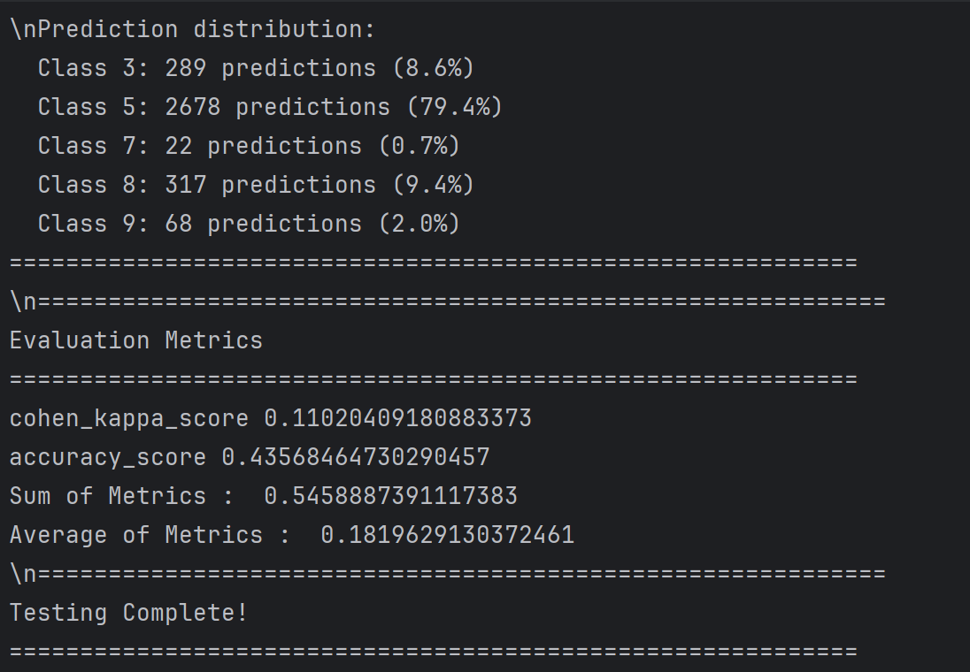

Iteration 2:
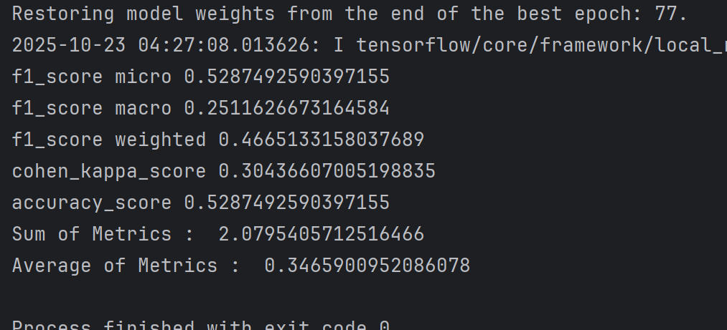

Iteration 3:
Train: 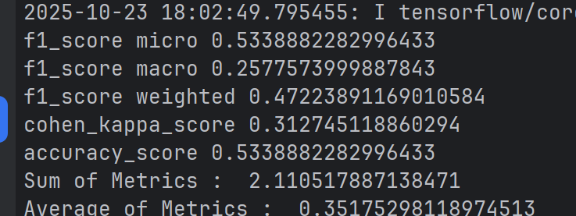

Test: 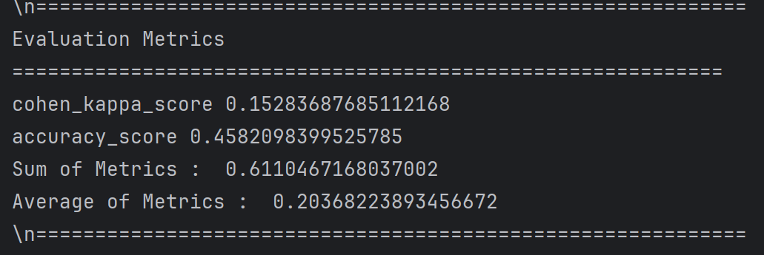

Ensemble model:
