Practical: CI/CD Pipeline for a Cloud-Native Application using GitHub, GitHub Actions and Kubernetes
23BCE093 HELI SHAH
Implemented in: https://github.com/Asc-85129/cicd-pipeline-demo • Date: 27 October 2026

1. Aim
To implement a Continuous Integration and Continuous Deployment (CI/CD) pipeline for a cloud-native application using GitHub as the source repository, GitHub Actions as the automation server and Kubernetes as the deployment platform. Every push to the main branch must automatically lint and test the code and, only if all checks pass, deploy the new version to a Kubernetes cluster and verify that it is serving traffic.
Note on scope: the lab sheet also lists Docker and Docker Hub. Docker Desktop makes the lab machine too slow to work with, so this implementation deliberately runs without Docker or Docker Hub. Section 2.3 explains each substitution. Every other part of the CI/CD flow (build, test, gate, artifact, deploy, rollout, verification) is implemented and was run for real on GitHub.
Learning objectives
- Explain the difference between Continuous Integration, Continuous Delivery and Continuous Deployment.
- Write a multi-job GitHub Actions workflow with triggers, job dependencies (needs) and conditions (if).
- Use automated linting and unit tests as a quality gate that blocks a bad change from being deployed.
- Pass build outputs between jobs with workflow artifacts.
- Describe a cloud-native application declaratively with a Kubernetes Deployment, Service and ConfigMap.
- Provision a Kubernetes cluster (k3s) on a CI runner, deploy to it and verify the rollout with a smoke test.
- Understand container runtimes beyond Docker (containerd) and how to ship code without a custom image.

2. Theory

2.1 CI/CD concepts
Continuous Integration (CI) means every developer integrates code into a shared branch often, and each integration is checked automatically by a build and test run. A broken change is caught within minutes and traced to one small commit, instead of being found days later during manual integration.
Continuous Delivery keeps the main branch releasable at all times, with a person approving the final release. Continuous Deployment goes one step further: every change that passes the pipeline goes to the target environment with no manual step. This practical implements Continuous Deployment. A green build on main is deployed straight to Kubernetes.
Concept | What it is | Role in this lab
GitHub | Git hosting service; source of truth for code and configuration | Hosts repo Asc-85129/cicd-pipeline-demo; a push to main is the pipeline trigger
GitHub Actions | CI/CD engine built into GitHub; workflows are YAML files in .github/workflows/ | Runs ci-cd.yml on hosted ubuntu-latest runners
Workflow / Job / Step | Workflow = whole pipeline; job = set of steps on one runner; step = one command or action | 2 jobs: build-test (CI) and deploy (CD)
needs / if | Job dependency and condition keywords | deploy needs build-test, so it is skipped when tests fail; it is also skipped for pull requests
Artifact | File produced by a job and stored by GitHub between jobs | app-release (app.py, requirements.txt, VERSION) is passed from CI to CD
Kubernetes | Container orchestrator; desired state is declared in YAML and reconciled by controllers | Runs 2 replicas of the app behind a NodePort Service
k3s | Lightweight, CNCF-certified Kubernetes distribution packaged as a single binary | Cluster started inside the CD job in about 15 s
containerd | Industry-standard container runtime (the one Docker itself uses underneath) | Runtime used by k3s; pulls and runs the python image without Docker
ConfigMap | Kubernetes object holding non-secret data, mountable as files | Carries app.py and requirements.txt into the pods at /app
Rollout / probes | Deployment rolling update; readiness and liveness probes decide pod health | kubectl rollout status waits until both pods pass /health

2.2 Pipeline stages
- Source - the developer pushes a commit to main on GitHub.
- Build / Lint - dependencies are installed on a fresh runner and flake8 checks style and syntax errors.
- Test - pytest runs the unit tests against the Flask app using its test client.
- Package - the deployable files plus a VERSION file (short commit SHA) are uploaded as an artifact.
- Deploy - a Kubernetes cluster is prepared, the code is published as a ConfigMap and the manifests are applied.
- Verify - the pipeline waits for the rollout and calls the live service; any failure turns the run red.

2.3 Running without Docker and Docker Hub
In the usual version of this lab, CI runs docker build, pushes the image to Docker Hub, and Kubernetes pulls that image. Docker is not actually required for any of these jobs, so each one was replaced:
Usual tool | Purpose | Replacement used here | Why it is equivalent
docker build | Package app + runtime into an image | Stock image python:3.11-slim + code in a ConfigMap | The pod still runs the exact committed code on a pinned Python runtime
Docker Hub | Store the versioned build output | GitHub Actions artifact app-release (+ VERSION = commit SHA) | Versioned, immutable build output handed from CI to CD
Docker Engine on the node | Run containers | containerd (built into k3s) | Kubernetes talks to containerd through the CRI; Docker support was removed from Kubernetes in v1.24 anyway
kind / Minikube on laptop | Local cluster | k3s installed on the GitHub runner | Real Kubernetes API (v1.36), nothing runs on the lab machine

Trade-off: installing Flask at pod start-up (pip install in the container command) adds a few seconds to start-up and needs internet access. That is fine for a lab. In production the image would be built once and stored in a registry. The change is small: add a build-and-push job and replace the image line in deployment.yaml.

3. Requirements
Item | Version / detail
OS | Windows 11 Home (lab machine), Git Bash
Git | 2.x for Windows (see Figure 1)
Python | 3.11.8 locally, 3.11.17 on the runner; Flask 3.0.3, pytest, flake8
GitHub CLI | gh, logged in as Asc-85129 (to create the repo and read runs/logs)
GitHub Actions runner | ubuntu-latest (Ubuntu 24.04.5 LTS, kernel 6.17 azure)
Kubernetes | k3s v1.36.5+k3s1, container runtime containerd 2.3.4
Browser | Microsoft Edge (headless) for the GitHub page screenshots
Not used | Docker Desktop, Docker Engine, Docker Hub

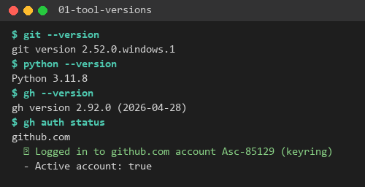
Figure 1: Local tool versions and GitHub CLI authentication

4. Architecture
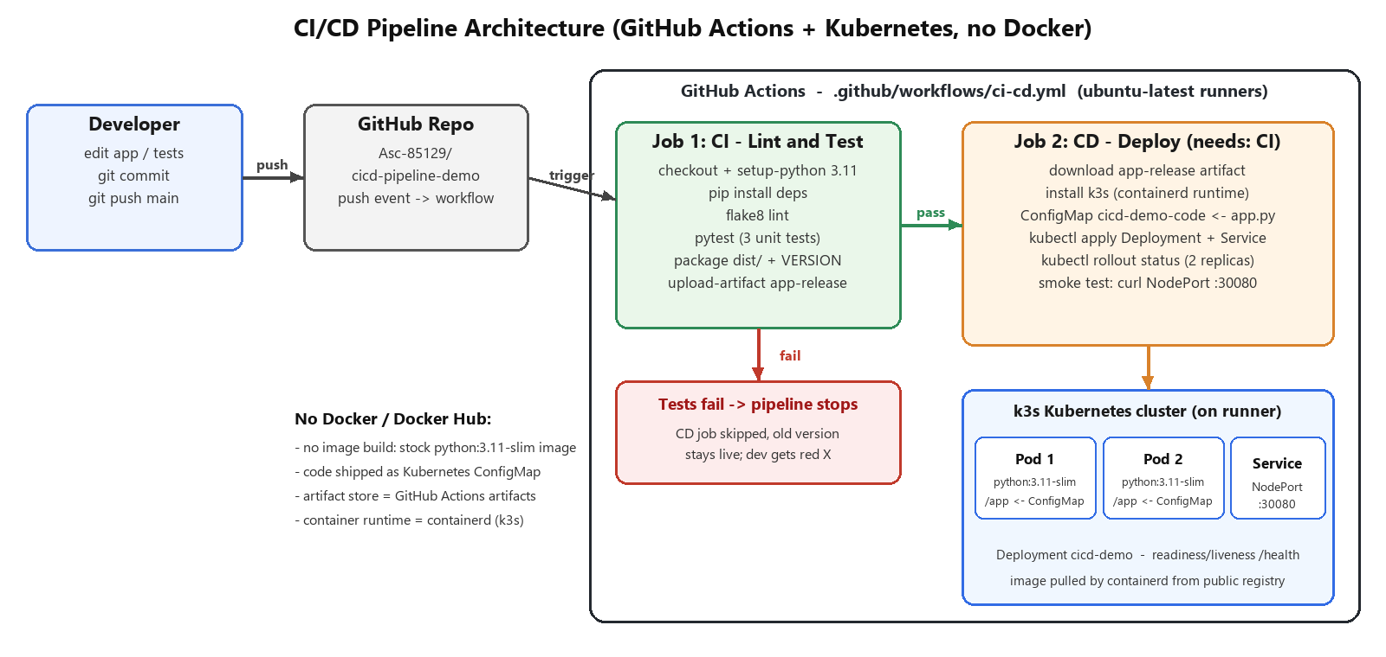
Figure 2: Pipeline architecture: CI job gates the CD job, which deploys to k3s on the runner
A push to main triggers the workflow. Job 1 (CI) runs on a fresh Ubuntu runner: it installs dependencies, lints, tests and uploads the release artifact. Job 2 (CD) starts only if Job 1 succeeded. It runs on a second, clean runner, downloads the artifact, installs k3s, stores the code in a ConfigMap, applies the Deployment and Service, waits for both replicas to become Ready and then smoke-tests the NodePort. If any CI step fails, the CD job is skipped and the version that was already deployed stays as it is.

5. Procedure
All work was done in D:\DevOps\cicd-pipeline. Final layout of the repository:
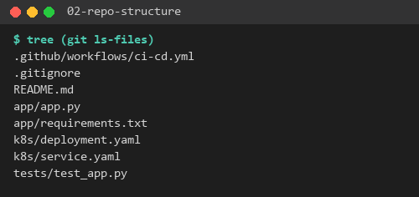
Figure 3: Files tracked in the repository

Step 1 – Write the cloud-native application (app/app.py)
A small stateless Flask service following twelve-factor rules: its configuration (port, version) comes from environment variables, it exposes a /health endpoint for Kubernetes probes, and it returns the pod hostname so that load-balancing across replicas can be seen.
"""Cloud-native demo service for the CI/CD practical."""
import os
import socket
from flask import Flask, jsonify
app = Flask(__name__)
VERSION = os.environ.get("APP_VERSION", "dev")
@app.route("/")
def index():
return jsonify(
message="Hello from CI/CD pipeline v2!",
version=VERSION,
pod=socket.gethostname(),
)
@app.route("/health")
def health():
return jsonify(status="ok")
def add(a, b):
return a + b
if __name__ == "__main__":
app.run(host="0.0.0.0", port=int(os.environ.get("PORT", 5000)))

Step 2 – Write unit tests (tests/test_app.py)
import os
import sys
sys.path.insert(0, os.path.join(os.path.dirname(__file__), "..", "app"))
from app import add, app # noqa: E402
def client():
app.config["TESTING"] = True
return app.test_client()
def test_index_returns_message():
resp = client().get("/")
assert resp.status_code == 200
assert resp.get_json()["message"] == "Hello from CI/CD pipeline v2!"
def test_health():
resp = client().get("/health")
assert resp.status_code == 200
assert resp.get_json() == {"status": "ok"}
def test_add():
assert add(2, 3) == 5
The tests and the linter were run locally before pushing, so the code entering CI was already known to pass:
pip install -r app/requirements.txt pytest flake8
python -m flake8 app tests --max-line-length=100
python -m pytest -v tests
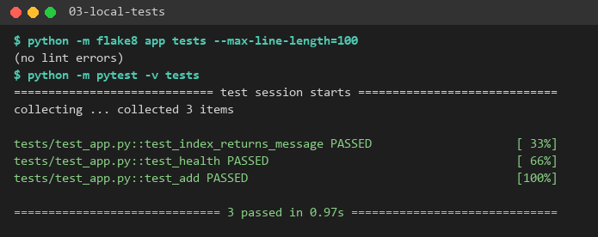
Figure 4: Local run: flake8 clean, 3/3 tests passed

Step 3 – Write the Kubernetes manifests (k8s/)
deployment.yaml: 2 replicas of the stock python:3.11-slim image. The ConfigMap cicd-demo-code is mounted at /app. The container installs the requirements and starts the app. APP_VERSION_PLACEHOLDER is replaced with the commit SHA at deploy time. The readiness probe keeps a pod out of the Service until /health answers, and the liveness probe restarts it if it hangs.
apiVersion: apps/v1
kind: Deployment
metadata:
name: cicd-demo
labels:
app: cicd-demo
spec:
replicas: 2
selector:
matchLabels:
app: cicd-demo
template:
metadata:
labels:
app: cicd-demo
spec:
containers:
- name: web
# Stock public image - no custom image build / registry needed.
image: python:3.11-slim
command: ["sh", "-c"]
args:
- pip install --no-cache-dir -r /app/requirements.txt && python /app/app.py
env:
- name: APP_VERSION
value: "APP_VERSION_PLACEHOLDER"
ports:
- containerPort: 5000
volumeMounts:
- name: app-code
mountPath: /app
readinessProbe:
httpGet:
path: /health
port: 5000
initialDelaySeconds: 5
periodSeconds: 5
livenessProbe:
httpGet:
path: /health
port: 5000
initialDelaySeconds: 30
periodSeconds: 10
volumes:
- name: app-code
configMap:
name: cicd-demo-code
service.yaml: a NodePort Service that load-balances port 30080 on the node to port 5000 on every pod with label app=cicd-demo.
apiVersion: v1
kind: Service
metadata:
name: cicd-demo
spec:
type: NodePort
selector:
app: cicd-demo
ports:
- port: 80
targetPort: 5000
nodePort: 30080

Step 4 – Write the GitHub Actions workflow (.github/workflows/ci-cd.yml)
Key design points: triggers on push and pull_request to main, plus a manual workflow_dispatch. needs: build-test makes deployment depend on a green CI job. if: github.event_name != 'pull_request' stops pull requests from deploying. The short SHA is written to VERSION, so each deployment can be traced to its commit. The smoke test checks that the live service returns that exact version. A failure-only step prints pod descriptions and logs for debugging.
name: CI-CD Pipeline
on:
push:
branches: [main]
pull_request:
branches: [main]
workflow_dispatch:
jobs:
# ---------------- Continuous Integration ----------------
build-test:
name: CI - Lint and Test
runs-on: ubuntu-latest
steps:
- name: Checkout code
uses: actions/checkout@v4
- name: Set up Python
uses: actions/setup-python@v5
with:
python-version: "3.11"
- name: Install dependencies
run: |
pip install -r app/requirements.txt
pip install pytest flake8
- name: Lint with flake8
run: flake8 app tests --max-line-length=100
- name: Run unit tests
run: pytest -v tests
- name: Package release artifact
run: |
mkdir -p dist
cp app/app.py app/requirements.txt dist/
echo "${GITHUB_SHA::7}" > dist/VERSION
- name: Upload artifact
uses: actions/upload-artifact@v4
with:
name: app-release
path: dist/
# ---------------- Continuous Deployment ----------------
deploy:
name: CD - Deploy to Kubernetes (k3s)
needs: build-test
if: github.event_name != 'pull_request'
runs-on: ubuntu-latest
steps:
- name: Checkout code
uses: actions/checkout@v4
- name: Download release artifact
uses: actions/download-artifact@v4
with:
name: app-release
path: dist/
- name: Start Kubernetes cluster (k3s, containerd - no Docker)
run: |
curl -sfL https://get.k3s.io | sh -s - --write-kubeconfig-mode 644
mkdir -p ~/.kube && cp /etc/rancher/k3s/k3s.yaml ~/.kube/config
kubectl wait --for=condition=Ready node --all --timeout=120s
kubectl get nodes -o wide
- name: Publish app code as ConfigMap
run: |
kubectl create configmap cicd-demo-code \
--from-file=dist/app.py --from-file=dist/requirements.txt \
--dry-run=client -o yaml | kubectl apply -f -
- name: Deploy manifests
run: |
VERSION=$(cat dist/VERSION)
sed "s/APP_VERSION_PLACEHOLDER/$VERSION/" k8s/deployment.yaml | kubectl apply -f -
kubectl apply -f k8s/service.yaml
- name: Wait for rollout
run: |
kubectl rollout status deployment/cicd-demo --timeout=180s
kubectl get deploy,pods,svc -o wide
- name: Smoke test
run: |
for i in 1 2 3; do curl -s http://localhost:30080/; echo; done
curl -sf http://localhost:30080/health
curl -s http://localhost:30080/ | grep -q "$(cat dist/VERSION)"
echo "Smoke test passed"
- name: Debug on failure
if: failure()
run: |
kubectl describe pods -l app=cicd-demo || true
kubectl logs -l app=cicd-demo --tail=50 || true

Step 5 – Create the GitHub repository and push
git init -b main
git add .
git commit -m "CI/CD pipeline: Flask app, tests, k8s manifests, GitHub Actions workflow"
gh repo create Asc-85129/cicd-pipeline-demo --public --source . --push
The push immediately triggered workflow run #1. No secrets are needed, because nothing is pushed to an external registry.
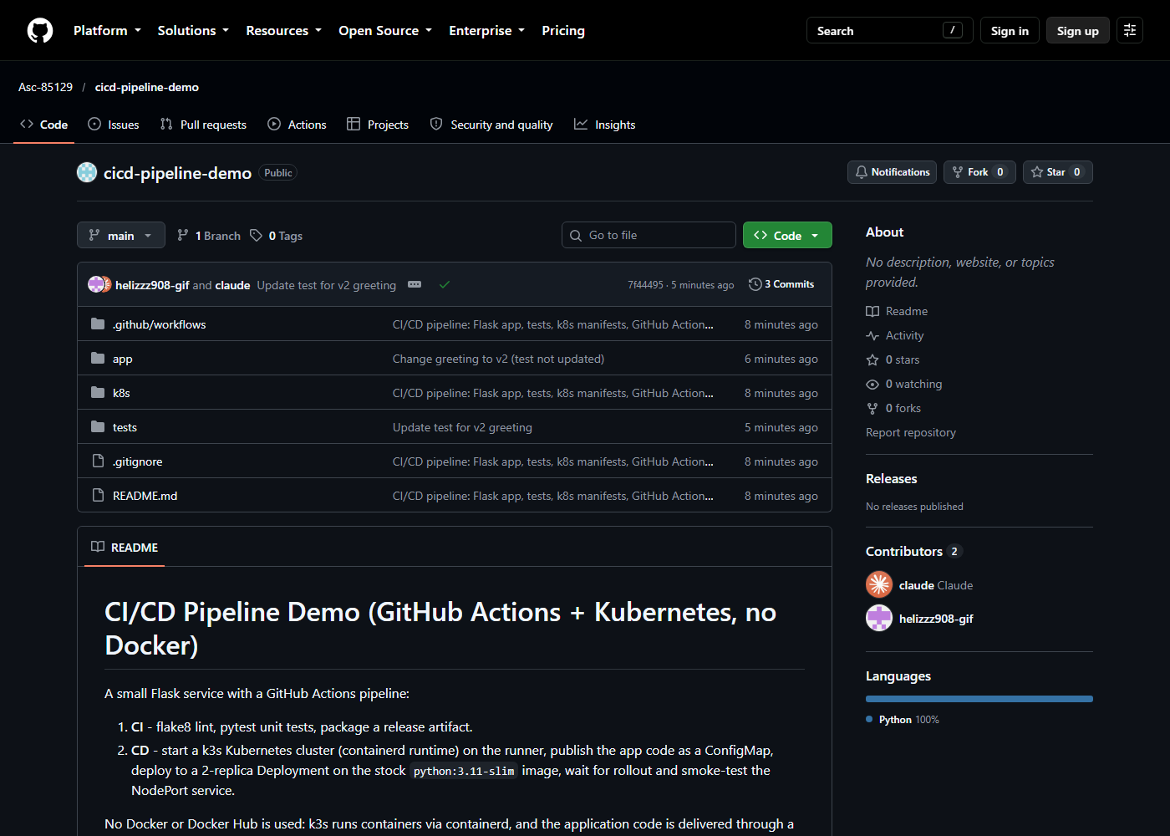
Figure 5: Repository on GitHub after the first push

6. Execution and Output

6.1 Run #1 – first commit, full pipeline green
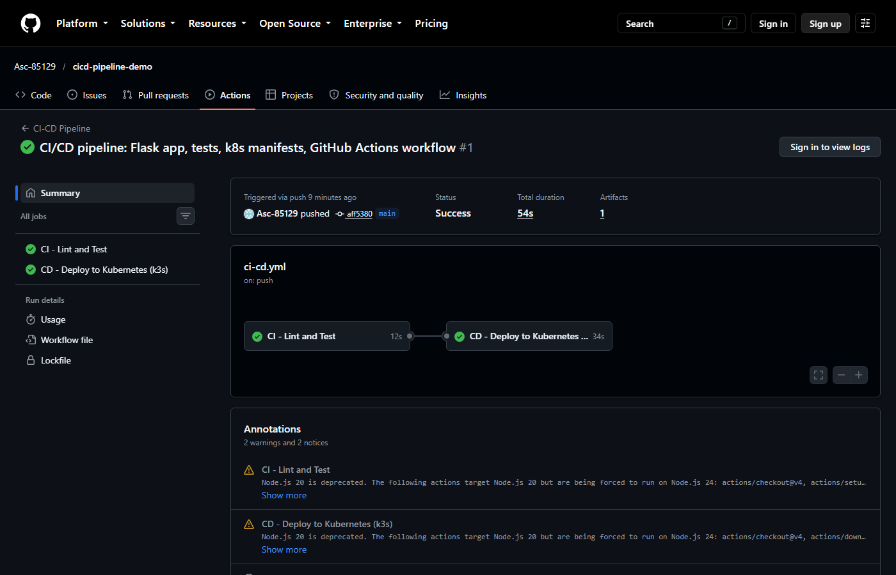
Figure 6: Run #1 summary: CI (12 s) followed by CD (34 s), status Success, 1 artifact
CI job log: flake8 reports nothing, and pytest passes all three tests on the runner:
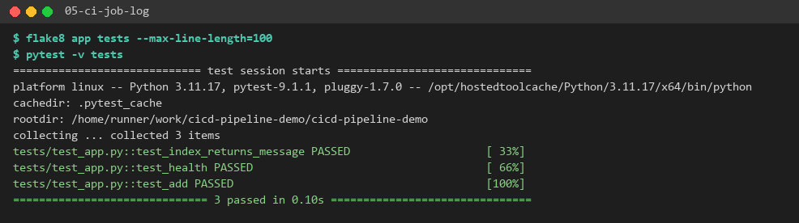
Figure 7: CI job: lint and unit tests on the GitHub runner
CD job: k3s installs and the node becomes Ready in a few seconds. Note the CONTAINER-RUNTIME column, containerd://2.3.4-k3s1.36. No Docker is involved.
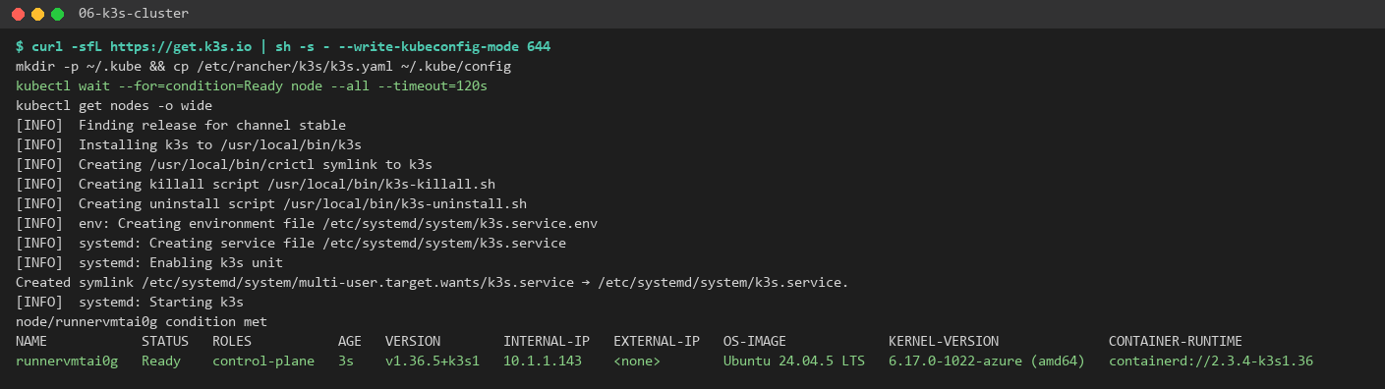
Figure 8: k3s cluster created on the runner, node Ready, runtime containerd
The ConfigMap, Deployment and Service are created. kubectl rollout status waits until both replicas are available, and then the Deployment shows 2/2 Ready with 2 pods Running:
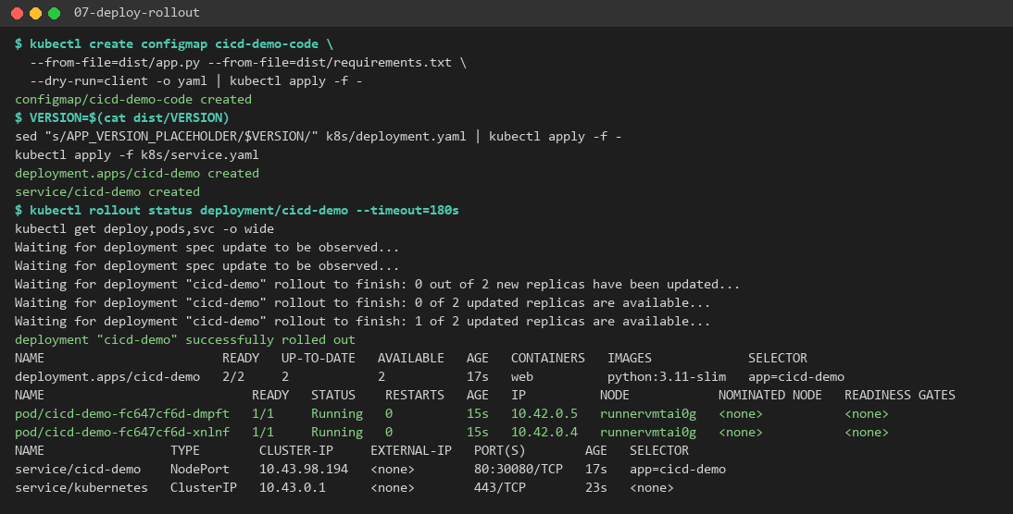
Figure 9: ConfigMap + manifests applied, rollout completes, 2/2 pods Running, NodePort 80:30080
Smoke test: three requests to the NodePort are answered by both pods (dmpft and xnlnf), which shows the Service is load-balancing. Each reply carries version aff5380, the commit that was pushed, and /health returns ok:
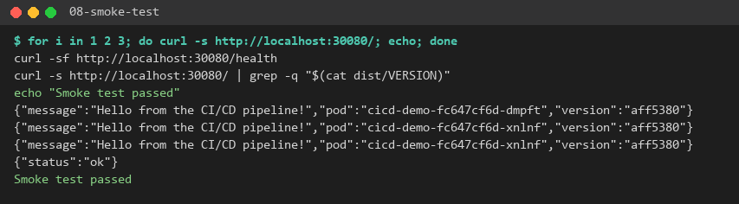
Figure 10: Smoke test against the live service

6.2 Run #2 – quality gate blocks a broken change
To show that the pipeline really works as a gate, the greeting in app.py was changed to "Hello from CI/CD pipeline v2!" without updating the test, and the change was pushed:
sed -i 's/Hello from the CI\/CD pipeline!/Hello from CI\/CD pipeline v2!/' app/app.py
git commit -am "Change greeting to v2 (test not updated)"
git push
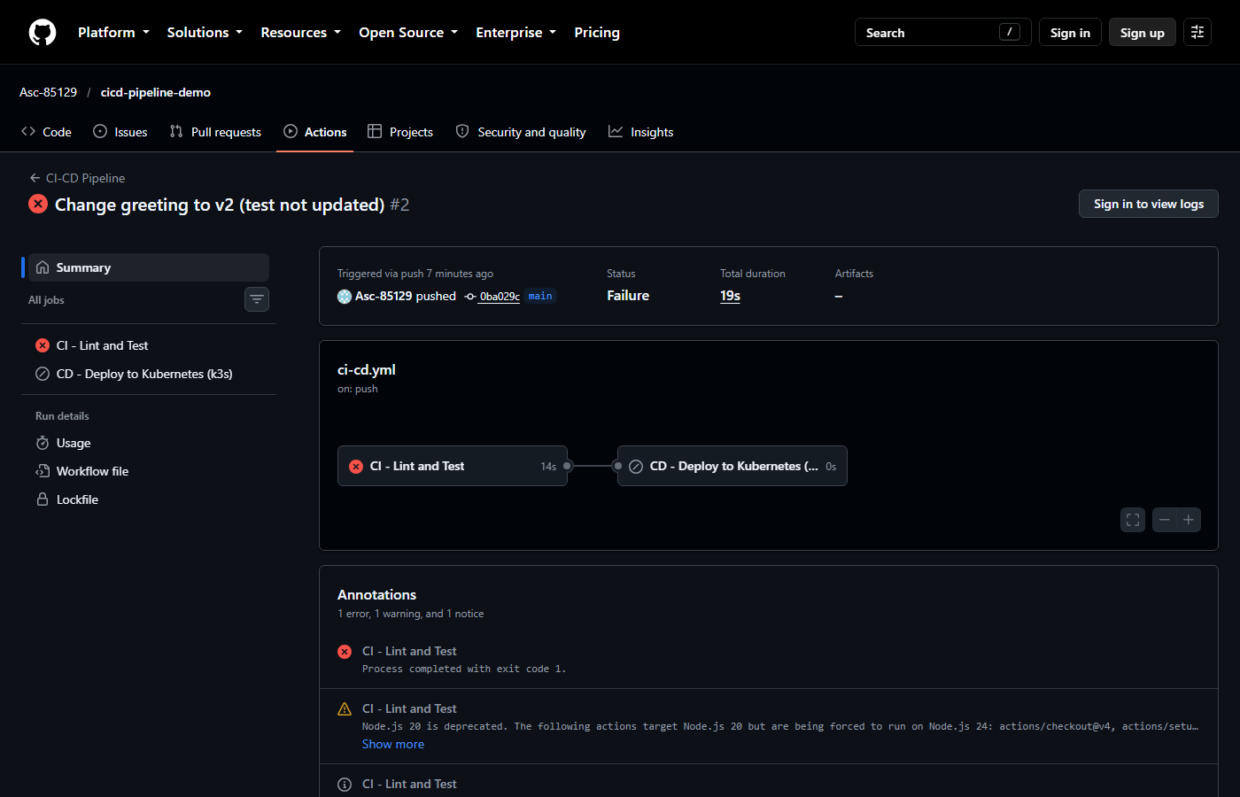
Figure 11: Run #2: CI failed, CD job skipped
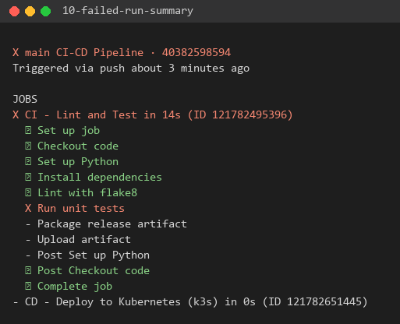
Figure 12: gh run view: the Run unit tests step failed, later steps and the deploy job skipped
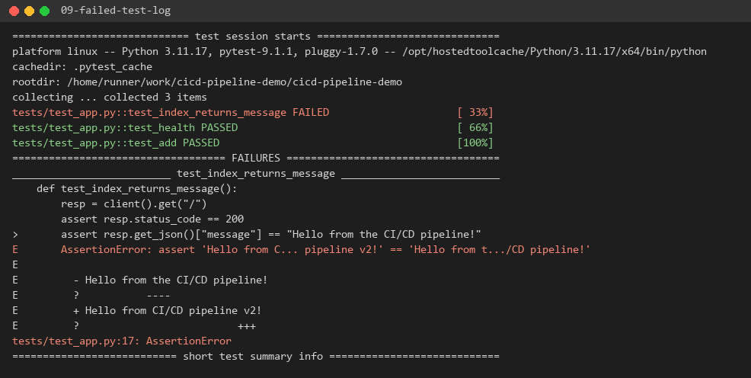
Figure 13: pytest output on the runner: assertion mismatch on the message field
Because deploy has needs: build-test, the deploy job was skipped and never ran. In a long-lived environment, the previous good version would still be serving users.

6.3 Run #3 – fix and redeploy v2
sed -i 's/Hello from the CI\/CD pipeline!/Hello from CI\/CD pipeline v2!/' tests/test_app.py
python -m pytest -q tests # 3 passed
git commit -am "Update test for v2 greeting"
git push
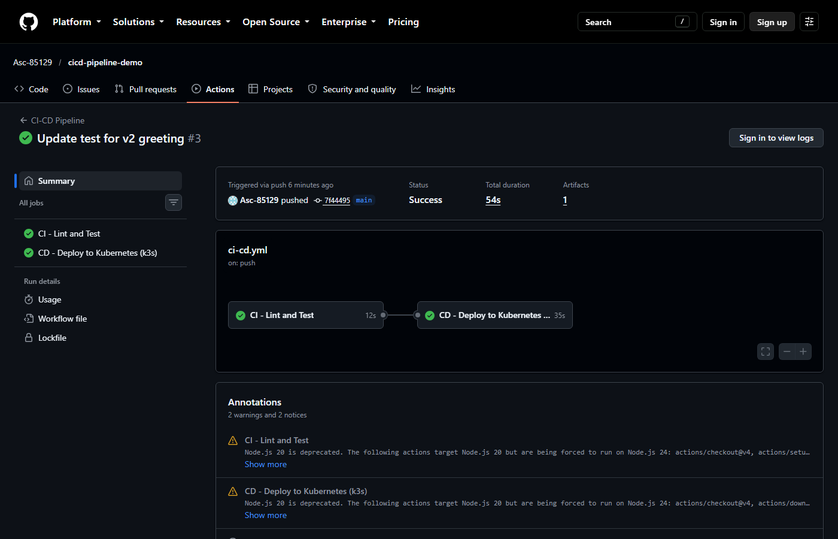
Figure 14: Run #3: both jobs green
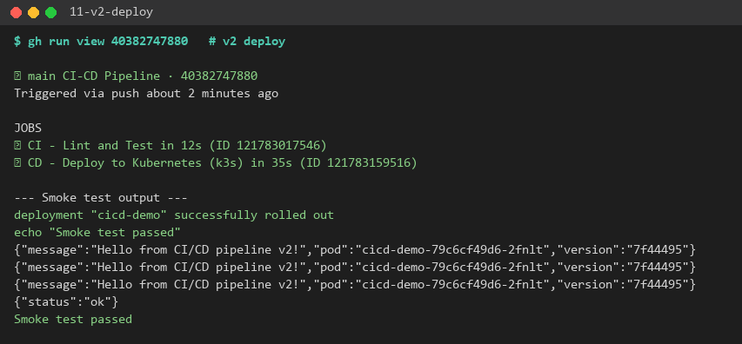
Figure 15: Run #3 smoke test: live service returns the v2 message with version 7f44495
The new version was deployed with no manual step: the change went from git push to a verified running deployment in under a minute.

6.4 Run history
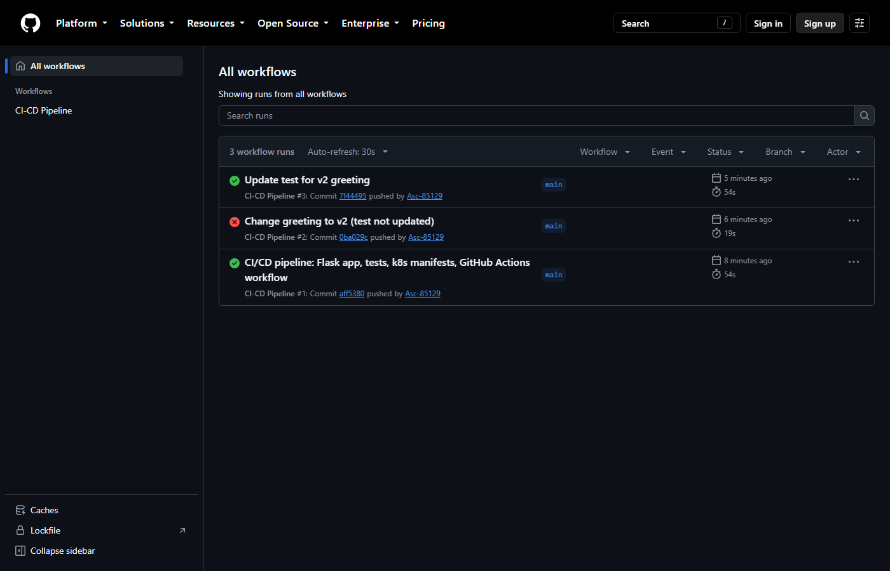
Figure 16: GitHub Actions run list for the workflow
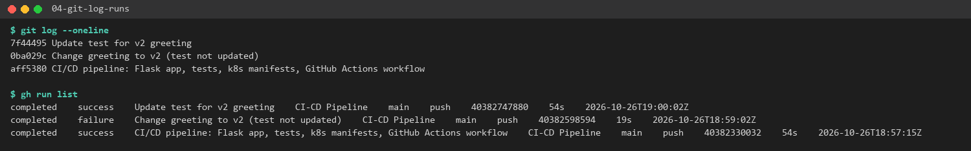
Figure 17: Commits and their matching workflow runs

7. Pipeline Run Summary
Run | Commit | Change | CI | CD | Outcome
#1 | aff5380 | Initial app, tests, manifests, workflow | Pass (12 s) | Pass (34 s) | v1 deployed, 2/2 pods, smoke test OK
#2 | (v2 greeting) | Greeting changed, test not updated | Fail (pytest) | Skipped | Bad change blocked before deployment
#3 | 7f44495 | Test updated for v2 | Pass (12 s) | Pass (35 s) | v2 deployed and verified

8. Troubleshooting
Problem | Cause | Fix
Docker Desktop makes the laptop lag | Docker Desktop runs a WSL 2 VM with large memory/CPU use | Removed Docker entirely: k3s with containerd on the GitHub runner, code delivered via ConfigMap
Docker Hub needs an account, token and repository secrets | An external registry needs credentials | Replaced with GitHub Actions artifacts. The pipeline needs no secrets at all.
Pods would fail if deployed before the code exists | The pods mount ConfigMap cicd-demo-code | The ConfigMap is created (idempotently, with --dry-run=client | apply) before the Deployment is applied
Without probes, Service traffic reaches a pod still running pip install | Kubernetes treats a container as ready as soon as it starts | Added a readinessProbe on /health. rollout status waits for both pods to be Ready.
Log captures contained ANSI colour codes and echoed commands | GitHub log format | Stripped with sed before rendering the screenshots
Annotation: Node.js 20 actions deprecated | actions/*@v4 target Node 20; GitHub forces Node 24 | Warning only, the runs pass. It can be cleared later by moving to newer major versions of the actions.

9. Result
A working CI/CD pipeline was implemented with GitHub, GitHub Actions and Kubernetes. Every push to main is linted and unit-tested automatically. A green build is packaged as a versioned artifact and deployed to a real Kubernetes (k3s) cluster as a 2-replica Deployment behind a Service, and the deployment is verified by an automated smoke test that checks the commit version being served. Run #2 showed that a failing test stops deployment, and run #3 showed a fixed change reaching production automatically. Docker and Docker Hub were not used: containerd (through k3s) ran the containers, and the code was delivered through a ConfigMap and GitHub artifacts.

10. References
- GitHub Actions documentation – https://docs.github.com/actions
- Workflow syntax (needs, if, artifacts) – https://docs.github.com/actions/writing-workflows/workflow-syntax-for-github-actions
- Kubernetes documentation: Deployments, Services, ConfigMaps, probes – https://kubernetes.io/docs/
- k3s documentation – https://docs.k3s.io
- Kubernetes dockershim removal FAQ – https://kubernetes.io/blog/2022/02/17/dockershim-faq/
- Flask documentation – https://flask.palletsprojects.com
- Project repository – https://github.com/Asc-85129/cicd-pipeline-demo

