**Remote SSH Login to Atlas 200 DK**

You can remote ssh login to Atlas 200 DK with following steps. Note, the following applies to **Windows 10/Mac/Ubuntu** systems. For **Windows 7** system or in case the following does not work for you, please use the vmware tool, following [VMWare for Atlas 200 DK Remote.docx](VMWare%20for%20Atlas%20200%20DK%20Remote.docx)

1. On your PC, download and Install **VScode** <https://code.visualstudio.com/>
2. Open **VScode**, in **Extensions**, search for **Remote-ssh** and install, as in following figure.

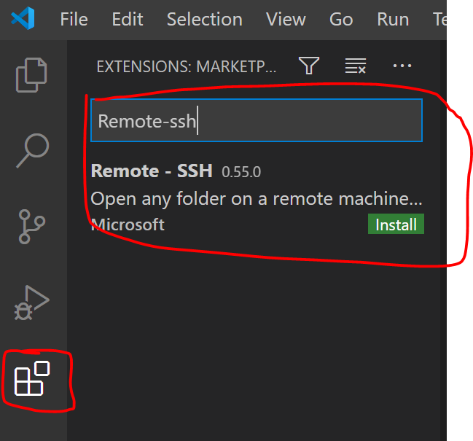

1. After installed, open the Remote-ssh extension, and click on the ‘**Configure**’ button to input the ssh configuration, as shown in the following figure.

Please replace ‘**user1’** and ‘**192.168.1.20**’ with the user name and IP address provided for you.

In the figure, ‘**ssh.exe**’ is for **Windows 10**, for **Linux** or **Mac**, use ‘**ssh’** instead.

# Jump box with public IP address

Host jump-box0

    HostName 216.71.202.212

    User user0

    Port 1111

# Target machine with private IP address

Host target-box0

    HostName 192.168.1.20

    User HwHiAiUser

    ProxyCommand ssh.exe -q -W %h:%p jump-box0

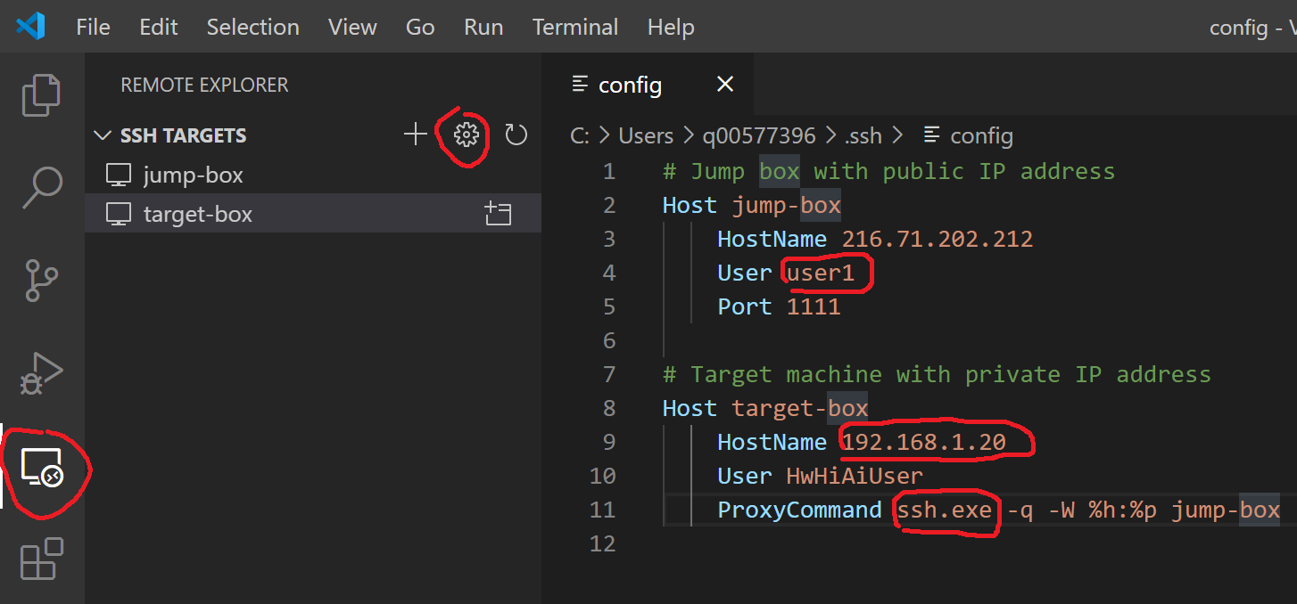

Note that, after you click the ‘configure’ button, it will ask you to select SSH configuration file as shown below figure, just choose the default one.

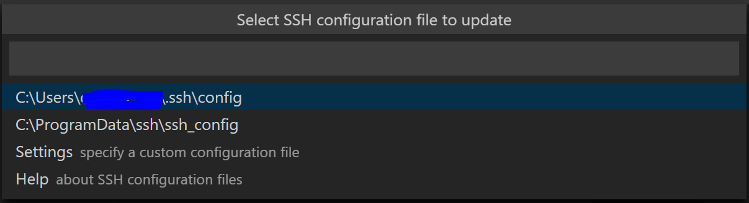

1. After you input the configuration, you will see ‘**target-box**’ in the SSH Target List. Right click on it, and select ‘ **Connect to Host in Current Window**’.
2. If VS Code cannot automatically detect the type of server you are connecting to, you will be asked to select the type manually.

Choose **Linux.**

And you may be asked ‘Are you sure want to continue’, select ‘Continue’

1. Then, you are request to enter the password for your user @216.71.202.212, and password for HwHiAiUser. For both case, password is the same. Enter the following

**Mind@123**

1. Wait for Setup to finish, and you will see ‘target-box’ connected as shown in below image

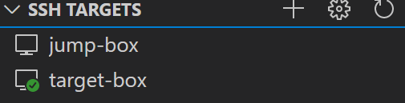

1. Then, go to ‘**Explorer’** -> ‘**Open Folder**’, and select the default path (home path for **HwHiAiUser**) and click **OK**, as shown below

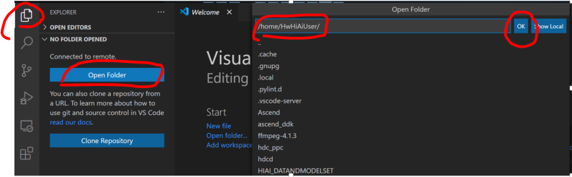

1. You might be asked to enter the password again, then you will see the files on Atlas 200 DK.

To open a terminal on Atlas 200 DK to run command, go to ‘Terminal’ -> ‘New Terminal’, as seen in below images.

